Terminal IT Agent: UC-01
Policy Conflict Detection: system architecture and engineering replication guide
Owner Sri · Version 1.0 · Date 17 May 2026 · Status Engineering review, ready to replicate
Audience engineers tasked with replicating this build in another AWS account or environment.
How to use this document Section 1 to 6 explain what the system is and how it works. Section 7 is the step-by-step replication runbook; if you only have an hour, start there. Section 8 to 13 cover security, ops, and what to build next.

1. Executive summary
Terminal IT Agent UC-01 is an AI helpdesk agent that detects cross-domain policy conflicts: cases where a written policy permits an action while a technical control silently prevents it (or vice versa). The canonical example, used as the smoke test in this build, is an employee who is blocked from Dropbox by a Zscaler URL filtering rule while the company's SharePoint Acceptable Use Policy explicitly lists Dropbox as approved cloud storage.
The agent ingests a helpdesk ticket, retrieves the most relevant policy excerpts from an Amazon Bedrock Knowledge Base built over uploaded policy artifacts (SharePoint AUP, Zscaler ZIA policy export, AWS config snapshots), asks a foundation model to reason whether the issue is a policy conflict, and posts a structured finding as an Adaptive Card to a Microsoft Teams channel. Bedrock Guardrails sit in front of the model invocation and intercept tickets that violate restricted topics (credential sharing, security-control bypass, SSL inspection disabling); intercepted tickets become critical-severity findings that escalate to the IT Security team.
The current implementation runs as a local Python script with one entry point. The Phase 1.5 path lifts the same code into a Lambda fronted by API Gateway with no logic change. The Phase 1.5+ roadmap is documented in section 13.

2. System overview

2.1 Problem statement
Large insurers (and most regulated enterprises) maintain dozens of written IT policy documents in SharePoint and dozens of technical-control configurations in Zscaler, AWS, Okta, and similar systems. The two sets drift apart over time: a policy is updated without the matching control change, or a control is tightened without updating the policy. Employees discover these conflicts when something they were told they could do silently stops working. The IT Service Desk fields the ticket but rarely has the cross-domain context to identify the conflict as the root cause; tickets get reassigned, escalated, and eventually resolved as one-off carve-outs without anyone closing the policy gap.

2.2 Goal
Give the Service Desk an automated co-analyst that, on every relevant ticket, reads the policy corpus and the technical-control export together and tells the agent whether the issue is a policy conflict, which two documents disagree, and what the next remediation step should be. Findings are routed to a Teams channel for human review; the agent does not auto-resolve tickets in this phase.

2.3 Key capabilities
- RAG over policy corpus. Bedrock Knowledge Base ingests policy documents from S3 and exposes a retrieve API. The agent issues a per-ticket query and gets the top K (default 5) most relevant chunks across all loaded sources.
- Multi-provider LLM. The reasoning step works with Anthropic API direct, Bedrock Nova, or Bedrock Claude. Selectable via an env var. Same prompt, same output schema across providers.
- Bedrock Guardrails. When configured, every Bedrock model invocation is wrapped by a guardrail that blocks denied topics and sensitive-information patterns. Interventions become critical-severity findings with escalation guidance.
- Structured findings. Output is a strict JSON schema (conflict_detected, confidence, policy_a, policy_b, recommendation, severity). Both terminal output and the MS Teams Adaptive Card are derived from this single schema.
- Replication-friendly. A single Python file, four environment variables, and one Knowledge Base. Engineers can stand this up in roughly two hours, end to end.

2.4 Non-goals
- No auto-remediation. The agent does not call any write API; it produces a finding and posts to Teams. A human Service Desk agent (or a downstream automation in a later phase) takes the action.
- No multi-turn conversation. The agent answers per ticket. No back-and-forth with the user.
- No production hosting in this phase. The script runs locally for the demo. Phase 1.5 puts it behind a Lambda.

3. High-level architecture
Five logical zones, top to bottom: input, agent runtime, Bedrock + storage, output, observability. The architecture diagram on the next page shows all five zones with the components inside each, plus the Bedrock Guardrails interception path highlighted in orange.

High-level architecture diagram
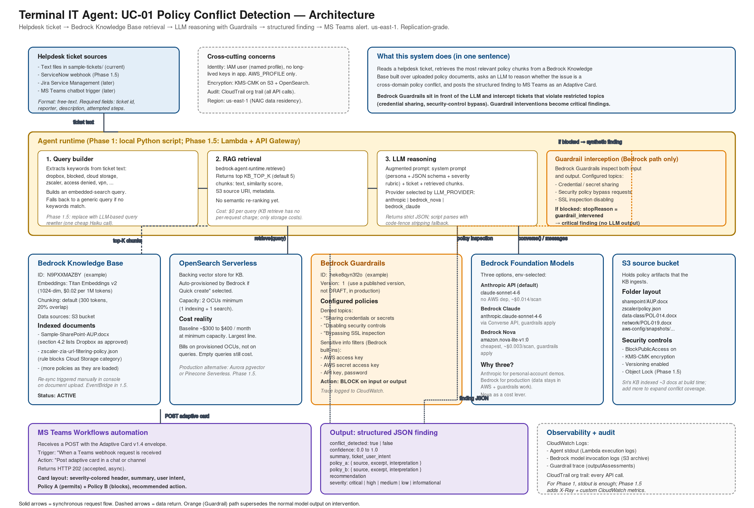

4. Component design
This section walks through each component, what it does, why we picked it, and how to configure it. Configuration values shown here are the ones used in the reference build; engineers replicating the system will substitute their own IDs.

4.1 Helpdesk ticket source
Today: text files committed to the repo under sample-tickets/. The agent takes a file path on the CLI and reads the content. The ticket format is free text; the agent extracts a ticket id (regex INC|REQ|TKT followed by digits) and treats the rest as content to feed the retrieval and reasoning steps.
- Phase 1.5 A ServiceNow webhook calls a Lambda when a new ticket lands in a watched Service Desk category. Same agent code; the Lambda is the new entry point.
- Phase 2+ Add Jira Service Management and an MS Teams chatbot trigger. Adapters live in a small ingest layer in front of the same agent.

4.2 S3 policy corpus bucket
Single S3 bucket holds every policy artifact the KB ingests. One folder per source system. Block public access, KMS-CMK encryption, versioning on. Object Lock is added in Phase 1.5 for tamper-evidence on policy snapshots.
s3://<your-policy-corpus-bucket>/
├── sharepoint/
│ └── Sample-SharePoint-AUP.docx (POL-IT-001 v3.2)
├── zscaler/
│ └── zscaler-zia-url-filtering-policy.json
├── data-classification/ (add: POL-IT-014)
├── network-standard/ (add: POL-IT-019)
└── aws-config-snapshots/ (add: SG drift snapshots)

4.3 Bedrock Knowledge Base
Managed RAG layer. Bedrock chunks the documents, embeds each chunk, stores vectors in a backing vector store, and exposes a retrieve API that returns top-K chunks by similarity score. The KB also exposes retrieve_and_generate (one-shot RAG), but the agent uses plain retrieve so the reasoning step is decoupled from retrieval and the output schema stays under our control.
Setting | Value (reference build)
Name | itopsorchestrator-policy-corpus
Embeddings model | Amazon Titan Text Embeddings v2 (1024 dim)
Vector store | OpenSearch Serverless (auto-provisioned via "Quick create")
Chunking strategy | Default fixed-size, 300 tokens, 20% overlap
Data source | S3 bucket from section 4.2; sync triggered manually after each upload
KB ID env var | BEDROCK_KB_ID (example: N9PXXMAZBY)
Retrieve top-K | KB_TOP_K, default 5; raise to 8 if your corpus grows beyond ~25 documents
Cost driver | OpenSearch Serverless OCUs (provisioned, not per-query); see section 12

4.4 OpenSearch Serverless (KB backing store)
Bedrock provisions this for you when you choose "Quick create" during KB setup. Capacity is set to 2 OCUs minimum (1 indexing + 1 search). The cost floor for OpenSearch Serverless is roughly $300 to $400 per month even at near-zero query volume, because OCUs bill on provisioned capacity rather than per request. For pilot scale this is acceptable; for production a swap to Aurora pgvector or Pinecone Serverless is recommended (see section 13).

4.5 Bedrock Guardrails
Bedrock Guardrails wrap every model invocation and inspect both input and output against configured policies. The reference build uses one guardrail with three configured policy types:
- Denied topics three custom topics defined in the guardrail console: sharing credentials or secrets, disabling or weakening security controls, bypassing SSL inspection. Each topic is described with a one-sentence definition plus 2 to 4 example utterances.
- Sensitive information filters Bedrock built-ins for AWS access key, AWS secret access key, API key, generic password. Action set to BLOCK so the model never sees nor returns these strings.
- Content filters (optional) Bedrock provides categories for prompt injection, sexual content, violence, hate, insults, misconduct. Default thresholds set to LOW where applicable. Not the core defense here; the denied topics carry the policy-specific work.
When a guardrail blocks, the Converse API returns with stopReason="guardrail_intervened" and an outputAssessments trace. The agent script catches this and builds a synthetic critical-severity finding rather than crashing or returning nothing. The trace prints to stdout so CloudWatch Logs can show which policy was triggered.
Important caveat: guardrails apply only to Bedrock model invocations (Converse API). The Anthropic API path (LLM_PROVIDER=anthropic) does not honor Bedrock guardrails. Use bedrock_nova or bedrock_claude in any environment where guardrail enforcement matters; the anthropic path is fine for developer demos on personal accounts.

4.6 Foundation models
Three options, selected by env var LLM_PROVIDER. Same prompt, same schema, different cost and trust profile.
Provider | Model ID | Auth | Guardrails honored? | Use when
anthropic (default) | claude-sonnet-4-6 (or override) | ANTHROPIC_API_KEY | No (Anthropic API) | Personal-account demos; no Bedrock model access yet
bedrock_nova | amazon.nova-lite-v1:0 | AWS IAM | Yes | Cost-optimized production. ~$0.003 per scan.
bedrock_claude | anthropic.claude-sonnet-4-6 | AWS IAM | Yes | Quality-optimized production. ~$0.014 per scan.

4.7 Agent runtime
A single Python file: itopsorchestrator_demo_uc01.py. Two subcommands: kb-check (validates KB connectivity, returns a probe retrieval) and analyze --ticket <file> (the full agent flow). The script has no external state beyond environment variables; rerunning it on the same ticket produces a fresh finding each time (no deduplication in Phase 1; Phase 1.5 adds an idempotency key on ticket id).
Internal structure:
- retrieve_policy_chunks(query) calls bedrock-agent-runtime.retrieve, returns a list of chunks with text, score, source S3 URI, and metadata.
- reason_with_llm(ticket_text, chunks) branches on PROVIDER. On Bedrock paths, builds a Converse call with guardrailConfig attached. Catches stopReason="guardrail_intervened" and returns a synthetic critical finding. On Anthropic path, calls the Messages API directly.
- post_finding_to_teams(finding, ticket_id) builds an Adaptive Card v1.4 with severity-colored containers, posts to the Workflows webhook, expects HTTP 202.
- _build_retrieval_query(ticket_text) heuristic keyword extractor over a small allow-list of policy nouns (dropbox, onedrive, zscaler, cloud storage, etc.). Phase 1.5 swaps this for an LLM-based query rewriter.

4.8 MS Teams Workflows automation
Microsoft retired the legacy "Incoming Webhook" connector in 2024 to 2025. The current path is a Power Automate workflow accessed from inside Teams (channel > three dots > Workflows). The reference build uses the template "Post to a channel when a webhook request is received" with the trigger schema set to the Bot Framework Adaptive Card envelope:
{ "type": "message",
"attachments": [{
"contentType": "application/vnd.microsoft.card.adaptive",
"content": { "$schema": "...adaptive-card.json",
"type": "AdaptiveCard",
"version": "1.4",
"body": [ ... ] } }] }
Webhook URL goes in TEAMS_WEBHOOK_URL. Returns HTTP 202 (accepted, async). Card lands in the channel within ~10 seconds.

5. Runtime data flow
The agent does three things per ticket: build a retrieval query, call the KB, call the model. The model call has three outcomes (cross-domain conflict detected, no conflict, guardrail intervention). The sequence diagram on the next page lays out all three paths against the same six lifelines.
- Path A, cross-domain conflict. Retrieval returns chunks from both source policies; the model identifies the disagreement and returns conflict_detected=true with policy_a and policy_b populated. Severity scored on the impact, typically high.
- Path B, no conflict. Retrieval may return policy chunks but the model determines they do not contradict the user's issue. conflict_detected=false; recommendation field carries the most likely alternative root cause (sync error, VPN, expired credentials).
- Path C, guardrail intervention. Guardrail blocks either the input (ticket text matches a denied topic) or the output (model response contains sensitive info). Converse returns stopReason="guardrail_intervened". Agent synthesizes a critical finding with escalation guidance.

Sequence diagram: three runtime paths
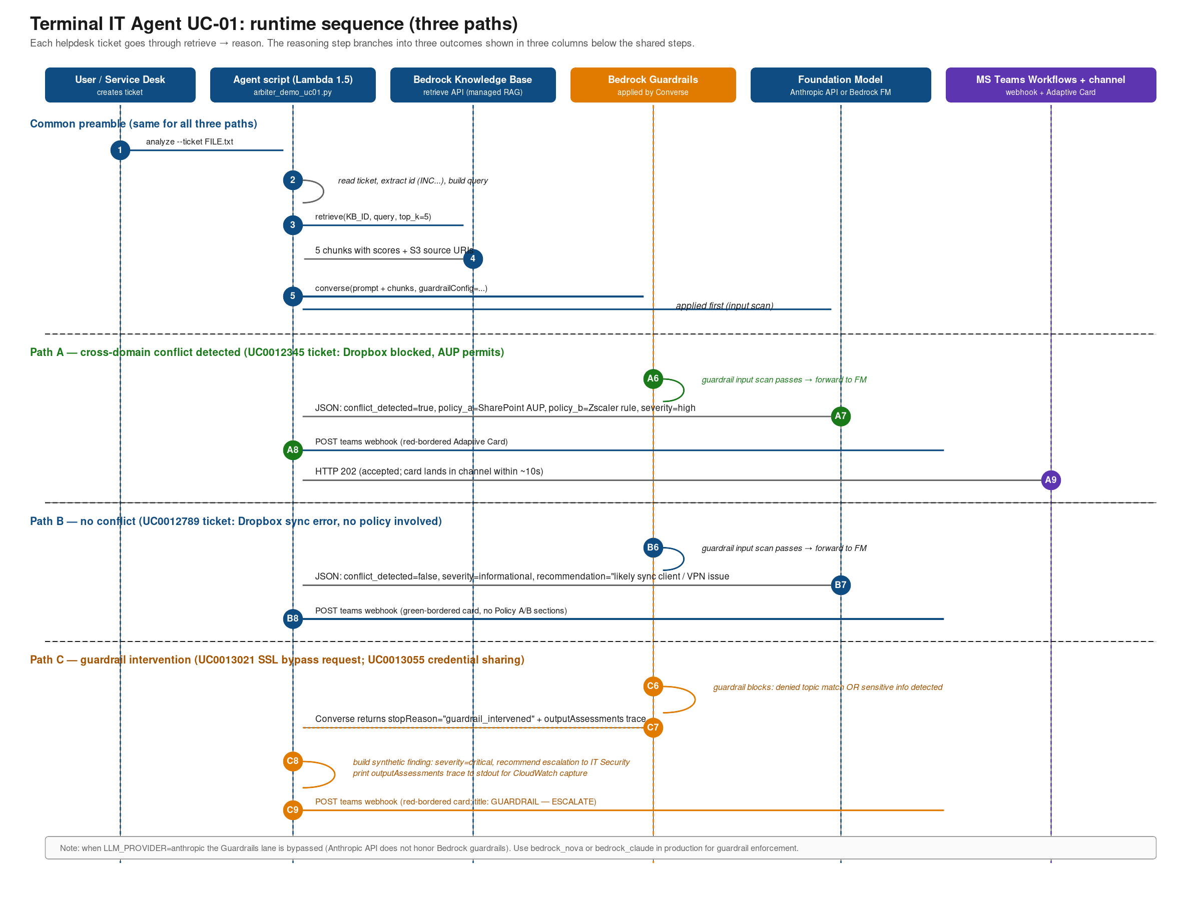

6. Data contracts
Three contracts engineers need to know: the ticket input format, the structured finding JSON, and the Adaptive Card payload. The finding JSON is the single source of truth; both terminal output and the Teams card are derived from it.

6.1 Helpdesk ticket input
Free text. The agent does not parse structured fields; the entire ticket goes into the model context. The only structured extraction is the ticket id (regex). For consistency, recommend the following header convention in any tickets that feed the agent:
Ticket: <INC|REQ|TKT><digits>
Reporter: <name> <<email>>
Reporter ID: <id>
Department: <dept>
Location: <site>
Created: <ISO timestamp>
Priority: <1..5>
Category: <category>

Short description: <one line>

Description:
<free text including steps to reproduce, attempted fixes, business impact>

6.2 Finding JSON schema
Returned by the model and validated by the agent. The keys must be present and the types must match; the agent prints the raw JSON to stdout and uses the same dict to render the Teams card.
{
"conflict_detected": true | false,
"confidence": 0.0 to 1.0,
"summary": "<one-sentence>",
"ticket_user_intent": "<what the user was trying to do>",
"policy_a": {
"source": "<filename or identifier of the policy that PERMITS>",
"excerpt": "<verbatim quoted clause from a retrieved chunk>",
"interpretation": "<one sentence>"
},
"policy_b": {
"source": "<filename or identifier of the policy that BLOCKS>",
"excerpt": "<verbatim quoted clause from a retrieved chunk>",
"interpretation": "<one sentence>"
},
"recommendation": "<concrete next step>",
"severity": "critical | high | medium | low | informational"
}

6.3 Teams Adaptive Card payload
Sent to the Workflows webhook. Body items are derived from the finding fields; container styles map to severity. The card has three logical sections: severity-colored header (title + subtitle + scored-by line), summary + user intent, and policy A + policy B + recommendation.

7. Replication runbook
Follow these steps in order. Estimated time end to end: 90 to 150 minutes including waits for Knowledge Base sync. Anything in angle brackets needs to be substituted for your environment.

7.1 AWS account prerequisites
- Sign in to an AWS account in us-east-1 (or another Bedrock-enabled region; this guide assumes us-east-1).
- Enable model access in Bedrock console > Model access for: Anthropic Claude Sonnet 4.6, Amazon Nova Lite (and any others you intend to use). Approval is usually instant for Amazon models, a few hours to a few days for Anthropic models on new accounts.
- Set up billing alerts at $5, $25, $100. There is no hard spend cap on AWS; alerts are the only guard.

7.2 IAM user and inline policy
- In IAM, create a user named itops-example01-runtime with programmatic access. Download the access key ID and secret immediately and store them in a secret manager (1Password, AWS Secrets Manager, etc.).
- Attach the following inline policy. The Resource ARNs need to be substituted with your account ID, KB ID, and (optionally) Guardrail ID.
{
"Version": "2012-10-17",
"Statement": [
{
"Sid": "BedrockInvoke",
"Effect": "Allow",
"Action": "bedrock:InvokeModel",
"Resource": "arn:aws:bedrock:us-east-1::foundation-model/*"
},
{
"Sid": "BedrockKB",
"Effect": "Allow",
"Action": [
"bedrock:Retrieve",
"bedrock:GetKnowledgeBase",
"bedrock:GetDataSource",
"bedrock:ListDataSources"
],
"Resource": "arn:aws:bedrock:us-east-1:<account-id>:knowledge-base/<kb-id>"
},
{
"Sid": "BedrockGuardrailOptional",
"Effect": "Allow",
"Action": [
"bedrock:ApplyGuardrail",
"bedrock:GetGuardrail"
],
"Resource": "arn:aws:bedrock:us-east-1:<account-id>:guardrail/<guardrail-id>"
}
]
}

7.3 S3 bucket for the policy corpus
- Create an S3 bucket in us-east-1. Example name: <your-org>-itopsorchestrator-policy-corpus.
- Settings: Block all public access ON; default encryption KMS-CMK (use AWS-managed key for the demo; switch to a customer-managed key in Phase 1.5); versioning ON.
- Upload the policy artifacts into the folder layout from section 4.2. At minimum upload the SharePoint AUP and the Zscaler policy JSON; both ship with this build.

7.4 Create the Bedrock Knowledge Base
- Bedrock console > Knowledge bases > Create knowledge base.
- Name: itopsorchestrator-policy-corpus. IAM service role: let Bedrock create one (it will get S3 read and OpenSearch write).
- Data source: S3, point at the bucket from 7.3. Chunking strategy: Default.
- Embeddings model: Amazon Titan Text Embeddings v2.
- Vector store: Quick create new (OpenSearch Serverless). This provisions the backing store automatically.
- After creation, click Sync on the data source. First sync takes 3 to 10 minutes for a small corpus. Wait for status Available.
- Copy the Knowledge Base ID (e.g. N9PXXMAZBY) from the KB detail page. You will need this in your .env.

7.5 Create the Bedrock Guardrail (optional but recommended)
Skip this section if you only need the conflict-detection path; the agent will still work without guardrails. To enable guardrail interception (paths C in the sequence diagram), follow these steps.
- Bedrock console > Guardrails > Create guardrail.
- Name: itopsorchestrator-policy-guardrail. Description: "Blocks credential sharing, security policy bypass, and SSL inspection disabling requests."
- Configure denied topics (Configure denied topics step):
- Topic 1: Sharing credentials or secrets. Definition: "Requests to share access keys, secret keys, passwords, API tokens, or other credentials with any user or channel." Examples: "send me the AWS access key", "share the .env file in Slack", "email me the production password".
- Topic 2: Disabling or weakening security controls. Definition: "Requests to disable, weaken, or bypass any technical security control including firewalls, MFA, antivirus, EDR, DLP, or proxies." Examples: "disable MFA for this user", "turn off DLP for my team".
- Topic 3: Bypassing SSL inspection. Definition: "Requests to disable Zscaler SSL inspection, add an SSL inspection bypass rule, or weaken the SSL category for a user group." Examples: "exempt my CI pipeline from SSL inspection", "lower SSL inspection on Developer Tools".
- Configure sensitive information filters: enable AWS access key, AWS secret access key, API key, password. Action: BLOCK on both input and output.
- Save guardrail as DRAFT, test with the two sample tickets (INC0013021 and INC0013055) in the Bedrock console test interface, then publish as version 1.
- Copy the Guardrail ID and Version. Both go in .env.

7.6 Set up the MS Teams Workflows webhook
- Open Microsoft Teams. Go to the channel where alerts should land. Hover the channel, three dots > Workflows.
- Search "webhook". Pick template "Post to a channel when a webhook request is received".
- Approve the Teams and Notifications connector permissions. Confirm the target team and channel. Click Add workflow.
- From the flow detail page, copy the workflow URL (format: https://prod-XX.westus.logic.azure.com/workflows/...). This is your TEAMS_WEBHOOK_URL.
- Test with curl. The trigger expects the Bot Framework envelope shape; the agent already sends it correctly.
curl -H "Content-Type: application/json" -d '{
"type": "message",
"attachments": [{
"contentType": "application/vnd.microsoft.card.adaptive",
"content": {
"$schema": "http://adaptivecards.io/schemas/adaptive-card.json",
"type": "AdaptiveCard",
"version": "1.4",
"body": [{ "type": "TextBlock", "text": "Webhook smoke test",
"weight": "Bolder", "size": "Large" }]
}
}]
}' "<TEAMS_WEBHOOK_URL>"

7.7 Clone the repo and set up Python
git clone <repo-url>
cd Terminal-IT-Agent/UC01-PolicyConflict
python -m venv .venv
source .venv/bin/activate # Windows: .venv\Scripts\activate
pip install -r requirements.txt

7.8 Configure .env
Copy .env.example to .env and fill in your values. Source the file in the shell you will run the agent in.
# LLM Provider: anthropic | bedrock_nova | bedrock_claude
export LLM_PROVIDER=bedrock_nova

# Anthropic (only required when LLM_PROVIDER=anthropic)
export ANTHROPIC_API_KEY="sk-ant-..."
export ANTHROPIC_MODEL=claude-sonnet-4-6

# AWS
export AWS_REGION=us-east-1
export AWS_DEFAULT_REGION=us-east-1
export AWS_PROFILE=<your-aws-profile>

# Bedrock Knowledge Base (required)
export BEDROCK_KB_ID=<your-kb-id>
export KB_TOP_K=5

# Bedrock Guardrails (optional; remove both lines to disable)
export GUARDRAIL_ID=<your-guardrail-id>
export GUARDRAIL_VERSION=1

# Bedrock model IDs
export BEDROCK_MODEL_ID=anthropic.claude-sonnet-4-6
export BEDROCK_NOVA_MODEL_ID=amazon.nova-lite-v1:0

# MS Teams Workflows webhook
export TEAMS_WEBHOOK_URL="https://..."

7.9 First-run verification
Three commands in order. Each should print a successful result; if any fails, see section 11.
source .env

# 1. Confirm AWS credentials
aws sts get-caller-identity

# 2. Confirm KB is reachable; this also runs a probe retrieval
python itopsorchestrator_demo_uc01.py kb-check

# 3. Run the full agent on the Dropbox-blocked ticket
python itopsorchestrator_demo_uc01.py analyze \
--ticket sample-tickets/ticket-INC0012345-dropbox-blocked.txt
Expected end state: a critical-colored Adaptive Card lands in the Teams channel with title "ITOpsOrchestrator policy conflict DETECTED · Ticket INC0012345", Policy A = SharePoint AUP excerpt, Policy B = Zscaler policy excerpt, recommendation referencing a CHG ticket to add a Zscaler carve-out for Dropbox Business.
Smoke-test the guardrail path with sample-tickets/ticket-INC0013055-share-env-credentials.txt. Expected end state: a critical-colored Adaptive Card with title "ITOpsOrchestrator policy conflict DETECTED" and Policy A = "Bedrock Guardrail" (the guardrail intervention path).

8. Configuration reference
Env var | Required? | Notes
LLM_PROVIDER | No (default anthropic) | anthropic | bedrock_nova | bedrock_claude. Production should use a Bedrock provider so Guardrails apply.
BEDROCK_KB_ID | Yes | Knowledge Base ID from the Bedrock console; e.g., N9PXXMAZBY.
KB_TOP_K | No (default 5) | Number of chunks retrieved per query. Raise to 8 if the policy corpus grows large.
TEAMS_WEBHOOK_URL | Yes | Power Automate workflow URL. Used to post findings.
AWS_REGION / AWS_DEFAULT_REGION | Yes | us-east-1 in this build.
AWS_PROFILE | No | If using a named profile in ~/.aws/credentials. Otherwise the default chain applies.
ANTHROPIC_API_KEY | When LLM_PROVIDER=anthropic | sk-ant-... format.
ANTHROPIC_MODEL | No (default claude-sonnet-4-6) | Pin a model snapshot in production.
BEDROCK_MODEL_ID | No (default anthropic.claude-sonnet-4-6) | Used when LLM_PROVIDER=bedrock_claude.
BEDROCK_NOVA_MODEL_ID | No (default amazon.nova-lite-v1:0) | Used when LLM_PROVIDER=bedrock_nova.
GUARDRAIL_ID | No | Bedrock guardrail identifier. When set, every Bedrock invocation passes through it.
GUARDRAIL_VERSION | No (default DRAFT) | Use a published numeric version in production; never DRAFT.

9. Security considerations
- Secrets handling. No long-lived credentials in the application. AWS credentials live in ~/.aws/credentials (Phase 1) and IAM roles (Phase 1.5). ANTHROPIC_API_KEY and TEAMS_WEBHOOK_URL live in .env; .gitignore excludes .env. Production moves both to Secrets Manager.
- IAM least privilege. The itops-example01-runtime user only gets bedrock:InvokeModel on foundation-model/* and bedrock:Retrieve plus describe actions on one specific KB and one specific guardrail. No EC2, no S3 write, no IAM modify.
- Data residency. us-east-1 only. KB, OpenSearch backing store, and all S3 buckets in the same region. No cross-region replication. Aligns with NAIC data residency requirements for US insurers.
- Encryption. S3 source bucket: KMS-CMK. OpenSearch Serverless: AWS-managed encryption (move to customer-managed in Phase 1.5). Bedrock invocations: TLS in transit; Bedrock does not persist prompts or outputs by default.
- Bedrock guardrails as security boundary. When enabled, guardrails BLOCK credential-sharing requests at the input stage; the model never sees the secret. Configure all known credential patterns; review the guardrail trace in CloudWatch monthly.
- Audit trail. CloudTrail org trail captures every API call. Bedrock model invocation logging can be enabled to archive prompts/responses to S3 for compliance review. Required before production.
- Network. Phase 1: local script on a corporate laptop, outbound through the corporate proxy. Phase 1.5: Lambda in a private VPC subnet with PrivateLink endpoints to Bedrock, S3, and Secrets Manager; no public egress except to Teams (allow-listed).

10. Failure modes and troubleshooting
Symptom | Likely cause | Fix
ERROR: BEDROCK_KB_ID env var is not set | .env not sourced into the current shell | Run source .env again. Confirm with echo $BEDROCK_KB_ID.
botocore.NoCredentialsError | AWS profile not exported or expired | Run aws sts get-caller-identity to confirm. Rotate credentials in ~/.aws/credentials if needed.
AccessDeniedException on bedrock:Retrieve | IAM policy missing bedrock:Retrieve or wrong KB ARN | Add the BedrockKB statement (section 7.2) with the correct account ID and KB ID.
AccessDeniedException on bedrock:InvokeModel | Model access not granted in Bedrock console | Bedrock > Model access > request access to the specific model. Wait for "Access granted".
Model returns valid JSON but conflict_detected=false on a ticket you expected to flag | Retrieval missed the relevant chunks | Bedrock console > KB > Test. Run the same query manually and inspect the chunks. If retrieval is off, broaden the chunking strategy or load more relevant policies.
JSONDecodeError: Expecting value | Model returned an empty or non-JSON response, typically due to a guardrail block on a non-Bedrock path | Verify LLM_PROVIDER is on a Bedrock path so guardrail interception returns a proper synthetic finding. The current script handles this case; update if needed.
Teams webhook returns non-202 | Workflow flow stopped, or the URL is stale, or schema mismatch | Check the flow run history in Power Automate. The most common cause is the trigger schema mismatching the payload; the agent sends the canonical Bot Framework envelope.
Guardrail does not intervene on the credential-sharing ticket | Guardrail not configured for the relevant denied topic, or version still DRAFT | Bedrock console > Guardrails > inspect the published version. Test the ticket in the console test interface. Publish a new version, update GUARDRAIL_VERSION.

11. Observability and operations
- Phase 1 (today). Agent prints structured progress to stdout. Each finding is also printed as JSON. CloudWatch Logs (Bedrock invocation logging) captures every model call when enabled in the Bedrock console.
- Phase 1.5 additions. Lambda execution logs into a dedicated CloudWatch Log Group. X-Ray tracing across retrieve and invoke calls. Custom CloudWatch metrics: findings_by_severity, retrieval_latency_p95, llm_latency_p95, guardrail_intervention_count, cost_per_finding.
- Phase 2 additions. CloudWatch dashboard with the above metrics; alarms on cost anomaly, guardrail intervention rate, and zero-finding days (likely a wiring break). On-call runbook documents the response for each alarm.

12. Cost model
Bedrock retrieval has no per-request charge. The major recurring costs are OpenSearch Serverless (provisioned capacity) and model invocations (per token). Everything else rounds to zero at pilot scale.
Line | Per query | Monthly (100 queries / day)
OpenSearch Serverless (KB store) | n/a | ~$300 to $400 (provisioned floor)
Bedrock KB retrieve API | $0 | $0
Titan embeddings (ingest, one-time) | n/a | < $1 for a small corpus
Bedrock Claude Sonnet 4.6 | ~$0.014 | ~$42
Bedrock Nova Lite | ~$0.003 | ~$9
Bedrock Guardrails (per 1K text units) | ~$0.0001 typical ticket | < $1
Teams Workflows | $0 | $0
Total with Nova + guardrails |  | ~$310 to $410 per month
Total with Sonnet + guardrails |  | ~$345 to $445 per month
OpenSearch Serverless is the floor and the largest single line. To reduce production cost, swap the KB backing store to Aurora pgvector (about $30 to $80 per month at this scale) or Pinecone Serverless. Bedrock supports both; the migration is a console reconfiguration with no application code change.

13. Phase 1.5 roadmap (what to build next)
- 1. Lambda lift. Same agent code, behind API Gateway. Triggered by a ServiceNow webhook or invoked manually. Secrets move to Secrets Manager. KB ID and webhook URL move to env config on the Lambda. Two-day swap, no rewrite.
- 2. LLM-based query rewriter. Replace the keyword extractor with a Haiku call that turns a ticket into a retrieval query. Improves retrieval quality on tickets that do not contain obvious nouns.
- 3. Idempotency on ticket id. Persist finding records to DynamoDB keyed by ticket id. Re-analyzing the same ticket updates the existing record rather than producing a duplicate Teams card.
- 4. Write-back to ServiceNow. Attach the finding as a worknote on the source ticket. Optional: auto-create a follow-up CHG ticket on the relevant team for verified conflicts.
- 5. Evaluation harness. Curated set of 30 to 50 tickets with known correct findings. Runs on every prompt or model change. Block deploys that regress on accuracy or severity assignment.
- 6. Migrate KB backing store. From OpenSearch Serverless to Aurora pgvector. Reduces the floor cost by roughly 80% at this scale.
- 7. Add more source systems. Bring AWS Config snapshots, Okta policy exports, and additional SharePoint policies into the KB. The agent does not need code changes; the model gets more context to reason over.

14. Appendices

14.1 Sample tickets included
- ticket-INC0012345-dropbox-blocked.txt explicit Dropbox block. Expected: conflict_detected=true.
- ticket-INC0012789-dropbox-sync-error.txt Dropbox sync error, no policy involved. Expected: conflict_detected=false.
- ticket-INC0013021-modify-zscaler-ssl-policy.txt DevOps request to disable SSL inspection and lower URL filtering. Expected: guardrail intervention (denied topic: bypassing SSL inspection + disabling security controls).
- ticket-INC0013055-share-env-credentials.txt new joiner asking for AWS keys and .env over Slack/email. Expected: guardrail intervention (denied topic: sharing credentials + sensitive info filter on AWS access key).

14.2 References
- Sample-SharePoint-AUP.docx. Fictional Nayak Fictional Insurance AUP v3.2 (section 4.2 approves Dropbox Business).
- zscaler-zia-url-filtering-policy.json. Fictional ZIA URL filtering export (rule Block-Cloud-Storage-All-Users).
- itopsorchestrator_demo_uc01.py. Agent script (~440 lines).
- requirements.txt. Dependencies: boto3 >= 1.34.131 for guardrail support, anthropic, requests.

14.3 Related documents
- Full POC architecture: ITOpsOrchestrator-POC-AWS-Architecture.docx
- UC-02 architecture: uc02_arch.png + UC02-Demo/
- Prototype-to-production roadmap: ITOps-Example02-Prototype-to-Production.docx

