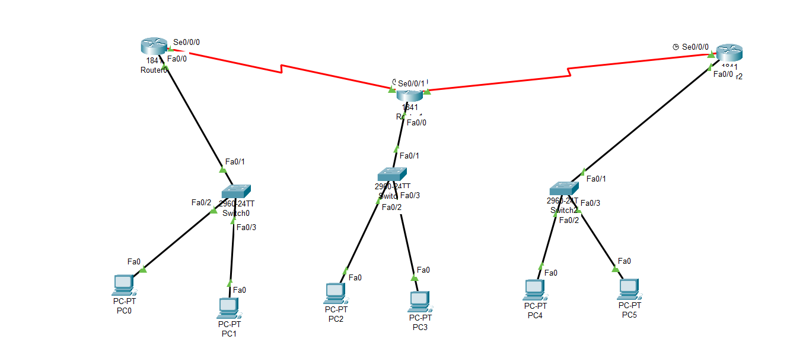

Router 1st

|  |
| --- |
| Router>  Router>en  Router#conf t  Enter configuration commands, one per line. End with CNTL/Z.  Router(config)#interface fa0/0  Router(config-if)#ip address 192.168.10.1 255.255.255.0  Router(config-if)# no shutdown  Router(config-if)#  %LINK-5-CHANGED: Interface FastEthernet0/0, changed state to up  %LINEPROTO-5-UPDOWN: Line protocol on Interface FastEthernet0/0, changed state to up  Router(config-if)#interface serial0/0/0  Router(config-if)#ip address 10.0.0.2 255.0.0.0  Router(config-if)#no shutdown  %LINK-5-CHANGED: Interface Serial0/0/0, changed state to down  Router(config-if)#exit  Router(config)#ex  Router#  %SYS-5-CONFIG_I: Configured from console by console  Router#wr  Building configuration...  [OK]  Router#conf t  Enter configuration commands, one per line. End with CNTL/Z.  Router(config)#ip route 192.168.11.0 255.255.255.0 10.0.0.3  Router(config)#ip route 192.168.12.0 255.255.255.0 10.0.0.3  Router(config)#exit  Router#  %SYS-5-CONFIG_I: Configured from console by console  Router#wr  Building configuration...  [OK]  Router#  %LINK-5-CHANGED: Interface Serial0/0/0, changed state to up  %LINEPROTO-5-UPDOWN: Line protocol on Interface Serial0/0/0, changed state to up |

Router 2nd

|  |
| --- |
| Router>  Router>en  Router#conf t  Enter configuration commands, one per line. End with CNTL/Z.  Router(config)#interface fa0/0  Router(config-if)#ip address 192.168.10.1 255.255.255.0  Router(config-if)# no shutdown  Router(config-if)#  %LINK-5-CHANGED: Interface FastEthernet0/0, changed state to up  %LINEPROTO-5-UPDOWN: Line protocol on Interface FastEthernet0/0, changed state to up  Router(config-if)#interface serial0/0/0  Router(config-if)#ip address 10.0.0.2 255.0.0.0  Router(config-if)#no shutdown  %LINK-5-CHANGED: Interface Serial0/0/0, changed state to down  Router(config-if)#exit  Router(config)#ex  Router#  %SYS-5-CONFIG_I: Configured from console by console  Router#wr  Building configuration...  [OK]  Router#conf t  Enter configuration commands, one per line. End with CNTL/Z.  Router(config)#ip route 192.168.11.0 255.255.255.0 10.0.0.3  Router(config)#ip route 192.168.12.0 255.255.255.0 10.0.0.3  Router(config)#exit  Router#  %SYS-5-CONFIG_I: Configured from console by console  Router#wr  Building configuration...  [OK]  Router#  %LINK-5-CHANGED: Interface Serial0/0/0, changed state to up  %LINEPROTO-5-UPDOWN: Line protocol on Interface Serial0/0/0, changed state to up |

Router 3rd

|  |
| --- |
| Router>en  Router#conf t  Enter configuration commands, one per line. End with CNTL/Z.  Router(config)#interface fa0/0  Router(config-if)#ip address 192.168.12.1 255.255.255.0  Router(config-if)#no shutdown  Router(config-if)#  %LINK-5-CHANGED: Interface FastEthernet0/0, changed state to up  %LINEPROTO-5-UPDOWN: Line protocol on Interface FastEthernet0/0, changed state to up  Router(config-if)#interface serial0/0/0  Router(config-if)#ip address 11.0.0.3 255.0.0.0  Router(config-if)#no shutdown  Router(config-if)#  %LINK-5-CHANGED: Interface Serial0/0/0, changed state to up  Router(config-if)#exit  Router(config)#exi  %LINEPROTO-5-UPDOWN: Line protocol on Interface Serial0/0/0, changed state to up  Router#  %SYS-5-CONFIG_I: Configured from console by console  Router#wr  Building configuration...  [OK]  Router#conf t  Enter configuration commands, one per line. End with CNTL/Z.  Router(config)#ip route 192.168.11.0 255.255.255.0 11.0.0.2  Router(config)#ip route 192.168.10.0 255.255.255.0 11.0.0.2  Router(config)#exit  Router#  %SYS-5-CONFIG_I: Configured from console by console  Router#wr  Building configuration...  [OK] |