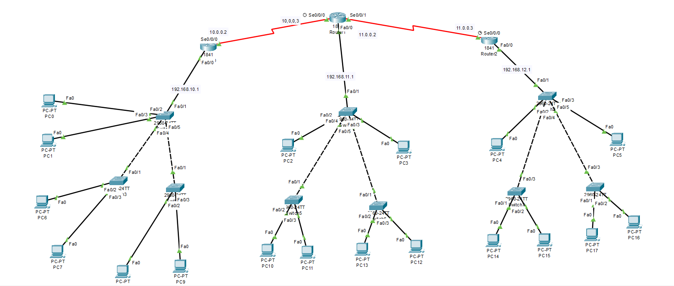

Router 1st

|  |
| --- |
| Router>en  Router#conf t  Enter configuration commands, one per line. End with CNTL/Z.  Router(config)#int fa0/0  Router(config-if)#ip address 192.168.10.1 255.255.255.0  Router(config-if)#no shutdown  Router(config-if)#  %LINK-5-CHANGED: Interface FastEthernet0/0, changed state to up  %LINEPROTO-5-UPDOWN: Line protocol on Interface FastEthernet0/0, changed state to up  Router(config-if)#int serial 0/0/0  Router(config-if)#ip address 10.0.0.2 255.0.0.0  Router(config-if)#no shutdown  %LINK-5-CHANGED: Interface Serial0/0/0, changed state to down  Router(config-if)#router ospf 1  Router(config-router)#network 192.168.10.0 0.0.0.255 area 0  Router(config-router)#network 10.0.0.0 0.255.255.255 area 0  Router(config-router)#exit  Router(config)#wr  ^  % Invalid input detected at '^' marker.  Router(config)#ex  Router#  %SYS-5-CONFIG_I: Configured from console by console  Router#wr  Building configuration...  [OK]  Router# |

Router 2nd

|  |
| --- |
| Router>en  Router#conf t  Enter configuration commands, one per line. End with CNTL/Z.  Router(config)#int fa0/0  Router(config-if)#ip address 192.168.11.1 255.255.255.0  Router(config-if)#no shutdown  Router(config-if)#  %LINK-5-CHANGED: Interface FastEthernet0/0, changed state to up  %LINEPROTO-5-UPDOWN: Line protocol on Interface FastEthernet0/0, changed state to up  Router(config-if)#int serial 0/0/0  Router(config-if)#ip address 10.0.0.3 255.0.0.0  Router(config-if)#no shutdown  Router(config-if)#  %LINK-5-CHANGED: Interface Serial0/0/0, changed state to up  Router(config-if)#  %LINEPROTO-5-UPDOWN: Line protocol on Interface Serial0/0/0, changed state to up  Router(config-if)#int serial 0/0/1  Router(config-if)#ip address 11.0.0.2 255.0.0.0  Router(config-if)#no shutdown  %LINK-5-CHANGED: Interface Serial0/0/1, changed state to down  Router(config-if)#router ospf 1  Router(config-router)#network 192.168.11.0 0.0.0.255 area 0  Router(config-router)#network 10.0.0.0 0.255.255.255 area 0  Router(config-router)#network 11.0.0.0 0.255.255.255 area 0  Router(config-router)#  00:08:47: %OSPF-5-ADJCHG: Process 1, Nbr 192.168.10.1 on Serial0/0/0 from LOADING to FULL, Loading Done  Router(config-router)#exit  Router(config)#exit  Router#  %SYS-5-CONFIG_I: Configured from console by console  Router#wr  Building configuration...  [OK]  Router#  %LINK-5-CHANGED: Interface Serial0/0/1, changed state to up  %LINEPROTO-5-UPDOWN: Line protocol on Interface Serial0/0/1, changed state to up  00:10:28: %OSPF-5-ADJCHG: Process 1, Nbr 192.168.12.1 on Serial0/0/1 from LOADING to FULL, Loading Done |

Router 3rd

|  |
| --- |
| Router>en  Router#conf t  Enter configuration commands, one per line. End with CNTL/Z.  Router(config)#int fa0/0  Router(config-if)#ip address 192.168.11.1 255.255.255.0  Router(config-if)#no shutdown  Router(config-if)#  %LINK-5-CHANGED: Interface FastEthernet0/0, changed state to up  %LINEPROTO-5-UPDOWN: Line protocol on Interface FastEthernet0/0, changed state to up  Router(config-if)#int serial 0/0/0  Router(config-if)#ip address 10.0.0.3 255.0.0.0  Router(config-if)#no shutdown  Router(config-if)#  %LINK-5-CHANGED: Interface Serial0/0/0, changed state to up  Router(config-if)#  %LINEPROTO-5-UPDOWN: Line protocol on Interface Serial0/0/0, changed state to up  Router(config-if)#int serial 0/0/1  Router(config-if)#ip address 11.0.0.2 255.0.0.0  Router(config-if)#no shutdown  %LINK-5-CHANGED: Interface Serial0/0/1, changed state to down  Router(config-if)#router ospf 1  Router(config-router)#network 192.168.11.0 0.0.0.255 area 0  Router(config-router)#network 10.0.0.0 0.255.255.255 area 0  Router(config-router)#network 11.0.0.0 0.255.255.255 area 0  Router(config-router)#  00:08:47: %OSPF-5-ADJCHG: Process 1, Nbr 192.168.10.1 on Serial0/0/0 from LOADING to FULL, Loading Done  Router(config-router)#exit  Router(config)#exit  Router#  %SYS-5-CONFIG_I: Configured from console by console  Router#wr  Building configuration...  [OK]  Router#  %LINK-5-CHANGED: Interface Serial0/0/1, changed state to up  %LINEPROTO-5-UPDOWN: Line protocol on Interface Serial0/0/1, changed state to up  00:10:28: %OSPF-5-ADJCHG: Process 1, Nbr 192.168.12.1 on Serial0/0/1 from LOADING to FULL, Loading Done |

At least

Router# show ip route