*Name (As per SSC certificate): Md. Ahsan Habib

*Present Address: Amar Ekushe Hall, KUET, Khulna-9203

*Email (Primary): mdnayan1507082@gmail.com

*Contact No. (Primary): +8801515626136, +8801773756759

*NID/Birth Certificate/Passport No.:

*SSC/ O. Level Registration No.: 1018894578

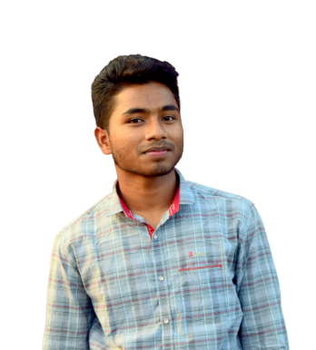

*

**Academic Details:**

|  |  |  |  |  |  |  |
| --- | --- | --- | --- | --- | --- | --- |
| **SL** | \***Certification Name** | \***Discipline/Major** | \***School/College/**  **University/Institute Name** | **\*Current Status** | **\*Result in CGPA till Last Semester** | **\*Tentative Passing Time**  **(MM-YYYY)** |
| 1. | *SSC | Science | Dhap Satgara B.M. Kamil Madrasah | Passed | 5.00/5.00 | 02-2013 |
| 2. | *HSC | Science | Dhap Satgara B.M. Kamil Madrasah | Passed | 5.00/5.00 | 05-2015 |
| 3. | *B.Sc. | CSE | Khulna University of Engineering & Technology | 8th Semester | 3.89/4.00 | 03-2020 |

**Skill/Knowledge:**

|  |  |  |
| --- | --- | --- |
| **SL** | **Computer Skills/Knowledge** | **Proficiency Description** |
| 1. | *Programming Language | C, C++, Java, Swift |
| 2. | *Operating System | Windows, Linux |
| 3. | Others | Python, C#, JavaScript, ASP, CSS, HTML, SQL |

**Professional or Academic Major Project(s)/Thesis:**

|  |  |  |  |
| --- | --- | --- | --- |
| **SL** | **Topic** | **Year** | **Description** |
| 1. | Green City | 4th 2019 | Thesis: Designing green city and construct network using Biologically Inspired Adaptive Network Design. |
| 2. | Tic-Tac-Toe ( iOS) | 3rd 2018 | Well know game. |
| 3. | Compiler | 3rd 2018 | A simple Compiler.  GitHub:<https://github.com/nayan082/compiler/tree/master/2k15_compiler_desing> |
| 4. | Smart Stick | 2nd 2017 | Hardware Project: A smart stick to help visually impaired.  GitHub: <https://github.com/nayan082/system-development> |
| 5. | KDS website | 2nd 2017 | A website for KDS(Kuet Debating Society) |
| 6. | Alarm Me(Android) | 2rd 2017 | An Android application for the alarm system. |
| 7. | Calculator(Android) | 2rd 2017 | A simple Calculator.  GitHub: <https://github.com/nayan082/Java_project_calculator> |

**Achievements/Contest Participation [if any]:**

|  |  |  |  |
| --- | --- | --- | --- |
| **SL** | **Name** | **Year** | **Description** |
| 1. | NASA SPACE APP CHALLENGE 2019 | 2019 | **Position**: Regional Champion (Khulna) & Global Nominee **Team**: Team Radiant |

**Training/Workshop:**

|  |  |  |  |
| --- | --- | --- | --- |
| **SL** | **Name** | **Year** | **Description** |
| 1. | BACS Regional Programming  Camp - Khulna Division | 2017 | Beginner level |

**Online Judge & Contest Judge ID(s) :**

|  |  |  |  |
| --- | --- | --- | --- |
| **SL** | **Online Judge & Contest Judge Name** | **ID** | **Achievement** |
| 1. | Codeforces | nayan_082 | Total Solve : 142 |
| 2. | Uva Online Judge | nayan_082 | Total Solve : 25 |
| 3. | Vjudge | nayan_082 | Total Solve : 19 |

**Publication(s):**

1. Staircase Detection System for the Visually Impaired People: A Review – Reference: <https://www.academia.edu/38314766/Staircase_Detection_System_for_the_Visually_Impaired_People_A_Review>

2. Staircase Detection to Guide Visually Impaired People: A Hybrid Approach (Under Review)