**React app Docs**

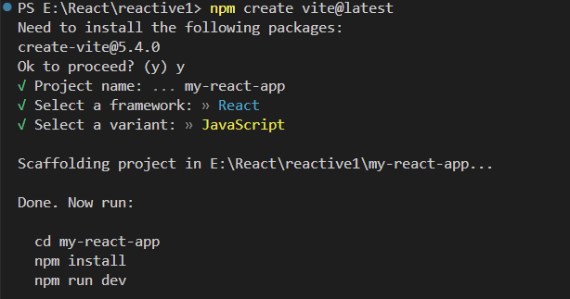

* Enclose the components within fragments
* Pops: read-only properties that are shared between elements.
* Click event : an interaction when a user clicks on a specific event.

We can respond to clicks by passing a callback to the onClick event handler.