Documentation review:

The documentation provides practical examples for each service, aiding developers in understanding integration processes.
Categorization into sections like Map Services and NDVI Services enhances navigability, allowing developers to quickly locate relevant information.
Providing information on common error codes and troubleshooting steps would assist developers in effectively managing potential issues.

Key improvements:
- Make it cross platform compatible, also including demos for popular frameworks like React.
For React integration and example code are present in the following repository:
https://github.com/nayan1306/vopen-react
demo app: https://vopen-react.vercel.app/

Key points to focus:
- Modified vapi-0.3.js to make it react compatible.
- Install dependencies as required.
- To retrieve a complete satellite image overlay, developers need to manually configure the date range. The from-date and to-date parameters should cover a 5-day period in the past to ensure optimal results. Adding information about tuning these parameters will be essential to assist new developers.
- In Location NDVI:
S2_NDVI_POINT_PROFILE
The following CORS error is encountered while testing on localhost.
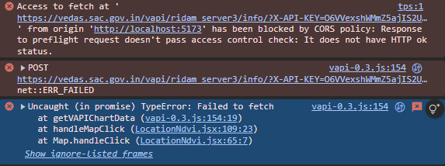
This prevents the location NDVI chart profie to load when clicked on a map location.
- In Polygon NDVI
S2_NDVI_PROFILE
The same error as location NDVI occurs when testing.
- The integrated APIs won’t work because CORS is not configured. Right now, they only work with a browser extension, which isn’t suitable for production. Please set up CORS properly on the server to fix this.

API console:
The system automatically adds an extra https:// to the allowed domains, in the API console.
