The DVM Recruitments Portal

Some Important Terms:
1.) Candidate refers to any junior who is intereseted in joining the DVM.

2.) After you get some information about a candidate, either by talking to them or by hearing about them from another DVM member, if you think that the kid has some potential, you can create an Assessment and assess the candidate.

3.) Each assessment is linked with a Task for the candidate.

4.) After an assessment you can Pitch a candidate and that means that you strongly believe that they should join the DVM and are awaiting further approval from others.

5.) The fifth and final term is Recommendation. A recommendation is issued by you to either a team or an induvisual of the DVM when you want them to interview and potentialy assess the candidate.

WalkThrough:
1.) Sign-in:
Login to the portal at _________________. On logging in, you arrive at the Home Page which can also be accessed by pressing on “Recruitments Portal” in the menu bar.
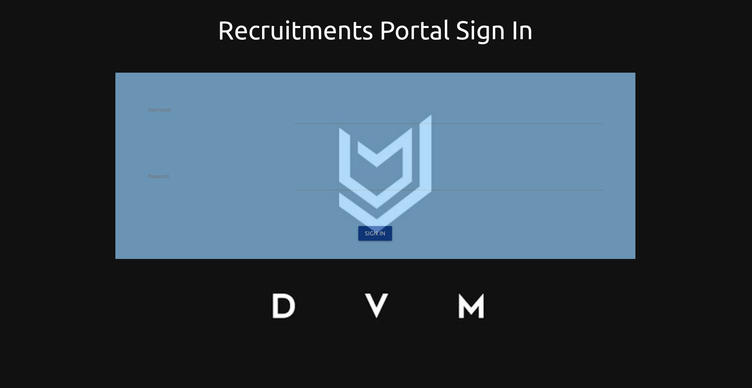
Sign In Page

Menu Bar

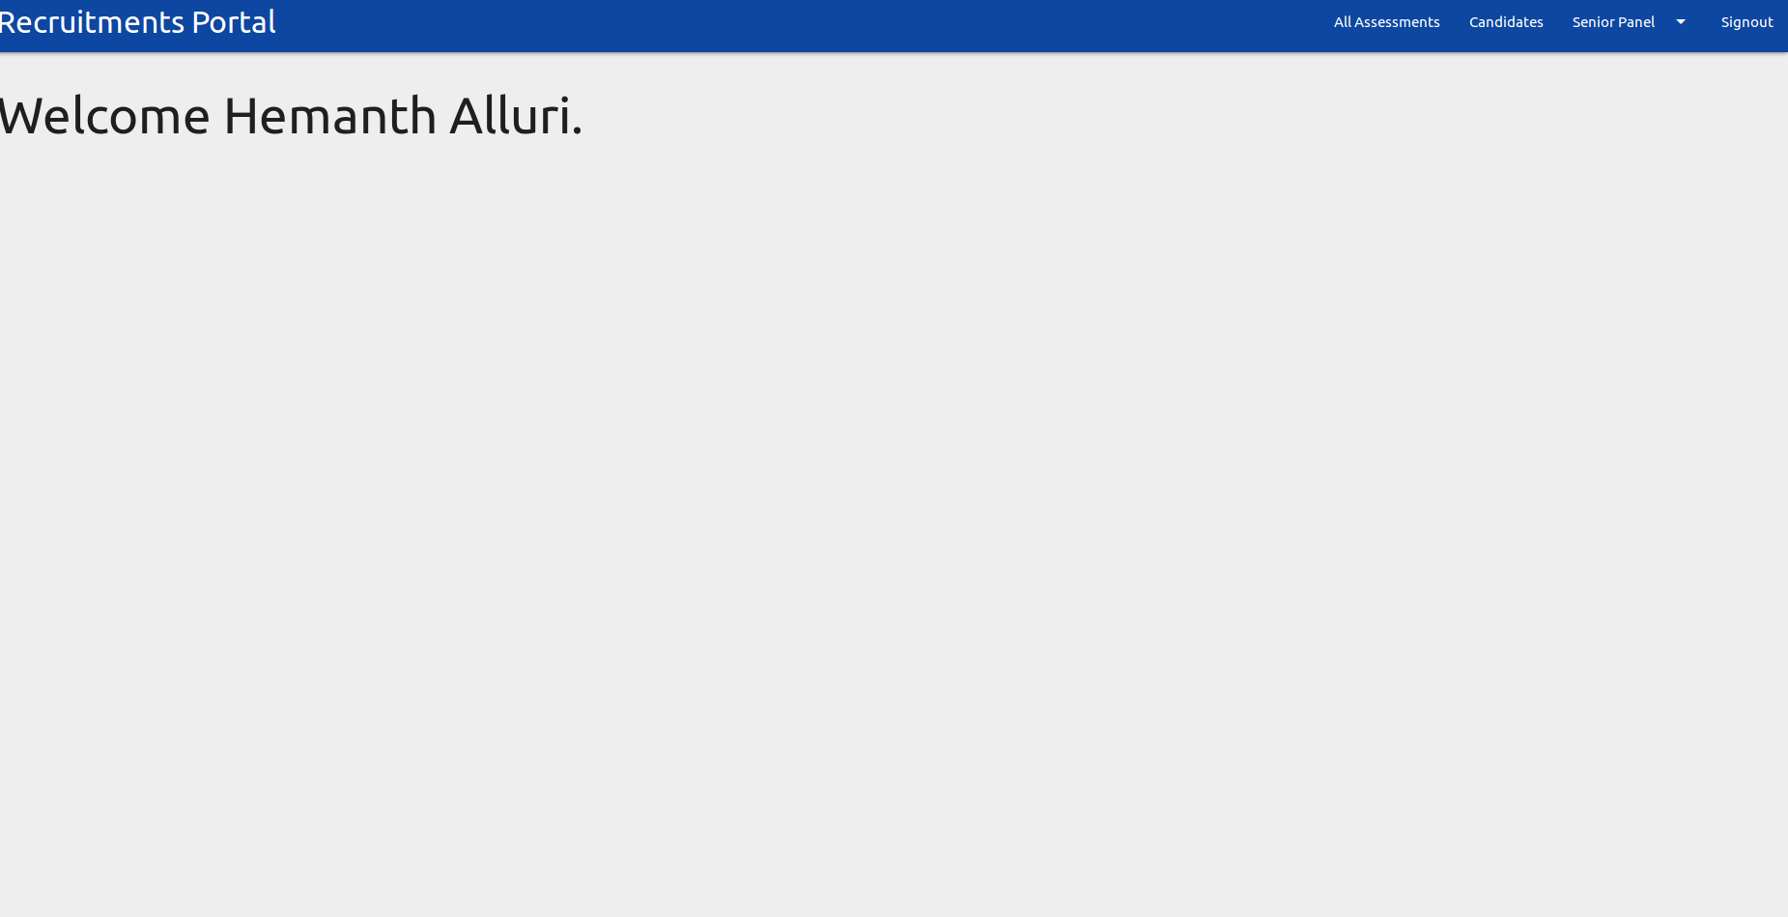
Home Page

2.) Creating, Viewing and Editing Candidates:
By clicking on Candidates in the menu bar, you can view a list of all of the current candidates in a tabular form. There are 6 main data values associated with any candidate of which only 3 are mandatory when adding are creating a new candidate.

Mandatory:
1. name (first and last)
2. phone number
3. email
Optional:
4. skill 1
5. skill 2
6. about

“Skill1” and “Skill2” refers to any particular skills that the DVM may be interested in. The “About” explains the human part of the candidate: their hobbies, where they are from, what their likes and dislikes are, and any other non-opinionated details about the candidate.

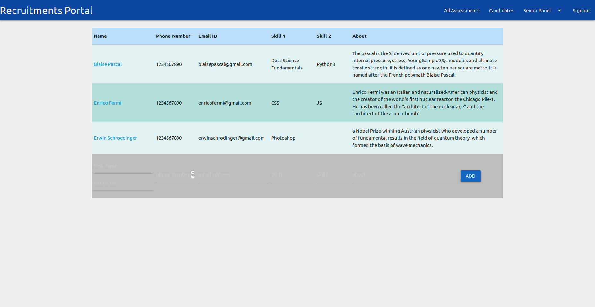
Candidates Page

to add a candidate, simply enter the details here in this grey bar below and hit add.

Now to view the candidate and to do basically anything else, click on the candidates name to go to the candidate's profile page. Here you're presented with a cleaner info sheet of that candidate at the top, and at the bottom you'll also find two tables about existing assessments on that candidate and the assigned tasks. The two can be associated by comparing the task ids.
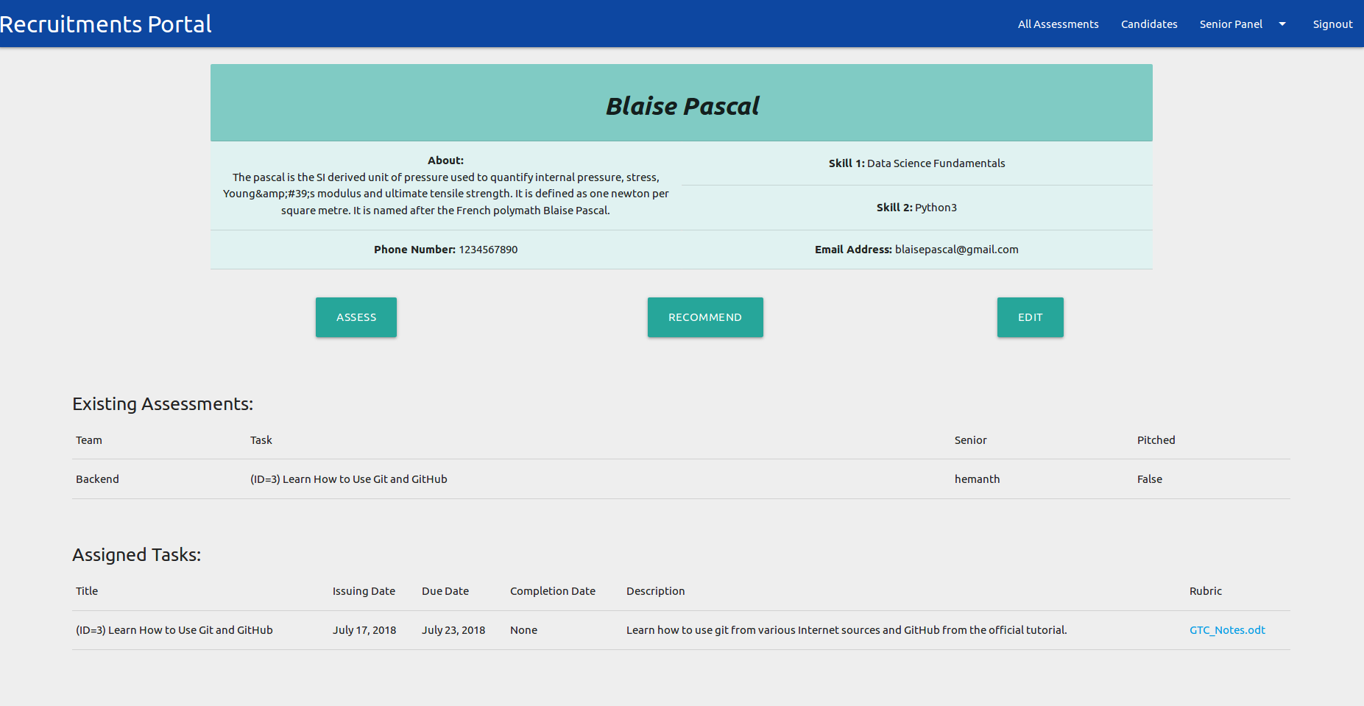
Matching IDs
Profile Page

From here you are presented with options to either assess, recommend or edit that candidate.

Let's look at how to edit first. You just press the edit button and then the info sheet turns into a form where you can make whatever changes you want and then update them. If you want to cancel your changes, just refresh the page.
Profile Page
(Edit Mode)
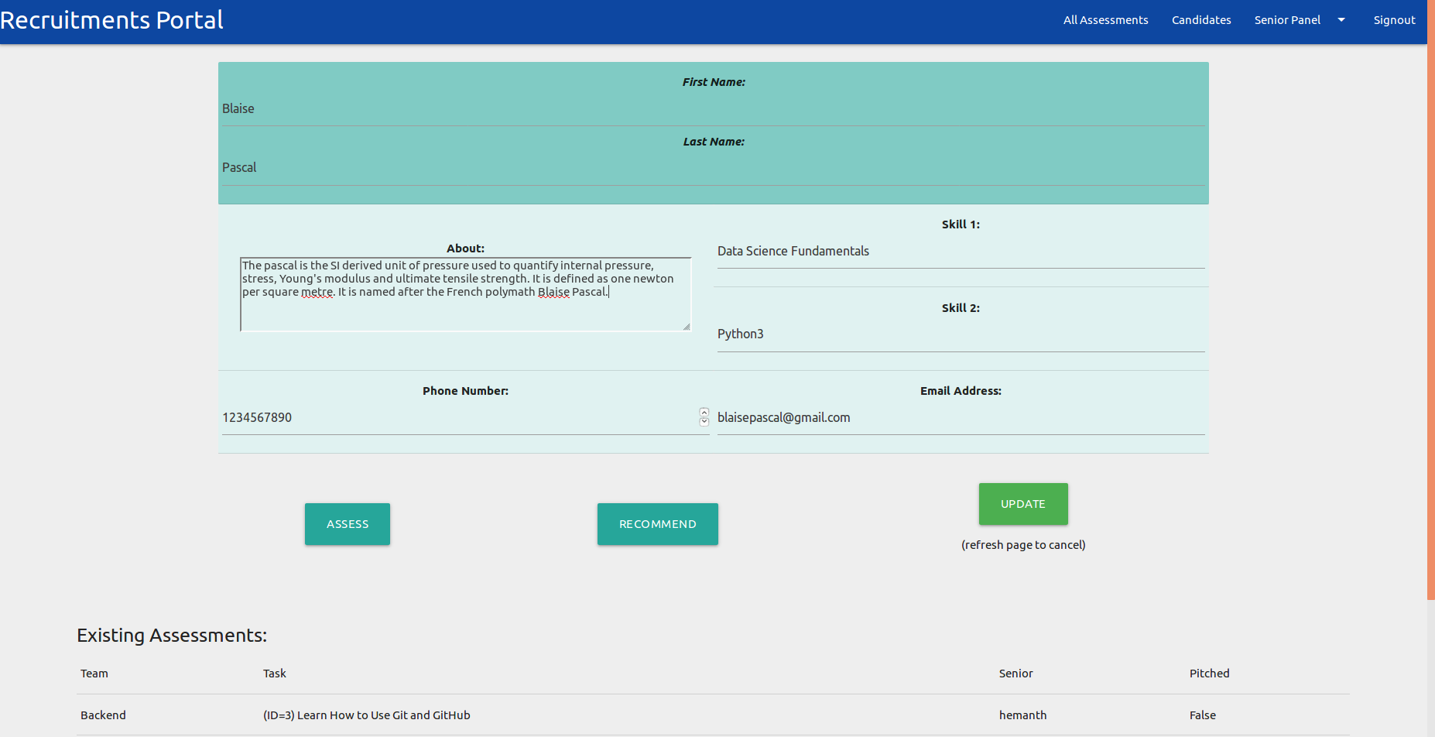

Next, let's look at how you can recommend any candidate and also accept or decline any recommendations you receive.

3.) Recommending Candidates:
To recommend a candidate, you have to go to their profile page and then hit recommend. From here you can either recommend the candidate to a whole team or to a particular induvisual.
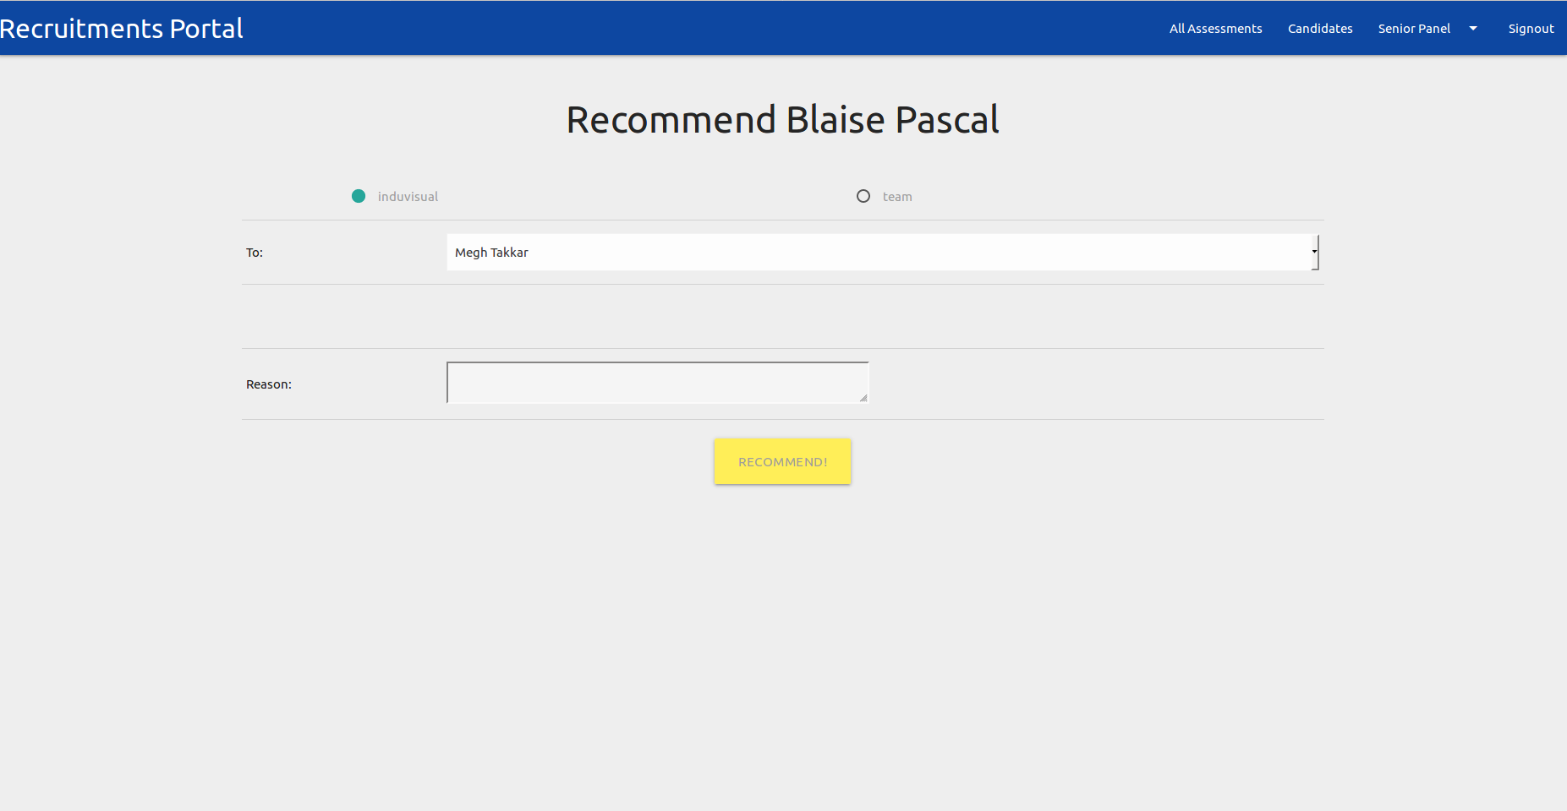
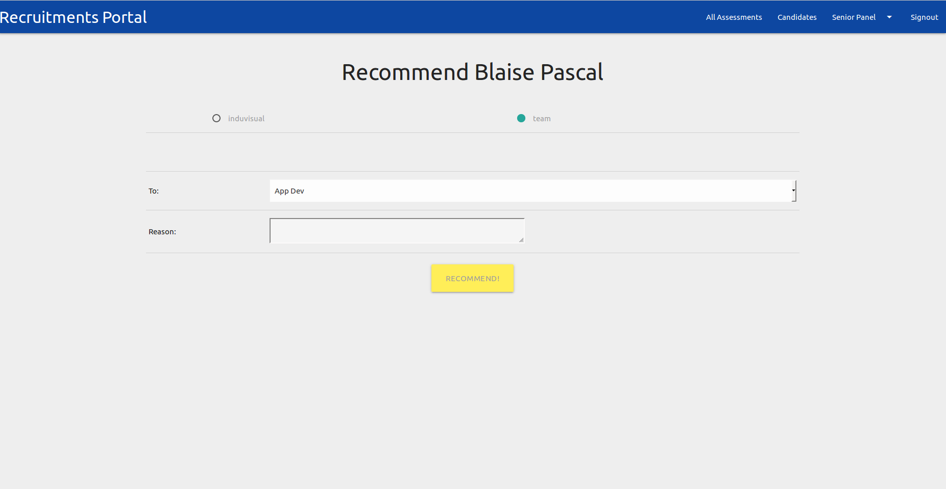

Recommend
(Induvisual Mode)
Recommend
(Team Mode)

I STRONGLY recommend against recommending a candidate to an entire team. To do so is spammy. Instead pick a person or two from that team who has a matching personality and tastes as the candidate you are recommending.

Make sure that you give a good reason for why the other person should review this candidate. Go ahead and make it as informal as you can since unlike assessments, this won't be visible to anyone else apart from you and the people you are recommending to.

4.) Accepting/Declining Recommendations:
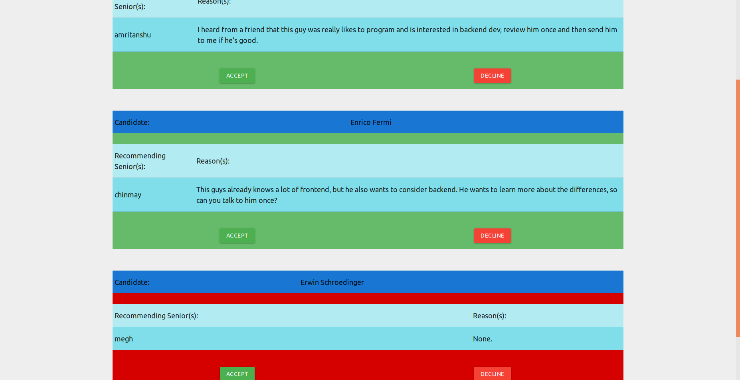
Accept and Decline Recommendations
To deal with your own recommedations from others, go to the my recommendations pannel from the Senior Pannel. The senior pannel contains pages that have data tailored to you.

Here you can simultaneously accept or decline multiple invitations. Note: you can recommend and receive recommendations from anyone, your senior, junior (2nd year and above) or batchie may send recommendations to you. There’s no descrimination involved.

Once you accept to review a candidate, they will be added to your My Candidates page (under Senior Pannel). This page will contain any candidate that you have either accepted to review or any candidate for which you made an assessment.

Now to look at the concept of assessments and tasks.

5.) Assessments:
To create an assessment for a candidate, you go to the candidate's profile page and hit assess. A quick note, you are allowed to assess any candidate only once. The reason is so that it encourages more people to interview a candidate thus preventing biasing and also promoting exposing the candidate to more of the DVM and vice versa. In fact this why the recommend feature exists. To select others that you want to have review the candidate.
Assessment
Panel
An assessment has two parts: the team that you are trying to assess them for, and a task.
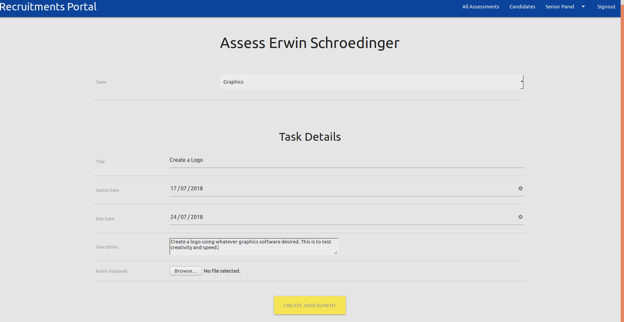

Broadly speaking, there are two types of tasks:

I. Casual Tasks are tasks without a due date. You issue theses by not specifying a due date. A question that could be asked here is when should you issue a casual task? Well, whenever you are convinced that a candidate is both skilled (for a newbie on campus anyhow) and determined to work for the DVM, you can issue a casual task.

II. The other type is a Regular Task with a due date.

When creating a task, make sure that you give a clear title and a good description.

If you want to be a really awesome and thorough senior, then you should also create a rubric for the task. a rubric clearly states the requirements of the task and how to proceed about finishing the task and presenting it. It doesn't need to be to big, but it should be clean and thorough. You share this rubric with the candidate and also upload it to the recportal.

Remember that the recportal is for us seniors only (2nd year and above), so share the rubric with the candidate seperately. Since we're all talented people here, you can upload your rubric as any type of file format, e.g. video team people can make an explanatory video, frontend can make a static document, etc. The point is you can do something cool if you want. But if you want to keep it simple, you can make it a .txt, .pdf, .odt, .xlsx, etc. type of file.

Once you create an assessment, you can update progress in that assessment from the My Assessments page in the senior panel. Here you can view all of the details of all of your assignments and update any one of them. One of the options in updating an assignment is pitching the candidate.
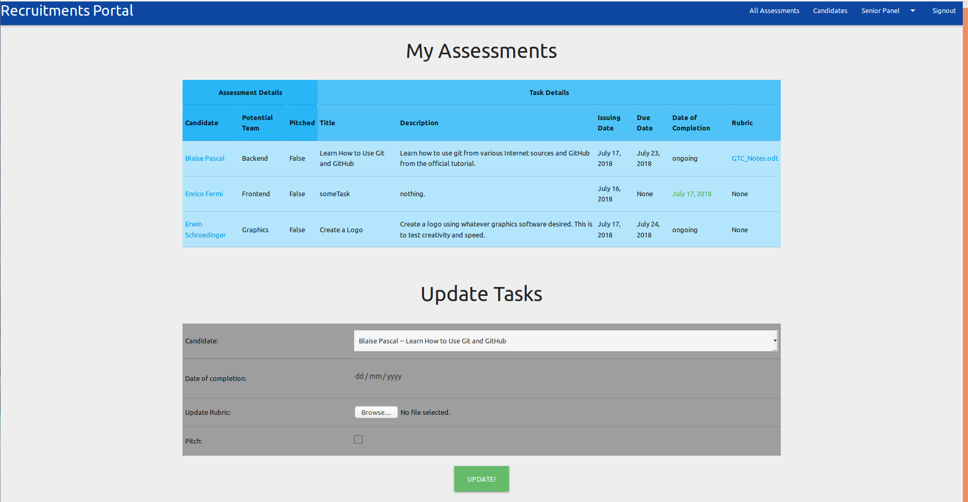

Finally, you can view all of the assignments from the All Assignments page. Red due dates mean that it’s overdue, green means that the task has been completed. You can also download or view the rubric for a particular task if you’re interested.

That’s All Folks

