Name : Nayan Vitesh Chavhan
Reg. No. : 25BAI10478

📄 PROJECT REPORT
Student Expense Tracker (Python GUI Application)

1. Introduction
Managing personal finances is an essential skill, especially for students who often have limited income and multiple expenses. Many students find it difficult to keep track of their daily spending, which leads to poor financial management.
This project, Student Expense Tracker, is developed to help students easily record, manage, and analyze their expenses using a simple and user-friendly interface.

2. Problem Statement
Students frequently face the following issues:
- Difficulty in tracking daily expenses
- Lack of awareness of spending habits
- Overspending due to poor budget management
- No simple tool for quick expense recording
These problems highlight the need for a lightweight and accessible solution.

3. Objectives
The main objectives of this project are:
- To develop a simple expense tracking system
- To help users record daily expenses efficiently
- To calculate total spending automatically
- To categorize expenses for better understanding

4. Proposed Solution
The solution is a Python-based GUI application built using Tkinter that allows users to:
- Add expense details (description, amount, category)
- View all recorded expenses
- Calculate total expenditure
- Store data permanently using a JSON file
This application is designed to be simple, fast, and easy to use.
5. Methodology
The development of this project followed these steps:
5.1 Requirement Analysis
Understanding the needs of students and identifying key features like expense entry, storage, and display.
5.2 Design
Designing a simple graphical interface using Tkinter.
5.3 Implementation
- Python is used as the programming language
- Tkinter is used for GUI development
- JSON file is used for data storage
5.4 Testing
The application was tested by:
- Adding multiple expenses
- Checking total calculations
- Restarting the app to verify data persistence

6. System Features
6.1 Add Expense
Users can input:
- Description
- Amount
- Category
6.2 View Expenses
All expenses are displayed in a list format.
6.3 Total Calculation
The application automatically calculates total expenses.
6.4 Data Storage
All data is saved in a JSON file, ensuring persistence.

7. Tools and Technologies Used
- Programming Language: Python
- GUI Library: Tkinter
- Data Storage: JSON file
- Platform: Windows

Flowchart and Diagram :
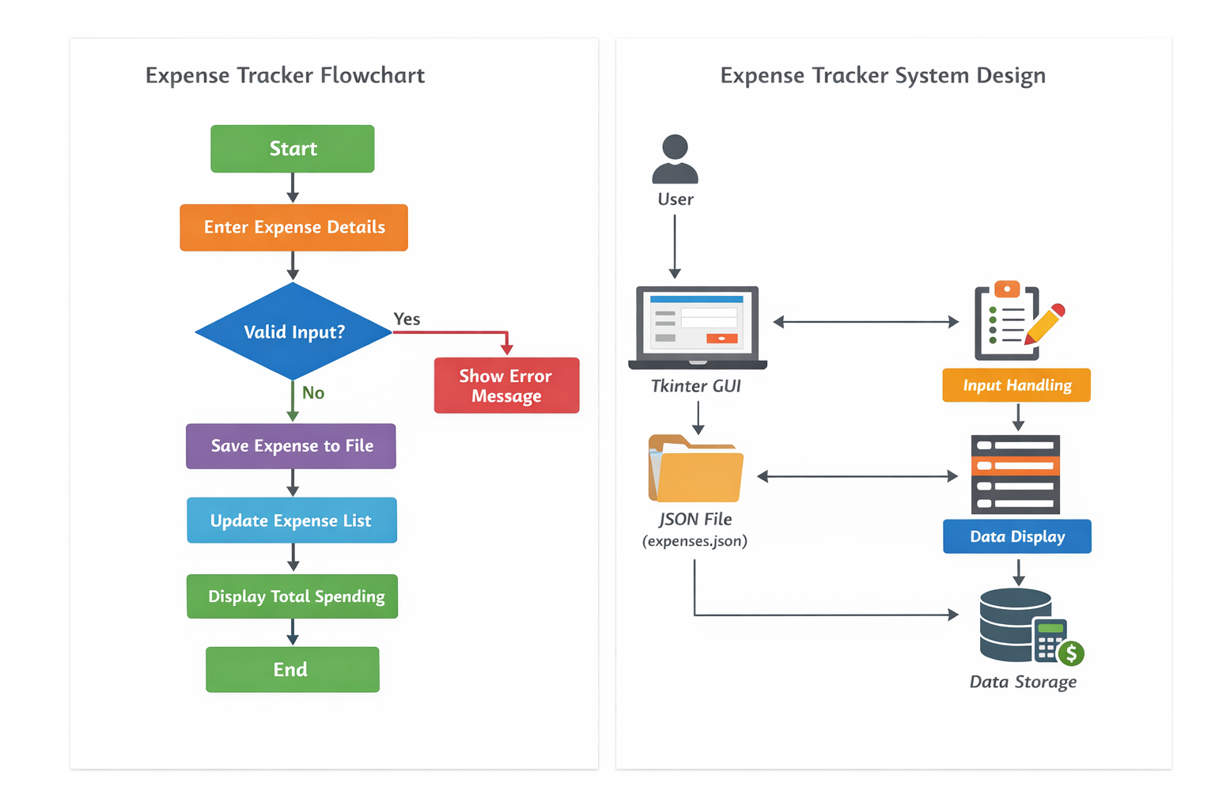

8. Challenges Faced
During development, the following challenges were encountered:
- Handling file storage and retrieval using JSON
- Updating the GUI dynamically after adding data
- Ensuring correct calculation of totals
These challenges were resolved through testing and debugging.

9. Results
The final application successfully:
- Stores user expenses
- Displays them clearly
- Calculates total spending accurately
The system is efficient and easy to use for students.

10. Learning Outcomes
Through this project, the following concepts were learned:
- Python GUI development using Tkinter
- File handling using JSON
- Event-driven programming
- Problem-solving and debugging

11. Conclusion
The Student Expense Tracker is a simple yet effective tool that helps students manage their finances. It solves a real-world problem and demonstrates practical application of programming concepts.

12. Future Enhancements
The project can be improved by adding:
- Edit and delete expense options
- Graphical charts for analysis
- Budget alerts
- Mobile or web version

