Name: Patel Nayankumar Tulsidas
Enrollment No. : 151060751020
Seat No. : M200876

Q-1.[practical 18] open a html file of GTU website and print the all the links available on this file.

Source Code:

#!/usr/bin/python3

import sys
import urllib.request
import re

def find_source(src):
mails = []
reg_ex = re.compile(r'[-a-z0-9._]+@([-a-z0-9]+)(\.[-a-z0-9]+)+',re.IGNORECASE)
for m in reg_ex.finditer(src):
print(m.group())

def main(args):
#url = "http://old.gtu.ac.in/Administration.asp"

#try:
# src = urllib.request.urlopen(url).read()
#except:
# print("URL can't Load")
# exit(420)
f = open("gtu_admin.html","r")
src = f.read()
find_source(str(src))

if __name__ == "__main__":
main(sys.argv[1:])

Output :

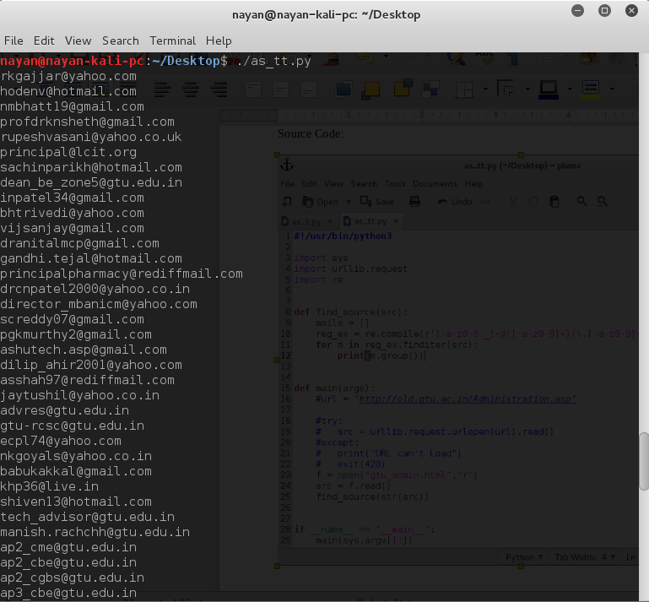

Q-2.[practical 24] Write a function named list_of_primes that accepts a positive integer n and returns a sorted list (ascending order) of all the prime numbers between 2 and n (including 2 but not including n)

Source Code:

#!/usr/bin/python3
import sys
def list_of_primes(args):
if len(args) != 2:
a = input("Enter Limit : ")
#print("Enter Argument... as -l limit")
#exit(4)
elif args[0] == '-l':
pass
else:
print("Enter Argument.. as -l limit")
exit(2)
try:
a = args[1]
except:
pass
if a== '':
print("Invalid Argument...")
exit(5)
elif a.isdigit():
a = int(a)
elif a[0] == '-' and a[1:].isdigit():
print("Negative Number Not Allowed")
else:
print("Invalid Argument")
exit(4)

primes = []
for n in range(2,a):
prime = True
for p in range(2,n):
if n%p == 0:
prime = False
if prime:
primes.append(n)
print(primes)
def main():
print("a sorted list (ascending order) of all the prime numbers between 2 and n (including 2 but not including n) ")
print(list_of_primes(sys.argv[1:]))
if __name__ == "__main__":
main()

Output:

