ABSTRACT

Fuchsia OS is a next-generation, open-source operating system developed by Google to address the limitations of existing operating systems like Android and Chrome OS. Built from the ground up using the Zircon microkernel, Fuchsia is designed to support a wide range of devices—from smartphones and tablets to embedded systems and IoT devices—with a focus on performance, scalability, security, and upgradability. Unlike Android, which is based on the Linux kernel, Fuchsia leverages a modular architecture that separates hardware drivers and system components, enabling more efficient system updates and enhanced security. The OS supports modern application development with Flutter for UI rendering, making cross-platform development seamless. Fuchsia also aims to offer a more controlled and consistent user experience, improved memory management, and real-time task execution. With its forward-looking design and multi-device adaptability, Fuchsia represents a significant evolution in operating system development, potentially serving as the unified platform for future Google-powered ecosystems.

CONTENTS

SL NO. | TITLE | PAGE NO
1 | INTRODUCTION | 5
2 | HISTORICAL BACKGROUND | 6
3 | SYSTEM ARCHITECTURE | 7-8
4 | THE FUCHSIA SYSTEM ARCHITECTURE | 9-10
5 | SOFTWARE ARCHITECTURE OF FUCHSIA | 11-12
6 | ZIRCON ARCHITECTURE | 13-15
7 | FRAMEWORK AND FIDL | 16-18
8 | FUTURE SCOPE | 19-21
9 | CONCLUSION | 22
10 | REFERENCES | 23

Chapter-1

INTRODUCTION

SUPPLY CHAIN TRANSPARENCY
Software Supply chain transparency refers to the extent to which all stakeholders—including suppliers, manufacturers, distributors, and consumers—have visibility into the sourcing, movement, and production processes of goods and services. As global supply chains become more complex, transparency has become critical in ensuring ethical practices, regulatory compliance, risk mitigation, and consumer trust Fig:1.1 represents the Basics process Supply Chain Transparency.
A transparent supply chain provides clear information about the origin of raw materials, labor conditions, environmental impact, and transportation routes. This visibility helps businesses identify potential risks, such as human rights violations, environmental degradation, or supplier fraud. For consumers, it fosters confidence in a brand’s values and sustainability practices.
Supply chain transparency is not only a strategic advantage but a moral imperative in today’s market. It promotes accountability, enhances efficiency, and supports sustainable development goals. Companies investing in transparent supply chains are better positioned to respond to disruptions and align with ethical consumer demands.
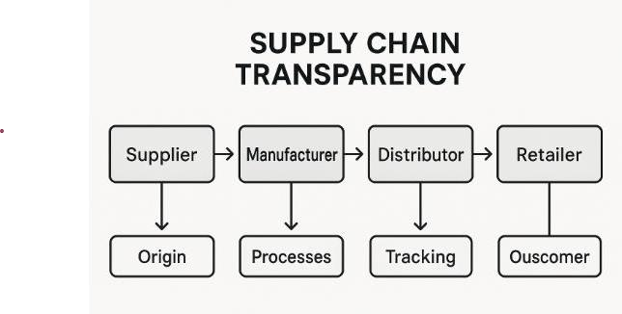
Fig:1.1 Basics process of Supply Chain Transparency

Chapter-2

GOALS

The primary goal of Supply Chain Transparency is to design and structure software systems in a way that ensures they are scalable, maintainable, and efficient.
Research on the following topics is conducted:

- End-to-End Traceability,

- Data Integrity and Trust
- Enhanced Accountability,
- Efficiency and Automation,
- Consumers Awareness
- Sustainability Tracking
- Inputs
- Output

Chapter-3

SOME APPLICATIONS OF SUPPLY CHAIN TRANSPARENCY

Food Safety & Traceability:

- Immutable Records:
Every step—from farm to fork—is recorded on a blockchain ledger that cannot be altered, ensuring data authenticity.
- Real-Time Tracking:
IoT sensors and QR codes feed real-time temperature, location, and storage data into the blockchain.
- Instant Recall Identification:
In case of contamination (e.g., Salmonella in eggs), blockchain helps quickly identify the source and affected batch—reducing waste and harm.
- Consumer Confidence:
Customers can scan a QR code to view a product’s journey, from harvesting to packaging to shipping—proving ethical and safe handling.
- Regulatory Compliance:
Regulators and inspectors get direct access to unchangeable records, simplifying audits checks.

Pharmaceutical Supply Chain (Anti-Counterfeit):
- Manufacturer
  - Produces original drugs
  - Applies serialization (unique barcode/QR code) on packaging
  - Logs product info in blockchain/database
- Wholesaler / Distributor
  - Scans and verifies product authenticity
  - Updates tracking information (location, date)
  - Ensures cold chain compliance, if applicable
- Pharmacy / Retailer
  - Verifies serialization against database

  - Reports suspicious packages

- Regulatory Authorities
  - Audit supply chain records
  - Take action on counterfeit reports
  - Enforce compliance with DSCSA / EU FMD (drug traceability regulations)

Sustainability and Ethical Sourcing

- Fashion Industry
  - Brands like Patagonia and Levi’s use blockchain to trace organic cotton or recycled fibers.
  - Ensures garments are made without child labor and with sustainable water usage.
- Electronics
- Companies like Apple and Fairphone trace conflict minerals (e.g., cobalt, lithium) used in batteries to ensure they aren't sourced from unethical mines.
- Encourages responsible mining practices and recycling.
- Food and Beverage
  - Coffee and chocolate companies trace beans back to certified Fair Trade farms.
  - Ensures farmers are paid fairly and avoid exploitative labor.
- Furniture and Wood Products
- Uses FSC (Forest Stewardship Council) certification to ensure timber is sourced from responsibly managed forests.

Chapter-4
Inventory and Logistics Optimization

The concept of supply chain transparency achieved through the integration of blockchain technology. It depicts the traditional flow of goods from the supplier, through the manufacturer, distributor, and retailer, ultimately reaching the consumer. The dotted lines and blockchain icons indicate how blockchain provides a transparent and traceable record of each step in this process, enhancing visibility and accountability across the entire supply chain, from the initial supplier to the final consumer Fig:4.1 represent the supply chain transparency using blockchain.
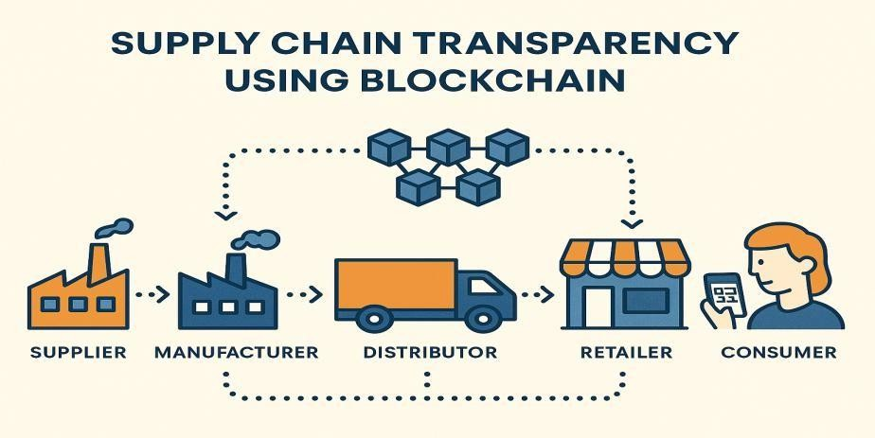
Fig: 4 . 1 Supply Chain Transparency using Blockchain

- Real-Time Inventory Tracking
  - How: IoT devices and RFID sensors update blockchain with stock levels in real time.
  - Benefit: Prevents overstocking and understocking by providing accurate, decentralized inventory data.
- Demand Forecasting and Planning
  - How: Blockchain stores historical sales, returns, and seasonal demand data transparently.
  - Benefit: Helps AI/ML algorithms make accurate predictions without data manipulation.
- Automated Replenishment with Smart Contracts
  - How: Smart contracts trigger orders when inventory drops below a threshold.
  - Benefit: Reduces human error and speeds up procurement cycles.

Chapter-5
SYSTEM DESIGN

System design is the process of architecting large-scale systems to ensure they are scalable, reliable, and efficient. It involves making decisions on databases, APIs, caching, load balancing, and more the Fig:5.1 represent the flow diagram of system design
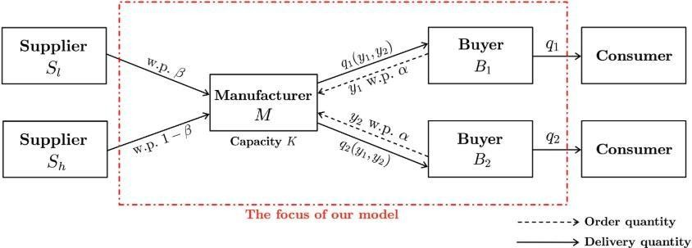
Fig:5.1 Represent Flow diagram of system design

- Raw Material Input
  - Supplier logs material on blockchain with origin and certification.
  - IoT sensors verify environmental conditions (e.g., temperature).
- Manufacturing
  - Manufacturer receives materials.
  - Product IDs are created and registered.
  - Smart contracts validate quality compliance.
- Distribution
  - Logistics partner scans and updates movement at checkpoints.
  - GPS & environmental sensors feed real-time data (stored on-chain/off-chain).
- Retail
  - Retailers receive products.
  - Blockchain records sale readiness and shelf status.
- Regulation
  - Authorities access audit logs for compliance and certification.

Chapter-6

DIFFERENT TYPES OF SUPPLY CHAIN TRANSPARENCY

Blockchain Ledger System

The A Blockchain Ledger System is a decentralized digital record-keeping system that logs transactions across a network of computers. In supply chains, it ensures that all transactions and product movements are transparent, tamper-proof, and accessible in real time to all authorized parties Fig:6:1 the diagram represent blockchain ledger system.
The only accounts that will show up in the ledger. Businesses have an expansive list of accounts, so you will need to make as many as required to track all transactions. For example, the asset accounts could contain cash in hand, cash in the bank, accounts receivable, prepaid expenses, real estate, machinery, and inventory.
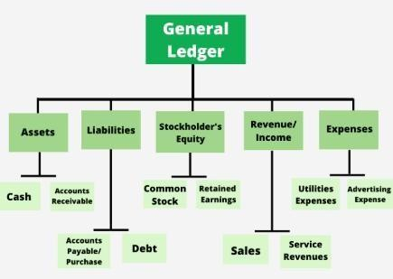
Fig 6.1: Represent the General Ledger structure
Accounting ledgers are an essential part of small business' bookkeeping practices. As a small business owner, you need to be aware of all the transactions your business has completed in an accounting period. That’s where the ledger comes into play.

Financial statements like the income statement, balance sheet, and statement of cash flows show the financial health of a business. Business owners can generate all three statements using the accounting cycle, which includes the general ledger.

Smart Contracts
.The A Smart Contract is a self-executing program stored on a blockchain that runs when predefined conditions are met. In supply chains, smart contracts automate and enforce business rules between untrusted parties without intermediaries.
A Smart Contract (or cryptocontract) is a computer program m that directly and automatically controls the transfer of digital assets between the parties under certain conditions. A smart contract works in the same way as a traditional contract while also automatically enforcing the contract. Smart contracts are programs that execute exactly as they are set up(coded, programmed) by their creators. Just like a traditional contract is enforceable by law, smart contracts are enforceable by code
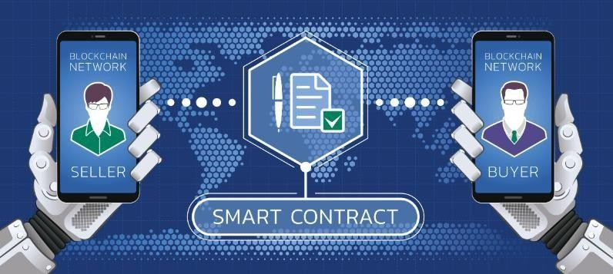

Fig:6.2 The process of a Smart Contract on a Blockchain Network

The Fig:6.2 illustrates the process of a Smart Contract on a Blockchain Network facilitating a transaction between a Seller and a Buyer. Financial statements like the income statement, balance sheet, and statement of cash flows show the financial health of a business. Business owners can generate all three statements using the accounting cycle, which includes the general ledger.

Seller and Buyer:
The top and bottom sections of the image show a "Seller" and a "Buyer," each interacting with a "Blockchain Network" via a mobile device. This represents the two parties involved in a transaction.

Blockchain Network:
Both the seller and buyer are connected to a "Blockchain Network," indicating that the transaction takes place on a decentralized, distributed ledger system.

Smart Contract:
The central element is the "Smart Contract," depicted as a document icon with a checkmark, symbolizing an agreement or code that automatically executes when predefined conditions are met. This contract acts as an intermediary, ensuring the terms of the agreement are fulfilled without the need for a third party.

Digital Twin Technology (Blockchain-Backed):

A Digital Twin of any device/system is a working model of all components integrated and mapped together using physical data, virtual data, and interaction data between them to make a fully functional replica of the device/system and that too on a digital medium Fig:6:3 the process of a Smart Contract on a Blockchain. Network

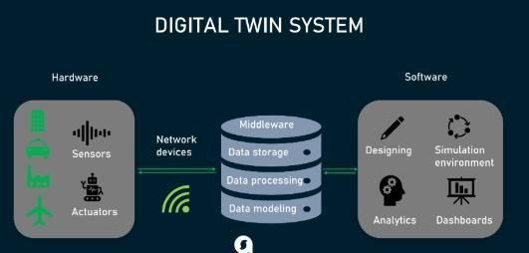
Fig:6.3 the process of a Smart Contract on a Blockchain Network

- Asset Creation
A physical asset is created (e.g., a batch of goods or a vehicle component). A digital twin is registered on blockchain.
- Sensor Data Feed
IoT devices continuously send data such as location, temperature, and usage.
- Blockchain Recording
The data is written to the blockchain as an immutable, timestamped log.
- Smart Contract Execution
If conditions (like overheating) are met, contracts trigger alerts or actions.
- Digital Twin Updates
The virtual model reflects real-time changes, accessible to all stakeholders.

Provenance and Traceability Platforms

  - This Provenance refers to the origin and journey of a product, including every process it undergoes.
  - Traceability is the ability to track and verify this journey in real-time, across all supply chain stages.
  - Blockchain-based platforms allow tamper-proof, end-to-end visibility of products, making it possible to:
  - Authenticate product origins,
  - Monitor movement and conditions,
  - Prevent fraud and counterfeits,
  - Support recalls and compliance.

Blockchain-Based Document Management Systems

A Blockchain-Based Document Management System (DMS) securely stores, shares, and verifies supply chain documents (e.g., invoices, certificates, bills) on a decentralized ledger. . Blockchain technology provides a common shared platform from where to store, retrieve and access documents.

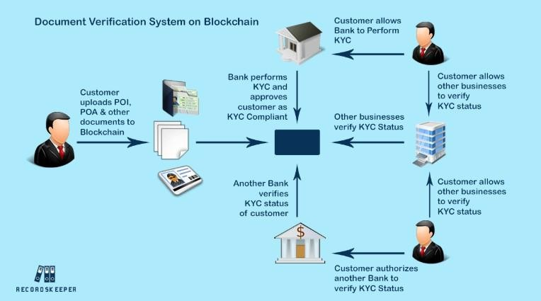

Fig:6.4 The process of a Smart Contract on a Blockchain Network

The key issues in document verification for banks and other businesses are in storage, retrieval and access to data. Hence came blockchain technology to solve these problems in storing and accessing of data. Blockchain technology provides a common shared platform from where to store, retrieve and access documents. The very nature of the technology is in the distributed, shared, open ledgers, by all. Fig:6:4 the process of a Smart Contract on a Blockchain Network
- Digital Signature: It is digitally signed and uploaded to the blockchain.

- Hashing: Only a hash (digital fingerprint) is stored on-chain; the actual document can be stored off-chain (e.g., IPFS or cloud).
- Verification: Any party can check if a document is authentic and unchanged by matching the current hash with the one on the blockchain.
- Smart Contracts: Automatically approve or reject actions (like customs clearance or payments) based on document validity.

Chapter-7

Implementation Code For Supply Chain Transparency

import hashlib import time import json
from random import randint, uniform

# Simulated physical device: MRI Scanner def get_sensor_data():
return {
'RPM': randint(1000, 3000),
'temperature': round(uniform(30.0, 80.0), 2),
'status': 'OK' if uniform(30.0, 80.0) < 65 else 'ALERT', 'timestamp': time.time()
}

# Blockchain block structure class Block:
def init (self, index, data, prev_hash): self.index = index
self.timestamp = time.time() self.data = data self.prev_hash = prev_hash
self.hash = self.compute_hash()

def compute_hash(self):
block_string = json.dumps(self. dict , sort_keys=True)

return hashlib.sha256(block_string.encode()).hexdigest() # Blockchain Ledger

class Blockchain: def init (self):
self.chain = [self.create_genesis_block()]

def create_genesis_block(self):
return Block(0, {'msg': 'Genesis Block'}, '0')

def add_block(self, data): last_block = self.chain[-1]
new_block = Block(index=len(self.chain), data=data, prev_hash=last_block.hash) self.chain.append(new_block)

def print_chain(self):
for block in self.chain:
print(f"\nBlock {block.index} @ {time.ctime(block.timestamp)}") print(f"Data: {block.data}")
print(f"Hash: {block.hash[:20]}...")
print(f"Prev: {block.prev_hash[:20]}...")

# Run simulation
if name == " main ": twin_chain = Blockchain()
for i in range(5): # simulate 5 reading cycles sensor_reading = get_sensor_data() twin_chain.add_block(sensor_reading) time.sleep(2)
twin_chain.print_chain()

OUTPUT

Block 1 @ Tue Jul 8 15:27:12 2025
Data: {'RPM': 2156, 'temperature': 62.83, 'status': 'OK', 'timestamp': 1720429632.85} Hash: 12f5c3ab879281bb72f0...
Prev: 981daddd7e1c3a9132a1...

Block 2 @ Tue Jul 8 15:27:14 2025
Data: {'RPM': 1987, 'temperature': 72.40, 'status': 'ALERT', ...} Hash: b81cbe37bb717...
Prev: 12f5c3ab879281...

OUTPUT EXPLANATION

Block 1 @ Tue Jul 8 15:27:12 2025

Component | Description
RPM: 2156 | The simulated rotation speed of the MRI's  mechanical subsystem (e.g., cryo-cooler or motorized gantry).
Temperature:  62.83°C | Represents the internal or coolant temperature. It's  getting warm but still within operational thresholds.
Status: “OK” | Logic-driven condition showing that temperature <  65°C, so no alert is triggered.
Timestamp:  1720429632.85 | UNIX time used for cryptographic accuracy.
Hash:  12f5c3ab... | Unique SHA-256 hash of the block—ensures data  integrity.
Prev Hash:  981daddd... | References the previous block’s hash (likely the  Genesis Block).

Block 2 @ Tue Jul 8 15:27:14 2025

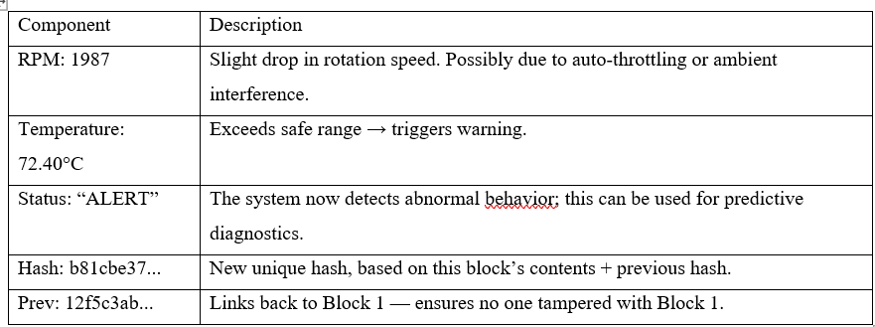

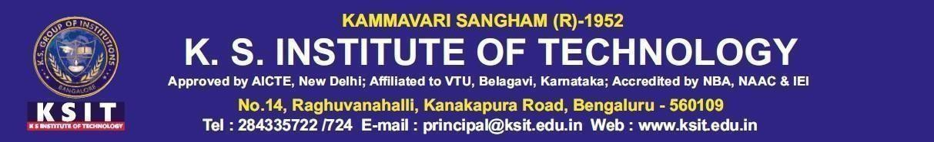

DEPARTMENT OF COMPUTER SCIENCE AND ENGINEERING
BLOCKCHAIN TECHNOLOGY (MSCS214A)

TOPIC: SUPPLY CHAIN TRANSPARENCY
PRESENTED BY: GUIDED BY:
BHOOMIKA N : 1KS24SCS01 DR. SUNITA CHALAGERI

RAGHAVI C S : 1KS24SCS05 ASSOCIATE PROFESSOR,

K.S INSTITUTE OF TECHNOLOGY KANAKAPURA ROAD, BANGALORE
INTRODUCTION

Supply chain transparency refers to the ability of all stakeholders — including suppliers, manufacturers, distributors, retailers, regulators, and consumers —to access accurate, real-time information about the origin, movement, and condition of goods and materials throughout the supply chain loping fig:1

Fig:1 High-level structure of a Software Engineering

GOALS OF SUPPLY CHAIN TRANSPARENCY

- Enhance Product Traceability
- Build Consumer Trust
- Prevent Fraud and Counterfeiting
- Improve Data Accuracy and Sharing
- Enable Faster Recall Management
- Ensure Regulatory Compliance
- Promote Ethical and Sustainable Sourcing.
- Reduce Operational Risks and Costs
- Optimize Inventory and Logistics

APPLICATION OF SUPPLY CHAIN TRANSPARENCY
- Product Provenance Tracking
- Real-Time Inventory Visibility
- End-to-End Supply Chain Monitoring
- Anti-Counterfeit & Authenticity Verification
- Cold Chain Compliance
- Regulatory Compliance & Auditing

OUTCOMES OF SUPPLY CHAIN TRANSPARENCY

  - Efficient & Scalable Systems
  - Modular & Reusable Code
  - Improved Maintainability & Flexibility
  - Faster Development & Deployment

ADVANTAGES OF SOFTWARE ARCHITECTURE

    - Improves Code Reusability
    - Enhances Maintainability
    - Promotes Scalability
    - Encourages Best Practices
    - Reduces Development Time
    - Increases Code Readability
    - Facilitates Code Flexibility
    - Enhances System Performance
    - Error Handling and Recovery
    - Simplifies Complex Problems

DISADVANTAGES OF SOFTWARE ARCHITECTURE

    - Increased Complexity
    - Overhead in Learning
    - Not a One-Size-Fits-All
    - Unnecessary Code and
    - Performance
    - Misuse and Overuse
    - Harder Debugging

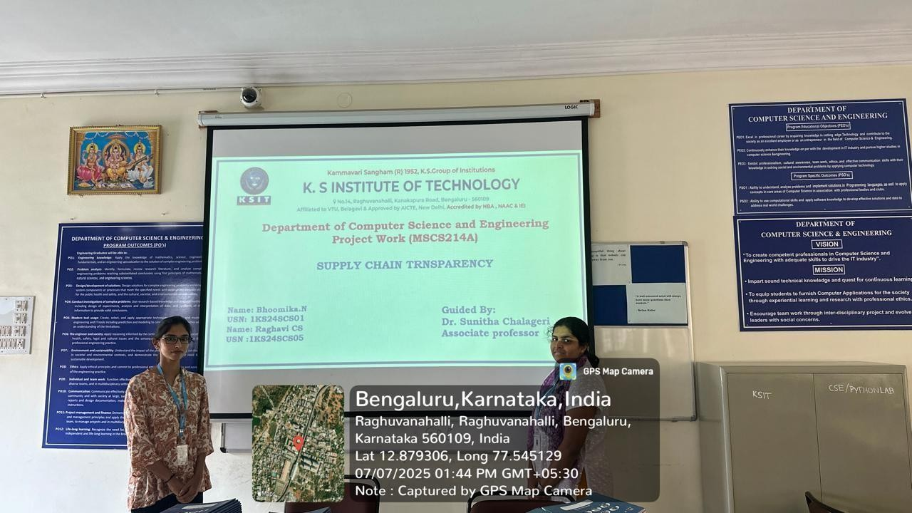

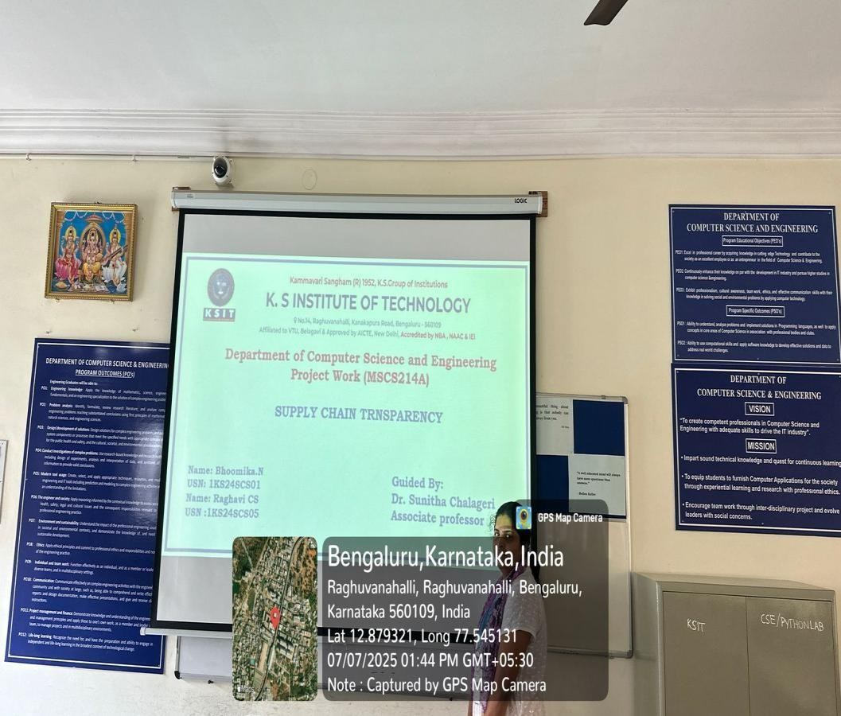

CONCLUSION

The Supply chain transparency has become a critical pillar for building trust, ensuring quality, and enhancing operational efficiency in modern global trade. By enabling real-time visibility, traceability, and data integrity, transparent supply chains empower stakeholders—from raw material suppliers to end consumers—to make informed, ethical, and accountable decisions. The integration of advanced technologies like Blockchain, IoT, Digital Twins, and Smart Contracts has revolutionized how transparency is implemented. Among these, blockchain stands out by providing a decentralized, tamper-proof ledger that ensures every transaction and event is recorded immutably. It eliminates information asymmetry, reduces fraud, and promotes compliance with environmental and regulatory standards experiences.

COMPREHENDED

Supply chain transparency refers to the ability of an organization to track and share information about every step of its product journey — from raw materials to end customers. This includes knowing where, when, how, and by whom each component was sourced, processed, shipped, and delivered. In today’s global and complex supply chains, transparency helps businesses ensure that their products are ethically sourced, safely handled, and traceable at every Transparency is no longer just a compliance requirement — it's a strategic necessity. Consumers today demand accountability. They want to know if the food they eat is safe, if the clothes they wear are ethically made, and if the electronics they use come from conflict-free zones. For businesses, this visibility improves brand trust, regulatory compliance, risk management, and resilience. It also helps quickly identify and respond to disruptions such as counterfeit goods, delays, recalls, or unethical labor practices.

REFERENCES

[1]. https://www.ibm.com/downloads/cas/PLNQERJX
[2]. https://www.weforum.org/reports/blockchain-deployment-toolkit [3].https://www2.deloitte.com/insights/us/en/focus/industry-4-0/blockchain-supplychain.html [4]. [https://www.ibm.com/blockchain/solutions/food-trust) [5].https://www.hyperledger.org/use/fabric)

