PIPE AND REDIRECTION OPERATION

- 1. Create a script named "myscript" in current directory to do the following.
A. commands - vi myscript.sh
a) create a dir named "subd1" in current directory: in vi editor.. 1. mkdir subd 1
b) create a file named "dircontent" with contents of the current directory : Is>dircon
c) display the contents of the file "dircontent": cat dircontent
d) display the contents of a non existing file named "unknownfile": cat unknown file

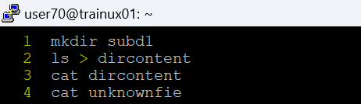
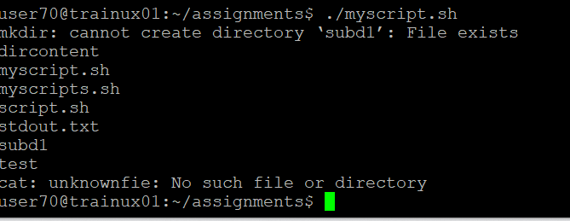
- Run the script and validate the output in following cases
- Redirect only the stdout to an o/p file named stdout.txt
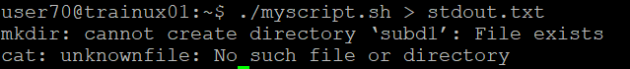

- Redirect only the stderr to an o/p file named stderr.txt

- Redirect both stdout and stderr to an o/p file named stdall.txt
- Display all o/p and error and also redirect both stdout and stderr to an o/p file named stdall.txt
Cat stdall.txt

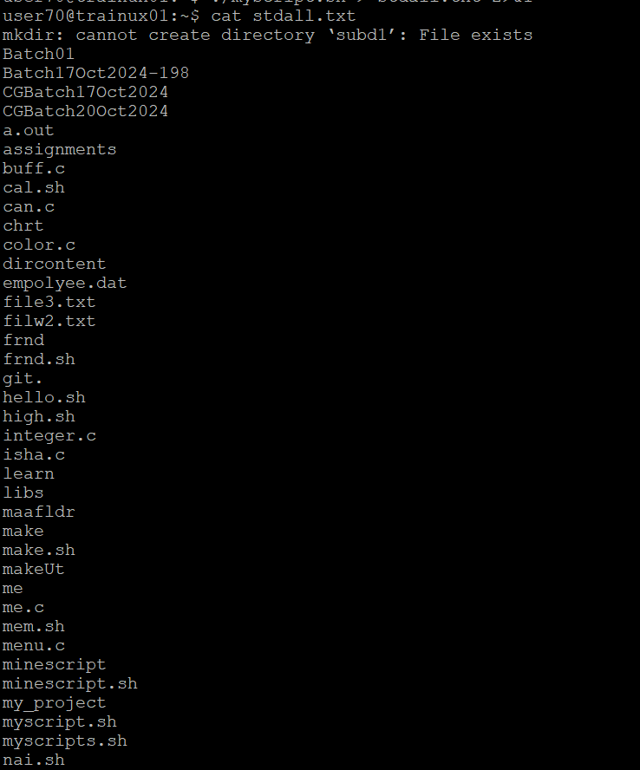

- Redirect the output of command below using pipe (|) to wc and get the output .
ls -l
