C tags

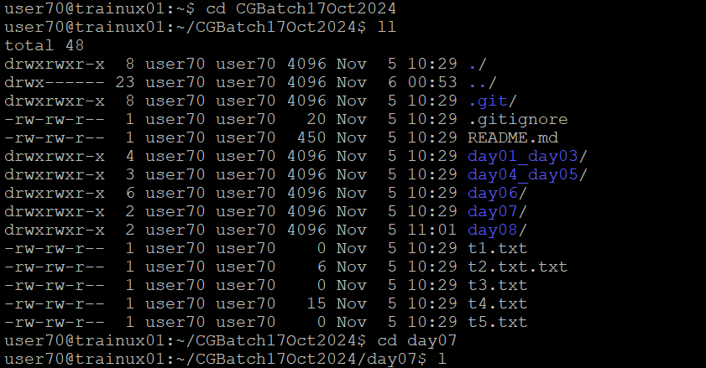

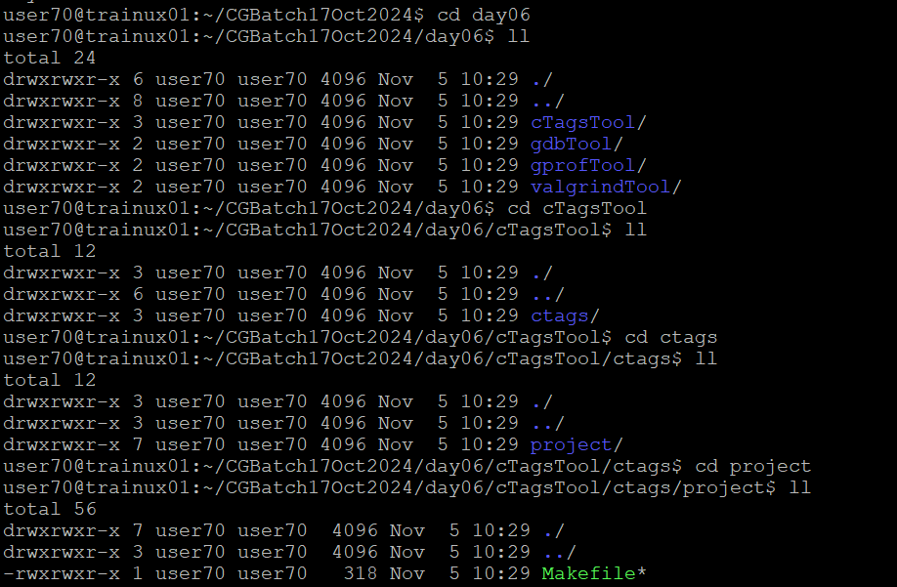

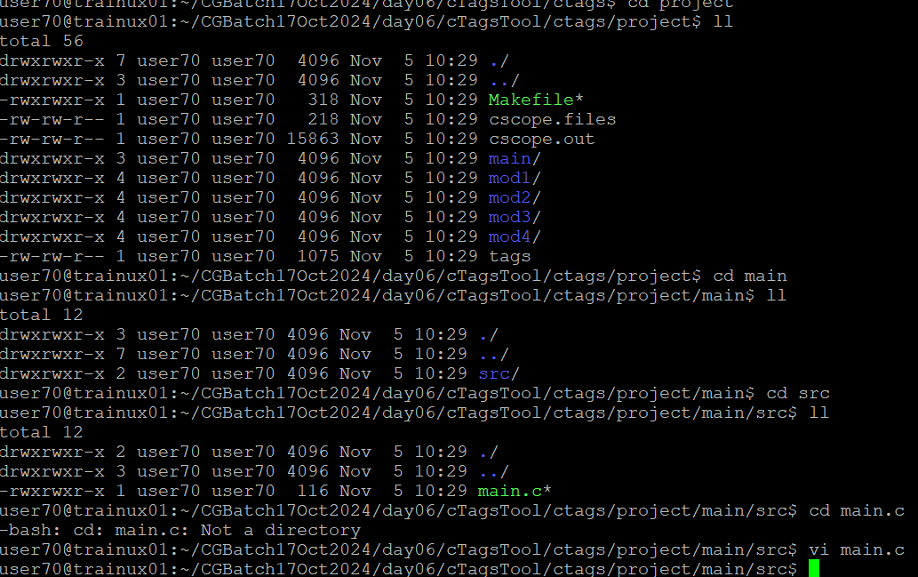

Bring the cursor to the function call of "mod1_func", and press Ctrl-]. Will notice vi opens the file where mod1_func is defined.

Now position the cursor on mod2_func call. Press Ctrl-]. Reach the definition of mod2 func.

Function call stack as of now: main() -> mod1_func() -> mod2_func().

Press Ctrl-t. You will return backwards to the calling place i.e. reach mod1_func()

Function call stack as of now: main() -> mod1_func()

Press Ctrl-t. Will return backwards to the calling place i,e. reach main()

Function call stack as of now: main()

There are many more commands and shortcuts in vi using ctags. e.g. you can give vi command its mod4 func Above command will jump to mod4_func() definition.

