Appendix -A
Loading and Converting the DSADS Dataset
import os
import numpy as np

base_path = "data"

X = []
y = []

for activity_folder in sorted(os.listdir(base_path)):
activity_path = os.path.join(base_path, activity_folder)
if not os.path.isdir(activity_path):
continue

label = int(activity_folder[1:]) # a01 → 1

for participant_folder in sorted(os.listdir(activity_path)):
participant_path = os.path.join(activity_path, participant_folder)

for file in sorted(os.listdir(participant_path)):
file_path = os.path.join(participant_path, file)

# FIXED: Files use comma-separated data
data = np.loadtxt(file_path, delimiter=",")

# Flatten 125×45 → 5625 vector
X.append(data.reshape(-1))
y.append(label)

X = np.array(X, dtype=np.float64)
y = np.array(y, dtype=np.int32)

print("Shape of X:", X.shape)
print("Shape of y:", y.shape)

OUTPUT:
runfile('/Users/nayana/untitled9.py', wdir='/Users/nayana')
Shape of X: (9120, 5625)
Shape of y: (9120,)
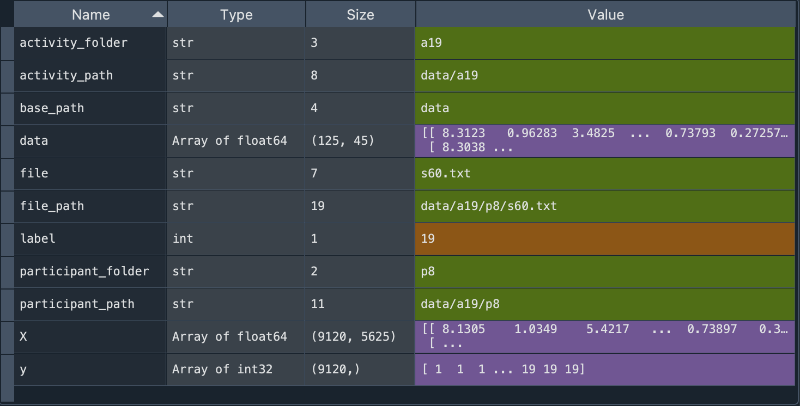
Appendix -B

# APPENDIX B — Standardisation (Normalisation)
# Z-score standardisation is applied so all features contribute equally.

from sklearn.preprocessing import StandardScaler

scaler = StandardScaler()
X_scaled = scaler.fit_transform(X)

print("Standardisation complete.")
print("Scaled shape:", X_scaled.shape)
OUTPUT :
Standardisation complete.
Scaled shape: (9120, 5625)
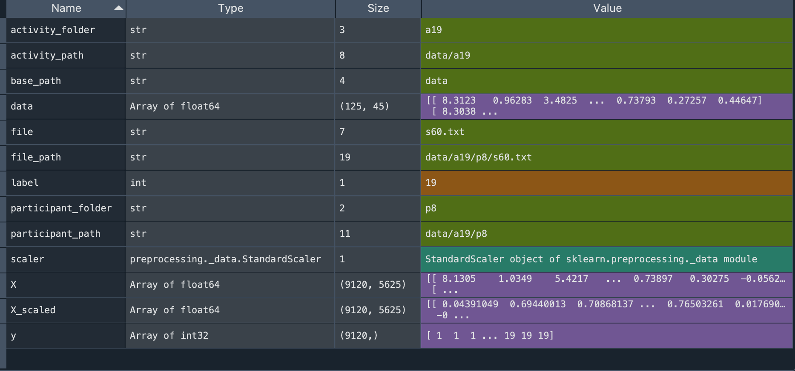

APPENDIX C — Principal Component Analysis (PCA) for Dimensionality Reduction
# APPENDIX C — PCA for Dimensionality Reduction
# Reducing 5625 features to 50 principal components.

from sklearn.decomposition import PCA

pca = PCA(n_components=50)
X_pca = pca.fit_transform(X_scaled)

print("PCA complete.")
print("Reduced shape:", X_pca.shape)

OUTPUT :
PCA complete.
Reduced shape: (9120, 50)
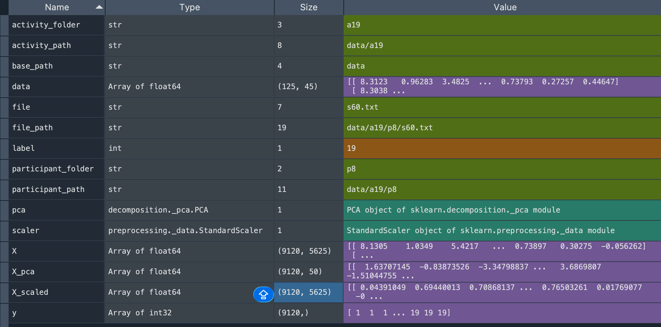

C.1 PCA Visualisation — Explained Variance and Cumulative Variance Plots
import os
import numpy as np
import matplotlib.pyplot as plt
from sklearn.preprocessing import StandardScaler
from sklearn.decomposition import PCA

# -----------------------------
# 1. SET YOUR DATASET FOLDER
# -----------------------------
folder = "/Users/nayana/Downloads/data" # change only if needed

X = []
y = []

# -----------------------------
# 2. LOAD THE DATA
# -----------------------------
for act in sorted(os.listdir(folder)): # a01, a02, ... a19
act_path = os.path.join(folder, act)

if not os.path.isdir(act_path):
continue

label = int(act[1:]) # convert "a01" → 1

for person in sorted(os.listdir(act_path)): # p1, p2, ... p8
person_path = os.path.join(act_path, person)

for file in sorted(os.listdir(person_path)): # s01.txt, ...
file_path = os.path.join(person_path, file)

# Load 125×45 matrix (comma-separated)
data = np.genfromtxt(file_path, delimiter=',')

# Flatten into 1×5625 vector
X.append(data.flatten())
y.append(label)

X = np.array(X)
y = np.array(y)

print("Dataset loaded:", X.shape, "Labels:", y.shape)

# -----------------------------
# 3. STANDARDIZE DATA
# -----------------------------
scaler = StandardScaler()
X_scaled = scaler.fit_transform(X)

# -----------------------------
# 4. APPLY PCA
# -----------------------------
pca = PCA(n_components=350)
pca.fit(X_scaled)

variance = pca.explained_variance_ratio_
cumulative = np.cumsum(variance)

# -----------------------------
# 5. PLOT: First 350 Components
# -----------------------------
plt.figure(figsize=(10,5))
plt.plot(variance[:350])
plt.title("Variance of First 350 PCA Components")
plt.xlabel("Component Number")
plt.ylabel("Variance Explained")
plt.grid(True)
plt.show()

# -----------------------------
# 6. PLOT: Cumulative Variance
# -----------------------------
plt.figure(figsize=(10,5))
plt.plot(cumulative[:350])
plt.title("Cumulative Explained Variance (First 350 Components)")
plt.xlabel("Component Number")
plt.ylabel("Cumulative Variance Explained")
plt.grid(True)
plt.show()

print("PCA plots generated!")
pca_50 = PCA(n_components=50).fit(X_scaled)
cumulative_50 = np.cumsum(pca_50.explained_variance_ratio_)

plt.plot(cumulative_50)
plt.title("Cumulative Explained Variance (First 50 Components)")
plt.xlabel("Component Number")
plt.ylabel("Cumulative Variance Explained")
plt.grid(True)
plt.show()

APPENDIX D — Train–Test Split and Model Training
# APPENDIX D — Train–Test Split and Training Models

from sklearn.model_selection import train_test_split
from sklearn.neighbors import KNeighborsClassifier
from sklearn.svm import SVC
from sklearn.tree import DecisionTreeClassifier

# Train-test split (80/20 stratified)
X_train, X_test, y_train, y_test = train_test_split(
X_pca, y, test_size=0.2, stratify=y, random_state=42
)

# KNN
knn = KNeighborsClassifier(n_neighbors=5)
knn.fit(X_train, y_train)

# SVM (RBF Kernel)
svm = SVC(kernel='rbf')
svm.fit(X_train, y_train)

# Decision Tree
dt = DecisionTreeClassifier(max_depth=20)
dt.fit(X_train, y_train)

print("Models trained successfully!")

OUTPUT :
Reduced shape: (9120, 50)
Models trained successfully!
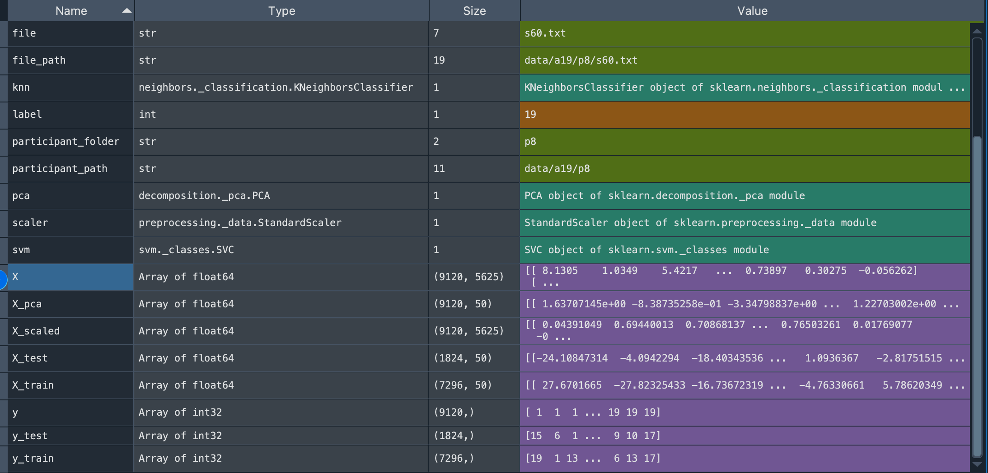

APPENDIX E — Evaluation and Confusion Matrices
from sklearn.metrics import accuracy_score, confusion_matrix
import matplotlib.pyplot as plt
import seaborn as sns

# Function to plot confusion matrix
def plot_cm(model, X_test, y_test, title):
y_pred = model.predict(X_test)
cm = confusion_matrix(y_test, y_pred)

plt.figure(figsize=(10, 7))
sns.heatmap(cm, cmap="Blues", annot=False)
plt.title(title)
plt.xlabel("Predicted")
plt.ylabel("True")
plt.show()

# Accuracy
print("KNN Accuracy:", accuracy_score(y_test, knn.predict(X_test)))
print("SVM Accuracy:", accuracy_score(y_test, svm.predict(X_test)))
print("Decision Tree Accuracy:", accuracy_score(y_test, dt.predict(X_test)))

# Confusion matrices
plot_cm(knn, X_test, y_test, "KNN Confusion Matrix")
plot_cm(svm, X_test, y_test, "SVM Confusion Matrix")
plot_cm(dt, X_test, y_test, "Decision Tree Confusion Matrix")

OUTPUT:
Shape of X: (9120, 5625)
Shape of y: (9120,)
Standardisation complete.
Scaled shape: (9120, 5625)
PCA complete.
Reduced shape: (9120, 50)
Models trained successfully!
KNN Accuracy: 0.9550438596491229
SVM Accuracy: 0.9857456140350878
Decision Tree Accuracy: 0.9276315789473685

