EXPERIMENT : 5

CREATE TABLE Customer(CustomerID int primary key , CustomerName varchar(30), ContactNo int, Address varchar(30), City varchar(60), PostalCode int, Country varchar(30));
DESC Customer;
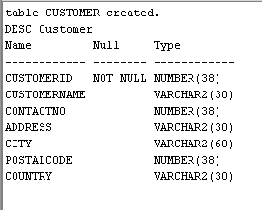

CREATE TABLE Employee_24(EmployeeID int primary key, LastName varchar(30), FirstName varchar(30), DOB date, Photo varchar(50));
desc Employee_24;

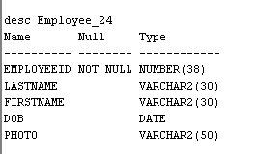

CREATE TABLE Orders_24(OrderID int primary key, CustomerID int,foreign key(CustomerID) references Customer, EmployeeID int, foreign key(EmployeeID) references Employee_24 , OrderDate varchar(30), ShipperID int);
desc Orders_24;

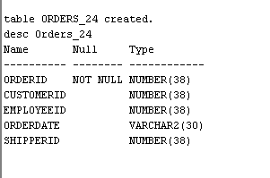

INSERT INTO Customer values(1, 'Arun', 9876543210, 'MG Road','kottayam', 686001, 'India');
INSERT INTO Customer values(2, 'Neena ', 9496228192, 'Disney','Kollam', 686002, 'India');
insert into Customer values(3,'Rahul',9234567819,'MG Road','Thrissur',686003,'USA');
insert into Customer values(4,'Anju',9765432189,'SM street','kottayam',686004,'USA');
insert into Customer values(5,'Ammu',0654321987,'MG Road','kochi',686005,'India');
select * from customer;

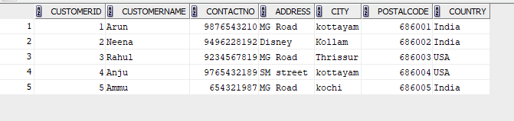

insert into Employee_24 values (101, 'Tony', 'Ann', '15/06/1985', 'annPic');
insert into Employee_24 values(102, 'Ram', 'Sita', '20/09/1990', 'sita.jpg');
insert into Employee_24 values (103, 'Sabu', 'Anit', '12/03/1988', 'anit.jpg');
insert into Employee_24 values (104, 'Joe', 'Maria', '05/11/1992', 'maria.jpg');
insert into Employee_24 values (105, 'manuel', 'Iza', '25/01/1987', 'iza.jpg');
select * from Employee_24;

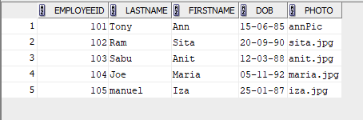

insert into Orders_24 values (1001, 1, 101, '10/01/2024', 1);
insert into Orders_24 values(1002, 2, 102, '15/02/2024', 2);
insert into Orders_24 values (1003, 3, 103, '12/03/2025', 3);
insert into Orders_24 values (1004, 4, 101, '18/04/2024', 1);
insert into Orders_24 values (1005, 5, 101, '02/05/2025', 2);
select * from orders_24;

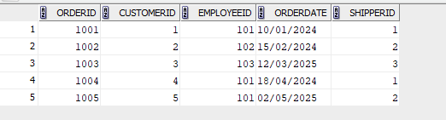

- SELECT * FROM Customer ORDER BY CustomerName ASC;
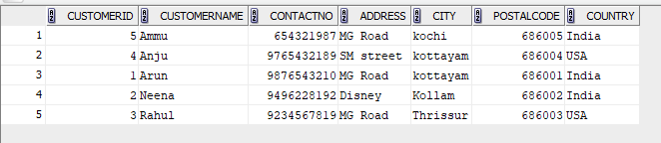

- SELECT * FROM Orders_24 ORDER BY TO_DATE(OrderDate,'DD/MM/YYYY') ASC;
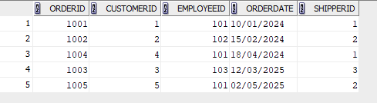

- SELECT * FROM Employee_24 WHERE DOB > DATE '1980-01-01' ORDER BY DOB DESC;
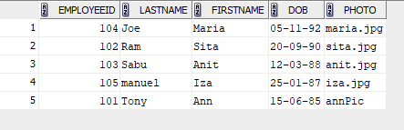

- SELECT * FROM Orders_24 WHERE CustomerID IN (SELECT CustomerID FROM Customer WHERE Country = 'USA') ORDER BY OrderDate DESC;

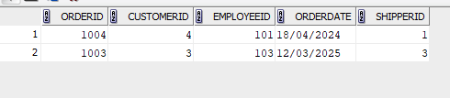

- SELECT CustomerID, COUNT(OrderID) AS TotalOrders FROM Orders_24 GROUP BY CustomerID;
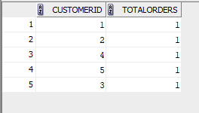

- SELECT City, COUNT(CustomerID) AS TotalCustomers FROM Customer GROUP BY City;
