create table customer_60( custid int primary key, Custname varchar(30), Address varchar(50), state varchar(50));
desc customer_60;
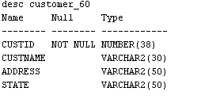

create table items_60(itemid int primary key, Itemname varchar(50), category varchar(50), Price varchar(50), Instock number check (Instock >= 0));
desc items_60;
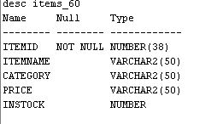
create table order__60(orderid int primary key, itemid int, foreign key(itemid) references items_60, custid int, foreign key(custid) references customer_60, quantity int, orderdate date);
desc order__60;
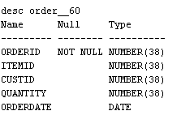

create table delivery_60(deliverid int primary key, custid int, foreign key(custid) references customer_60, orderid int, foreign key(orderid) references order__60);
desc delivery_60;
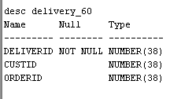

insert into items_60 values(101, 'Laptop', 'Electronics', 75000, 10);
insert into items_60 values (102, 'Headphones', 'Electronics', 2000, 25);
insert into items_60 values (103, 'Office Chair', 'Furniture', 5000, 15);
insert into items_60 values (104, 'Mobile Phone', 'Electronics', 30000, 8);
insert into items_60 values (105, 'Water Bottle', 'Home', 500, 50);
select * from items_60;
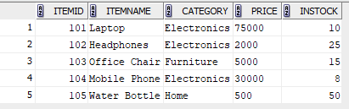

insert into customer_60 values (1, 'Vinu', 'MC Road', 'India');
insert into customer_60 values (2, 'Rashmi', 'SM street', 'India');
insert into customer_60 values (3, 'Jayan', 'MC Road', 'India');
insert into customer_60 values (4, 'Vishnu', 'Beach road', 'USA');
insert into customer_60 values (5, 'Ajitha', 'Chicago Center', 'USA');
select * from customer_60;
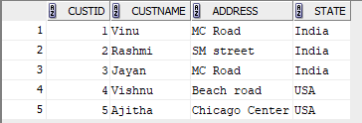

insert into order__60 values (201, 101, 1, 1, TO_DATE('15-02-2026','DD-MM-YYYY'));
insert into order__60 values (202, 102, 2, 2, TO_DATE('16-02-2026','DD-MM-YYYY'));
insert into order__60 values (203, 103, 3, 1, TO_DATE('17-02-2026','DD-MM-YYYY'));
insert into order__60 values (204, 104, 1, 1, TO_DATE('18-02-2026','DD-MM-YYYY'));
insert into order__60 values (205, 105, 4, 3, TO_DATE('19-02-2026','DD-MM-YYYY'));
select * from order__60;
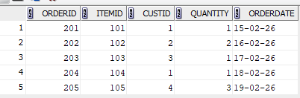

insert into delivery_60 values(301, 1, 201);
insert into delivery_60 values (302, 2, 202);
insert into delivery_60 values (303, 3, 203);
insert into delivery_60 values (304, 1, 204);
insert into delivery_60 values(305, 4, 205);
select * from delivery_60;
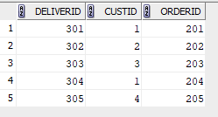
1. List the details of all customers who have placed an order
select distinct c.* from Customer_60 c join Order__60 o on c.custid = o.custid;
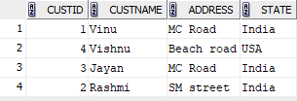

2. List the details of all customers whose orders have been delivered
select distinct c.*from Customer_60 c join Order__60 o on c.custid = o.custid join
Delivery_60 d on o.orderid = d.orderid;
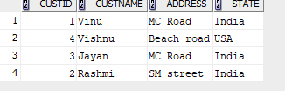

3. Find the order date for all customers whose name starts in the letter‘J’
select o.orderdate from Order__60 o join Customer_60 c on o.custid = c.custid where
c.custname LIKE 'J%';
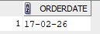

4. Display the name and price of all items bought by the customer’Rashmi’.
select i.Itemname, i.Price from Items_60 i join Order__60 o ON i.itemid = o.itemid JOIN
Customer_60 c ON o.custid = c.custid WHERE c.custname = 'Rashmi';

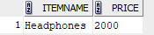

5. List the details of all customers who have placed an order after January 2013 and not received delivery of items
select distinct c.*from Customer_60 c join order__60 o on c.custid = o.custid left joindelivery_60 d on o.orderid = d.orderid where o.orderdate > '31-01-2013' and d.deliverid is null;
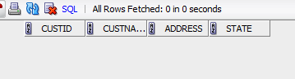

6. Find the itemid of items which has either been ordered or not delivered. (UseSET UNION)
select itemid from order__60 union select o.itemid from Order__60 o left join
Delivery_60 d on o.orderid = d.orderid where d.deliverid is null;
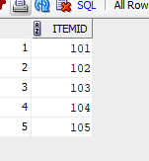
7. Find the name of all customers who have placed an order and have their orders
SELECT custname FROM Customer_60 WHERE custid IN (SELECT custid FROM order__60) INTERSECT SELECT custname FROM Customer_60 WHERE custid IN (SELECT o.custid FROM Order__60 o JOIN Delivery_60 d ON o.orderid = d.orderid );
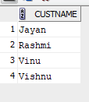
8. Find the custname of all customers who have placed an order but not having their orders delivered. (Use SET MINUS) delivered.(Use SET INTERSECTION)

9. Find the name of the customer who has placed the most number of orders.
10. Find the details of all customers who have purchased items exceeding a price of 5000$
11. Find the name and address of customers who has not ordered a ‘Samsung GalaxyS4’
12. Perform Left Outer Join and Right Outer Join on Customers & Orders Table.
13. Find the details of all customers grouped by state
14. Display the details of all items grouped by category and having a price greater than average price of all items.

