Module Name: Automation & Regression Testing - SauceDemo
Test Case ID: st_10
Tester Name:Dumraliya Nayan(Enrollment No: 2504030100045)
Webpage URL: https://www.saucedemo.com

Scenario ID: REG01:- Login
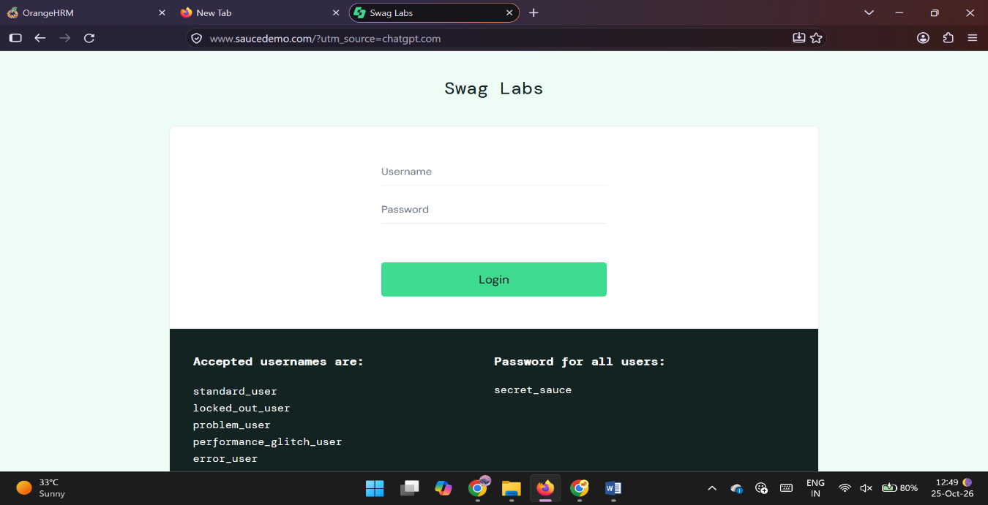

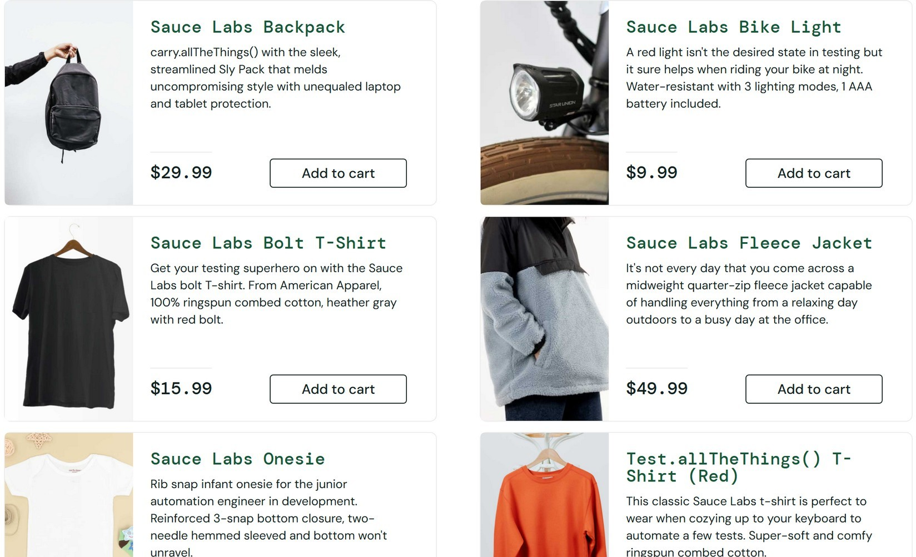
Scenario ID: REG02:- Product display

Scenario ID: REG03:- Add to cart Test Steps
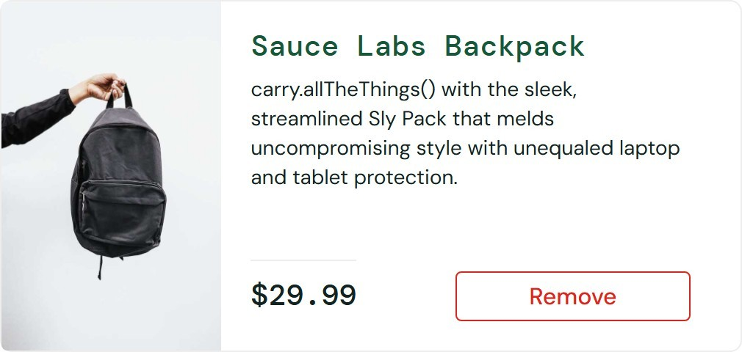

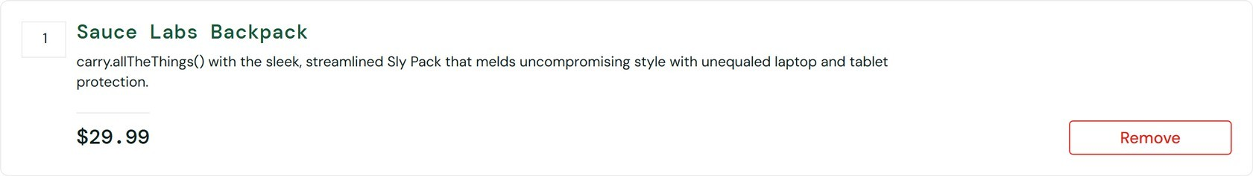
Scenario ID: REG04:- Remove from cart Test

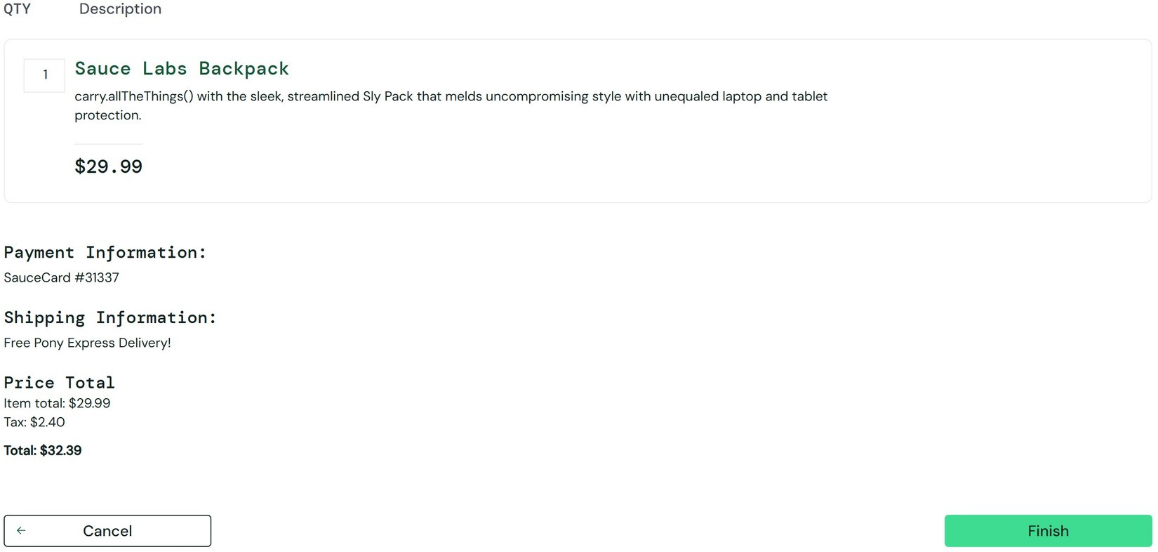
Scenario ID: REG05:- Checkout Test Steps:

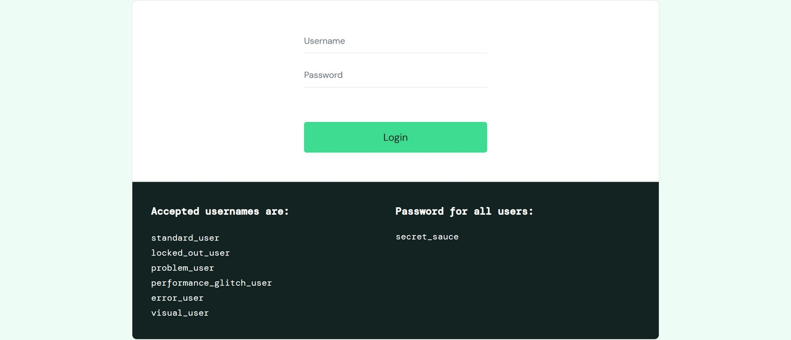
Scenario ID: REG06:- Logout

Regression Testing Result (Build Comparison)

TC ID | Previous Result |  | Current Result | Status
REG01 | Pass |  | Pass | Pass
REG02 | Pass |  | Pass | Pass
REG03 | Pass |  | Pass | Pass
REG04 | Pass |  | Pass | Pass
REG05 | Pass |  | Pass | Pass
REG06 | Pass |  | Pass | Pass

