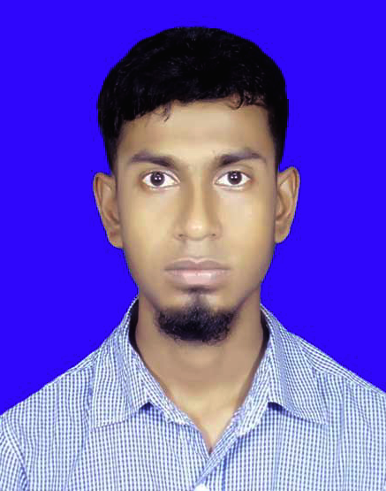**MD.NAYAN HOSSAIN**

Diploma in Computer Engineer

|  |  |  |
| --- | --- | --- |
| **Mailing Address**  **E-mail**  **Phone**  **Github**  **LinkedIn** | **:**  **:**  **:**  **:**  **:** | Vill- Digripara , Post- Dashuria(6620), P.S- Ishwardi, District-Pabna  [nayanhossainbd.786@gmail.com](mailto:nayanhossainbd.786@gmail.com)  01704-458206  http://github.com/nayanhossainbd  https://linkedin.com/in/nayanhossainbd |

**Career Objective**

I would like to work in the Creative Department in the different local/ multinational, IT solution of Bangladesh as a Team Member and grow up rapidly with increasing responsibilities

**Education**

|  |  |  |  |
| --- | --- | --- | --- |
| **Degree** | University Board | Result | Passing Year |
| **Diploma In Computer Engineering** | Bangladesh Technical Education Board | **3.47 (4.00)** | 2019 |
| **Secondary School Certificate** | Rajshahi | **5.00(5.00)** | 2015 |
| **Computer Office Application Program** | Bangladesh Technical Education Board. | A+ | 2018 |

**Training:**

**1) Web Development (PHP and Laravel) :** Duration- 3 months, Year- 2019,

**Institute:** Creative IT Institute of Bangladesh.

**2) Web Development (Core PHP):** Duration- 6 months, Year- 2018,

**Institute:** Smart Soft IT Institute, Pabna.

**3) Graphics Design:** Duration – 6 months-(200 hours), Year - 2018.

Technology Division Of BSCIC.

**4) Office Application:** Duration – 6 months-(200 hours), Year - 2018.

Technology Division of BSCIC.

**5) Mobile App And Game Animation:** Duration – 3 months, Year - 2018.

ICT Ministry of Bangladesh.

**Workshop**

None

**Experience**

**Internship: Web Development** atCreative IT Institute of Bangladesh.

**Jobs:**

**1) Role: Web Developer**

**Company:** Intezie Limited.

**From:** 01 July, 2019

**To:** 30 June, 2020

**2) Role: Web Developer**

**Company:** AR Trade International.

**From:** 01 August, 2020

**To:** Running

**Personal Details**

Father’s Name : Md. Tarikul Islam

Mother’s Name : Most. Ambia Khatun

Date of Birth : 01-11-1999

Marital Status : Single

Religion : Islam

Nationality : Bangladeshi (By Birth)

NID Number : 8254070538

Permanent Address : Vill- Pakuria(Digripara), Post- Dashuria(6620), P.S- Ishwardi,

Dist- Pabna..

**Interests**

Coding, Programming, Traveling, Watching movies, Listening Songs & Reading Novels, Playing outdoor Games.

**Other Skills**

Adobe Photoshop, Illustrator, Animate, Microsoft Office, Emailing and Internet Browsing.

**Language Competency**

Bangla: Fluent in Bangla

English: Full working knowledge in English.

**References**

**Md. Atayer Rabbi Kajol**

Executive Director,

Creative It Institute.

Momtaj Plaza, Dhanmondi, Dhaka

Contact Number: +8801990779794

**Md. Shohan Hossain**

Software Engineer &

Web Department head,

Creative It Institute.

Email: shohan.cit.bd@gmail.com

Contact Number: +8801990779770

Nayan

**Signature**