The world’s energy supply is 81% reliant on fossil fuels (oil, gas and coal).

Reserves of oil, natural gas and nuclear energy (uranium 235) will be largely exhausted by the end of the 21st century and coal

Within two or three centuries:

* Oil: 50 to 100 years,
* Gas: 60 to 70 years,
* Coal: 200 years

**Renewable energy sources, which represent real hope for the future, are still only marginal:**

• Hydroelectric (and marine) energy.

• Wind energy, one of the most profitable sources, which is increasing by 30% every year. On a global scale, wind farms supply

the equivalent of 40 nuclear reactors (eight times more than in 1995).

• Solar energy (photovoltaic and thermal).

• Geothermal.

• Biomass

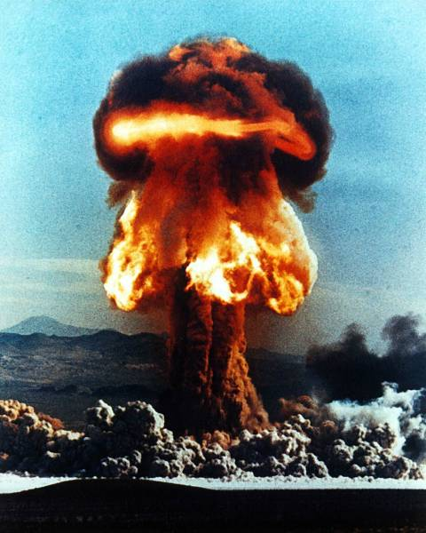

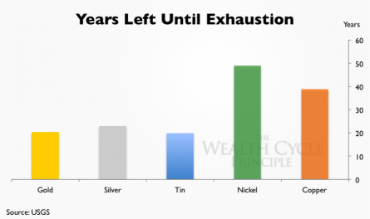

Air pollution

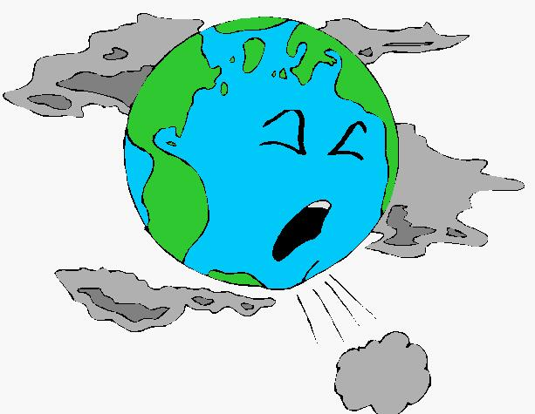

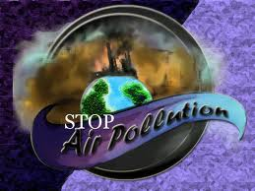

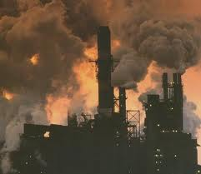

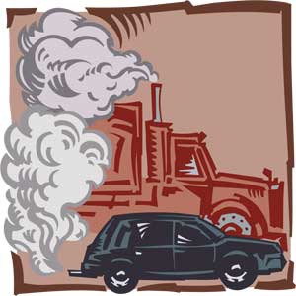

* Any visible or invisible particle or gas found in the air that is not part of the original, normal composition.
* Natural: forest fires, pollen, dust storm
* Unnatural: man-made; coal, wood and other fuels used in cars, homes, and factories for energy

xhjsq_im[1]

Threat to organism

Currently, human activity - through the burning of fossil fuels - is changing the basic

chemistry of our seas at an unprecedented rate, making them more acidic. As

atmospheric CO2 has risen, the oceans have become 30% more acidic over the last 150

years .

Surface mining of coal causes direct and indirect damage to wildlife. The impact on wildlife stems primarily from disturbing, removing and redistributing the land surface. Some impacts are short-term, and confined to the mine site; others have far-reaching, long-term effects. The most direct effect on wildlife is destruction or displacement of species in areas of excavation and spoil piling. Mobile wildlife species like game animals, birds, and predators leave these areas. More sedentary animals like invertebrates, reptiles, burrowing rodents and small mammals may be destroyed.

If streams, lakes, ponds or marshes are filled or drained, fish, aquatic invertebrates and amphibians are destroyed. Food supplies for predators are reduced by destruction of these land and water species. Animal populations displaced or destroyed can eventually be replaced from populations in surrounding ranges, provided the habitat is eventually restored; an exception would be the extinction of a resident endangered species.

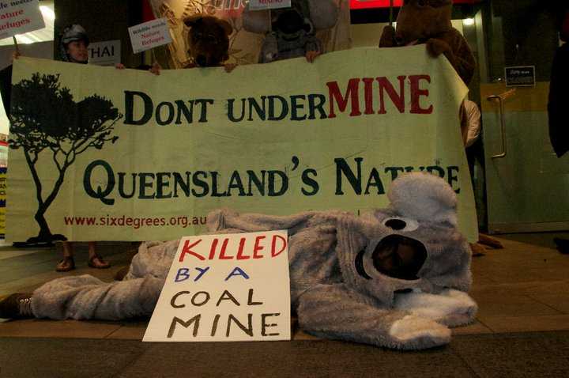

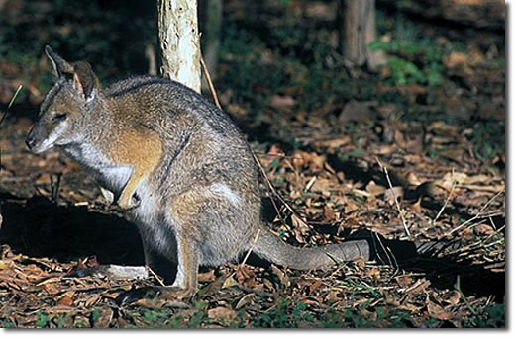

Wind energy

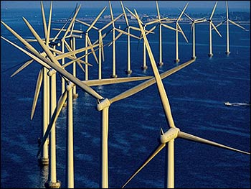

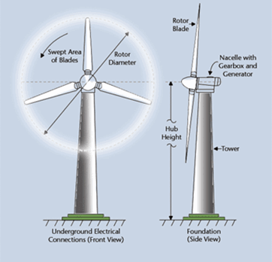

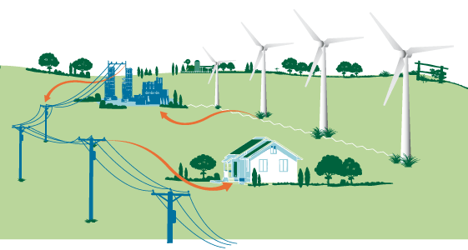

On modern wind turbines, large blades are pushed by the wind, driving a generator that converts the energy into electricity. The turbines are designed to track the wind as it changes direction in order to capture the maximum amount of wind. If the wind speed becomes excessively high, the turbine shuts down to avoid mechanical damage. Modern turbines can be as tall as 100 meters (328 feet).

The electricity produced by the turbines is then transported from the turbines through underground distribution lines to a substation, where the voltage is adjusted into a form of energy that can be delivered and used by homes and businesses.

Solar energy

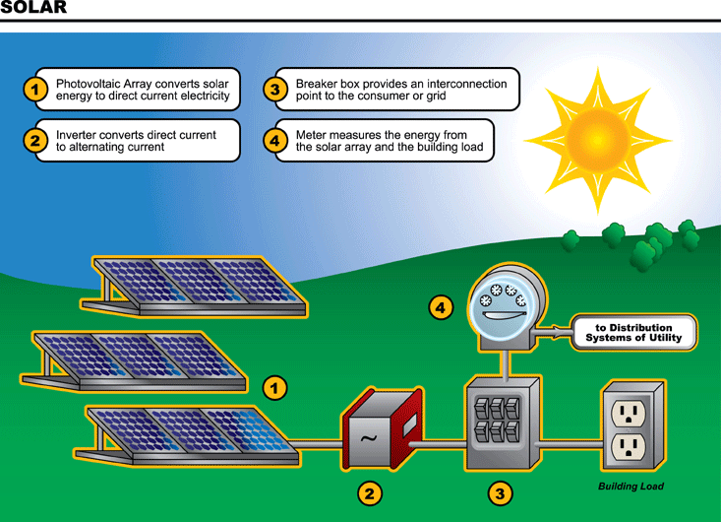

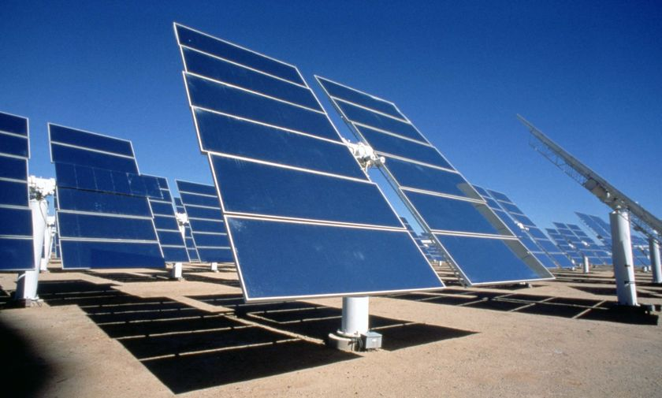

**Solar energy**, radiant [light](http://en.wikipedia.org/wiki/Light) and [heat](http://en.wikipedia.org/wiki/Heat) from the [sun](http://en.wikipedia.org/wiki/Sun), has been harnessed by humans since [ancient times](http://en.wikipedia.org/wiki/Ancient_history) using a range of ever-evolving technologies. Solar energy technologies include [solar heating](http://en.wikipedia.org/wiki/Solar_heating), [solar photovoltaic’s](http://en.wikipedia.org/wiki/Solar_photovoltaics), [solar thermal electricity](http://en.wikipedia.org/wiki/Solar_thermal_electricity) and [solar architecture](http://en.wikipedia.org/wiki/Solar_architecture), which can make considerable contributions to solving some of the most urgent problems the world now faces.[[1]](http://en.wikipedia.org/wiki/Solar_energy#cite_note-ie11-0)

Solar technologies are broadly characterized as either [passive solar](http://en.wikipedia.org/wiki/Passive_solar) or [active solar](http://en.wikipedia.org/wiki/Active_solar) depending on the way they capture, convert and distribute solar energy. Active solar techniques include the use of photovoltaic panels and [solar thermal](http://en.wikipedia.org/wiki/Solar_thermal_energy) collectors to harness the energy. Passive solar techniques include orienting a building to the Sun, selecting materials with favorable [thermal mass](http://en.wikipedia.org/wiki/Thermal_mass) or light dispersing properties, and designing spaces that [naturally circulate air](http://en.wikipedia.org/wiki/Ventilation_(architecture)).

hydroelectricity

**Hydroelectricity** is the term referring to [electricity](http://en.wikipedia.org/wiki/Electricity) generated by [hydropower](http://en.wikipedia.org/wiki/Hydropower); the production of electrical power through the use of the gravitational force of falling or flowing water. Using dams and generators.

A dam is built to trap water, usually in a valley where there is an existing lake. Water is allowed to flow through tunnels into the dam, to turn turbines and thus drive generators.

