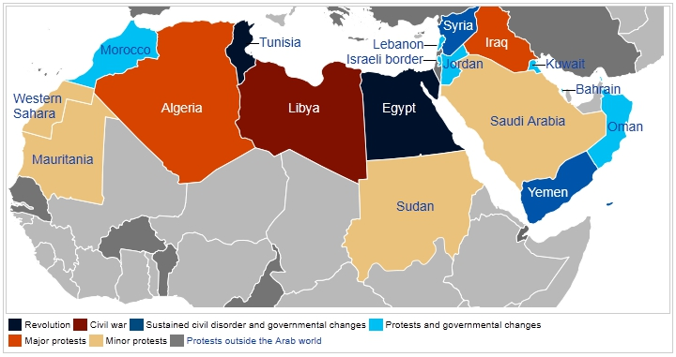

In the Middle East countries like Egypt, Saudi Arabia and Tunisia where Arab’s constitute a major part of the population, people feel that “Democracy is like an alien to their religion.” Germany strictly opposes this and has taken various numbers of steps to provide democracy in these countries.

In December 2010 the 'jasmine revolution' in Tunisia heralded a wave of democracy in the Arab world. It was followed by the ousting of political leaders in Egypt and Libya. Germany responded quickly to the new geopolitical situation. The German government is prepared to stand by and advise demo­cratic, reform-oriented forces in Egypt and elsewhere in the region,' Also the German Development Minister Dirk Niebel declared in February 2011 that they won’t democratize any country from the outside but if asked for help they would gladly help them.

Even though the countries of the Middle East and North Africa differ widely, they are all facing similar problems and challenges: democratic structures need to be developed anew and carefully nurtured. The German Federal Ministry for Economic Co­op­er­a­tion and De­vel­op­ment (BMZ) will be providing strong, long-term support for the process of transformation taking place in the region. It will concentrate on the following areas in particular: Good governance and the rule of law, Education and training, Media freedom and freedom of opinion, Employment, Transformation of the economy based on social and market-economy principles. Germany also takes a leading role in shaping European Union (EU) activities to support the transformation processes, including the launch of the 'SPRING' (Support to Partnership, Reform and Inclusive Growth) initiative in autumn 2011. By means of this programme, funded to the sum of 350 million euros, the EU is supporting democratic change and economic growth in North Africa and the Middle East.

In response to the political upheavals in Tunisia and in Egypt, the BMZ set up and endowed three funds for the countries of North Africa and the Middle East.

* Economic Fund: The purpose of the regional fund for small, medium-sized and micro enterprises, the current volume of which is 52 million Euros, is to support the refinancing of micro-finance institutions. This will help create new jobs in the micro and small enterprise segment of the economy.
* Fund to Promote Democracy: To support democratic change the BMZ has set up a fund to finance consultancy services on structural and regulatory policy. More than 6 million Euros is available for special measures under the auspices of organizations already present in the region, such as political foundations, church de­vel­op­ment agencies and the Deutsche Welle Academy.
* Education Fund: The BMZ is providing 8 million Euros to support a regional project via the Deutsche Gesellschaft für Internationale Zusammenarbeit (GIZ) concerned with training and employ­ment for young people. The objective is to open up new educational and de­vel­op­ment opportunities for the younger generation.

**Supporting the transformation process in Yemen**

The security situation in Yemen prompted the withdrawal of seconded personnel in March 2011. Just a core team was able to recommence work at the start of 2012. German de­vel­op­ment co­op­er­a­tion supports the transformation process and gives extensive help, particularly in areas which benefit poorer people (education, water, health, food aid).

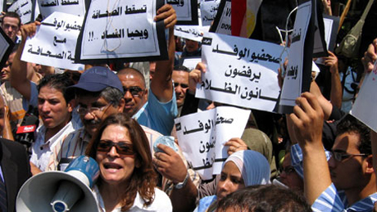

[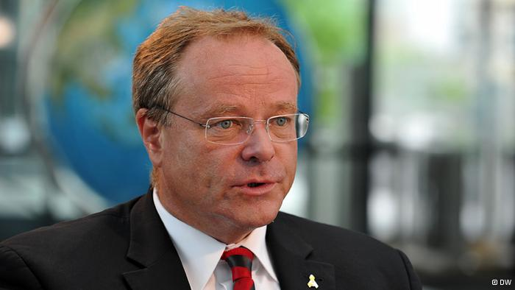](http://www.google.co.in/url?sa=i&rct=j&q=German+De%C2%ADvel%C2%ADop%C2%ADment+Minister+Dirk+Niebel&source=images&cd=&cad=rja&docid=NhbdD5iZjyb9pM&tbnid=do6BaRUXfjidyM:&ved=0CAUQjRw&url=http://www.dw.de/german-development-minister-in-uganda-and-rwanda/a-16849580&ei=-WL9UfHHNpDPrQf14oDwBw&bvm=bv.50165853,d.bmk&psig=AFQjCNHaXc96EPzuMrsoOCQPatcvG4uPQA&ust=1375646831945839)

Germany

"I want to call upon all parties involved not to use any violence. There is no question that despite Egypt’s variety of opinions human rights applies to all its citizens.

"The country's problems can only be solved if Egypt enters a political process as quickly as possible and democratic and rule of law will be established as soon as possible."

-Chancellor Angela Merkel

[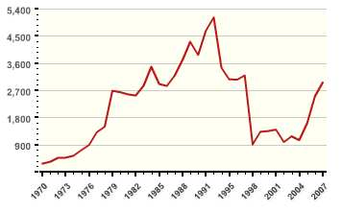](http://www.google.co.in/url?sa=i&rct=j&q=terrorism+graph+in+middle+east+countries&source=images&cd=&cad=rja&docid=sSLynj4BaOgUVM&tbnid=wdOWzZLm8zs3wM:&ved=0CAUQjRw&url=http://shaneleavy.blogspot.com/2010/05/did-war-on-terror-work.html&ei=rmX9UZWANcjWrQeX2oDIAg&bvm=bv.50165853,d.bmk&psig=AFQjCNG1z9nHTfzchsQe2pY5zFRObWn9GA&ust=1375647150510863)

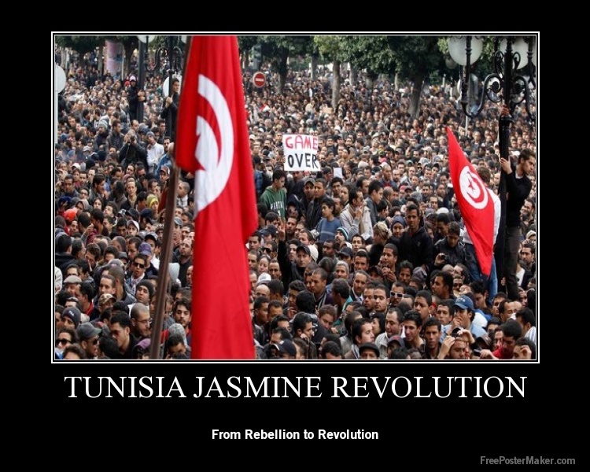

CURREN AFFAIRS

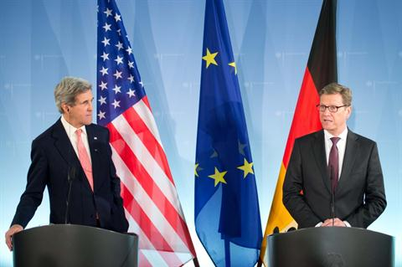

Germany's foreign minister warned on Thursday that delivering weapons to Syria's rebels could result in an arms race in the region and stressed the [EU](javascript:void(0)) would send only "defensive" equipment.

German foreign minister Guido Westerwelle, right, gives a statement as US Secretary of State,John Kerry, left, listens at the Foreign Ministry in Berlin, Germany, Tuesday Feb, 26, 2013.

