PROJECT PROPOSAL

CodeGen
Natural Language to Java Code Generation and Java to C# Code Translation using Large Language Models.

Group Number: 6

Team Members
- Ayyagari Sattwik
- Shib Shankar Dhara
- Taruni Swathi
- Dhrubajyoti Maiti

PROJECT PROPOSAL

Title
CodeGen: Natural Language to Java Code Generation and Java to C# Code Translation using Large Language Models

1. Introduction
With the rapid advancement of Artificial Intelligence and Large Language Models (LLMs), automated code generation and code translation have become important research areas. Software developers often describe requirements in natural language before implementing them in a programming language. Similarly, organizations frequently migrate software systems from one programming language to another, which is a time-consuming and error-prone process.
This project aims to develop a code generation system that automatically converts natural language descriptions into Java code and further translates Java code into equivalent C# code. The system leverages modern code language models and supervised fine-tuning techniques to automate both tasks.

2. Problem Statement
Developing software applications requires significant programming expertise and manual effort. Users may be able to describe desired functionality in natural language but lack the knowledge to implement it in Java. Additionally, organizations migrating applications from Java to C# often face challenges in manually rewriting large amounts of code while preserving functionality.
The proposed system aims to bridge these gaps by:
- Generating Java code from natural language descriptions.
- Translating Java code into equivalent C# code.
- Evaluating the quality and correctness of generated code using standard code-generation metrics.

3. Objectives
The primary objectives of this project are:
- Generate Java code from natural language descriptions.
- Translate Java code into C# code.
- Fine-tune a lightweight code language model for both tasks.
- Evaluate generated code using standard code-generation metrics.
- Measure syntactic correctness and compilation success of generated code.

4. Architecture

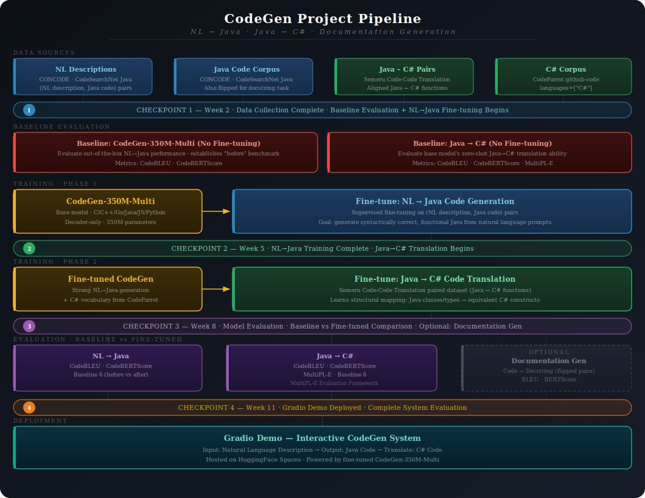

5. Proposed Methodology
The project will be carried out in the following phases:

Phase 1: Data Collection
Relevant datasets containing paired natural language descriptions and Java code, as well as paired Java and C# implementations, will be collected.
For Natural Language to Java generation:
- CodeXGLUE-CONCODE Dataset
- Text-Code Concode Java Dataset
- CodeSearchNet Java Dataset
These datasets provide natural language descriptions paired with corresponding Java implementations.
For Java to C# translation:
- Semeru Code-Code Translation Java-CSharp Dataset
This dataset contains aligned Java and C# function pairs suitable for supervised code translation.

Phase 2: Model Training
A lightweight code language model, CodeGen-350M-Multi, will be used as the base model.
The model will be fine-tuned using supervised learning on natural language and Java code pairs to perform Natural Language to Java code generation.
CodeGen-350M-Multi is selected because it already possesses strong Java language understanding while remaining computationally efficient for fine-tuning.

Phase 3: Java to C# Translation
The fine-tuned model will be further adapted for Java-to-C# code translation using paired examples from the Semeru Code-Code Translation Java-CSharp dataset.
The model will learn to generate syntactically correct and functionally equivalent C# implementations from Java source code.

Phase 4: Evaluation
The generated outputs will be evaluated using standard code-generation and code-translation metrics.

CodeBLEU
CodeBLEU evaluates generated code based on:
- N-gram matching
- Syntax matching
- Abstract Syntax Tree (AST) structure
- Data-flow correctness

MultiPL-E HumanEval-CS Based Evaluation
For the Java to C# translation task, functional correctness will be evaluated using the MultiPL-E HumanEval-CS benchmark by executing predefined unit tests. The following metrics will be used:
- Pass@k Score
Measures whether at least one of the top-k generated outputs passes all test cases.
- Percentage of unit tests successfully passed by the generated code.
- Checks whether the generated code produces correct outputs for given inputs.
These metrics provide practical validation of code usability beyond textual similarity.

6. Expected Outcomes
At the end of the project, we expect to:
- Generate valid Java code from natural language descriptions.
- Translate Java code into equivalent C# implementations.
- Achieve measurable improvements through fine-tuning.
- Produce compilable and syntactically correct generated code.

7. Real-World Applications
The proposed system can be useful for:
- Intelligent code assistants.
- Software migration from Java to C#.
- Automated code generation tools.
- Educational programming assistants.
- Enterprise modernization projects.

8. Conclusion
This project aims to simplify software development and migration processes by automating the conversion of natural language descriptions into Java code and translating Java implementations into C# code. By leveraging Large Language Models and curated datasets, the system seeks to improve developer productivity while reducing manual coding effort.

References
- CodeGen-350M-Multi
- CodeBLEU
- Semeru Code-Code Translation Java-CSharp Dataset
- CodeXGLUE-CONCODE Dataset
- Text-Code Concode Java Dataset
- CodeSearchNet Java Dataset
- https://huggingface.co/datasets/semeru/code-code-translation-java-csharp
- https://huggingface.co/datasets/AhmedSSoliman/CodeXGLUE-CONCODE
- https://huggingface.co/datasets/semeru/Text-Code-concode-Java
- https://huggingface.co/datasets/Nan-Do/code-search-net-java
- https://huggingface.co/Salesforce/codegen-350M-multi

