AIML Batch 26 — PG Certification
IIIT Hyderabad · TalentSprint — Capstone Project Proposal
Project 6 — CodeGen
Teaching a Small Code Language Model a New Language:
Python-to-Rust Code Translation & Generation with Execution-Based Evaluation and RAG
Group 45
Team Members
Krishna Adithya Duvvuri (Trainee ID: 2501489)
N V Ravi Teja Dogiparthi (Trainee ID: 2501822)
Naveen Katara (Trainee ID: 2501952)
Rishabh Mishra (Trainee ID: 2507514)

Mentors: Nayan Anand & Pawan Baswani
Date: 31 May 2026
Selected Track: Programming-Language Translation (Text→PL and PL→PL)

Table of Contents
1. Title 3
2. Problem Statement 3
3. Objectives 3
4. Literature Review 4
4.1 Code Language Models & Translation 4
4.2 Evaluation Metrics 4
4.3 RAG Systems 4
5. Methodology 4
5.1 System Architecture 4
5.2 Workflow 5
6. Core Tasks 6
7. Tools & Resources 6
8. Project Timeline / Checkpoints 7
9. Expected Outcomes 7
10. Real-World Applications 8
11. Challenges 8
12. Deployment Plan 9
13. Conclusion 9
14. References 9

1. Title
CodeGen — Teaching a Small Code Language Model a New Language: Python-to-Rust Code Translation and Generation with Execution-Based Evaluation and RAG.

2. Problem Statement
Language models are increasingly used to understand and synthesise programming languages, powering code generation, translation and modernisation. Very large proprietary models do this well but are expensive, closed and impractical to run privately. Small, open code language models (a few hundred million parameters) can be hosted locally and fine-tuned cheaply, but they are trained on a fixed set of popular languages and perform poorly on languages they barely saw in training.
This project studies how far a small, open model can be pushed on real translation tasks for a language it barely supports, and how much fine-tuning and Retrieval-Augmented Generation (RAG) can improve it. We choose Rust as the target language because it is largely absent from the training mix of our base model, Salesforce codegen-350M-multi (trained mainly on C, C++, Go, Java, JavaScript and Python). Rust is therefore a genuine “new language” to extend the model to, has abundant open-source code for training and retrieval, and a strong toolchain that makes execution-based evaluation reliable. We ask:
- How well does the small model translate Python into Rust and generate Rust from English, judged by whether the output compiles and passes tests?
- How much does fine-tuning the model on Rust improve correctness over the vanilla model?
- How much additional gain comes from a RAG layer (and, as a stretch, AST information)?
- How large is the remaining gap to a large general-purpose LLM on the same tasks?

3. Objectives
- Build an execution-based evaluation harness for Rust (compile, run and test generated code).
- Establish baselines for the vanilla codegen-350M-multi model on Rust.
- Extend the model to Rust via continued pre-training plus supervised fine-tuning, using parameter-efficient methods (LoRA / QLoRA).
- Implement the core tasks: English→Python generation, Python→Rust translation, and English→Rust (both directly and via a Python pivot).
- Add a RAG layer (top-K retrieval of similar code; AST-based indexing as a stretch).
- Benchmark the small model against a large LLM and quantify the gains from fine-tuning and from RAG.
- Deploy a working demo of the final system.

4. Literature Review

4.1 Code Language Models & Translation
Nijkamp et al. (2023), “CodeGen” (ICLR 2023), introduced the open CodeGen family; the 350M “multi” checkpoint we adopt is its smallest practical member. Feng et al. (2020), “CodeBERT”, provide bimodal code/text encoders used for our code embeddings. Roziere et al. (2020), “TransCoder” (NeurIPS 2020), showed that models can translate between programming languages and argued translations must be judged by computational correctness — motivating our execution-first approach. Yang et al. (2025), “Scaling Laws for Code: Every Programming Language Matters”, show that training on parallel pairs (concatenating code with its translation) and using Python as a pivot language significantly improve cross-lingual translation — directly supporting our parallel-pairing fine-tuning and English→Python→Rust pivot — while noting that Rust, as a compiled language, is intrinsically harder and ‘fast-saturating’, which tempers our accuracy expectations.
Most directly, Cassano et al. (2024), “MultiPL-T” (Knowledge Transfer from High-Resource to Low-Resource Programming Languages), demonstrate a validated recipe for teaching a small, open code model a low-resource language: generate candidate solutions from Python, keep only those that compile and pass tests, and fine-tune on them. They report strong gains for languages such as Julia, Lua, OCaml, R and Racket on models like StarCoder2 and DeepSeek-Coder. This is a direct, reproducible blueprint that we adapt to Rust, which materially de-risks the language-extension goal.

4.2 Evaluation Metrics
Cassano et al. (2023), “MultiPL-E”, translate the Python HumanEval and MBPP benchmarks — with their unit tests — into 18+ languages including Rust, giving us ready-made, test-backed Rust problems. Ren et al. (2020) proposed CodeBLEU (AST + data-flow aware similarity); Zhou et al. (2023) introduced CodeBERTScore (EMNLP 2023), which correlates better with functional correctness. We treat compilation rate and execution accuracy as primary, with CodeBLEU/CodeBERTScore as secondary.

4.3 RAG Systems
Lewis et al. (2020) proposed Retrieval-Augmented Generation, combining a parametric generator with a non-parametric retriever to ground outputs in external documents without retraining. Wang et al. (2024), “Searching for Best Practices in RAG”, study the full pipeline (retrieval, reranking, repacking) and the chunking, embedding and vector-store choices we follow over a code corpus.

5. Methodology

5.1 System Architecture
A query — a Python function or an English description — optionally passes through a RAG layer that retrieves the top-K most similar Python→Rust examples and adds them as context. The small, Rust-fine-tuned code model then generates Rust, which is compiled and run by an execution harness. Outputs are scored by execution accuracy and code-similarity metrics, and benchmarked against a large LLM.
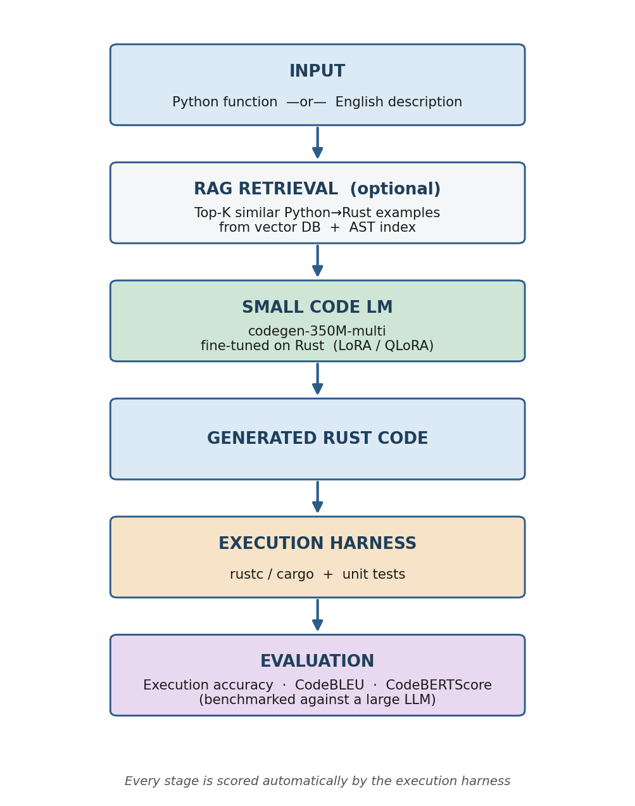
Figure 1. End-to-end system architecture for the Python→Rust pipeline.

5.2 Workflow
The system is built incrementally across five stages, mirroring the four checkpoints: (1) build the execution harness first so every experiment is scored automatically; (2) measure the vanilla model as a baseline; (3) fine-tune on Rust (continued pre-training, then supervised Python→Rust pairs, with LoRA); (4) add the RAG layer and sweep K; (5) compare against a large LLM and deploy. Each task is evaluated in four configurations — vanilla, fine-tuned, fine-tuned + RAG, and large LLM — so gains are attributable to fine-tuning and to retrieval.
Python as a pivot and data engine. Because the model is strongest in Python and weakest in Rust, we use Python as an intermediate language. The English→Python step is both an end task and the first stage of data generation: we generate Python from problem descriptions, validate it against Python tests, then translate the validated Python into Rust and keep only translations that compile and pass tests (the MultiPL-T recipe). For end-to-end English→Rust we compare the direct route against this English→Python→Rust pivot.
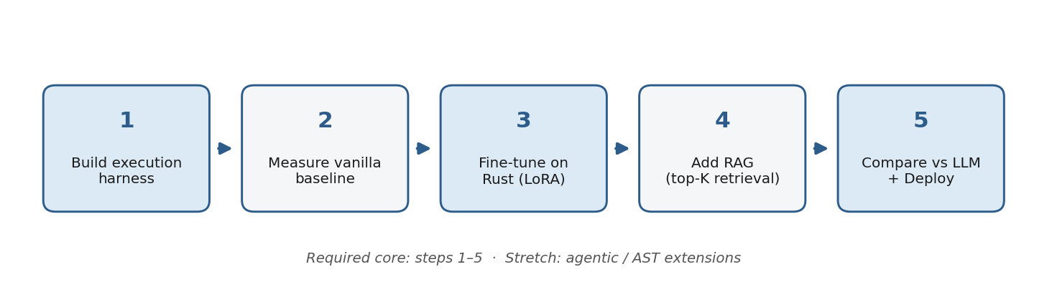
Figure 2. Five-stage build and evaluation workflow.

6. Core Tasks
We address three generation/translation tasks that build on each other, with Python used as a high-resource pivot between English and Rust.

Task 1 — English → Python Generation
- Input: a natural-language problem description. Output: a Python function, validated against Python unit tests.
- Why it matters: Python is the model’s strongest language, so this step is reliable. It serves two roles — a capability in its own right, and the first stage of both the Python pivot and our data-generation engine (validated Python is what we then translate into Rust).

Task 2 — Python → Rust Translation (primary)
- Input: a Python function. Output: an equivalent, compiling, test-passing Rust function.
- Evaluation: execution accuracy and compilation rate (primary); CodeBLEU / CodeBERTScore (secondary).

Task 3 — English → Rust Generation (direct vs. pivot)
- Input: a natural-language description. Output: a Rust function.
- Two routes compared: (a) direct English→Rust, and (b) the pivot English→Python→Rust (Task 1 then Task 2). For a model weak in Rust, the pivot is expected to win — and quantifying that gap is a key result.

Task 4 — Fine-tuning, RAG & LLM Comparison
- Compare vanilla small model vs. fine-tuned vs. fine-tuned + RAG vs. a large LLM on a held-out set.
- RAG enhancements: code-embedding retrieval, top-K experimentation, and AST-based indexing (stretch).

7. Tools & Resources

Models
- codegen-350M-multi — the small base model and primary baseline (an existing public Rust fine-tune of this model confirms the approach is achievable).
- Optionally a slightly stronger but still small model (e.g. DeepSeek-Coder-1.3B or Qwen2.5-Coder-1.5B) for the best fine-tuned result — both run on free-tier GPUs with QLoRA.
- A large general-purpose LLM, used only as a comparison baseline (not fine-tuned).

Datasets
Dataset | Role
MultiPL-E (Rust) | Test-backed Rust problems for execution accuracy (Text→Rust & Python→Rust).
Rosetta Code (Python + Rust) | Parallel Python→Rust function pairs for supervised fine-tuning.
The Pile / CodeParrot (Rust subset) | Rust corpus for continued pre-training and the RAG index.
MultiPL-T method + synthetic solutions | Generate and execution-validate Rust training data from Python (knowledge-transfer recipe).
HumanEval / MBPP (Python) | Source side for translation and quick sanity baselines.

Metrics
- Execution accuracy & compilation rate (primary).
- CodeBLEU / CodeBERTScore (secondary); BLEU / BERTScore (supporting, for any text).

8. Project Timeline / Checkpoints
Checkpoint | Week | Deliverable
Checkpoint 1 | Week 2 | Rust execution harness + benchmarks; vanilla baselines; fine-tuning started on a Rust subset.
Checkpoint 2 | Week 5 | Python→Rust & Text→Rust working; model fine-tuned on the complete dataset.
Checkpoint 3 | Week 8 | RAG layer built and evaluated; comparison tables (vanilla / fine-tuned / +RAG / LLM).
Checkpoint 4 | Week 11 | Final fine-tuned model in RAG; deployed demo; full evaluation; report + presentation.

9. Expected Outcomes

Stage-wise
- A working Rust execution/evaluation harness and a documented vanilla baseline.
- A Rust-fine-tuned small model with measurable gains over the baseline.
- A RAG-enhanced system with quantified top-K improvements.
- A clean, reusable parallel Python→Rust dataset (curated as part of the work).

Final outcome
- A deployed system that translates Python→Rust and generates Rust from English, with results benchmarked against a large LLM and validated by execution.

Definition of success (and minimum viable scope)
Because the base model is small and Rust is a relatively hard, low-resource target, absolute accuracy is expected to be modest — the project is judged on a measurable, well-analysed improvement from fine-tuning and RAG over the vanilla baseline, not on achieving a high score or matching a large LLM. We define a minimum viable deliverable that satisfies all four checkpoints even in the worst case:
- A working Rust execution/evaluation harness and documented vanilla baselines.
- At least one fine-tuned model showing a measurable improvement over the baseline.
- A basic RAG layer with a top-K ablation, and an honest comparison against a large LLM.
- A live demo of the deployed system, plus the report, presentation and paper summaries.
Any gains beyond this — larger accuracy improvements, AST-based retrieval, or an agentic extension — are treated as upside, not as conditions for success.

10. Real-World Applications
- Language migration: auto-draft Python→Rust translations with tests guaranteeing behaviour is preserved.
- Niche / under-supported stacks: teach an open model a less-common language instead of waiting on a vendor.
- Cost & privacy: useful quality on a narrow, targeted task at a fraction of the compute, with code kept on-premise.
- Developer assistants: in-IDE translation and Rust generation, validated by an automatic harness rather than blind trust.

11. Challenges
- Parallel Python→Rust data is scarcer than SQL data — curation and cleaning is real work (mitigated by the MultiPL-T synthetic-generation recipe).
- Small models have inherently modest accuracy on a hard target language; we therefore measure success by improvement over the baseline, not by absolute scores.
- Running untrusted generated code safely requires a sandboxed execution environment.
- Limited GPU memory — addressed with parameter-efficient fine-tuning (LoRA / QLoRA).
- Rigorous, leakage-free evaluation with a properly held-out test split.

12. Deployment Plan
- Backend: Python + FastAPI serving the model.
- Model hosting: Hugging Face / local GPU.
- Vector DB: FAISS (or Chroma) for the RAG index.
- UI: a Streamlit web interface; Docker for packaging.
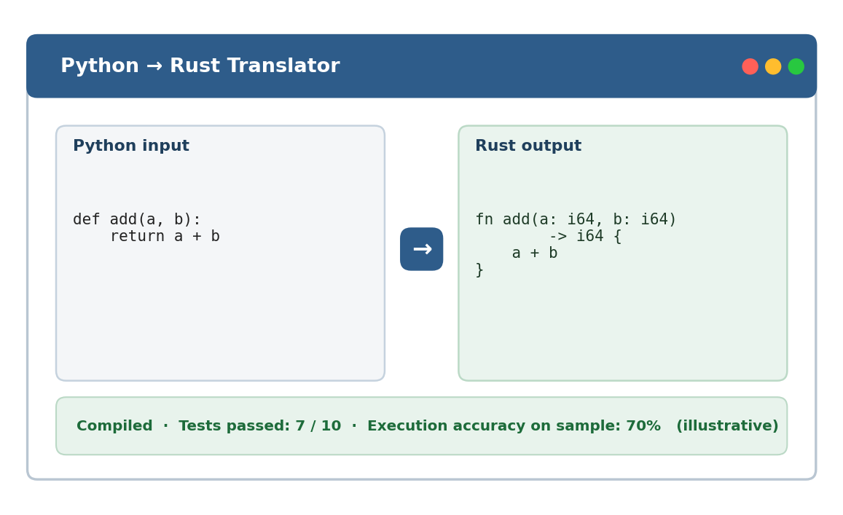
Figure 3. Deployment UI mockup — paste Python, get verified Rust.

13. Conclusion
This project takes a small, open code model that barely knows Rust and teaches it the language, using it to translate Python into Rust and to generate Rust from natural language. By judging every output through actual compilation and tests, improving the model with fine-tuning and RAG, and benchmarking against a large LLM, the project delivers a practical, privately-hostable code-translation system — and demonstrates, end-to-end, how a small model can be cheaply extended to a new programming language.

14. References
- Nijkamp, E., et al. (2023). CodeGen: An Open Large Language Model for Code with Multi-Turn Program Synthesis. ICLR. https://arxiv.org/abs/2203.13474
- Roziere, B., Lachaux, M.-A., Chanussot, L., & Lample, G. (2020). Unsupervised Translation of Programming Languages (TransCoder). NeurIPS. https://arxiv.org/abs/2006.03511
- Cassano, F., et al. (2023). MultiPL-E: A Scalable and Polyglot Approach to Benchmarking Neural Code Generation. IEEE TSE. https://arxiv.org/abs/2208.08227
- Cassano, F., et al. (2024). Knowledge Transfer from High-Resource to Low-Resource Programming Languages for Code LLMs (MultiPL-T). OOPSLA. https://arxiv.org/abs/2308.09895
- Yang, J., et al. (2025). Scaling Laws for Code: Every Programming Language Matters. arXiv:2512.13472. https://arxiv.org/abs/2512.13472
- Lewis, P., et al. (2020). Retrieval-Augmented Generation for Knowledge-Intensive NLP Tasks. NeurIPS. https://arxiv.org/abs/2005.11401
- Wang, X., et al. (2024). Searching for Best Practices in Retrieval-Augmented Generation. EMNLP. https://arxiv.org/abs/2407.01219
- Ren, S., et al. (2020). CodeBLEU: a Method for Automatic Evaluation of Code Synthesis. https://arxiv.org/abs/2009.10297
- Zhou, S., et al. (2023). CodeBERTScore: Evaluating Code Generation with Pretrained Models of Code. EMNLP. https://arxiv.org/abs/2302.05527
- Feng, Z., et al. (2020). CodeBERT: A Pre-Trained Model for Programming and Natural Languages. EMNLP Findings. https://arxiv.org/abs/2002.08155
- Salesforce codegen-350M-multi model card. https://huggingface.co/Salesforce/codegen-350M-multi

