
PG Certification Program in Artificial Intelligence and Machine Learning
Cohort 26
CodeGen
Capstone Project Group 30
Group Members
- Tushnik Chakrabarty
- Prakhar Nigam
- Lohitha Kilim
- Taran Tripathi

May 26, 2026
Project Supervisor: Prof. Anil Neelkanti
Project Mentors: Pawan Baswani,
Nayan Anand Jha

Problem Statement
Language models are increasingly used beyond natural language to understand and synthesize programming languages. This has multiple very important applications, including automating code generation and documentation, understanding and transforming large legacy codebases, making data querying and visualization interactive, etc. The goal is to apply existing models to solve various software-related tasks and further fine-tune an existing model to expand it to a new language that is not already supported by the model.

Literature Review

CodeBLEU
CodeBLEU: a Method for Automatic Evaluation of Code Synthesis (2009.10297v2)
BLEU (Bilingual Evaluation Understudy) measures n-gram similarity between ground truth and the generated text. For software programs this is a minimalist approach since a high similarity score does not guarantee that the generate program will execute. Additionally, the generated code may execute correctly but may use different variable names or function names than the ground truth. BLEU score doesn’t factor these nuances of software program. CodeBLEU is enhancement over BLEU where CodeBLUE is not just a measure of n-gram similarity but also:
- Give more weightage to the keywords of the programming language, instead of equal weightage of the corpus of words in natural language.
- Utilizes Abstract Syntax Tree (AST) where similarity of the software program generated with the ground truth based on the Abstract Syntax Tree (AST), where sub-trees are expected to be similar if the generated code is like the ground truth.
- Identifies data flow within the generated program and the ground truth program, and the data flow should be same, irrespective of what names the variable use. The data flow should be same.
CodeBLUE uses three major tasks for measuring the correctness of the program generated:
Task | Details | Data Set
Text-to-Code | Where code is generated from a natural language description of the function documentation and the programming context | Dataset released by  Iyer et al. (2018), which consists of 100k training samples,  2k validation samples and 2k test samples
Code Translation | Where code is generated for a target programming language from a different programming language. | Dataset crawled from several open-source projects and paired the methods in the two languages based on their file names and method names.  Duplicate removal, the total number of method pairs were 11.8k, split in 0.5k as the validation set and 1k pairs for test.
Code Refinement | Automatically Fix bugs in the code | Released by Tufano et al. (2019). The source is buggy Java functions while the target is the according fixed ones.  The dataset contains two subsets (i.e. small and medium) based on the code length. For the small dataset, the function numbers of training, development and test samples are 46,680, 5,835 and 5,835. For the medium dataset, the function numbers  are 52,364, 6,545 and 6,545 respectively.

Table 1 Tasks for CodeBLEU and the dataset
When measured, CodeBLEU gave better metrics for the three tasks against the human scores when compared against BLEU against human scores and accuracy against human scores.
The CodeBLUE measurement gives weightage of each of the four scores namely, BLEU, weighted BLUE, AST Match and Data Flow Match. Measurements indicate that using AST and data flow matches are more coreelated to human scores than BLEU and weighted BLEU scores. Measuring performance with different weights of each of the parameters, the CodeBLEU approach recommends giving higher (an equal) weightage to both AST match and data flow match and low weightage to BLEU and weighted BLUE scores.

CodeBERTScore
CodeBERTScore: Evaluating Code Generation with Pretrained Models of Code (2302.05527v2)
The CodeBERTScore is a measurement that ranks one or more implementations of a program given the natural language context of the intent where higher rank implies generated code is more preferably by human programmers.
CrystalBLEU extends BLEU by ignoring the 500 most occurring n-grams given that they are trivially shared between the prediction (generated code) and the reference (ground truth) BLEU and CrystalBLEU rely on the lexical exact match of tokens. CodeBLEU extends to include AST and data flow match to measure correctness of generated code. But all these fails in one aspect, that the same intent of the program can be written in multiple ways achieving the same outcome. All three measurement approaches fail here. For example, a for loop can be unrolled and achieve the same outcome.
CodeBERTScore encodes the generated code and the reference code independently with pretrained models, with the inclusion of natural language instructions or comments. Cosine similarity is then computed between the encoded representations of each token in the generated code and each token in the reference code. Finally, the best matching token vector pairs are used to compute precision and recall. CodeBERTScore allows comparing code pairs that are lexically different while considering:
- The programmatic- or natural-language-context, if provided.
- The contextual information of each token; and
- Implementation diversity.
CodeBERTScore, trained base model in self-supervised pre-training with Masked Language Modelling on Python, C++, Java and C. Each programming language had its own model.
Dataset used on the language subset of CodeParrot, filtered by keeping only files that having average length <100 and more than 25% alphanumeric characters. Even after 1,000,000 training steps, none of the models had completed one epoch, so every training sample was seen only once.
The experiments identified that:
- Higher layers encode semantic information for each token more accurately while the lower final layers are more task based
- Using a language specific model is more beneficial than using a generic model to generate program in any language
- Encoding the natural language instructions for generated code in the context increases the correlation with human preference and is a good measure.

CodeGen
CODEGEN: An Open Large Language Model for Code with Multi-Turn Program Synthesis (2203.13474v5)
Software program generation when performed using zero shot, or a single prompt. This relies on a descriptive prompt in natural language and the model’s ability to understand the intent correctly and then generate the program. Instead, if the program is broken down in multiple steps, where each step builds upon the previous step, the details and in the intent in the prompt are small and the generate code correct. The final program is then an assembly of all the previous prompts and their generated code.
The correctness of the generated code gets better as the model size and the data size scale-up.
The CodeGen models are trained sequentially on The Pile dataset for English corpus for the programming language data. This CodeGen-NL serves as the base for CodeGen-Multi where the CodeGen-NL is trained on Google’s BigQuery data set in multiple programming languages. The CodeGen-Multi is then trained on BigPython data set for programs written in python and called CodeGen-Mono.

Methodologies

Approach

Training

- Generate documentation for each C++ and Python program using a code-specialised LLM, and verify its fidelity by regenerating code from that documentation.
- Compute a baseline accuracy for the base codegen-350M-multi model on the NL → PL1 and PL1 → PL2 conversion tasks.
- Fine-tune codegen-350M-multi with LORA / PEFT in two phases: Phase 1 (NL → PL1) and Phase 2 (PL1 → PL2).
- Compare every generated program against its ground truth using AST similarity and GraphCodeBERTScore.
DataSet:
- Use the bigcode/the-stack-dedup dataset, filtered to C++ and Python records.
- Choose language: C++ / Python
The diagram below shows the steps to generate documentation for the programs (C++ and Python) and to ensure the fidelity of the documentation generated.
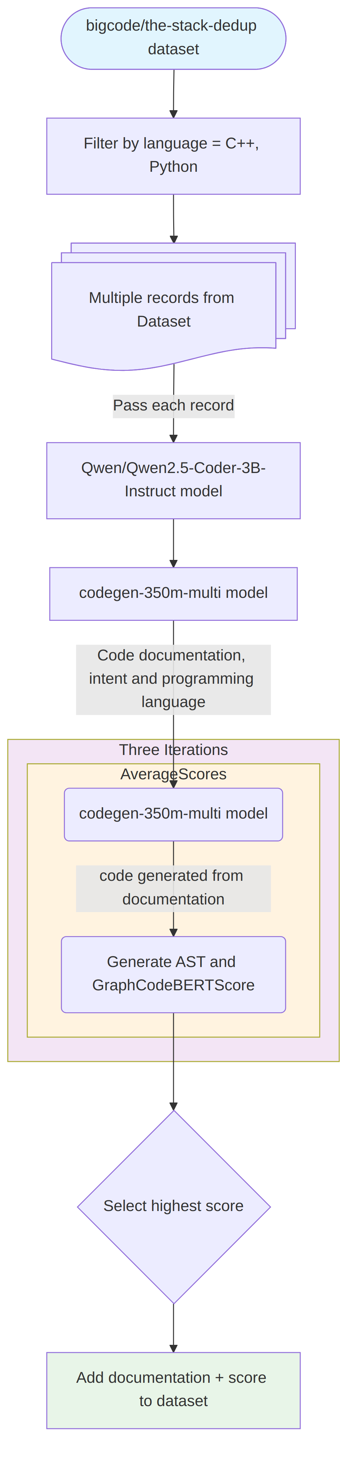
Figure 1 Document Generation Fidelity
The diagram below shows the baseline accuracy computation for the NL → PL1 and PL1 → PL2 conversions using the base model.
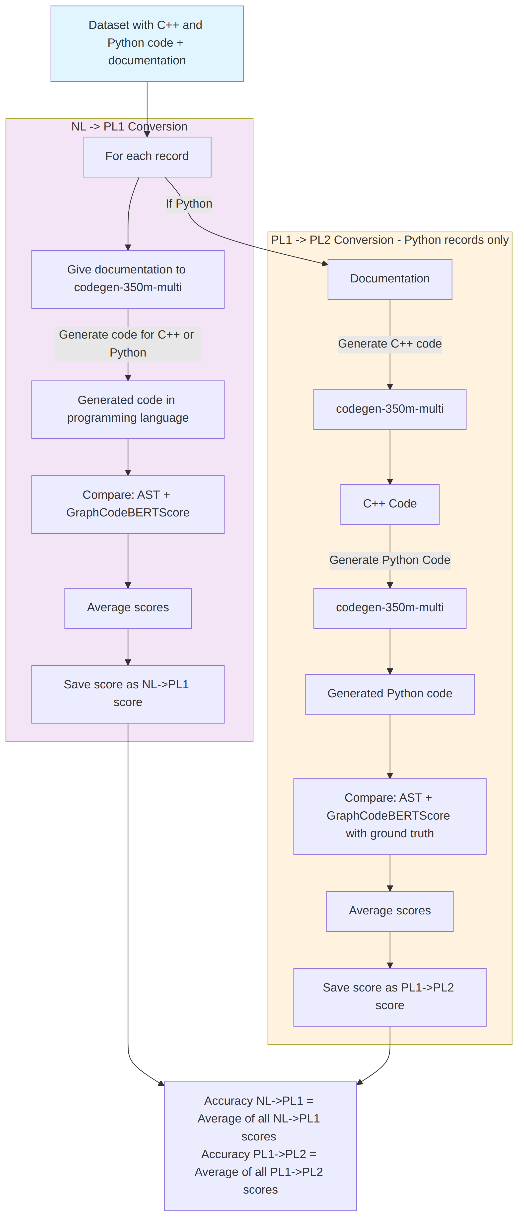
Figure 2 Baseline Accuracy Computation
Phase 1 performs LORA fine tuning of codegen-350M-multi to generate programs from C++ and Python documentation, where the documentation serves as the prompt to generate the code.
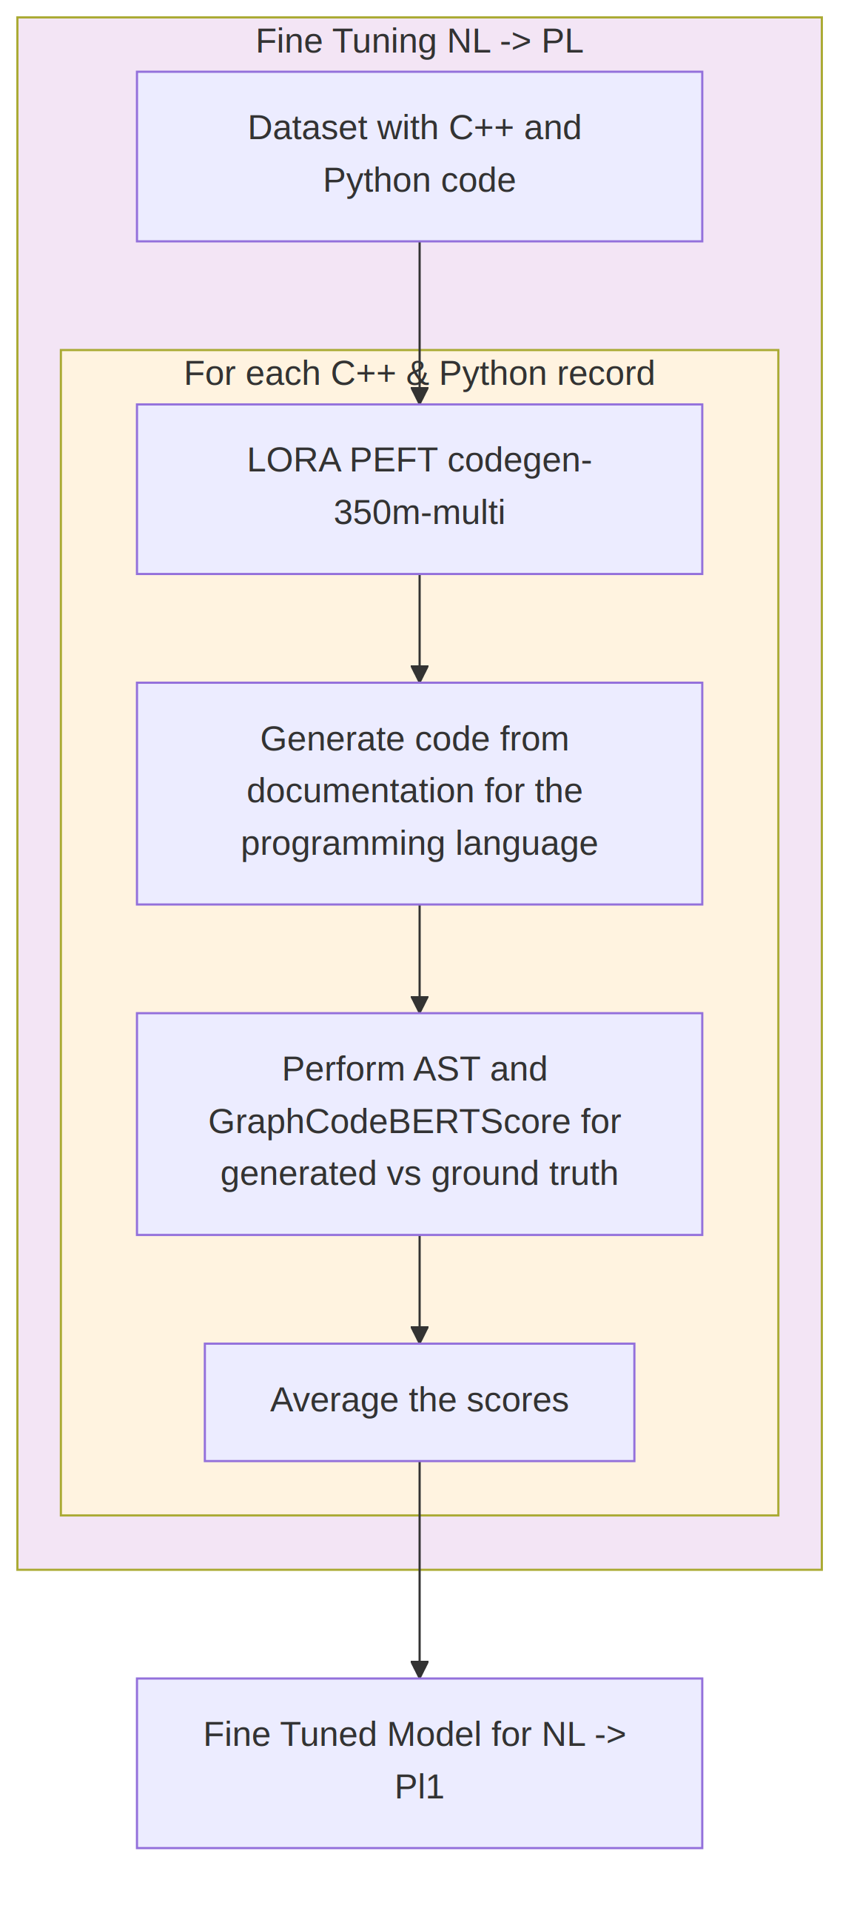
Figure 3 Phase 1: NL → PL1
In Phase 2, the documentation of a Python record is passed to the PEFT codegen-350M-multi to create a C++ program; the generated C++ code is then converted back to Python, and the generated Python program is compared with the ground truth using AST and GraphCodeBERTScore. This differs from Phase 1, where the generated output stayed in the same programming language as the source record.
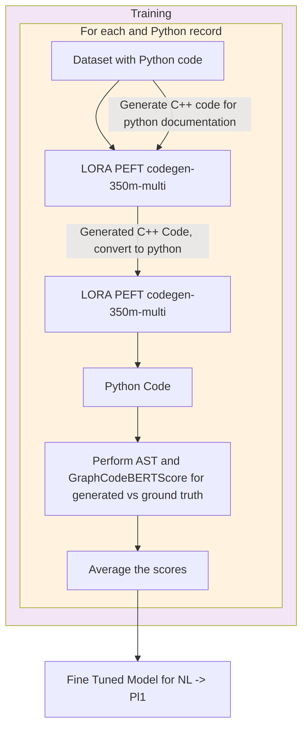
Figure 4 Phase 2: PL1 → PL2

Models Used
NL → PL (documentation → code): Salesforce/codegen-350M-multi, fine-tuned with LORA / PEFT (hugging face)
PL1 → PL2 (C++ → Python): Salesforce/codegen-350M-multi, fine-tuned with LORA / PEFT (hugging face)
Semantic code similarity (GraphCodeBERTScore): microsoft/graphcodebert-base (hugging face)
Documentation generation & LLM judge: Qwen/Qwen2.5-Coder-7B-Instruct (hugging face)
Abstract Syntax Tree generation & comparison: tree-sitter (C++ and Python grammars)
Speech-to-text for voice prompts (stretch): openai/whisper-base (hugging face)

Evaluation
The following evaluation criteria will be utilized:
- NL → PL1 (documentation → code) accuracy (A): average of AST similarity and GraphCodeBERTScore between the generated and the ground-truth code
- PL1 → PL2 (C++ → Python) accuracy (B): average of AST similarity and GraphCodeBERTScore between the generated Python and the ground-truth Python
- Documentation fidelity (C): code regenerated from the generated documentation is scored with AST similarity and GraphCodeBERTScore, retaining the best of three iterations
- Python execution accuracy (D): the generated Python is executed in a sandboxed runner to confirm it runs successfully
- where the execution accuracy is defined as $Accuracy=\frac{Number of correctly executing python code}{Total Number of program generated}$
The model accuracy for C++ to Python conversion will be calculated as:
Model Accuracy = $αA+βB+γC+δD$
The hyperparameters $α,β, γ and δ$ determine the weightage of each of the evaluation criterias on the accuracy. The evaluation of models for accuracy will vary these to identify the optimal hyperparameters.
Generated Python is executed for each record through a sandboxed runner that captures success or failure, so a pass/fail execution result can be determined across the dataset.

Dataset
For text to programming language use “bigcode/the-stack-dedup · Datasets at Hugging Face”. The CodeParrot is not accessible.
Use https://github.com/kunpai/codocbench/tree/main for code documentation to then extract intent and compare intents.
Design Patterns https://github.com/RefactoringGuru/design-patterns-cpp: Collection of pattern implementations organized by category. Will need some
CodeSearchNet: Contains C++ functions paired with documentation/comments, useful for instruction-to-code fine-tuning https://huggingface.co/datasets/code_search_net

Augmented for: Include Design Patterns, need sample data set, and pseudo code.

Stretch Task
The audio (ASR) stretch task has been implemented: a Gradio interface accepts a spoken prompt, transcribes it with openai/whisper-base, and feeds the transcription to the model for code generation. This enables multi-turn program synthesis from voice input, where a program is broken down into smaller tasks whose prompts are spoken and then stitched together into a larger program. Text-to-speech readout of the generated documentation remains a further extension.

Possible Outcomes in Stage

Applicability in real world
Most of the LLMs available can generate reasonable code from natural language text and from one common programming language to another. While correctness, completeness and coherency of the generated or converted program and execution efficiency may not be equivalent to human output and need a manual review, such conversions do not exist for not so common programming languages. Ada95 is a type-strict programming language used in aerospace, there is a lot of legacy code that needs to be maintained while the skill for the language is depleting fast.
If direct programming language to programming language conversion isn’t feasible yet, another path is generating intent/documentation for program in one language and then using that as text to generate program in another language.

References
[1] codegen-350M-multi: https://huggingface.co/Salesforce/codegen-350M-multi
[2] CoDocBench: https://github.com/kunpai/codocbench
[3] Spider: https://spider2-sql.github.io/
[4] BirdBench: https://bird-bench.github.io/
[5] CodeParrot: https://huggingface.co/datasets/codeparrot/github-code
[6] CodeBLEU: https://arxiv.org/abs/2009.10297
[7] CodeBERTScore: https://arxiv.org/abs/2302.05527
[8] Datasets: https://github.com/codefuse-ai/Awesome-Code-LLM#8-datasets

