

Project Title: Date: June 3, 2026

RepoCoderStudio: Repository-Aware AI Analytics and Development Assistant using Small Code Language Models
Group Number: 46
Team Details:
Name | Role | Contact | Email
Anil Nelakanti | Project Supervisor |  | anil.nelakanti@gmail.com
Nayan | Mentor | 8521779776 | nayananandjha@gmail.com
Pavan B | Mentor
Anupa Viswanath | Member | 9497220890 | anupa.viswanath@gmail.com
Mohan Krishna Mylavaram | Member | 9618555668 | mohankrishna.322@gmail.com
Praveen Kumar Chitikesi | Member | 9985704511 | chpraveen7@gmail.com
Mohan Kumar | Member | 9582084999 | mohan.wing@outlook.com

Table Of Contents
1. Introduction 2
2. Literature Review 2
2.1. Models 2
2.2 Datasets 3
2.3. Tools 3
2.4. Metrics 4
3. Proposed Approach 4
3.1. Phase 1: Baseline (Foundations) 4
3.1.1. Stage 1: Code Understanding & Documentation 4
3.1.2. Stage 2: NL→Python 5
3.1.3. Stage 3: Python→Java 5
3.2. Phase 2: Improvements (Integration & Contextual Accuracy) 6
3.2.1. Stage 4: Repository Awareness 6
3.2.2. Stage 5: Retrieval-Augmented Generation (RAG) 6
3.3. Phase 2: Generalizability (Workflow Orchestration) 7
3.3.1. Stage 6: Agentic Coding Assistant 7
4. Applicability 7
5. Challenges 8
6. Project Timeline 9
7.VisualRoadmap 10
8. References 11

1. Introduction
Modern software engineering faces challenges such as maintaining large codebases, migrating legacy systems, and enabling non-technical users to interact with data and applications. Developers spend significant time writing documentation, translating code between languages, and navigating repositories.
RepoCoder Studio addresses these problems by building a repository-aware AI assistant that can:
- Automate documentation and commit messages.
- Generate executable code from natural language.
- Translate code between programming languages for interoperability.
- Understand repository structures for efficient navigation.
- Improve accuracy with retrieval-augmented generation (RAG).
- Orchestrate multi-step workflows through agentic assistants.

Real-world problem solved: This project reduces developer effort, accelerates prototyping, and supports enterprise modernization by combining lightweight models with repository awareness and retrieval augmentation.

2. Literature Review

2.1. Models
- CodeGen-350M-Multi (Salesforce, 2022): A transformer-based small language model trained on GitHub code. It is lightweight and reproducible on modest hardware, making it ideal as a baseline for documentation and synthesis tasks. Its smaller size allows experimentation without requiring extensive compute resources.
- Qwen2.5-Coder (Alibaba, 2024): Optimized for multi-language programming tasks. It demonstrates strong performance on HumanEval and MBPP benchmarks, making it suitable for natural language to Python generation and Python to Java translation. Its design emphasizes efficiency and correctness across multiple programming languages.
- DeepSeek-Coder (2024): A repository-aware model designed for contextual integration. It is particularly effective for tasks involving repository indexing, dependency tracing, and retrieval. Its architecture emphasizes efficiency, making it suitable for large-scale repository tasks.
- CodeParrot (HuggingFace, 2021): Pretrained on large-scale GitHub code, providing broad coverage for synthesis and completion tasks. While not the primary model, it serves as a useful benchmark for evaluating synthesis performance.

2.2 Datasets
- CoDocBench (Kunpai et al., 2023): A benchmark for code-to-documentation tasks across multiple languages. Provides docstring and summary pairs, enabling evaluation of documentation generation quality.
- CodeSearchNet (Husain et al., 2019): Aligns code with natural language descriptions, enabling semantic retrieval and evaluation. Useful for measuring how well generated documentation matches human-written descriptions.
- HumanEval (Chen et al., 2021): Contains Python programming problems with ground-truth solutions. Widely used for evaluating synthesis accuracy.
- MBPP (Austin et al., 2021): A multi-task Python benchmark covering diverse programming problems, including algorithms and utility functions.
- EvalPlus (2023): Extension of HumanEval with fine-grained correctness checks, ensuring evaluation beyond syntactic similarity.
- XLCoST (2022): A multilingual code translation dataset, including aligned Python→Java pairs. Provides high-quality bilingual examples for translation tasks.
- CodeNet (2021): Large-scale dataset with millions of code samples across multiple languages. Provides diversity and scale for translation tasks.
- TransCoder (2020): Focused on idiomatic translation between programming languages. Ensures that translations are not only syntactically correct but also idiomatic.
- RepoBench (2024): Repository-level dataset for evaluating code reuse, dependency awareness, and navigation.
- SWE-Bench Lite (2024): Benchmark for software engineering tasks requiring repository-level retrieval, including bug fixing and dependency tracing.

2.3. Tools
- FAISS (Johnson et al., 2017): Vector similarity search library, widely used for dense retrieval in RAG pipelines. Enables efficient retrieval of relevant code snippets.
- Tree-Sitter (2018): Parser framework enabling AST-based indexing. Critical for structural retrieval and dependency tracking.
- LangGraph (2024): Framework for agentic orchestration. Supports multi-agent workflows including planning, retrieval, generation, and validation.

2.4. Metrics
- CodeBLEU (Ren et al., 2020): Extends BLEU with code-specific features such as syntax and data flow. Measures similarity between generated and reference code.
- CodeBERTScore (Zhang et al., 2023): Embedding-based evaluation for semantic similarity in code generation. Captures deeper semantic alignment than surface-level metrics.
- ROUGE-L: Measures overlap between generated and reference summaries. Useful for documentation tasks.
- Pass@k: Probability that at least one of k generated solutions is correct. Widely used for synthesis evaluation.
- Execution Accuracy: Measures whether generated programs run correctly. Complements similarity metrics by testing functional correctness.
- Compilation Success: Ensures that translated code compiles successfully. Critical for translation tasks.
- AST Similarity: Measures structural equivalence between generated and reference code. Useful for translation and repository tasks.
- Retrieval Precision/Recall: Precision measures the proportion of retrieved items that are relevant; recall measures the proportion of relevant items retrieved.
- MRR@k (Mean Reciprocal Rank): Evaluates ranking quality of retrieval results.
- Task Success Rate, Workflow Success Rate, End-to-End Accuracy: Metrics for agentic orchestration, measuring correctness and usability of multi-step workflows.

3. Proposed Approach

3.1. Phase 1: Baseline (Foundations)

3.1.1. Stage 1: Code Understanding & Documentation
- Use: Automates docstrings, commit messages, summaries → improves maintainability.
- Model:
  - CodeGen-350M-Multi.
- Datasets:
  - CoDocBench → multi-language code-doc pairs.
  - CodeSearchNet → code-text alignment for semantic evaluation.
- Metrics:
  - CodeBLEU → syntax and data-flow aware similarity.
  - CodeBERTScore → embedding-based semantic similarity.
  - ROUGE-L → overlap with reference summaries.
  - Expanded explanation: These metrics ensure generated documentation is not only fluent but also semantically aligned with code functionality.

3.1.2. Stage 2: NL→Python
- Use: Converts natural language into executable Python code → supports prototyping and education.
- Model:
  - Qwen2.5-Coder,
  - DeepSeek-Coder (comparison).
- Datasets:
  - HumanEval → algorithmic problems with ground-truth solutions.
  - MBPP → diverse Python tasks.
  - EvalPlus → fine-grained correctness checks.
- Metrics:
  - Pass@k → probability of correct solution within k attempts.
  - Execution Accuracy → correctness when executed in sandbox.
  - CodeBLEU → structural similarity to ground-truth.
  - Expanded explanation: These metrics balance syntactic correctness (CodeBLEU) with functional correctness (execution accuracy).

3.1.3. Stage 3: Python→Java
- Use: Translates Python code to Java → enables enterprise migration.
- Model:
  - Qwen2.5-Coder
  - CodeGen
  - DeepSeek-Coder
- Datasets:
  - XLCoST → aligned Python–Java pairs.
  - CodeNet → large-scale multilingual dataset.
  - TransCoder → idiomatic translation dataset.
- Metrics:
  - Compilation Success → ensures generated Java compiles.
  - Execution Correctness → correctness when executed.
  - AST Similarity → structural equivalence of code.
  - CodeBLEU → translation quality.
  - Expanded explanation: These metrics ensure translations are not only syntactically valid but also semantically equivalent and idiomatic.

3.2. Phase 2: Improvements (Integration & Contextual Accuracy)
Phase 1 tasks feed into Phase 2:
Documentation (Stage 1) → retrieval corpus.
NL→Python outputs (Stage 2) → indexed functions.
Python→Java translations (Stage 3) → bilingual pairs for retrieval.

3.2.1. Stage 4: Repository Awareness
- Use: Builds structural understanding of repositories → enables dependency tracing and navigation.
- Model:
- DeepSeek-Coder
- Tree-Sitter AST parsing.
- Datasets:
- RepoBench → repository-level tasks.
- SWE-Bench Lite → bug-fixing and dependency tracing.
- Metrics:
- Retrieval Precision → proportion of relevant items retrieved.
- Retrieval Recall → proportion of all relevant items retrieved.
- MRR@k → mean reciprocal rank of correct retrievals.
- File/Function Identification Accuracy → correctness of locating repo components.
- Expanded explanation: These metrics measure how well the assistant navigates and understands repository structures.

3.2.2. Stage 5: Retrieval-Augmented Generation (RAG)
    - Use: Improves generation/translation by grounding outputs in retrieved examples → reduces hallucinations.
    - Models:
      - Qwen2.5-Coder
      - FAISS
      - bge-reranker.
    - Datasets:
      - HumanEval/MBPP solutions → retrieval corpus for NL→Python.
      - XLCoST/CodeNet bilingual pairs → retrieval corpus for Python→Java.
      - Repository files + AST chunks → contextual retrieval.
    - Metrics:
      - Retrieval Precision → relevance of retrieved examples
      - Pass@k Improvement → gain in correctness compared to baseline
      - Execution Accuracy → correctness of augmented outputs
      - CodeBLEU/AST Similarity Gains → improvement in translation quality.
      - Expanded explanation: These metrics show how retrieval improves both correctness and semantic alignment compared to baseline LM-only outputs.

3.3. Phase 2: Generalizability (Workflow Orchestration)
Phase 2 outputs are orchestrated into real workflows:
Repository awareness provides the structural map.
RAG supplies relevant examples.
Phase 1 tasks (docs, NL→Python, Python→Java) become building blocks for multi-agent workflows.

3.3.1. Stage 6: Agentic Coding Assistant
    - Use: Multi-agent orchestration for bug fixing, feature integration, and multi-step development tasks.
    - Framework: LangGraph agents (Planner, Retriever, Generator, Validator).
    - Datasets: SWE-Bench Lite + integrated datasets.
    - Metrics:
      - Task Success Rate → proportion of tasks completed correctly.
      - Workflow Success Rate → proportion of multi-step workflows completed.
      - End-to-End Accuracy → correctness of final outputs.
      - User Satisfaction → qualitative evaluation of usability. Expanded explanation: These metrics ensure the assistant is not only technically correct but also practically useful in real-world workflows.

4. Applicability
Enterprise Development: Documentation automation, repository navigation.
Legacy Modernization: Python→Java translation for enterprise migration.
Hackathon/Exam Readiness: Rapid prototyping pipelines.
Education: NL→Python for teaching programming concepts.

5. Challenges
1. Execution Environment Complexity
- Issue: Running Python and Java code requires sandboxing and containerization.
- Mitigation: Use Docker-based environments to isolate execution and ensure reproducibility.
2. Hallucination in Code Generation
- Issue: Models may invent APIs, functions, or schema elements that do not exist.
- Mitigation: Apply static validation (AST checks, schema validation) and retrieval grounding via RAG.
3. Dataset Coverage Limitations
- Issue: Benchmarks like HumanEval and MBPP may not cover enterprise-scale tasks.
- Mitigation: Augment with large-scale datasets (CodeNet, RepoBench) and synthetic data generation.
4. Translation Quality (Python→Java)
- Issue: Translations may compile but fail to capture idiomatic Java practices.
- Mitigation: Use TransCoder dataset for idiomatic mapping and evaluate with AST similarity + human review.
5. Repository Complexity
- Issue: Large repositories with deep dependency chains may overwhelm retrieval.
- Mitigation: Use Tree-Sitter for AST indexing and FAISS for efficient retrieval, combined with reranking.
6. Multi-Agent Error Propagation
- Issue: In agentic orchestration, errors from one agent can cascade.
- Mitigation: Introduce Validator agent to check outputs at each stage before passing them forward.
7. Resource Constraints
- Issue: Training/fine-tuning even small models can hit memory limits.
- Mitigation: Use gradient accumulation, parameter-efficient fine-tuning (LoRA), and cloud-based compute when needed.

6. Project Timeline
Week | Milestone | Deliverable
1–2 | Documentation Generation | Docstrings, commit messages (CoDocBench, CodeSearchNet)
3–4 | NL→Python | Executable code generation (HumanEval, MBPP, EvalPlus)
5–6 | Python→Java | Translation pipeline (XLCoST, CodeNet, TransCoder)
7–8 | Repository Awareness | AST indexing, dependency tracing (RepoBench, SWE-Bench Lite)
9 | RAG Integration | Retrieval-augmented NL→Python & Python→Java (FAISS, embeddings)
10 | Agentic Orchestration | Multi-agent workflow prototype (LangGraph)
11 | Final Deployment | End-to-end RepoCoder Studio

7.VisualRoadmap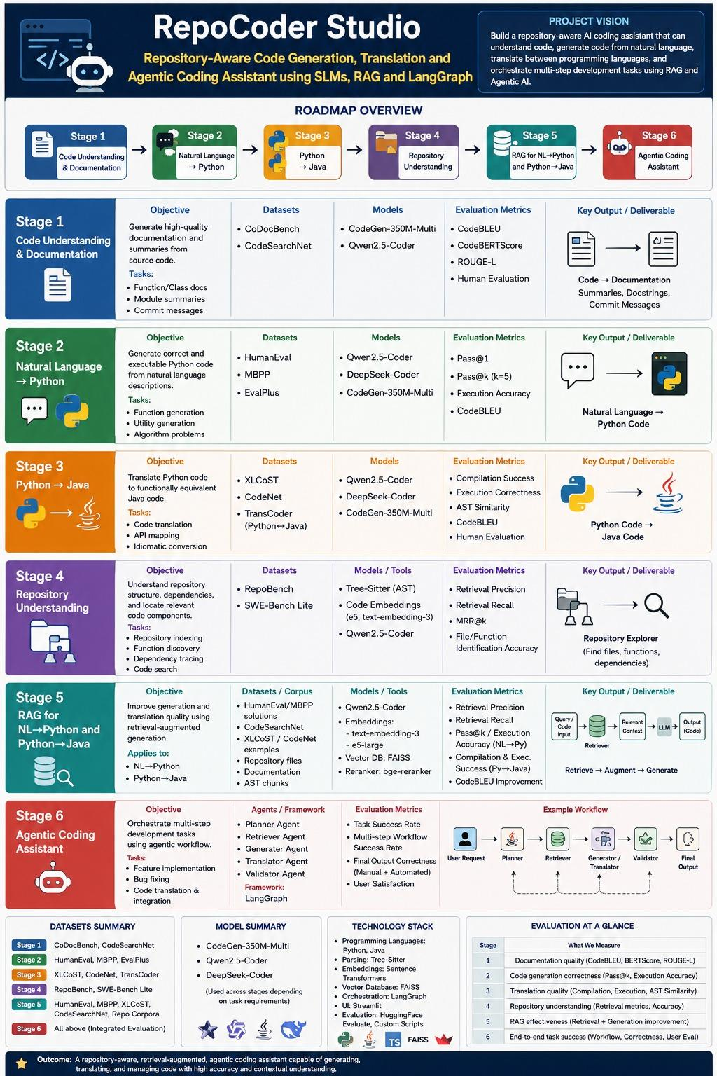

8. References

- Austin, J., et al. (2021). Program synthesis with large language models.
- Chen, M., et al. (2021). Evaluating large language models trained on code.
- Husain, H., et al. (2019). CodeSearchNet challenge: Evaluating semantic search on code.
- Johnson, J., et al. (2017). Billion-scale similarity search with GPUs.
- Kunpai, L., et al. (2023). CoDocBench: Benchmarking code documentation generation.
- Ren, S., et al. (2020). CodeBLEU: A metric for code generation.
- Zhang, Y., et al. (2023). CodeBERTScore: Evaluating code generation with embeddings.
- XLCoST (2022). Cross-lingual code translation dataset.
- CodeNet (2021). A large-scale dataset for code classification and translation.
- TransCoder (2020). Unsupervised translation of programming languages.
- RepoBench (2024). Benchmarking repository-level tasks.
- SWE-Bench Lite (2024). Software engineering benchmark for bug fixing.

