

AIML B25 - PGCP

CodeGen
Group -18

S. Kousik - 2500496

Utkarsh Sinha - 2420470

Ramesh Narella - 2500497

Kalyani Ankasala - 2500595

Project Mentor: Nayan Anand
Project Supervisor: Anil Nelakanti
November 15, 2025
Contents
1. Introduction 5
2. Text-to-SQL Generation using Graph-RAG (Task 1) 5
3. SQL (PostgreSQL) to MongoDB Query Migration (Task 2) 6
4. Graph RAG Architecture 8
5. Challenges 9
✔ Schema generalization and large graph management. 9
✔ Ensuring functional equivalence during migration. 9
✔ Managing LLM hallucination and prompt length constraints. 9
✔ Handling nested/normally denormalized data mappings. 9
✔ Performance optimization in Mongo db pipelines. 9
6. Project Timelines 9
7. References 10
✔ Large Language Model Enhanced Text-to-SQL Generation: A Survey 10
✔ A Survey on Employing Large Language Models for Text-to-SQL Tasks 10
✔ Text-to-SQL: A methodical review of challenges and models 10
✔ From Natural Language to SQL: Review of LLM-based Text-to-SQL Systems 10
✔ Retrieval‑Augmented Generation with Graphs (GraphRAG) 10
✔ Graph Retrieval‑Augmented Generation: A Survey — Peng et al., 2024 10
✔ Document Graph RAG: Knowledge Graph Enhanced Retrieval‑Augmented Generation — Knollmeyer et al., 2025 10

Introduction
CodeGen is an AI-driven code generation and query translation system designed to bridge the gap between natural language, relational databases, and NoSQL systems. The project focuses on enabling non-technical users to interact with complex data systems using plain English, while ensuring accuracy, scalability, and explainability.
The system leverages Graph-based Retrieval Augmented Generation (GraphRAG) to incorporate structured schema knowledge into large language model (LLM) reasoning. CodeGen supports two core pipelines:

1. Text-to-SQL Generation – converting natural language queries into valid SQL queries.
2. SQL-to-NoSQL Translation – migrating SQL queries into semantically equivalent NoSQL (MongoDB) queries.

GraphRAG Architecture

Paper Title: In-depth Analysis of Graph-based RAG in a Unified Framework
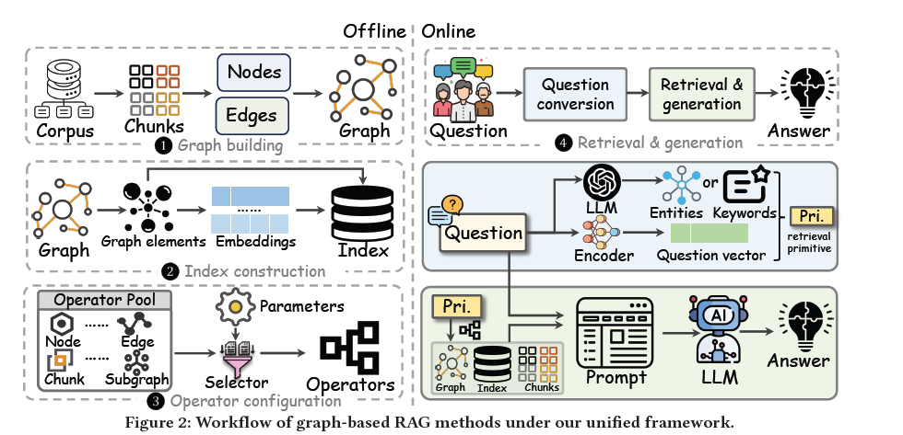

Text-to-SQL Generation using Graph-RAG (Task 1)

Build a model that converts natural language (text) queries into accurate SQL queries using a Graph-based Retrieval-Augmented Generation (Graph-RAG) architecture. This enables non-technical users to access relational databases through conversational interfaces.

Literature Review

Seq2SQL (Zhong et al., 2017): Introduced a reinforcement learning approach for translating NL to SQL.

RAT-SQL (Wang et al., 2020): Used relation-aware self-attention for schema understanding.

PICARD (Scholak et al., 2021): Added grammar-constrained decoding to ensure SQL syntactic validity.

Graph RAG (2023–2024): Leveraged knowledge graphs and schema-aware retrieval to improve accuracy in multi-table query generation

Proposed Approach

Schema Graph Construction

Extract table, column, and foreign key relationships from PostgreSQL to build a schema graph using NetworkX or Neo4j.

Graph Embedding and Retrieval

Convert schema subgraphs into textual summaries, embed them using Sentence Transformers, and store them in a vector database (FAISS/pgvector).

Prompt Augmentation

At query time, retrieve relevant schema subgraphs and examples to enrich LLM prompts.

SQL Generation using LLM

Use an open-source LLM (e.g., Flan-T5, CodeLLaMA) to generate SQL queries based on the retrieved schema context.

Execution and Feedback

Execute generated SQL queries on a test database, validate correctness, and refine generation using execution feedback.

Evaluation Metrics

Metric | Description
Exact Match (EM) | Percentage of generated SQLs matching ground truth
Execution Accuracy (EX) | Percentage of queries returning correct results
Component Match (CM) | Clause-level structural accuracy
Efficiency Score (ES) | Checks for redundant or inefficient SQL generation

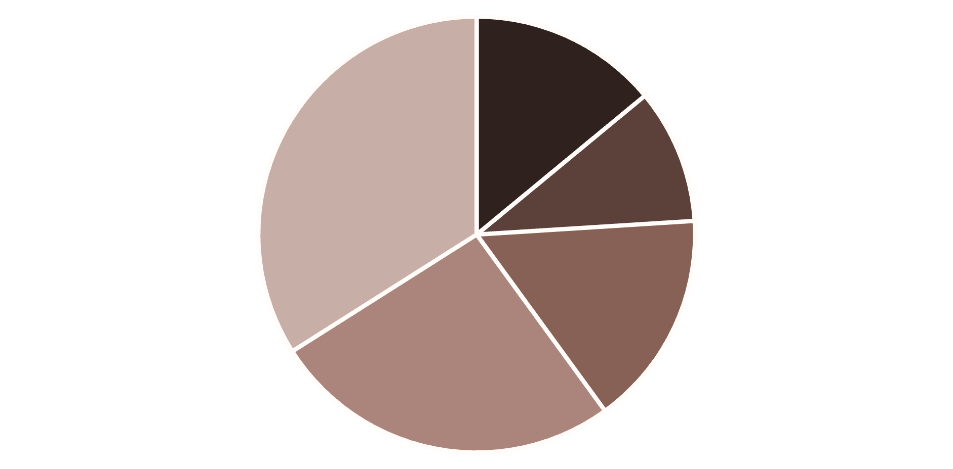
50
Total Queries
62.33%
Average Similarity Score
83.80%
Average Component Accuracy
24.0%
Acceptable Accuracy (Exact + Semantic)
ACCURACY DISTRIBUTION
EXACT_MATCH (14.0%)
SEMANTICALLY_EQUIVALENT (10...
MINOR_DIFFERENCES (16.0%)
MAJOR_DIFFERENCES (26.0%)

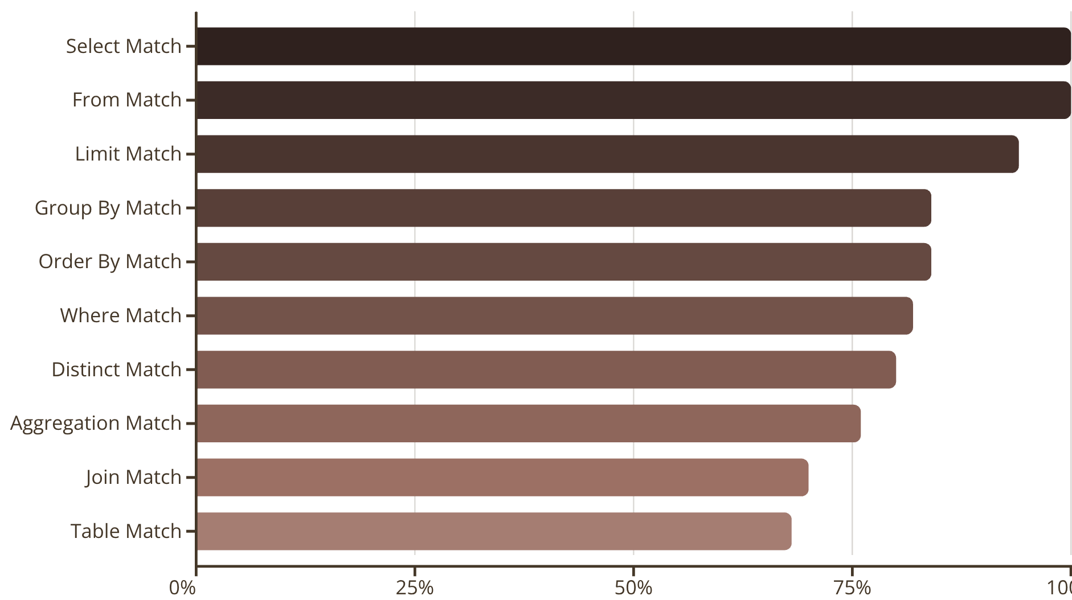

Tools and Technologies

Graph Database: Neo4j / NetworkX

Vector Index: FAISS / pgvector

LLMs: Flan-T5, CodeLLaMA, T5-Base

Database: PostgreSQL

Deployment: FastAPI / Streamlit

Real-World Applicability

Business Intelligence: Conversational analytics for SQL databases.

Education: SQL tutoring and query generation for students.

Customer Support: Database-driven chatbots for customer data retrieval.

SQL to NoSQL Translation (Task 2)
Develop a system that translates PostgreSQL queries into equivalent MongoDB queries, enabling seamless migration from relational databases to NoSQL systems.

Literature Review

Rel2Doc (Garbin et al., 2024): Automates migration of normalized relational schemas to MongoDB documents.

A Spark-Based SQL-to-NoSQL Converter (Abdel-Fattah et al., 2022): Uses distributed computing to transform RDBMS data into NoSQL structures.

Hybrid IR-based Translators (2021–2023): Convert SQL ASTs into intermediate representations, then map to NoSQL pipelines.

LLM-Aided Query Conversion (2024): Leverages LLMs for flexible SQL→Mongo pipeline translation with schema alignment

Proposed Approach

Schema Mapping and Graph Integration

Extend the Graph-RAG schema graph with mapping metadata (table→collection, column→field, FK→embedded/lookup).

SQL Parsing and AST Extraction

Parse PostgreSQL queries using sqlglot or moz_sql_parser into abstract syntax trees (ASTs).

Graph-Aided Translation

Use the schema graph and metadata to determine translation strategies — whether to use $lookup or denormalized embedding.

MongoDB Query Generation

Transform the SQL AST into MongoDB aggregation pipelines or CRUD operations using rule-based templates.

Validation and Testing

Execute both SQL and generated Mongo queries on sandboxed datasets; compare results for functional equivalence.

Evaluation Metrics

Metric | Description
Functional Equivalence Rate (FER) | % of queries returning identical results
Translation Coverage | % of supported SQL constructs correctly translated
Execution Time Ratio (ETR) | Mongo vs Postgres performance ratio
Error Rate | % of queries requiring manual or LLM-assisted correction
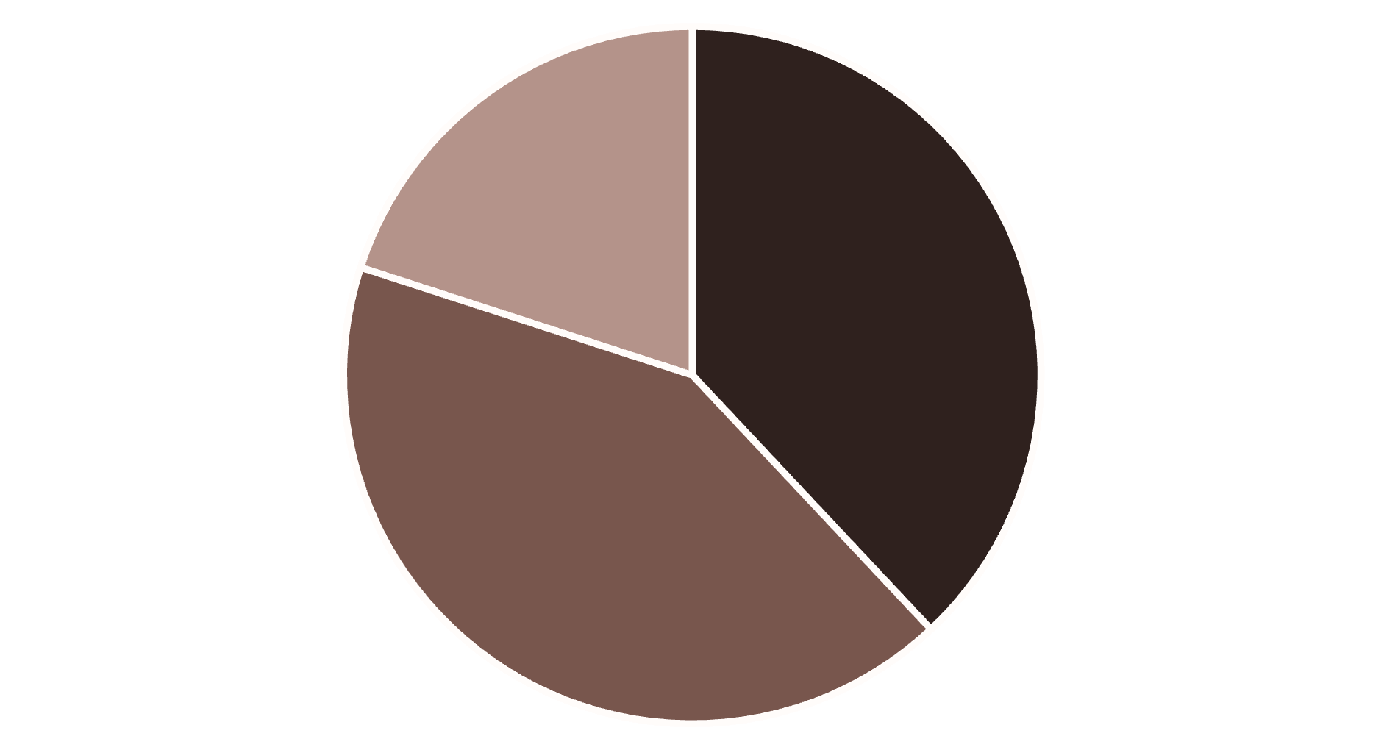
KEY METRICS
50
Total Queries
CORRECT (38.0%)
MOSTLY_CORRECT (42.0%)

80.0%
38.0%
90.44%

Acceptable Rate
Correct Rate
Average Validation Score

sssss

MINOR_ISSUES (20.0%)

Tools and Technologies

SQL Parser: sqlglot / ANTLR

Graph Database: Neo4j (schema + migration metadata)

NoSQL DB: MongoDB

LLM Support: CodeLLaMA or GPT for complex query translation

Validation: psycopg2 (Postgres), pymongo (Mongo)

Real-World Applicability

Enterprise Migration: Automate relational database into NoSQL query and data migration.

Hybrid Data Systems: Run SQL queries on NoSQL stores through translation.

Cloud Modernization: Assist cloud vendors and enterprises in adopting scalable data architectures.

Challenges

Schema generalization and large graph management.

Ensuring functional equivalence during migration.

Managing LLM hallucination and prompt length constraints.

Handling nested/normally denormalized data mappings.

Performance optimization in Mongo db pipelines.

Project Timelines

Phase | Duration | Task
Phase 1 | Week 1–2 | Data collection, schema extraction, graph construction
Phase 2 | Week 3–4 | Graph-RAG implementation, SQL generation module
Phase 3 | Week 5–6 | Evaluation, fine-tuning, validation
Phase 4 | Week 7–8 | SQL→Mongo translator implementation
Phase 5 | Week 9–10 | Testing, integration, final report & deployment

References

Large Language Model Enhanced Text-to-SQL Generation: A Survey

A Survey on Employing Large Language Models for Text-to-SQL Tasks

Text-to-SQL: A methodical review of challenges and models

From Natural Language to SQL: Review of LLM-based Text-to-SQL Systems

Retrieval‑Augmented Generation with Graphs (GraphRAG)

Graph Retrieval‑Augmented Generation: A Survey — Peng et al., 2024

Document Graph RAG: Knowledge Graph Enhanced Retrieval‑Augmented Generation — Knollmeyer et al., 2025
- Text to SQL literature review by team members
- Graph Rag Git Hub Repo

