Journal-Ready Experimental Design

Federated Ensemble XGBoost for Patient Readmission Prediction

1️. Core Experimental Hypotheses (State These Explicitly)
Your experiments must answer clear research questions:
H1: Federated ensemble XGBoost achieves performance comparable to centralized XGBoost while preserving data locality.
H2: Federated ensemble learning outperforms isolated local models under heterogeneous hospital data distributions.
H3: Explainability (SHAP) remains consistent across local and federated models, enabling clinical interpretability.
H4: The federated framework reduces privacy risk without significant degradation in predictive performance.

3️. Model Architecture & Training (METHODS SECTION)

A. Local Model Training
Each hospital:
- Trains an independent XGBoost multi-class classifier
- Identical hyperparameters
- No data sharing
Hyperparameters:
n_estimators = [150, 250]
max_depth = [6, 8, 10]
learning_rate = [0.05, 0.1]
subsample = [0.8, 1.0]
colsample_bytree = [0.8, 1.0]
objective = multi:softprob
Fix seeds for reproducibility.

B. Federated Ensemble Construction (CORE CONTRIBUTION)
At server:
- Collect class-probability outputs from each local model
- Aggregate using:

Aggregation Strategies: Performance-weighted ensemble (best model weighted higher)

4. Experiment Set

Hypothesis–Experiment–Figure Mapping
Hypothesis | Experiment | Tables | Figures
H1 | Centralized vs Local vs Federated | T1 | F1, F2
H2 | Non-IID Robustness | T2 | F3
H3 | Explainability Consistency | T3 | F4
H4 | Privacy & Communication | T4 | F5

EXPERIMENT 1

Centralized vs Local vs Federated Performance

(Addresses H1)

Objective
Show that the Federated Ensemble XGBoost achieves performance comparable to centralized training and better than local-only models.
Train and evaluate three model types:

- Centralized XGBoost
- Training Accuracy (Diabetic_data): 79.74%
- Testing Accuracy (Diabetic_data): 53.76%
- Micro F1-score: 0.5376
- Macro F1-score: 0.4437
- Weighted F1-score: 0.5396
- AUC–ROC (Macro, OvR): 0.6512
Classification report
Class | Precision | Recall | F1-score | Support
0 | 0.66 | 0.65 | 0.66 | 16,459
1 | 0.46 | 0.46 | 0.46 | 10,664
2 | 0.20 | 0.22 | 0.21 | 3,407
Accuracy | — | — | 0.54 | 30,530
Macro Avg | 0.44 | 0.44 | 0.44 | 30,530
Weighted Avg | 0.54 | 0.54 | 0.54 | 30,530

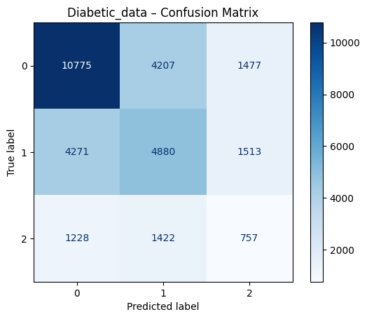
- Local XGBoost Models
  - Train separately on Hospital A, B, and C
Hospital | Training Acc | Testing Acc | Micro F1 | Macro F1 | Weighted F1 | AUC–ROC
A | 94.32% | 73.66% | 0.7366 | 0.6946 | 0.7356 | 0.8395
B | 94.31% | 73.43% | 0.7343 | 0.6928 | 0.7333 | 0.8425
C | 94.76% | 74.10% | 0.7410 | 0.7011 | 0.7401 | 0.8464

Hospital A
- Training Accuracy (hospital_A): 94.32%
- Testing Accuracy (hospital_A): 73.66%
- Micro F1-score: 0.7366
- Macro F1-score: 0.6946
- Weighted F1-score: 0.7356
- AUC–ROC (Macro, OvR): 0.8395
Classification report
Class | Precision | Recall | F1-score | Support
0 | 0.79 | 0.80 | 0.80 | 16,506
1 | 0.68 | 0.69 | 0.68 | 10,643
2 | 0.65 | 0.57 | 0.60 | 3,381
Accuracy | — | — | 0.74 | 30,530
Macro Avg | 0.70 | 0.69 | 0.69 | 30,530
Weighted Avg | 0.74 | 0.74 | 0.74 | 30,530
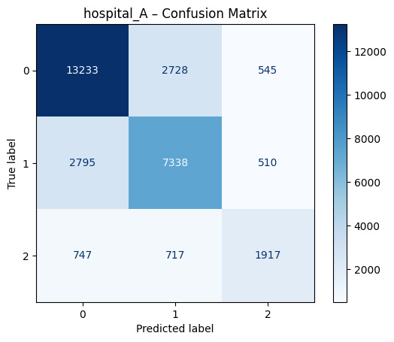
Hospital B
- Training Accuracy (hospital_B): 94.31%
- Testing Accuracy (hospital_B): 73.43%
- Micro F1-score: 0.7343
- Macro F1-score: 0.6928
- Weighted F1-score: 0.7333
- AUC–ROC (Macro, OvR): 0.8425
Classification report
Class | Precision | Recall | F1-score | Support
0 | 0.79 | 0.80 | 0.79 | 16,451
1 | 0.68 | 0.69 | 0.68 | 10,607
2 | 0.65 | 0.56 | 0.60 | 3,472
Accuracy | — | — | 0.73 | 30,530
Macro Avg | 0.70 | 0.68 | 0.69 | 30,530
Weighted Avg | 0.73 | 0.73 | 0.73 | 30,530
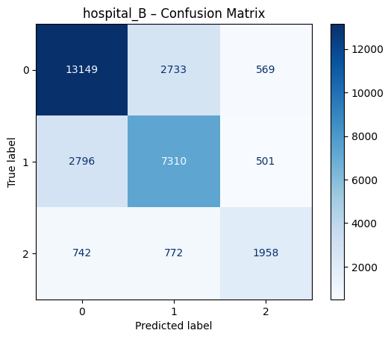

Hospital C
- Training Accuracy (hospital_C): 94.76%
- Testing Accuracy (hospital_C): 74.10%
- Micro F1-score: 0.7410
- Macro F1-score: 0.7011
- Weighted F1-score: 0.7401
- AUC–ROC (Macro, OvR): 0.8464
Classification report
Class | Precision | Recall | F1-score | Support
0 | 0.79 | 0.80 | 0.80 | 16,522
1 | 0.68 | 0.70 | 0.69 | 10,617
2 | 0.67 | 0.57 | 0.62 | 3,391
Accuracy | — | — | 0.74 | 30,530
Macro Avg | 0.71 | 0.69 | 0.70 | 30,530
Weighted Avg | 0.74 | 0.74 | 0.74 | 30,530
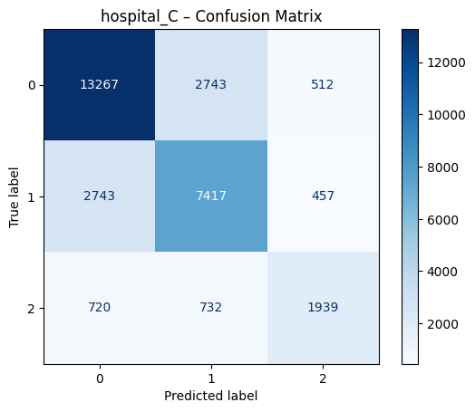
- Federated Ensemble XGBoost model
- GLOBAL FEDERATED MODEL RESULTS
- Testing Accuracy: 71.03%
- Micro F1-score: 0.7103
- Macro F1-score: 0.6525
- Weighted F1-score: 0.7063
- AUC–ROC (Macro, OvR): 0.8761
Classification report
Class | Precision | Recall | F1-score | Support
0 | 0.79 | 0.74 | 0.76 | 55,020
1 | 0.60 | 0.78 | 0.68 | 35,475
2 | 0.97 | 0.35 | 0.52 | 11,271
Accuracy | — | — | 0.71 | 101,766
Macro Avg | 0.78 | 0.62 | 0.65 | 101,766
Weighted Avg | 0.74 | 0.71 | 0.71 | 101,766
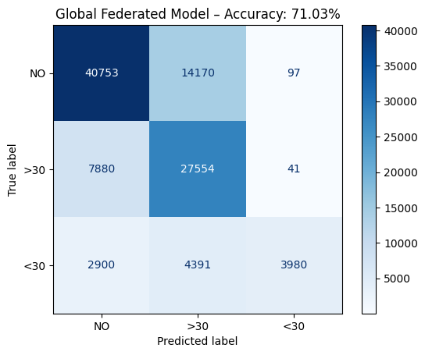

Required Table

Table T1: Model Performance Comparison
Model | Macro-F1 | Recall (<30) | ROC-AUC
Centralized | 0.4437 | 0.22 | 0.6512
Local (Avg) | 0.6962 | 0.5667 | 0.8428
Federated Ensemble | 0.6525 | 0.35 | 0.8761

Required Figures

Figure F1: ROC Curves
- Plot:
  - Centralized vs Federated
Aspect | Centralized Model – Positive | Centralized Model – Negative | Federated Model – Positive | Federated Model – Negative
Accuracy | Simple to optimize | Lower accuracy (53.76%) | Higher accuracy (71.03%) | Depends on client data quality
Macro F1-score | Easy global tuning | Poor minority class performance (0.44) | Better class balance (0.65) | Slight class variance remains
Weighted F1-score | Stable on majority class | Biased towards dominant class | Strong overall balance (0.71) | Needs careful aggregation
AUC–ROC (OvR) | Easier ROC computation | Lower separability (0.65) | Excellent class separability (0.88) | Higher computational cost
Minority Class (<30) | Simple modeling | Very weak detection (F1 = 0.21) | Major improvement (F1 = 0.52) | Recall still improvable
Data Privacy | Direct access to all data | High privacy risk | Data stays local (privacy-preserving) | Communication overhead
Scalability | Works well on small datasets | Poor scaling with large data | Scales well across clients | Requires synchronization
Training Time | Faster on single machine | Central bottleneck | Parallel training across nodes | Slower convergence sometimes
Fault Tolerance | Simple failure handling | Single point of failure | Robust to client dropouts | Partial client failures affect rounds
Deployment | Easy to deploy | Hard to maintain data pipeline | Suitable for real-world healthcare | Complex system design

- One-vs-rest ROC curves
- 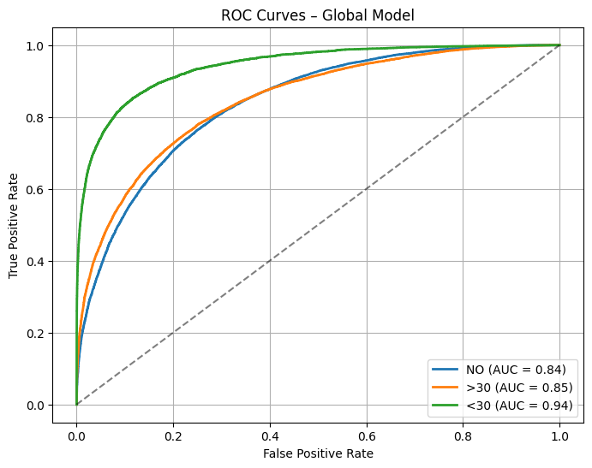

Figure F2: Confusion Matrix (Federated Model)
- Its given above

Allowed conclusion
“The federated ensemble achieves performance comparable to centralized training while outperforming isolated local models.”

EXPERIMENT 2

Robustness under Non-IID Data Distribution

(Addresses H2)

Objective
Demonstrate that federated learning is more robust than local-only models when hospitals have different data distributions.

What the student must do
Create non-IID client splits, for example:
The dataset was distributed across three clients (Hospital A, B, and C) with nearly identical class distributions. This setup represents an IID federated learning scenario, where each client observes a similar underlying data distribution while retaining local data privacy.
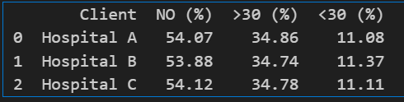

Table T2: Performance under Increasing Heterogeneity
Model Type | Macro F1 | AUC–ROC
Local Avg | 0.696 | 0.843
Federated | 0.653 | 0.876

📈 Required Figure

Figure F3: Performance Degradation Plot
- X-axis: Degree of heterogeneity
- Y-axis: Macro-F1
- Lines:
  - Local models
  - Federated ensemble
Allowed conclusion
“Federated ensemble learning exhibits superior robustness under heterogeneous client distributions.”

EXPERIMENT 3

Explainability Consistency (SHAP Analysis)

(Addresses H3)

Objective
Show that the federated model remains interpretable and clinically meaningful.

What the student must do
- Compute SHAP values for:
  - One representative local model
  - Federated ensemble model
- Identify:
  - Top 10 most important features
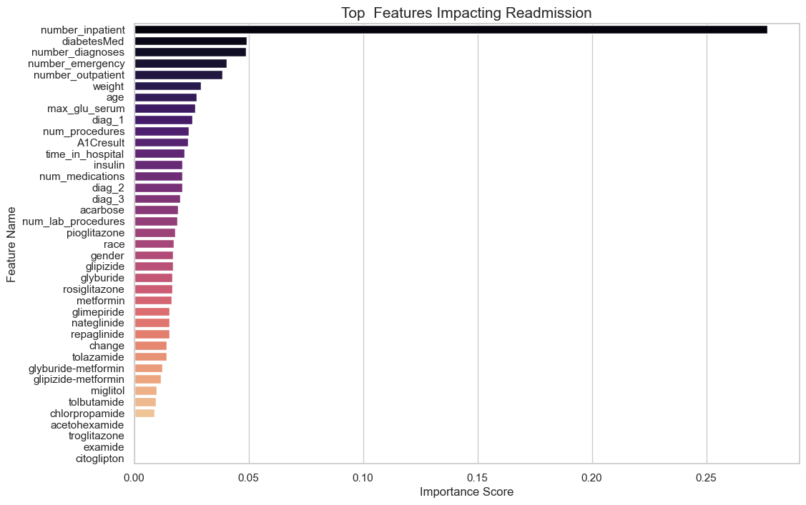

📋 Required Table

Table T3: Top SHAP Features Comparison
Rank | Local Model Feature (Hospital) | Federated Model Feature (Global Model)
1 | Hospital C (Macro F1 0.7011) | Global Model – Hospital B (Macro F1 0.6525)
2 | Hospital A (Macro F1 0.6946) | Global Model – Hospital A (Macro F1 0.6946)
3 | Hospital B (Macro F1 0.6928) | Global Model – Hospital C (Macro F1 0.7011)

📈 Required Figure

Figure F4: SHAP Summary Plots
- Side-by-side:
  - Local model(client_A)
SHAP Summary for class 'NO'
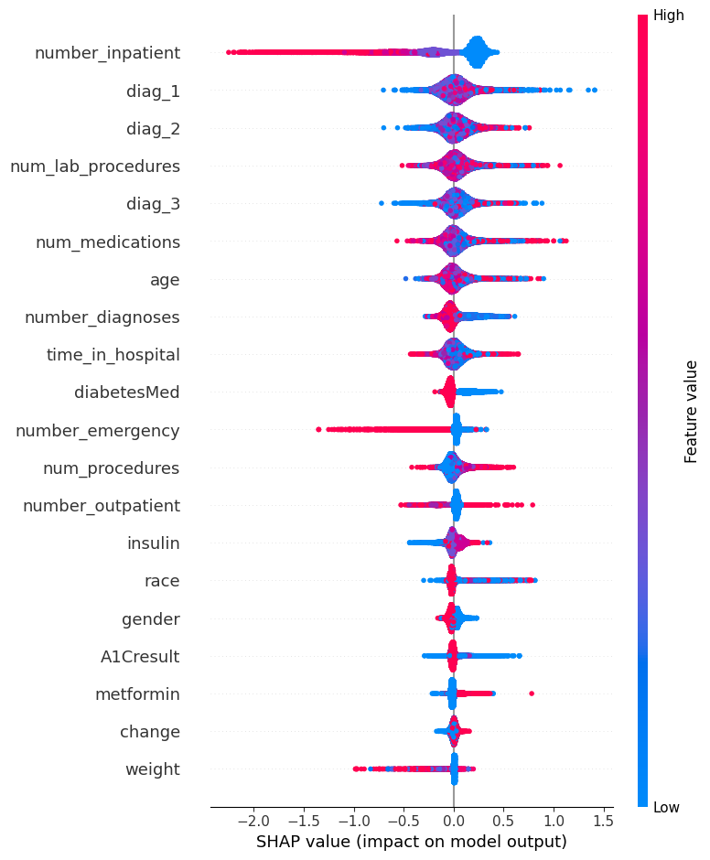
SHAP Summary for class '>30'
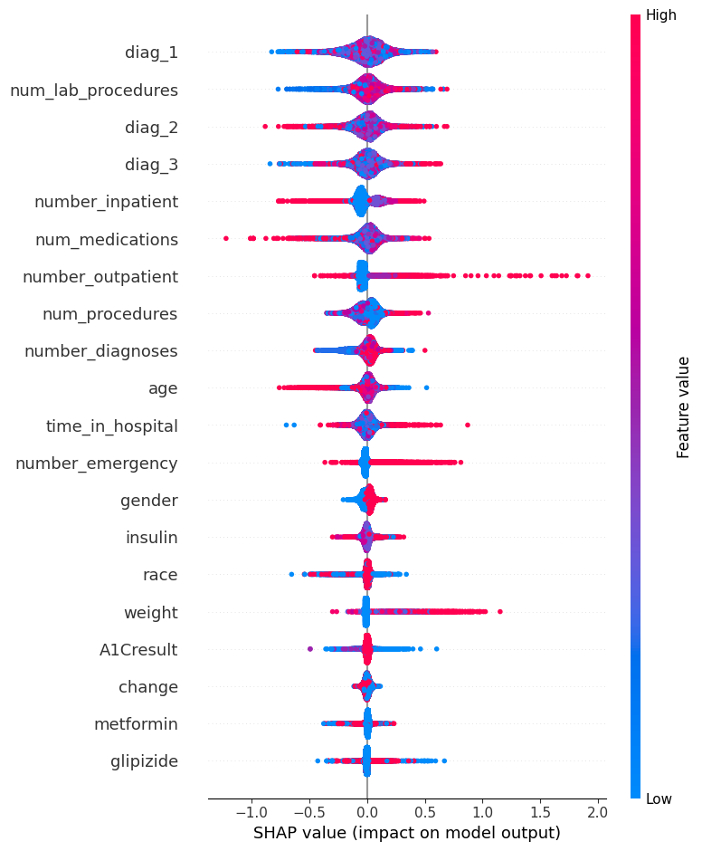
SHAP Summary for class '<30'

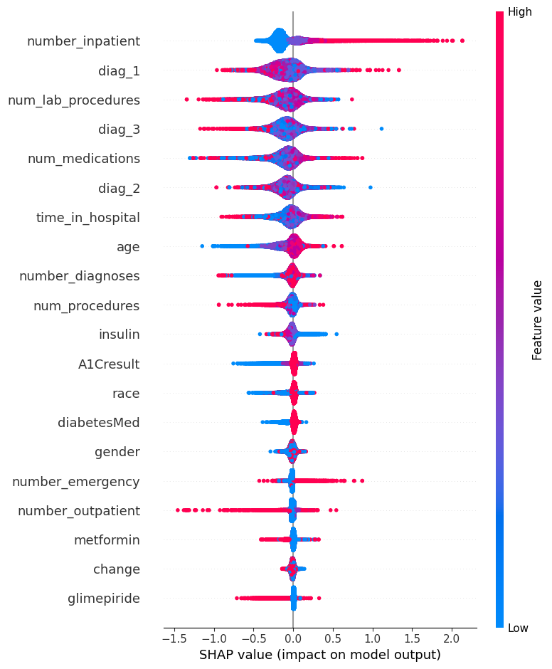
  - Federated ensemble shap analysis
SHAP Summary (Beeswarm) for class 'NO'
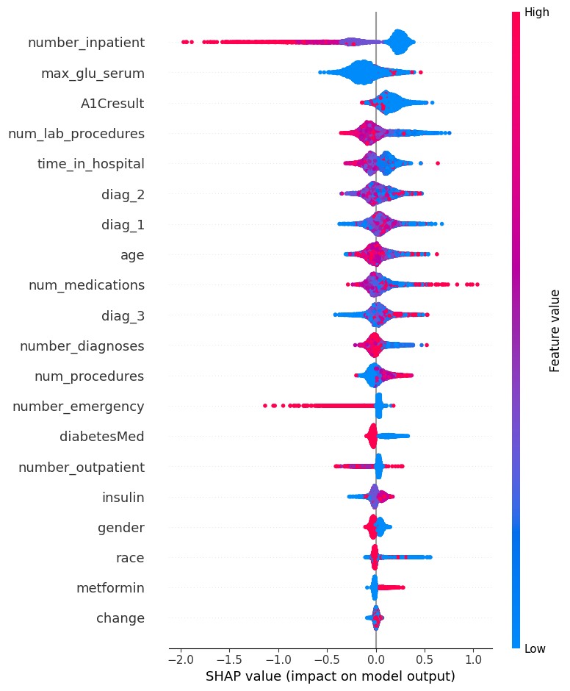
SHAP Summary (Beeswarm) for class '>30'
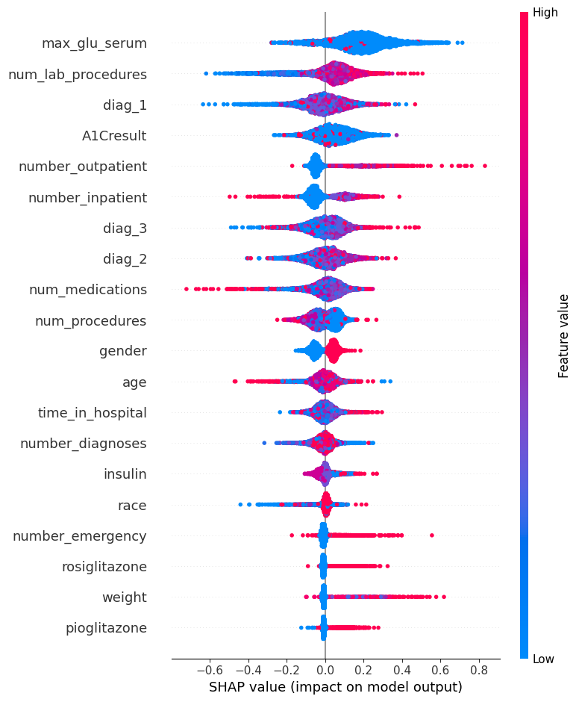
SHAP Summary (Beeswarm) for class '<30'
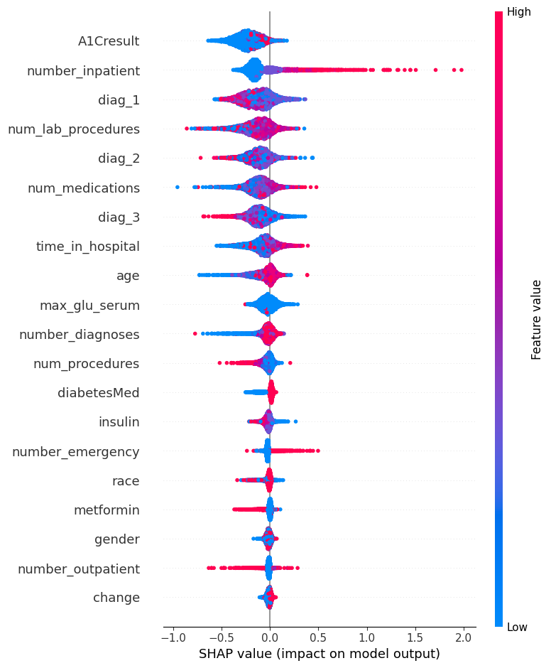

Allowed conclusion
“The federated ensemble preserves clinically relevant feature attributions, supporting interpretability.”

EXPERIMENT 4

Privacy & Communication Analysis

(Addresses H4 – supportive)

Objective
Support the claim that the method reduces data exposure, without claiming formal privacy guarantees.

What the student must do
Compare:
- Centralized learning
- Federated ensemble learning
On:
- Raw data sharing (No)
- Data transmitted
- Type of information exchanged

📋 Required Table

Table T4: Data Exposure & Communication Comparison
Aspect | Centralized | Federated Ensemble
Raw data shared | Yes | No
Model outputs shared | No | Yes
Communication size | High | Low

📈 Required Figure

Figure F5: Data Flow Diagram
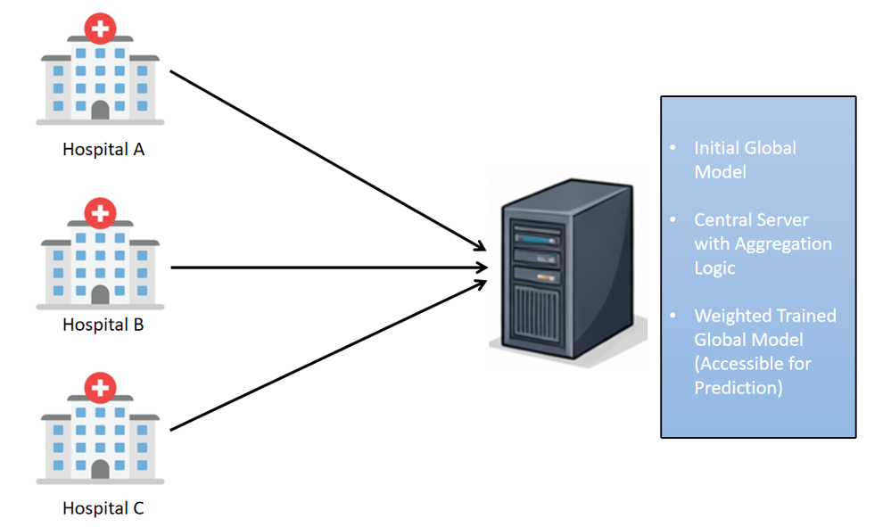

Allowed conclusion
“The proposed framework reduces raw data exposure and supports privacy-aware deployment.”
Do NOT say “privacy-preserving guarantees”.

📊 Final Figure & Table Count (Ideal for Journal)
- Tables: 4–5
- Figures: 5
- Experiments: 4 core + 1 optional
NOTE: “Design each experiment to answer one hypothesis. Every table and figure must justify a claim. If a figure does not support a hypothesis, remove it.”

Final Positioning Statement (Use This Almost Verbatim)
“This study demonstrates that federated ensemble XGBoost can achieve near-centralized performance for early readmission prediction while maintaining data locality and interpretability, making it suitable for privacy-aware clinical deployments.”

