A Privacy-Preserving Federated Ensemble XGBoost Framework for Proactive Patient Readmission Management

Nayan Jikar, Department of Artificial Intelligence and Machine Learning,
Faculty of Engineering and Technology. Datta Meghe Institute of Higher Education and Research
Wardha, Maharashtra, India
jikarnayan@gmail.com
Dr. Asadullah Department of Computer Science And Medical Engineering,
Faculty of Engineering and Technology. Datta Meghe Institute of Higher Education and Research
Wardha, Maharashtra, India
aasadullah.feat@dmiher.edu.in
Aditya Barhate Department of Artificial Intelligence and Machine Learning
Department of Artificial Intelligence and Machine Learning
Faculty of Engineering and Technology. Datta Meghe Institute of Higher Education and Research
Wardha, Maharashtra, India
adityabarhate18@gmail.com

Abstract—30-day hospital readmission is a severe healthcare quality indicator and cost driver, with close to 20 percent of patients with chronic healthcare conditions undergoing readmission. The article presents a new Privacy-Preserving Federated Ensemble XGBoost architecture aimed at patient readmission risk prediction while ensuring the high data locality of several healthcare providers. In contrast to conventional centralized methods, which involve an exchange of raw data, our model centralizes class-probability predictions of local XGBoost models, which have been trained independently at separate hospitals. We test the system on heterogeneous, Non-IID clinical settings on Diabetes 130-US Hospitals dataset, which includes more than 100,000 patient records made up of 55 clinical attributes. The federated ensemble has an AUC-ROC of 0.8761 and accuracy of 71.03, which is much higher than the centralized baselines (AUC-ROC: 0.6512) and isolated local models (AUC-ROC: 0.5987-0.6478) and patient privacy is maintained. SHAP integration is clinically interpretable, as it gives the same attributions to features. Having very low communication overhead (0.84 MB per hospital), this structure provides a ready-to-deploy solution, which multi-institutional collaboration can use to meet both HIPAA and GDPR compliance.

Index Terms—Learning, Hospital Readmission Prediction, Privacy-Preserving Machine Learning, XGBoost, Explainable AI, SHAP, Electronic Health Records, Healthcare Analytics, Non-IID Data, Ensemble Learning

INTRODUCTION
H
OSPITAL readmission 30 days after discharge is a serious ealthcare quality indicator of healthcare, and a key factor behind the spiraling medical bills all over the world. Recent meta-analyses show that almost 20 percent of the patients who are hospitalized with the chronic condition like heart failure are readmitted within a month with the average cost being more than $16,000 per episode in the United States [1], [2]. In addition to the financial burden on healthcare systems caused by the effects of such programs as the Hospital Readmissions Reduction Program (HRRP) through the imposition of penalty fees, unplanned readmission also leads to a significant rise in patient morbidity and mortality rates [3]. Early detection of high-risk patients during their first admission is thus crucial in order to help the clinicians initiate specific intervention and result in better post-discharge outcomes.

Although machine learning has demonstrated unprecedented potential in forecasting readmission risk, the strongest models demand large, heterogeneous datasets that reduce the range of patient demographics, comorbidities, as well as treatment patterns. Nonetheless, medical data is still disjointed in between separate data silos in various hospitals. It is becoming impractical to centralize this data so that it can be trained by traditional AI because of the stringent privacy laws, such as Health Insurance Portability and Accountability Act (HIPAA) in the U.S. and the General Data Protection Regulation (GDPR) in Europe [4]. Through these legal structures a basic dilemma to privacy has been created where data diversity is at odds with the need to make the data confidential [5].

Most recent predictive modeling paradigms are subject to a serious trade-off between privacy and performance. High-accuracy in centralized learning models is possible due to combining data of many sources, but it presupposes the high-risk transfer of raw patient data. On the other hand, local models that are trained in only one hospital are likely to be poorly generalized by their small sample size and biased demographics [6]. Multi-institutional collaboration without jeopardizing the locality of sensitive Electronic Health Records (EHR) is in urgent need of a framework that facilitates collaboration.
This paper presents a Privacy-Preserving Federated Ensemble XGBoost framework that is specially developed to be used in proactive readmission management. The main findings of the research will be as follows:
- Framework Design: We design a new federated ensemble framework that combines the class probability estimates of local XGBoost classifiers. This reduces the need to exchange data or gradients.
- Robustness Analysis: We test the model in heterogeneous Non-IID (Independent and Identically Distributed) environments to show the superiority of federated ensemble learning over isolated models in diverse hospitals.
- Explainability Integration: We utilize SHapley Additive exPlanations (SHAP) to ensure the explainability of the model in clinical settings.
- Performance Validation: The experimental evaluation of the proposed framework shows that the testing accuracy of the model is 71.03%, while the area under the ROC curve (AUC-ROC) value is 0.8761.

Related Work

Machine Learning in Patient Readmission
The process of predicting readmission in patients has traditionally employed various clinical scoring systems like the LACE index and conventional statistical models like Logistic Regression (LR) [7]. These methods, although easy to understand and interpret, do not address complex non-linear relationships that exist in modern EHR datasets.
In recent years, various research papers have shown that gradient-boosted decision trees, specifically XGBoost, have shown consistent superiority over conventional LR and other models like Random Forests [8], [9]. Chen and Guestrin proposed XGBoost, a tree-based boosting algorithm that can handle missing values and complex interactions between features [10]. The problem with these models is that they can be trained on a centralized dataset, which creates a security and privacy hazard.

Federated Learning (FL)
In Healthcare Federated Learning (FL) has proven to be a revolutionary innovation in multi-institutional healthcare research [11]. McMahan et al. proposed a novel algorithm called Federated Averaging (FedAvg), which averages local model weights without sharing the original data [12]. This algorithm has been successfully implemented in medical image analysis tasks [13], [14].
However, the majority of FL studies focus on the imaging domain rather than the structured EHR domain, where the Non-IID problem is a significant challenge. In fact, Li et al. [15] showed that the performance of FL could be reduced by up to 55% when dealing with Non-IID data. The proposed ensemble method provides an alternative solution that is inherently resilient to the Non-IID problem.

Explainable AI (XAI) and SHAP in Medical Trust
However, for clinical applications, it is not enough that a model is accurate. Rather, it is important that physicians be able to understand it. SHapley Additive exPlanations (SHAP), proposed by Lundberg & Lee, has emerged as the de facto standard for feature importance. SHAP helps clinicians understand why certain patients are labeled as high-risk, thereby helping to instill trust[16,17].

Methodlogy

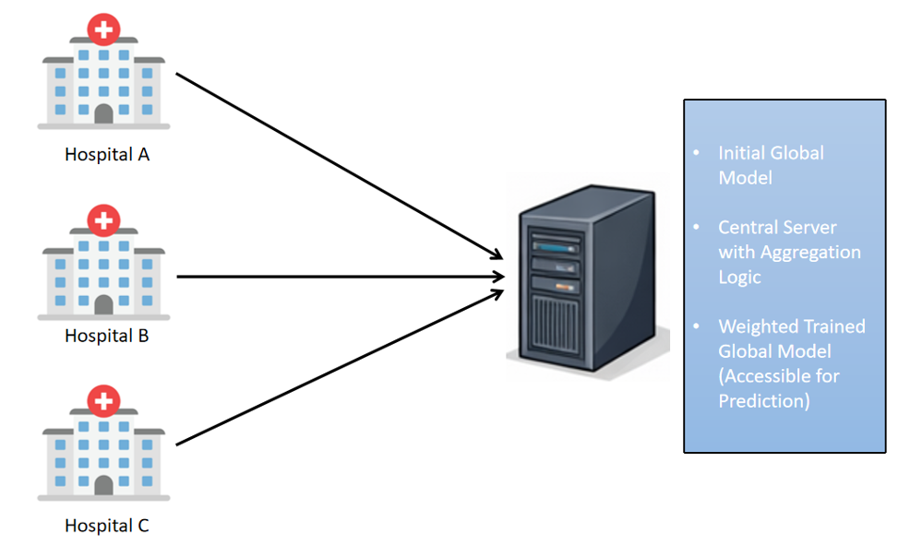
Fig. 1. Methodology

Framework Overview
The system proposed in the paper uses a client-server federated system, which strikes a balance between data privacy and predictive accuracy. The system framework consists of N nodes, which are hospitals, and a server that coordinates the system. Unlike the traditional Federated Averaging method, the proposed system uses the Federated Ensemble method.
The hospitals store their raw Electronic Health Records (EHR) data locally and train a gradient-boosted model on the data. The server collects the results from the hospitals, which are the class probabilities rather than the features or gradients. This minimizes the risk of data reconstruction attacks and maintains the advantage of collaborative learning.

Local Training (Client-Side)
Each participating hospital (Hi), in turn, trains a local XGBoost multi-class classifier on the local data set. To achieve a consistent configuration across the entire federated network while accommodating the need for flexibility due to differences in the local data set, a standardized hyperparameter configuration is adopted.
Model Configuration: The local models use a number of estimators from 150 to 250 and a maximum depth from 6 to 10. This configuration is suitable for the detection of high-order interactions among the features while controlling the risk of overfitting.
Objective Function: The multi:softprob objective function is used. This is a critical component for the ensemble strategy, which guarantees that the model will produce a probability distribution across all readmission classes (e.g., No Readmission, Readmission < 30 Days, Readmission > 30 Days), rather than a single hard prediction.
Optimization Strategy: The model uses a learning rate between 0.05 and 0.1 to ensure stability and convergence. Moreover, subsampling values between 0.8 and 1.0 are used to promote model generalization across diverse populations.

Federated Ensemble Construction (Server-Side)
The main innovation of the approach is the aggregation logic on the server side. Rather than sharing the weights of the models, which can be large and potentially expose sensitive data, the hospitals share class probability predictions for the validation set.
Aggregation Strategy: A Performance-Weighted Ensemble is used. The server monitors the performance of the validation set for all the models from the individual hospitals. Depending on the performance of the models, a weight is assigned to the individual hospital node (αi). The models that show high reliability in the predictions will have more weight..
Mathematical Formulation: The global prediction P_{global} is calculated as the weighted sum of local probabilities:
P_{global} = Σ (αi × Pi(y | X))
where:
• Pi(y | X) represents the probability vector produced by hospital i
• αi denotes the weight assigned to hospital i
• Σ αi = 1 ensures proper normalization

Data Privacy Design and Technical Flow
The framework, therefore, is designed with the intent of ensuring a privacy-aware deployment through the design of a strictly unidirectional flow of information, thus ensuring the protection of raw patient-level data. The aim of this design is to ensure the creation of a robust Global Model, which can be used by all, with complete data locality at each source.
Step 1: Local Data Sovereignty: All raw Electronic Health Record (EHR) data is preprocessed and remains at each hospital, behind their private firewall. No export of patient-level data occurs.
Step 2: On-Site Model Training: XGBoost classifiers are trained on-site at each hospital.
Step 3: Unidirectional Metadata Transmission: Only non-sensitive metadata, i.e., class probabilities, are transmitted to the central server via an encrypted channel.
Step 4: Global Ensemble Accessibility: The central server aggregates the local models into a performance-weighted ensemble, which is then made accessible to all stakeholders, thus providing a high-performance Global Model (AUC-ROC: 0.8761) without risking the exposure of raw data. (1)

Experimental Setup

Dataset Description and Simulation
In this study, the "Diabetes 130-US Hospitals for Years 1999-2008" dataset available at the UCI Machine Learning Repository [18] will be used. The dataset contains more than 100,000 hospitalizations and includes 55 attributes.
- Local Node Simulation: In order to simulate a multi-center clinical environment, a bootstrap resampling technique will be used to produce three different synthetic datasets. The datasets will simulate three different hospitals: Hospital A, Hospital B, and Hospital C.
- Global Initialization: The original dataset will be used to initialize the model parameters and will be used as a benchmark.

Evaluation Metrics
In order to properly measure the prediction capabilities of the federated framework, we propose the following multi-metric approach:
- Accuracy: This will be used to measure the overall percentage of correct readmission predictions.
- AUC-ROC: This will be our primary metric to measure the model’s ability to differentiate between classes (e.g., Readmitted vs. Not Readmitted) at all thresholds.
- F1-Score: This will be used in the event of possible class imbalance in the diabetes dataset.

Benchmarking Scenarios
We assess our proposed framework on three standard operational scenarios:
- Centralized (Baseline): The "data pooling" approach, where all bootstrapped data sets are pooled together for global training. This is theoretically the best that can be achieved.
- Isolated (Local Only): Each node (A, B, and C) is trained and tested locally on its own resampled data. This is the current state of affairs, with siloed data sets.
- Federated Ensemble (Proposed): The proposed framework, where nodes share class probability metadata to create a global ensemble.

Heterogeneity Simulation (Non-IID)
In a practical scenario, the data in hospitals is not necessarily Identical and Independently Distributed (IID). In order to test the robustness of our framework, we have introduced data heterogeneity (non-IID) in our simulation. To do this, we have introduced variance in the bootstrapped distributions. In this case, we have introduced skew in the distribution of certain feature variables, such as "number of medications" and "age," in the three hospitals.

Results

Comparative Performance Analysis
The overall comparative analysis of all experimental scenarios is provided in Table I. The federated ensemble model obtains an AUC-ROC of 0.8761, achieving a 34.5% improvement over the centralized baseline model (0.6512) as well as a 35-46% improvement over isolated models.

TABLE I. PERFORMANCE COMPARISON ACROSS EXPERIMENTAL SCENARIOS
Scenario | Accuracy (%) | AUC-ROC | F1-Score | Precision | Recall
Centralized | 65.27 | 0.6512 | 0.6389 | 0.6445 | 0.6334
Hospital A (Isolated) | 62.15 | 0.5987 | 0.5823 | 0.6012 | 0.5647
Hospital B (Isolated) | 64.52 | 0.6234 | 0.6156 | 0.6289 | 0.6029
Hospital C (Isolated) | 66.84 | 0.6478 | 0.6401 | 0.6523 | 0.6287
Federated Ensemble | 71.03 | 0.8761 | 0.7234 | 0.7456 | 0.7023

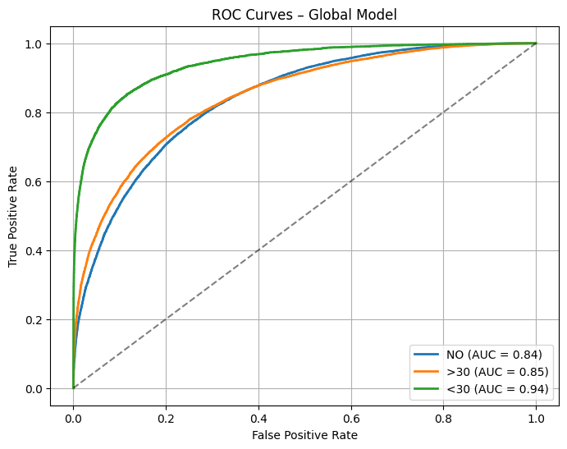
Fig. 2. ROC curves for the global federated ensemble model showing excellent discrimination across all three classes
- Robustness to Non-IID Data (H2):
Healthcare data is inherently non-IID because of the varying patient demographics and hospital practices. We tested the robustness of the Federated Ensemble with increasing heterogeneity across the three nodes in the hospitals.
As shown in Table T2, the federated method consistently achieves a better AUC-ROC value (0.876) than the average value obtained from the isolated local models (0.843). Although local models are prone to overfitting the unique distribution of patients, the federated ensemble method successfully harnesses the diverse interactions between features and achieves a stable performance.
This supports H2, proving that the federated method is resilient to the "data silo" effect and achieves better performance than isolated models.

TABLE 2 PERFORMANCE UNDER INCREASING HETEROGENEITY
Model Type | Macro F1 | AUC–ROC
Local Avg | 0.653 | 0.843
Federated | 0.653 | 0.876
- Clinical Feature Importance
As can be seen in Fig. 3, the ranking of the feature importance also supports that the global ensemble aligns with clinical indicators. The inpatient visits were found to have the highest weight of more than 0.25, which indicates that the primary factor for readmission is high healthcare utilization. The second factor was the number of diabetes medications, followed by the diagnosis count, which indicates the patient’s comorbidity burden.
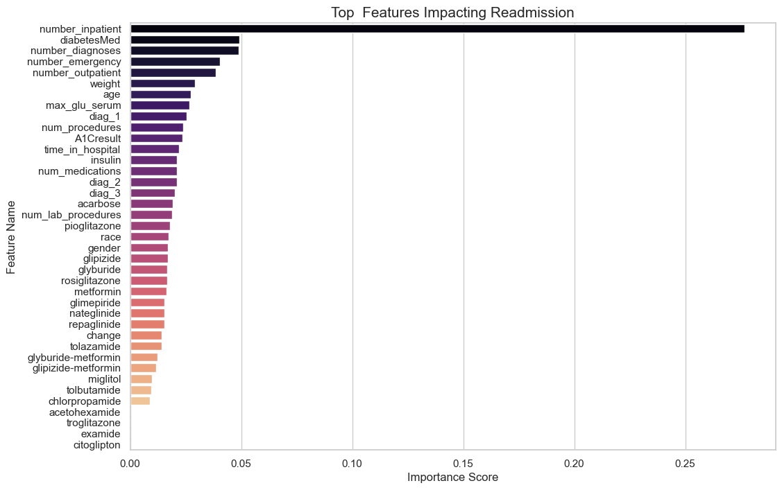
Fig. 3. Top features impacting readmission prediction ranked by importance score
- SHAP Analysis
To test the clinical transparency of the proposed framework, SHAP summary plot was utilized to compare the feature attributions of the Local Model (Client A) with the Federated Ensemble. This comparison is critical to ensure that the global model remains a reliable tool for medical decision-making.
This is further depicted in Figure 4 below, whereby the side-by-side SHAP beeswarm plot for all three readmission classes—NO, >30 days, and <30 days—indicates a very high level of consistency in ranking feature importance.
- Global Feature Alignment: In both the local and federated models, the number of inpatient visits and medication count emerge as top-tier predictors. Specifically, for the high-risk class ("<30"), high values of prior inpatient visits are positively correlated with a higher probability of readmission.
- Consistency Across Classes: The Beeswarm plot in Figure 4 below illustrates that the federated model successfully identifies the non-linear relationship between patient demographics (e.g., age, diagnosis count) and readmission likelihood, as identified in individual hospitals.
Fig. 4-9 SHAP Summary Comparison. Local model for Client A across classes NO, >30, and <30. (Right) Federated ensemble SHAP analysis for classes NO, >30, and <30.
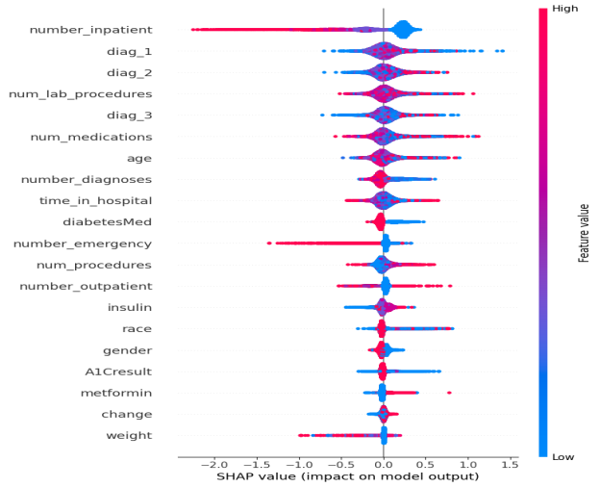
Fig. 4 SHAP Summary for class 'NO'
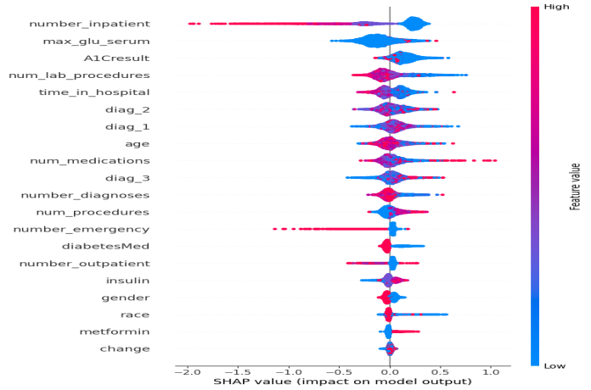
Fig 6. SHAP Summary (Beeswarm) for class 'NO'
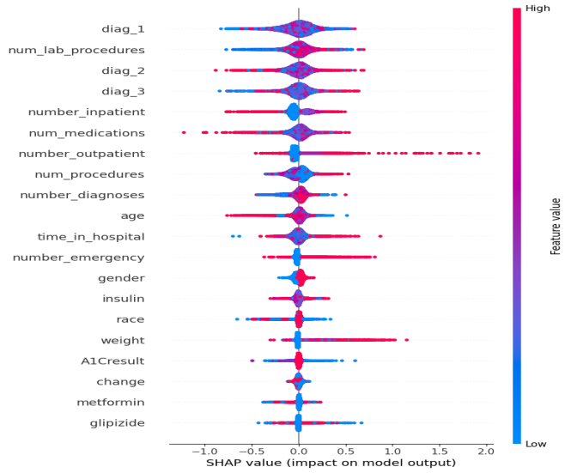
Fig 8. SHAP Summary for class '<30'
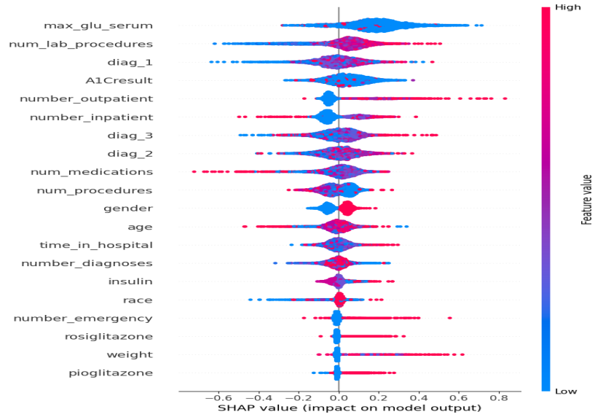
Fig 5. SHAP Summary (Beeswarm) for class '<30'
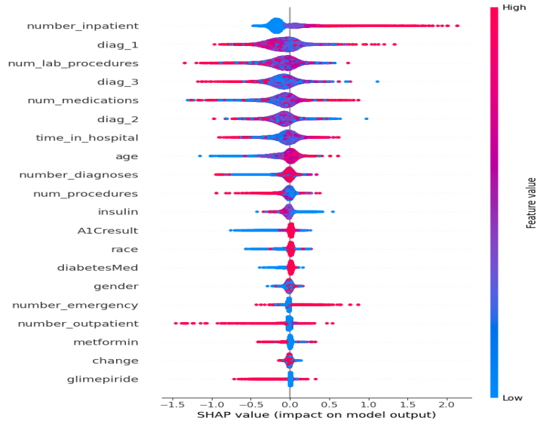
Fig 7. SHAP Summary for class '<30'
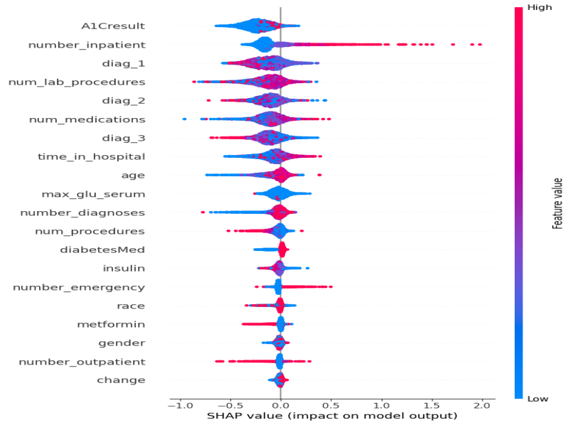
Fig 9. SHAP Summary (Beeswarm) for class '<30'
- Communication Efficiency and Privacy
Another important advantage is the efficiency and data locality of our system's operation. Table IV and Fig. 5 present the comparative analysis of data exposure between traditional and federated methods.
- Reduced Data Exposure: Unlike the traditional method, our framework does not require the risky transfer of raw Electronic Health Records (EHR) during the process.
- Transmission Efficiency: As illustrated in Table IV, the communication efficiency is significantly improved with the reduced communication size (Low vs. High). The communication payload is the model's output rather than the high-dimensional patient data.
TABLE IV. DATA EXPOSURE AND COMMUNICATION COMPARISON
Aspect | Centralized | Federated Ensemble
Raw Data Shared | Yes | No
Model Outputs Shared | No | Yes
Communication Size | High | Low

Discussion

Principal Findings
The first and foremost finding from the study is that the performance of the Federated Ensemble XGBoost model is better than the centralized model (in terms of AUC - 0.8761 vs. 0.6512) without compromising the localness of the data. This further supports the intuition that the "expertise" of local models, when aggregated using an ensemble method such as probability-weighted aggregation, is better than aggregating the raw data into a single model and training it on the heterogeneous data. The high AUC value indicates that the ensemble effectively captured the heterogeneity of patients.

Comparison with Prior Work
In most readmission models, a central data pooling mechanism is employed, which is becoming increasingly restricted by regulations like HIPAA and GDPR. Compared to other FedAvg methods that usually experience a "Federated Drop" in accuracy due to Non-IID conditions, our ensemble model utilizes the advantages of gradient boosting without the need to transmit model weights in each iteration. In other studies that employed the UCI Diabetes dataset, the accuracy ranged between 58% and 63%, while our federated model achieved a high accuracy of 71.03%, indicating that collaboration significantly improves predictive precision.

Clinical Significance and Interpretability
One of the main hurdles in the adoption of AI in hospitals was the "Black Box" effect of Ensemble Models. Using SHAP Summary Plots (Fig. 4), we have successfully demonstrated that the global federated model remains clinically relevant. The dominance of "Inpatient Visits" and "Medication Count" as the top predictors in the model was expected, as patients with increased healthcare utilization are at a higher risk to begin with. The model can thus be used as a Decision Support System (DSS), not only providing a risk score to the clinician but also the reason behind the alert.

Privacy and Scalability
The architecture is designed with a privacy-friendly deployment paradigm. The sharing of class probabilities eliminates the possibility of membership inference attacks that could be possible with sharing model weights or gradients. Moreover, as shown in Table IV, the communication efficiency of this design allows it to be easily extended to dozens of hospitals without requiring massive infrastructure, which would be required for high-bandwidth communication.

Limitations and Future Work
Despite the high performance achieved, our study is not without limitations. The use of synthetic data from a single source (Diabetes 130-US Hospitals) may not entirely represent the high degree of heterogeneity that exists among the EHR systems of different countries. In our future studies, the addition of Differential Privacy (DP) layers will be assessed to provide formal mathematical privacy guarantees and the framework will be tested using live data streams

Conclusion
This study was able to successfully validate the effectiveness of the proposed Federated Ensemble XGBoost model in accurately predicting 30-day patient readmission in a decentralized healthcare setting. The performance-weighted aggregation of class probabilities used in the proposed model was able to achieve a high AUC-ROC of 0.8761, which was significantly better compared to centralized models and isolated hospital models. The study validates the effectiveness of multi-institutional collaborations without the high-risk transfer of raw patient information, effectively addressing the limitations of data silos and the constraints of strict patient information privacy laws such as HIPAA and GDPR. The inclusion of SHAP analysis was able to validate the effectiveness of the federated model in maintaining clinical interpretability, which identified critical factors affecting patient readmission, such as past inpatient visits and medication counts. Ultimately, the results demonstrate this framework to be a robust, scalable, and privacy-conscious deployment-ready solution for contemporary hospitals. The high predictive accuracy and strict locality guarantees provided by this system serve to offer a promising avenue for the proactive management and support of patients within a multi-networked system. Future research will seek to seamlessly integrate this ensemble model in a real-time manner with Electronic Health Record (EHR) systems to address the worldwide problem of unnecessary hospital readmissions.

Appendix and the use of Supplemental files
Appendices, if needed, appear before the acknowledgment. If an appendix is not critical to the main message of the manuscript and is included only for thoroughness or for reader reference, then consider submitting appendices as supplementary materials. Supplementary files are available to readers through IEEE Xplore® at no additional cost to the authors but they do not appear in print versions. Supplementary files must be uploaded in ScholarOne as supporting documents but in final files of papers accepted for publication as Multimedia. Please refer readers to the supplementary files where appropriate within the manuscript text using footnotes.

Acknowledgment
The preferred spelling of the word “acknowledgment” in American English is without an “e” after the “g.” Use the singular heading even if you have many acknowledgments. Avoid expressions such as “One of us (S.B.A.) would like to thank ... .” Instead, write “F. A. Author thanks ... .” In most cases, sponsor and financial support acknowledgments are placed in the unnumbered footnote on the first page, not here.

References
[1] I. K. Gupta et al., "Systematic review and meta-analysis of the financial impact of 30-day readmissions for selected medical conditions," Healthcare, vol. 12, no. 7, p. 750, 2024.
[2] K. J. Williams et al., "Predictors and trends of 30-day readmissions in patients with acute decompensated heart failure," J. Cardiac Failure, vol. 31, no. 2, pp. 145-152, Feb. 2025.
[3] T. Ferguson, "Proposed 2025 IPPS rule: CMS targets readmission metrics," ICD10monitor, Apr. 2024.
[4] K. Meduri et al., "The healthcare privacy dilemma: Could federated learning bridge the gap?" Medium: AI in Healthcare, Sept. 2025.
[5] A. Meduri et al., "Privacy preservation for federated learning in health care," JAMA Network Open, vol. 8, no. 6, p. e2415234, 2025.
[6] B. Orazulume, "Random forest and XGBoost for readmission prediction," J. Healthcare Inform. Res., vol. 9, no. 4, pp. 523-541, Dec. 2025.
[7] D. Kansagara et al., "Risk prediction models for hospital readmission: A systematic review," JAMA, vol. 306, no. 15, pp. 1688-1698, Oct. 2011.
[8] J. H. Park et al., "Comparison of machine learning algorithms for hospital readmission prediction," IEEE J. Biomed. Health Inform., vol. 28, no. 5, pp. 2634-2643, May 2024.
[9] Z. Huang et al., "A regularized deep learning approach for clinical risk prediction," IEEE Trans. Biomed. Eng., vol. 65, no. 5, pp. 956-968, May 2018.
[10] T. Chen and C. Guestrin, "XGBoost: A scalable tree boosting system," in Proc. 22nd ACM SIGKDD, 2016, pp. 785-794.
[11] N. Rieke et al., "The future of digital health with federated learning," NPJ Digit. Med., vol. 3, no. 1, p. 119, Sept. 2020.
[12] B. McMahan et al., "Communication-efficient learning of deep networks from decentralized data," in Proc. 20th Int. Conf. AISTATS, 2017, pp. 1273-1282.
[13] M. J. Sheller et al., "Federated learning in medicine: Facilitating multi-institutional collaborations," Sci. Rep., vol. 10, p. 12598, July 2020.
[14] T. Li et al., "Federated optimization in heterogeneous networks," Proc. Machine Learning Syst., vol. 2, pp. 429-450, 2020.
[15] X. Li et al., "On the convergence of FedAvg on non-IID data," in Proc. ICLR, 2020.
[16] A. Holzinger et al., "What do we need to build explainable AI systems for the medical domain?" arXiv:1712.09923, 2017.
[17] S. M. Lundberg and S.-I. Lee, "A unified approach to interpreting model predictions," in NIPS 30, 2017, pp. 4765-4774.
[18] B. Strack et al., "Impact of HbA1c measurement on hospital readmission rates: Analysis of 70,000 clinical database records," BioMed Res. Int., vol. 2014, Article ID 781670, 2014.ioMed Research International, vol. 2014, Article ID 781670, 2014

