|  |  |
| --- | --- |
| Course name | Python for mechanical engineering |
| **Lesson name** | **Numerical Modelling of angle of attack of an aerofoil** |
| **Lesson objective** | **Analysis on angle of attack on NACA 6409 aerofoil** |
| Created by | Nishchay N |

**Problem statement:** Analysis on the variation of flow based on the angle of attack of NACA 009aerofoil.

**Model Inputs:**

|  |  |  |
| --- | --- | --- |
| **Sl. No** | **Parameter** | **Value** |
|  | **Boundary** |  |
|  | X List | [-50.,150.,150., -50., -50.] |
|  | Y List | [-60., -60.,60.,60., -60] |
|  | Segmentation List | [50,25,50,25] |
|  | **Aerofoil** |  |
|  | x and y list | From the excel sheet |
|  | Scale | 90 |
|  | Angle of attack | 0,5,10,15,20,25 |
|  | **Boundary conditions** |  |
|  | Volumetric flow rate | 0.5 |
|  | N x | 40 |
|  | N y | 40 |

**NACA 009 aerofoil:**

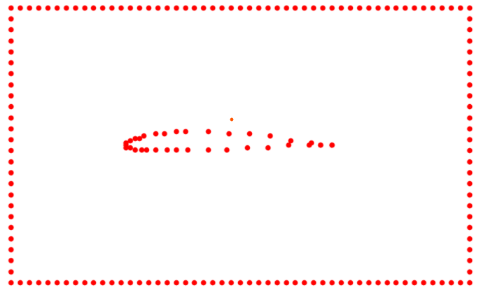

**Results:**

|  |  |
| --- | --- |
| **Angle of attack = 0** | **Angle of attack = 5** |
|  |  |
| **Angle of attack = 10** | **Angle of attack = 15** |
|  |  |
| **Angle of attack = 20** | **Angle of attack = 25** |
|  |  |