Assignment 10
Using the tables “DEPARTMENTS” and “EMPLOYEES” perform the following queries
- Display the employee details, departments that the departments are same in both the emp and dept.
CODE:
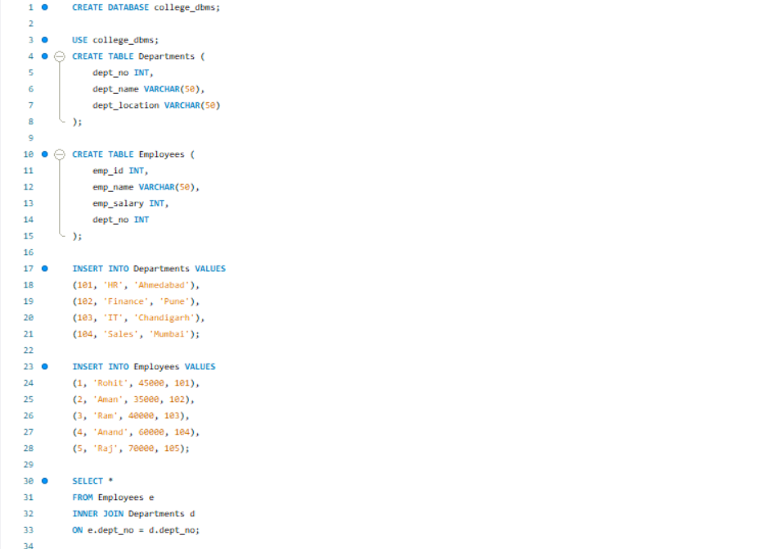

OUTPUT:
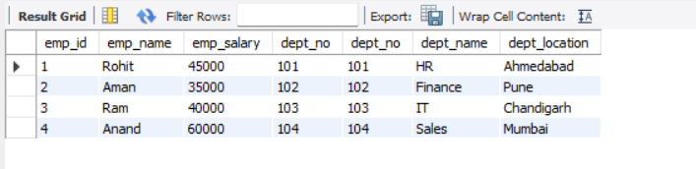

- Display the employee name and Department name by implementing a left outer join.
CODE:

OUTPUT:
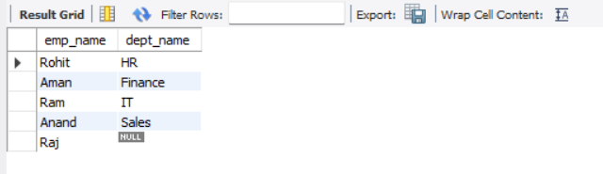

- Display the employee name and Department name by implementing a right outer join.
CODE:
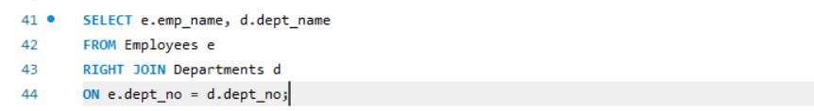
OUTPUT:
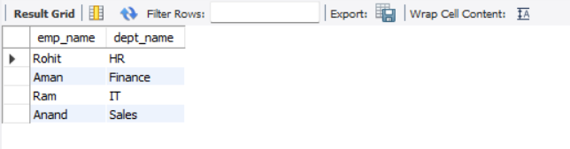

- Display the details of those who draw a greater salary than the average salary.
CODE:
OUTPUT:
