Assignment 7
Rollback and Commit commands
Create Teacher table with the following fields (Name, DeptNo, Date of joining, DeptName, Location, Salary)

(a) Insert five records.
CODE:
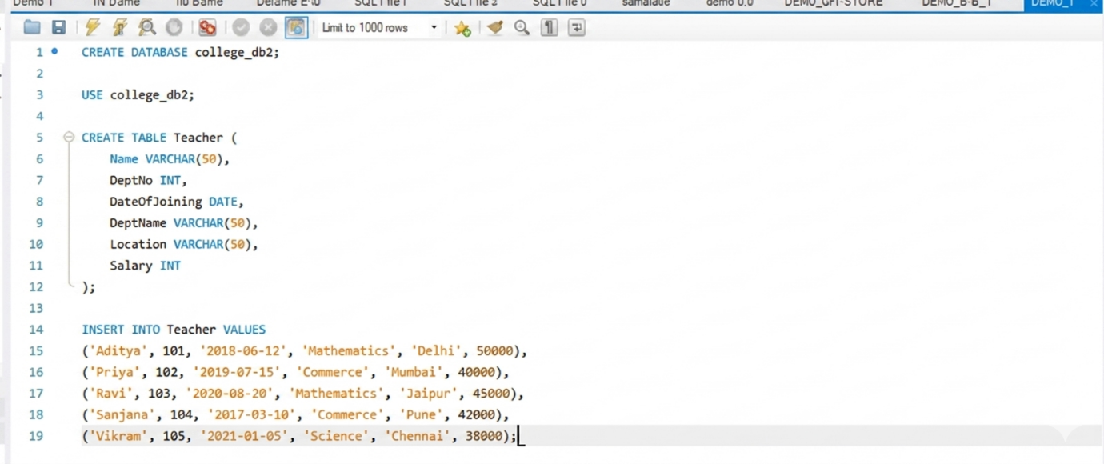

(b) Give Increment of 25% salary for Mathematics Department .
CODE:
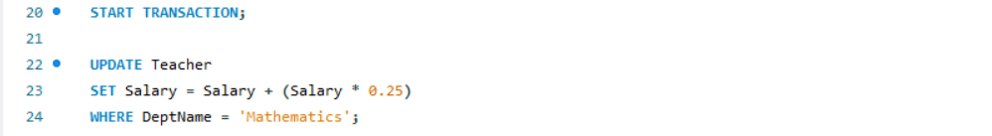

(c) Perform Rollback command.
CODE:
(d)Give Increment of 15% salary for Commerce Department.
CODE:
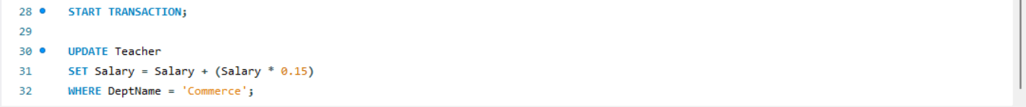

(e) Perform commit command.
CODE:
