Assignment 8
(Exercise on order by and group by clauses)
Create Sales table with the following fields ( Sales No, Salesname, Branch, Salesamount, DOB)
(a) Insert five records.
CODE:
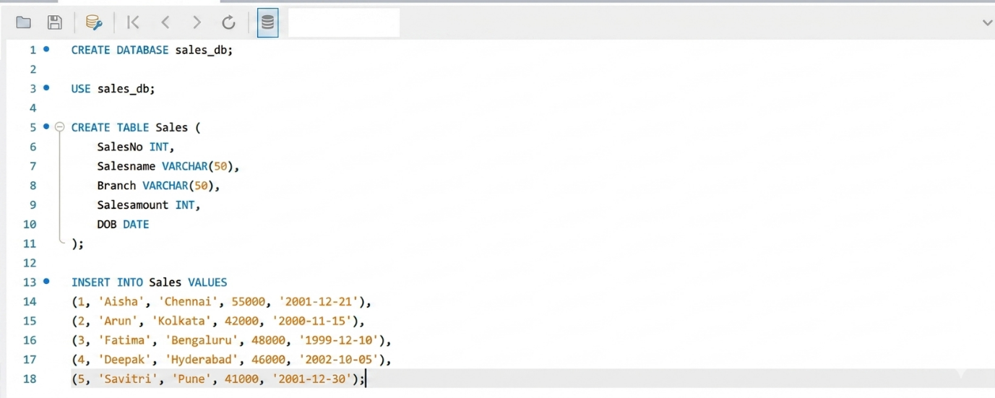

(b) Calculate total salesamount in each branch.
CODE:
OUTPUT:
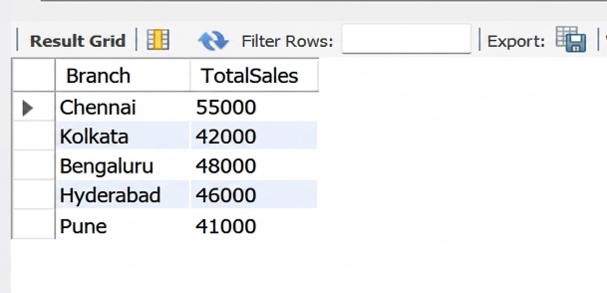

(c) Calculate average salesamount in each branch.
CODE:
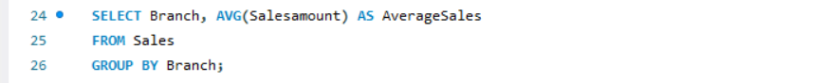
OUTPUT:
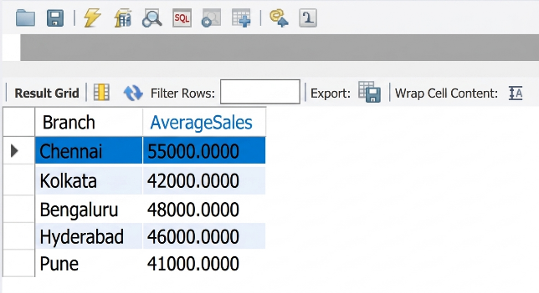

(d) Display all the salesmen, DOB who are born in the month of December as day in character format i.e. 21-Dec-09.
CODE:
OUTPUT:
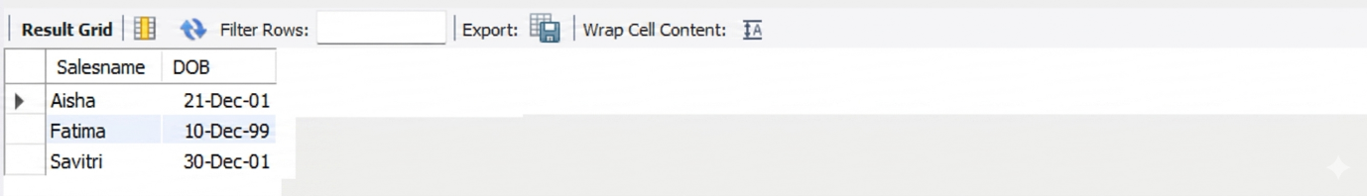

(e ) Display the name and DOB of salesman in alphabetical order of the month.
CODE:
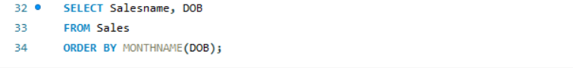
OUTPUT:
