Assignment 9
Consider the following tables namely “DEPARTMENTS” and “EMPLOYEES” Their schemas
are as follows,
Departments ( dept no , dept name , dept_location ); Employees ( emp_id , emp_name , emp_salary,dept_no);
- Develop a query to grant all privileges of employees table into departments table.
CODE:
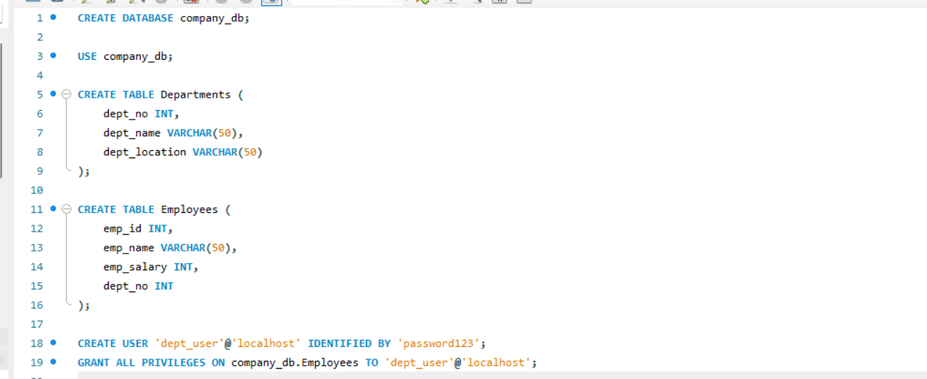

- Develop a query to grant some privileges of employees table into departments table.
CODE:

- Develop a query to revoke all privileges of employees table from departments table.
CODE:
- Develop a query to revoke some privileges of employees table from departments table.
CODE:

- Write a query to implement the save point.
CODE:
