Assignment 6
(Exercise on updating records in table)
Create Client_master with the following fields (ClientNO, Name, Address, City, State, bal_due)
(a) Insert five records.
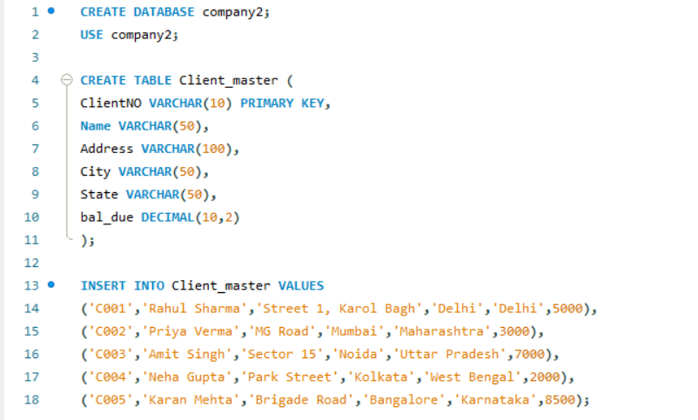
(b) Find the names of clients whose bal_due> 5000 .
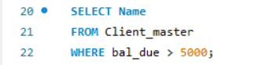
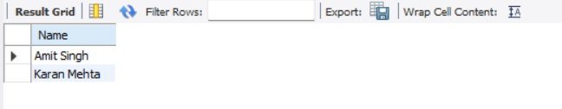
(c) Change the bal_due of ClientNO “ C123” to Rs. 5100.

(d) Change the name of Client_master to Client12.
(e) Display the bal_due heading as “BALANCE”.

