1. Portal Overview
The Legal Case Monitoring Portal will give every government department in the State a single place to track its cases before the Gauhati High Court, act on court directions in time, and keep an accountable record of how each case is handled internally.
It builds on the work already done under the scraping-based system, with three main changes:
- Official data source. Case data will be obtained through the official eCourts / High Court APIs (NAPIX), for which access has been approved, in place of scraping and the portal's exposed APIs.
- All departments. The portal will serve every department, with cases recommended to each through code-based mapping and a probability score, and claimed by the department (Section 4).
- Own database. The portal will continue to maintain its own database, starting from the data already collected (86,219 cases and 3,94,153 orders), on which alerts, search and research are provided.

1.1 Users and what they see
Access follows the government hierarchy. A user sees only the cases their position entitles them to, as set out in Table 1.
User | Who | What they can see and do
State oversight | Office of the Chief Minister / Chief Secretary | Read-only view of all cases across all departments, with State-level dashboards and reports.
Department head | Secretary / head of a department | All cases of the department and its directorates; approvals and oversight.
Department admin | Nodal officer of a department | Manages the department's users, codes and keywords; reviews recommended cases and claims the department's cases.
Department officer | Officer handling cases | Cases allotted to them within the department; updates custody, adds notes and files, acts on alerts.
Directorate user | Officer of a directorate under a department | Cases of their own directorate, and requests sent to it.
Standing counsel | Government advocate | Cases they appear in, and notes and files shared with counsel.
Central operator | Central monitoring cell | Oversees unclaimed cases and data quality; follows up where a case is left unclaimed.
Auditor | Audit / vigilance | Read-only access to case records and the audit log.
Table 1: Users and access

2. System Architecture
The system is organised in layers, from the court data sources at the bottom to users at the top. Each layer has a single responsibility and communicates only with the layers next to it, so that any one part, such as a data source, can be changed without affecting the rest. Figure 1 shows the complete architecture.
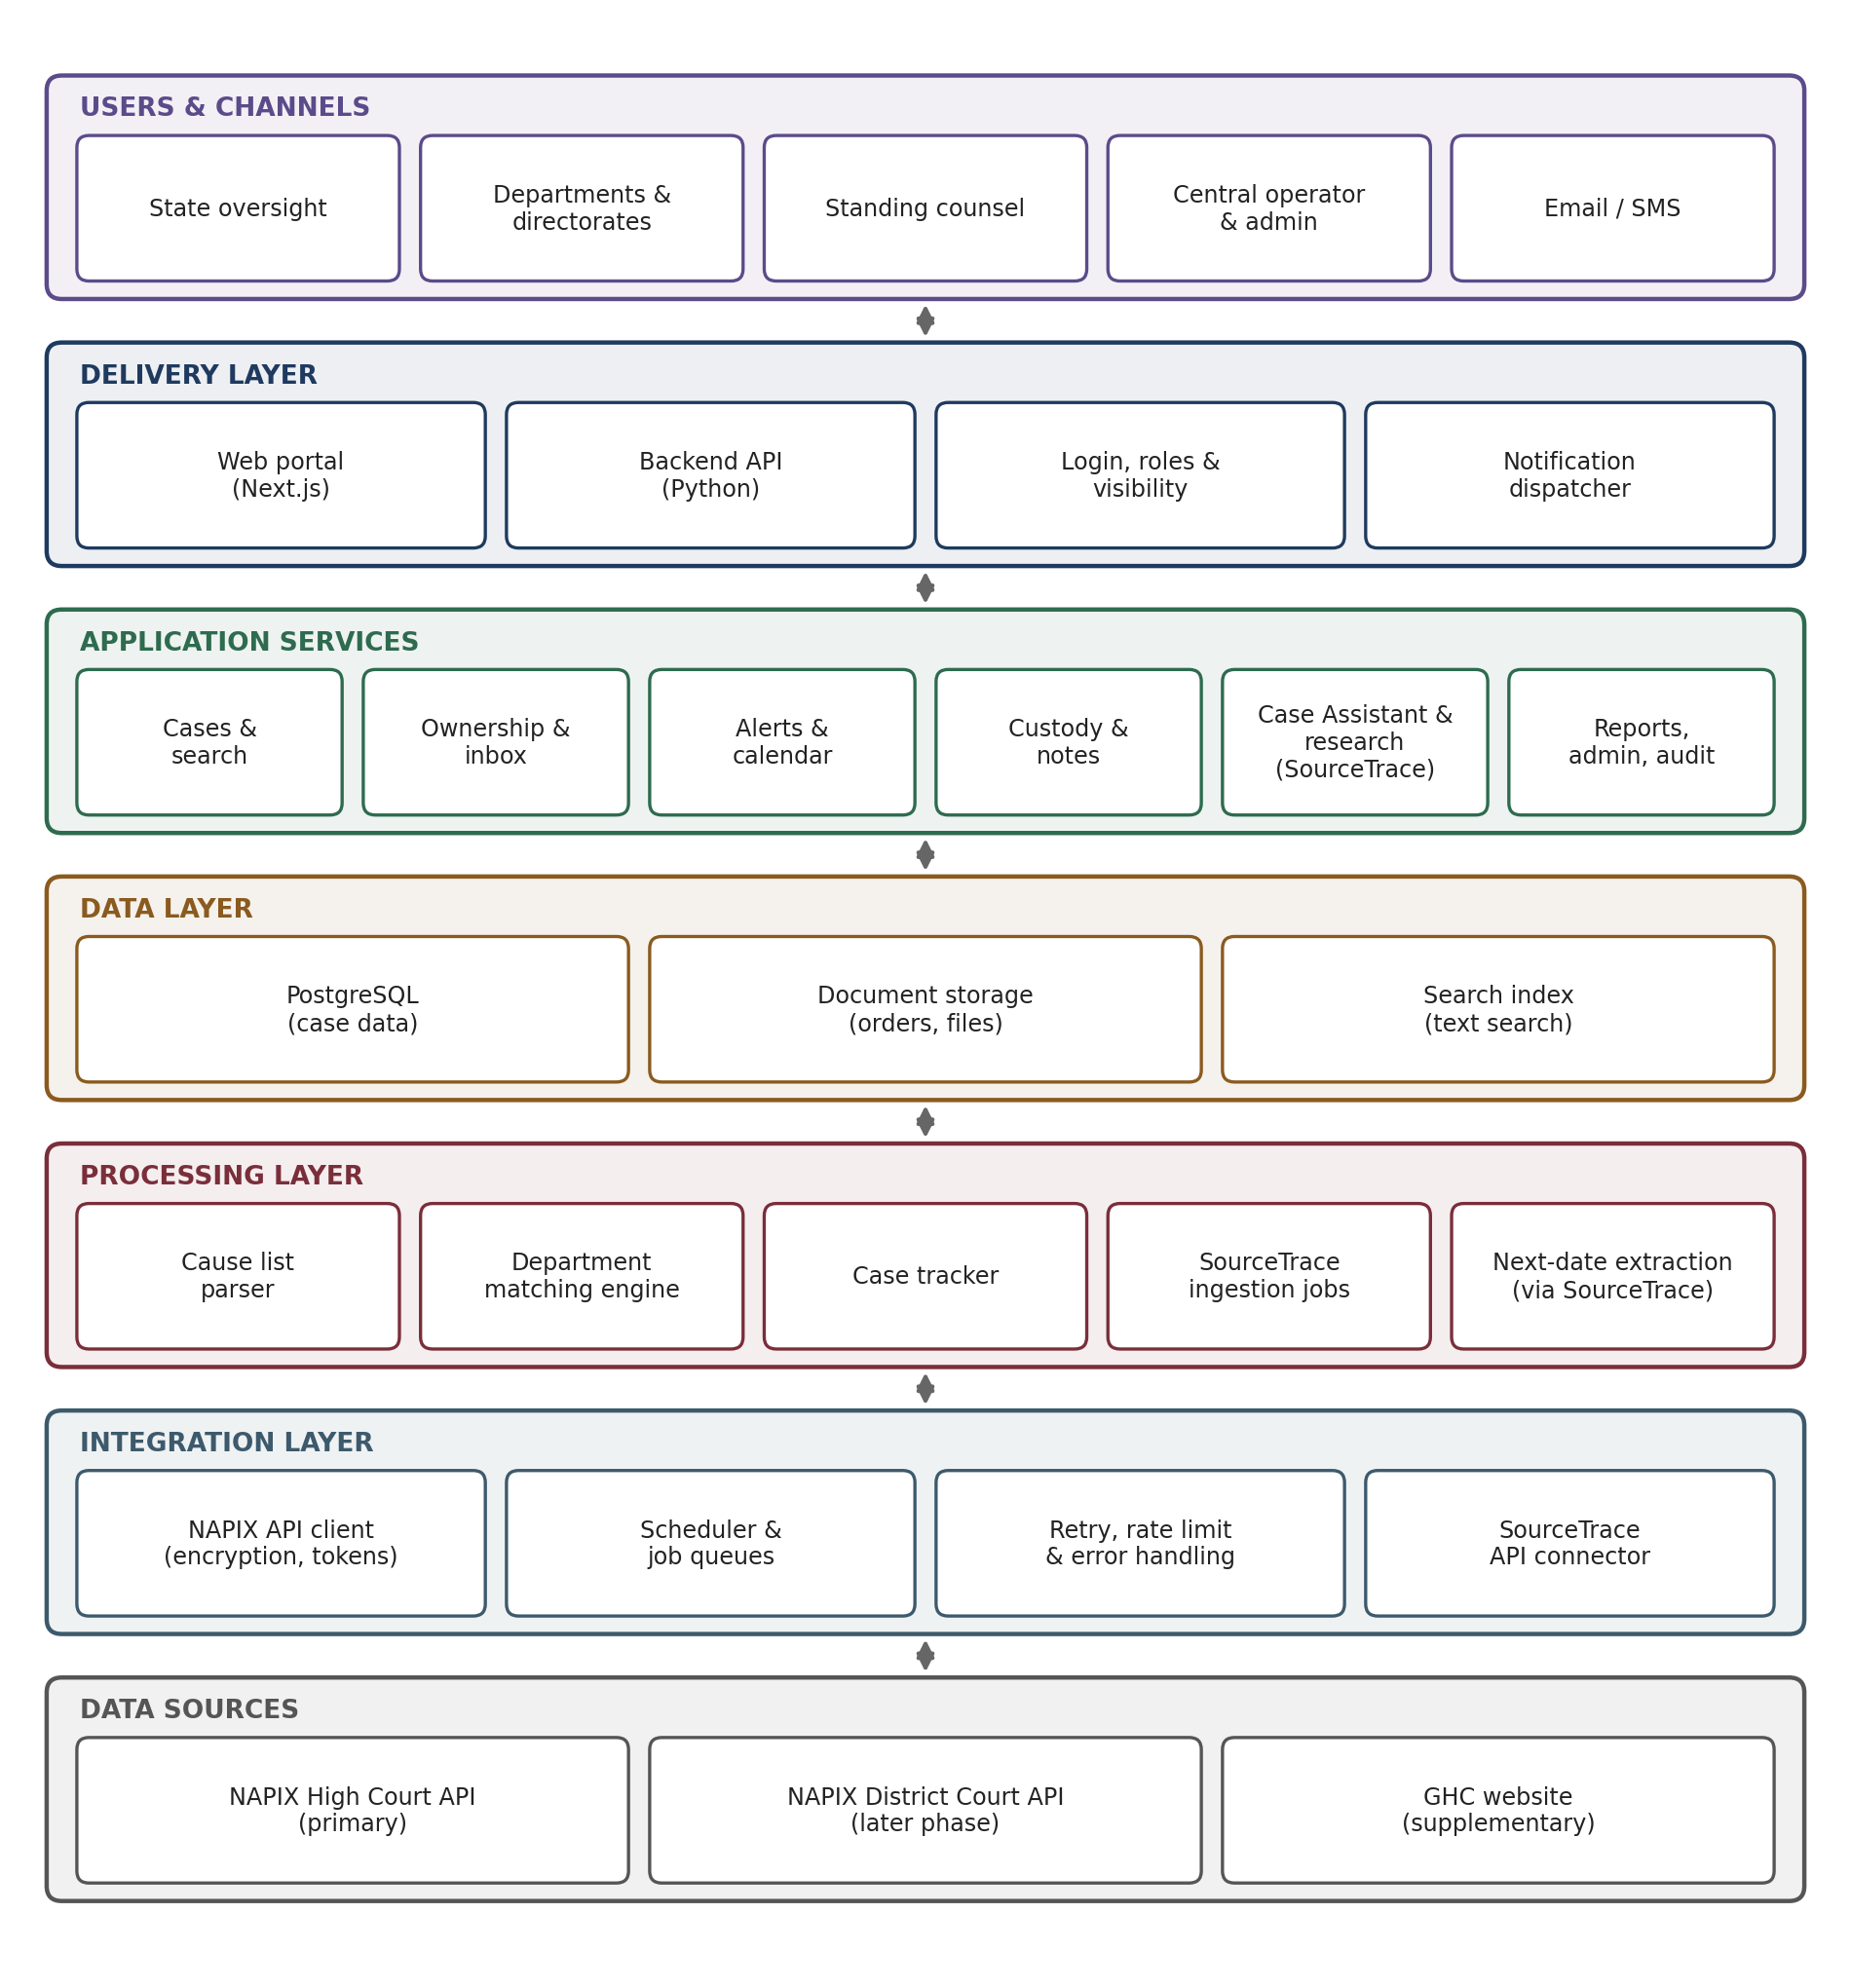
Figure 1: System architecture

2.1 Layers and components
Layer | Components and role
Data sources | NAPIX High Court API (primary source for cause lists, case details, orders and status); NAPIX District Court API (later phase); GHC website (supplementary, for cross-checking and gaps).
Integration layer | NAPIX API client that handles request encryption and tokens as required by the NAPIX specification; scheduler and job queues that run all data collection in the background; retry, rate-limit and error handling so that a failed call is retried and logged, never lost; SourceTrace API connector that ingests court orders into SourceTrace automatically, and sends Case Assistant questions, research and order-reading requests to it (Section 3.2).
Processing layer | Cause list parser (reads the official cause list document); department matching engine (codes, keywords and scoring); case tracker (daily refresh of tracked cases); automatic ingestion of new orders into SourceTrace; next-date extraction, with SourceTrace reading each order.
Data layer | PostgreSQL database for all case data; document storage for orders and uploaded files; search index for text search across cases and orders.
Application services | Business logic of the portal: cases and search, ownership and inbox, alerts and calendar, custody and notes, Case Assistant and research (through SourceTrace), reports, administration and audit.
Delivery layer | Backend API (Python) serving the portal; web portal (Next.js); login, roles and visibility rules applied to every request; notification dispatcher for in-app, email and SMS messages.
Table 2: Architecture layers

2.2 Technology
Component | Technology
Web portal (frontend) | Next.js
Backend API | Python (FastAPI)
Background jobs and scheduling | Celery with Redis
Database | PostgreSQL, with PgBouncer for connection pooling
Document storage | Server file storage, with a link to each file held in the database
Case research and reading orders | SourceTrace, the in-house RAG solution, connected through its API
Monitoring | Prometheus and Grafana for system health; Flower for background jobs
Deployment | Docker containers (Docker Compose)
Table 3: Technology stack

3. API Usage Map

3.1 NAPIX APIs
Table 4 lists every NAPIX High Court API the portal will use, what it is used for, when it is called, and which part of the portal it feeds. All calls go through the integration layer; no part of the portal calls NAPIX directly.
NAPIX API | Used for | When | Feeds
Cause List Bench | List of benches sitting on a date | Daily | Daily ingestion
Cause List Details | All cases listed before each bench | Daily, per bench | Department matching, hearing alerts, cause list archive
Show Cause List | Official cause list document, parsed as a cross-check | Daily | Cause list archive, parser
Search by CNR | Full case history: parties, advocates, hearings, orders list, linked cases | When a case is first seen; weekly full refresh | Case detail page, linked cases
Current Status | Next date, stage and decision date; many CNRs per call | Daily, for all tracked cases | Case tracker, alerts
Show Order | The order or judgment document for a given date | When a new order appears | Orders archive; ingestion into SourceTrace
Show Business | Business transacted in a case on a given date | With each new hearing | Proceedings timeline
Search by Case Number / Filing Number | Finding a specific case not yet in the database | On user search | Search
Search by Party Name / Advocate Name / Act | Finding cases by party, advocate or Act | On user search; scheduled department discovery | Search, department mapping
State, District, Bench Master | Reference codes | At setup; monthly | Administration
Table 4: NAPIX API usage
Department discovery. Besides the daily cause lists, each department's registered party names and keywords will be run periodically through the Search by Party Name API. This finds a department's pending cases even before they appear in a cause list.
Live verification. The NAPIX APIs will be tested live before development proceeds. Until the content of the Cause List Details API is confirmed to be complete, the official cause list document and the existing parser will be kept as a cross-check, and the GHC website as a supplementary source.

3.2 SourceTrace API
SourceTrace, the in-house RAG solution, is used for the Case Assistant, all case research, and reading court orders. The portal connects to it only through the SourceTrace API connector in the integration layer, using the SourceTrace APIs.
SourceTrace API | Used for | When | Feeds
Ingestion API | Adding each court order, and each court filing uploaded by users, to SourceTrace with its case details (CNR, case number, court, document date) | When a new order is downloaded or a court filing is uploaded | Case Assistant, research, next-date extraction
Query API | Reading an order to find the next-date direction; answering Case Assistant and research questions with references | After ingestion; on user request | Alerts, Case Assistant, legal research
Table 5: SourceTrace API usage
Automatic ingestion of court orders. Every court order is ingested into SourceTrace automatically, with no manual step, as shown in Figure 2:
- When a new order is downloaded through the Show Order API and stored, an ingestion job is placed in the background job queue.
- The job sends the order document and its case details to the SourceTrace ingestion API.
- The portal records the result against the order: its ingestion status (pending, ingested or failed) and the reference returned by SourceTrace.
- Failed ingestions are retried automatically. Orders that still fail are listed on an administration screen for attention.
- Once an order is ingested, the next-date extraction job asks SourceTrace, through the query API, to read the order and return the next-date direction.
The same mechanism is used for court filings uploaded by users (Section 5.6), and for the one-time ingestion of the existing 3,94,153 orders, run in batches so as not to overload either system.
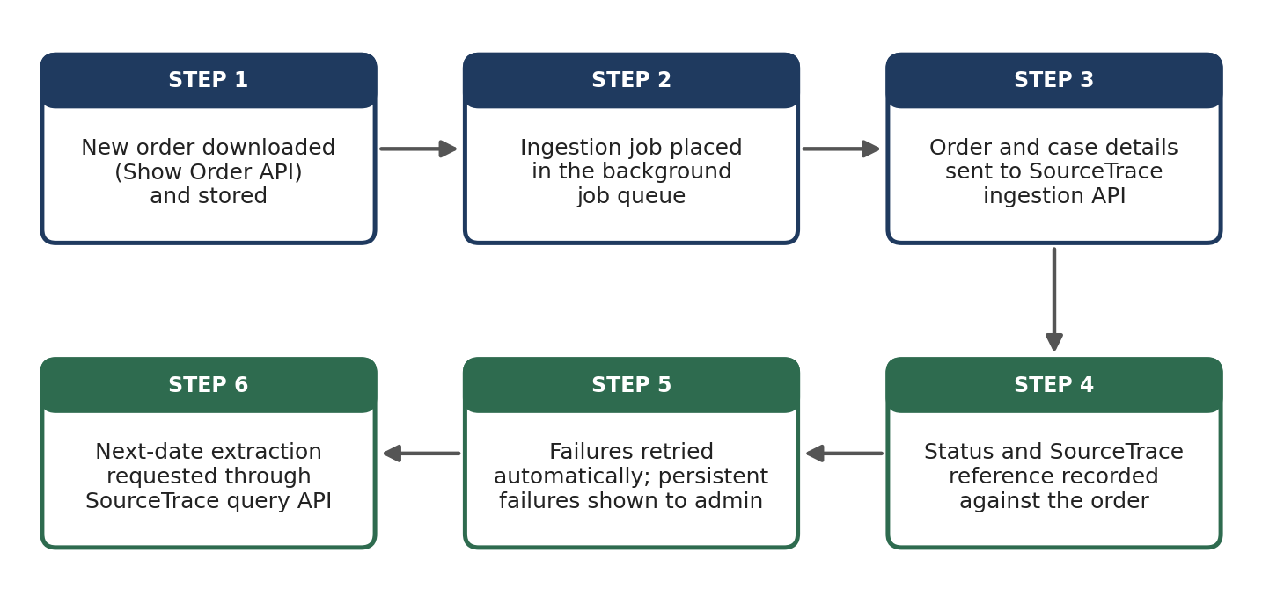
Figure 2: Automatic ingestion of court orders into SourceTrace

4. Department Case Mapping
Each day's cause list contains many cases of all kinds, of which only some concern a given department. The mapping function recommends each case to the department it most likely belongs to, so that departments mainly see their own cases. No case is assigned automatically: a case becomes a department's case only when the department claims it.

4.1 Codes and signals
Gauhati High Court cause lists show who appears for the government, usually as a standing counsel code in the advocate column (for example, “SC, EDU” or “PP, ASSAM”). Each code is mapped to its department in the administration module. The system scores every case for every department using the following signals:
- Standing counsel code: a mapped code in the cause list entry. This is the strongest signal.
- Keywords and name patterns: department names and designations appearing in the party names (for example, “Director of Secondary Education”).
- Linked-case history: if a related case, such as the original case behind an appeal, has already been claimed by a department, the new case leans toward that department.
- Watchlist: specific cases a department has asked to follow.

4.2 Probability score and recommendations
The signals are combined into a score between 0 and 1 for each department, and the score decides how prominently the case is recommended to each department, as shown in Figure 3 and Table 6. In every case, the department decides by claiming it.
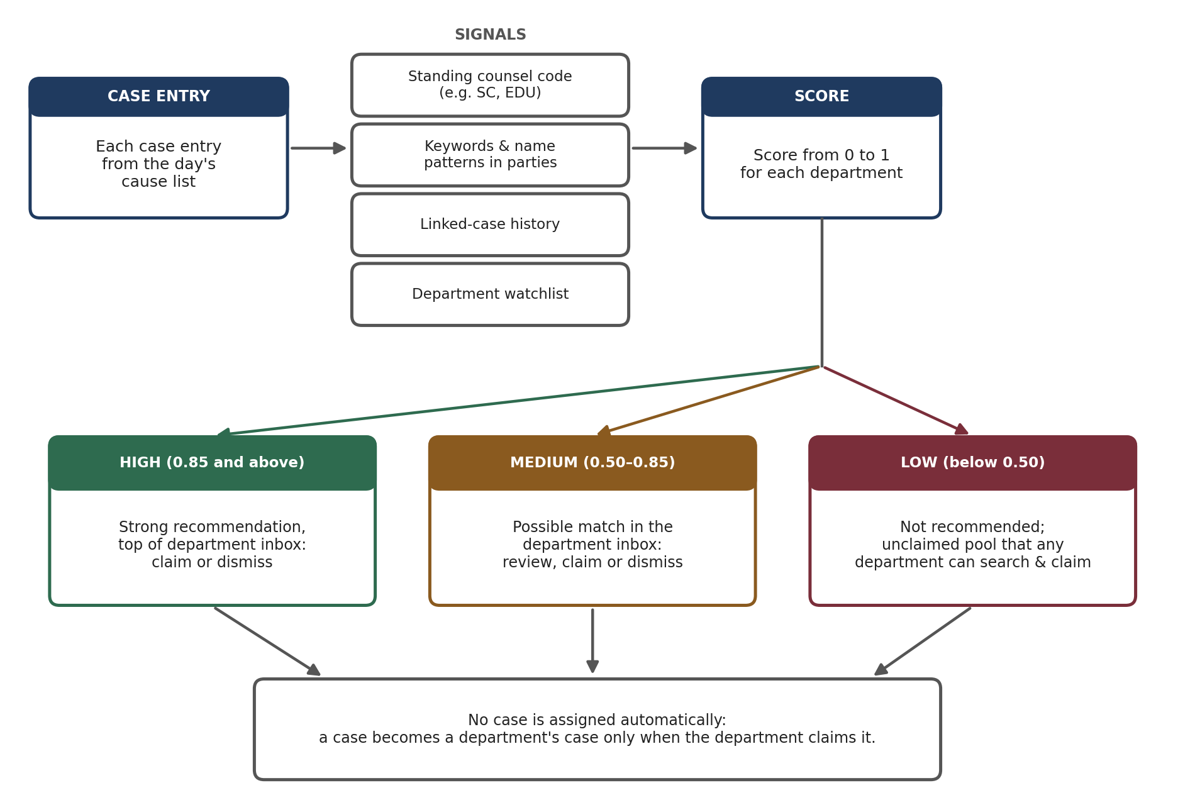
Figure 3: Department case mapping
Score | What happens
High (0.85 and above) | Shown at the top of the department's inbox as a strong recommendation. The department claims it, or dismisses it if it is not theirs.
Medium (0.50 to 0.85) | Shown in the department's inbox as a possible match, for the department to review and claim or dismiss.
Low (below 0.50) | Not recommended. Kept in the pool of unclaimed cases, which any department can search and claim manually.
Table 6: Recommendations by score
A department can also suggest another department for a case it dismisses, and the case is then recommended to that department. A case may be recommended to more than one department; if more than one claims it, one is recorded as the primary owner and the others as watchers who receive its updates. Cases left unclaimed are visible to the central operator for follow-up.

5. Portal Functionality Map
This section describes each module of the portal: what it does, its main features, where its data comes from, and which other modules it links to. Table 7 at the end gives a summary.

5.1 Dashboard
The first screen after login, showing each user what needs their attention. Its content depends on the user's role.
Key features
- State oversight: case counts by department, upcoming hearings across the State, overdue actions and compliance status.
- Department: new recommendations awaiting review, hearings this week, cases with pending action, and cases in custody of each office.
- Officer: own cases, own pending actions and own alerts.
Aspect | Details
Data and APIs | Portal database (cases, alerts, custody). No direct API calls; data is kept current by the daily cycle.
Links to | Case inbox, alerts and calendar, case detail page, reports.

5.2 Search
Finds any case, whether it is already held by the portal.
Key features
- Search by CINO, case number, party name or advocate name, with filters for status, year, case type and department.
- The portal's own database is searched first; if the case is not found, NAPIX search APIs are queried live, and the case is fetched and stored (Figure 7).
- Results respect visibility rules: users see full details only for cases within their access.
Aspect | Details
Data and APIs | Portal database; NAPIX Search by Case Number, Filing Number, Party Name and Advocate Name; Search by CNR for the full record.
Links to | Case detail page; case inbox (to claim a case found through search).

5.3 Case Detail Page
The complete view of a single case, organised in tabs.
Key features
- Overview: status, next hearing, court and bench, registration details, owning department and current custody.
- Parties and advocates; hearings and proceedings timeline; orders with view and download.
- Linked cases, with a relationship graph of appeals and connected matters.
- Custody, and the notes and files trail (Sections 5.7 and 5.8).
- Documents: court orders, and documents uploaded by users such as writ petitions and affidavits (Section 5.6).
- Case Assistant: an AI chat window for asking questions about the case, powered by SourceTrace (Section 5.9).
Aspect | Details
Data and APIs | Portal database, kept current through Search by CNR, Current Status, Show Business and Show Order APIs.
Links to | Orders and case documents, custody and workflow, notes trail, alerts, Case Assistant.

5.4 Department Case Inbox
Where a department review recommended cases and claims its own, based on the mapping in Section 4.
Key features
- Recommended: cases recommended to the department, strongest matches first, each with the signals behind its score, to claim or dismiss.
- Claimed: the department's own cases.
- Unclaimed pool: low-score and dismissed cases that the department can search and claim.
- Transfers: cases sent to or received from other departments.
Aspect | Details
Data and APIs | Matching engine output (from Cause List Details and Party Name Search APIs); portal database.
Links to | Case detail page, administration (codes and keywords).

5.5 Alerts and Hearing Calendar
Makes sure no hearing or court direction is missed.
Key features
- Calendar of upcoming hearings for the user's cases, with critical (within 48 hours) and this-week highlights.
- Next dates from orders: specific dates are read directly; periods such as “list after two weeks” are identified by SourceTrace and counted from the order date; unclear directions are flagged for manual review (Figure 6).
- Compliance alerts for actions the court has directed, with due dates.
Aspect | Details
Data and APIs | Cause List Details (listed hearings); Current Status (next date); Show Order and SourceTrace (next dates from orders).
Links to | Notifications, case detail page, dashboard, custody (alerts go to the current custody holder).

5.6 Orders and Case Documents
Holds every document of a case in one place: the court orders collected automatically, and the documents uploaded by users, such as writ petitions and affidavits. Documents are available from the Documents tab of the case detail page.
Key features
- Court orders: every order of every tracked case, stored with its date, for view and download. Text is extracted so orders can be searched by content, and each new order is ingested into SourceTrace automatically (Section 3.2).
- Document upload: users with access to a case can upload documents to it, such as the writ petition, affidavit-in-opposition, reply, rejoinder, interlocutory applications, annexures, compliance reports, parawise comments and instructions to counsel.
- Each upload records the document type, date, a short description, and who uploaded it from which office. PDF, Word and image files are accepted.
- Document types are grouped as court filings (documents filed in or received from the court) and internal documents (such as parawise comments and instructions to counsel).
- Visibility is set per document, as for notes: the whole case, shared with counsel, or private to the office.
- Court filings are ingested into SourceTrace in the same way as orders, so the Case Assistant can use them. Internal documents are not sent to SourceTrace.
- All documents can be viewed and downloaded from the case page, subject to their visibility.
Aspect | Details
Data and APIs | Show Order API (court orders); uploads by users; document storage; text search index; SourceTrace ingestion API.
Links to | Case detail page, alerts (next-date extraction), Case Assistant, notes trail (attachments), audit log.

5.7 Custody and Workflow
Shows, for every case, which office and officer currently hold it and what action is pending, similar to file movement in eOffice.
Key features
- Custody card: holder office and officer, pending action, since when, and due date.
- Requests between offices, for example a department asking a directorate for parawise comments, with stages and due dates.
- Hand-over of a case to another office, recorded with a note.
Aspect | Details
Data and APIs | Portal database only (internal workflow; no court API).
Links to | Notes trail, alerts, dashboard, reports (pending actions by office).

5.8 Case Notes Trail
An official noting history that belongs to the case and follows it across every custody move.
Key features
- Notes by type: general, instruction, opinion, hearing note, compliance, decision, hand-over.
- Each note records the author's name, designation and office at the time; notes cannot be edited or deleted, and corrections are added as new notes linked to the original.
- Attachments on notes; visibility set per note (whole case, shared with counsel, or private to the office).
Aspect | Details
Data and APIs | Portal database and document storage.
Links to | Case detail page, custody and workflow, audit log.

5.9 Case Assistant and Legal Research
All case research is carried out through SourceTrace, the in-house retrieval-augmented generation (RAG) solution. Its main use in the portal is the Case Assistant: an AI chat window on every case page, where users ask questions about the case and get answers drawn from the case's own orders, related past cases, and the Acts, rules and policies uploaded to SourceTrace. It helps officers and counsel understand the case and prepare their notes for presenting before the court.
Key features
- Chat on every case page. The Case Assistant opens from the case detail page. With each question, the portal passes the case's context to SourceTrace (its CNR, case details, orders and court filings), so answers are about that case.
- What it draws on. The case's own orders and court filings, such as the writ petition; orders and judgments in related past cases; and the Acts, rules and policies uploaded to SourceTrace.
- Answers with references. Every answer cites the source documents, such as a particular order or a section of an Act, and each reference opens in the portal, so the user can check it before relying on it.
- Preparing notes. A useful answer can be copied, with its references, into a new note in the case notes trail (Section 5.8), where it is taken forward like any other note.
- Conversation history. Each user's conversation on a case is saved, so they can return to it later. It is visible only to that user.
- General research. Users can also ask questions or search across all orders and uploaded Acts, rules and policies without starting from a particular case.
- What is sent to SourceTrace. Court orders and uploaded court filings are ingested automatically (Section 3.2), and Acts, rules and policies are uploaded to SourceTrace. Departments' notes and internal documents are not sent to SourceTrace.
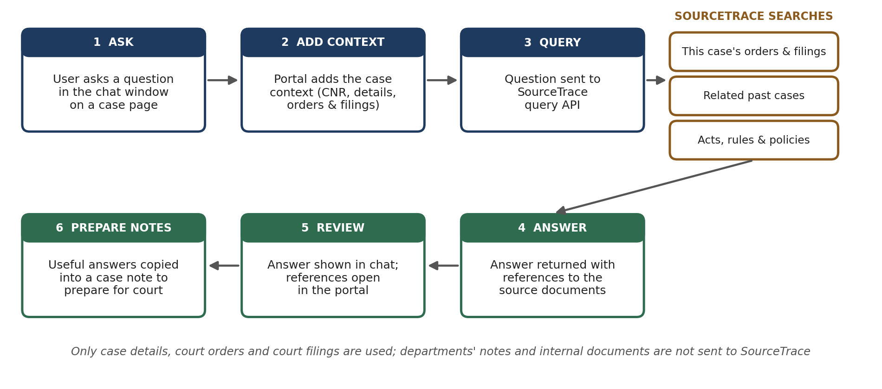
Figure 4: Case Assistant
Aspect | Details
Data and APIs | SourceTrace query API, through the SourceTrace API connector; court orders (ingested from the Show Order API), uploaded court filings, and Acts, rules and policies held in SourceTrace; case details from the portal database.
Links to | Case detail page, case notes trail, orders and case documents.

5.10 Reports
Management information for departments and State oversight.
Key features
- Pending cases by department, court and age; hearings and disposals over a period.
- Pending actions and overdue compliance by office.
- Data collection health: status of the daily data cycle, and any failed API calls or SourceTrace ingestions.
Aspect | Details
Data and APIs | Portal database. Reports can be exported to Excel and PDF.
Links to | Dashboard, case inbox, custody.

5.11 Administration
Setup and configuration of the portal.
Key features
- Departments, directorates and offices, in the government hierarchy.
- Code-to-department mapping, and keywords and name patterns used for recommendations.
- Users and roles; notification settings; reference data from NAPIX masters.
Aspect | Details
Data and APIs | Portal database; NAPIX State, District and Bench Master APIs.
Links to | Department mapping, case inbox, notifications, all modules (through roles).

5.12 Notifications
Delivers alerts and updates to the right people.
Key features
- In-app and email for all alerts; SMS for high-priority alerts, such as a hearing within 48 hours.
- Recipients chosen from the case owner, custody holder and watchers.
- Daily digest option to avoid excessive messages.
Aspect | Details
Data and APIs | Alerts and workflow events; email and SMS gateways.
Links to | Alerts, custody, case inbox.

5.13 Audit Log
A permanent record of every significant action in the portal.
Key features
- Logins, ownership decisions, custody moves, notes, file uploads and configuration changes.
- Searchable by user, case and date; read-only for auditors.
Aspect | Details
Data and APIs | Portal database (append-only).
Links to | All modules.

5.14 Summary
Module | Main NAPIX APIs | Main links
Dashboard | None directly | Inbox, alerts, case page, reports
Search | Case/Filing No., Party, Advocate search; CNR | Case page, inbox
Case detail page | CNR, Current Status, Show Business, Show Order | Documents, custody, notes, alerts, Case Assistant
Case inbox | Cause List Details, Party Name search | Case page, admin
Alerts and calendar | Cause List Details, Current Status, Show Order | Notifications, custody
Orders and case documents | Show Order; uploads by users | Case page, alerts, Case Assistant
Custody and workflow | None (internal) | Notes, alerts, reports
Notes trail | None (internal) | Case page, custody, audit
Case Assistant and research | SourceTrace query API (orders from Show Order) | Case page, notes, orders
Reports | None directly | Dashboard, inbox, custody
Administration | State, District, Bench Master | All modules
Notifications | None | Alerts, custody, inbox
Audit log | None | All modules
Table 7: Modules, APIs and links

6. End-to-End Flows

6.1 Daily data cycle
Every day, before court hours, the scheduler runs the complete collection cycle for the next cause list date. By the time users log in, the day's cases have been matched to departments and alerts are up to date.
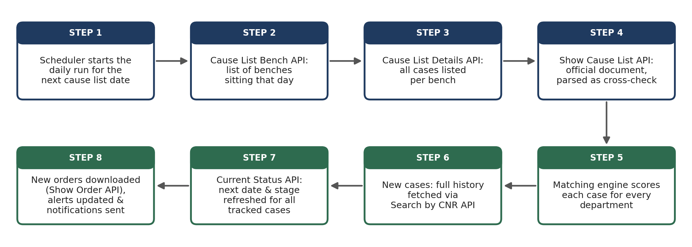
Figure 5: Daily data cycle

6.2 From court order to alert
When a new order appears for a tracked case, it is downloaded, its text is extracted, and the next-date direction is identified. The resulting date feeds the alerts calendar.
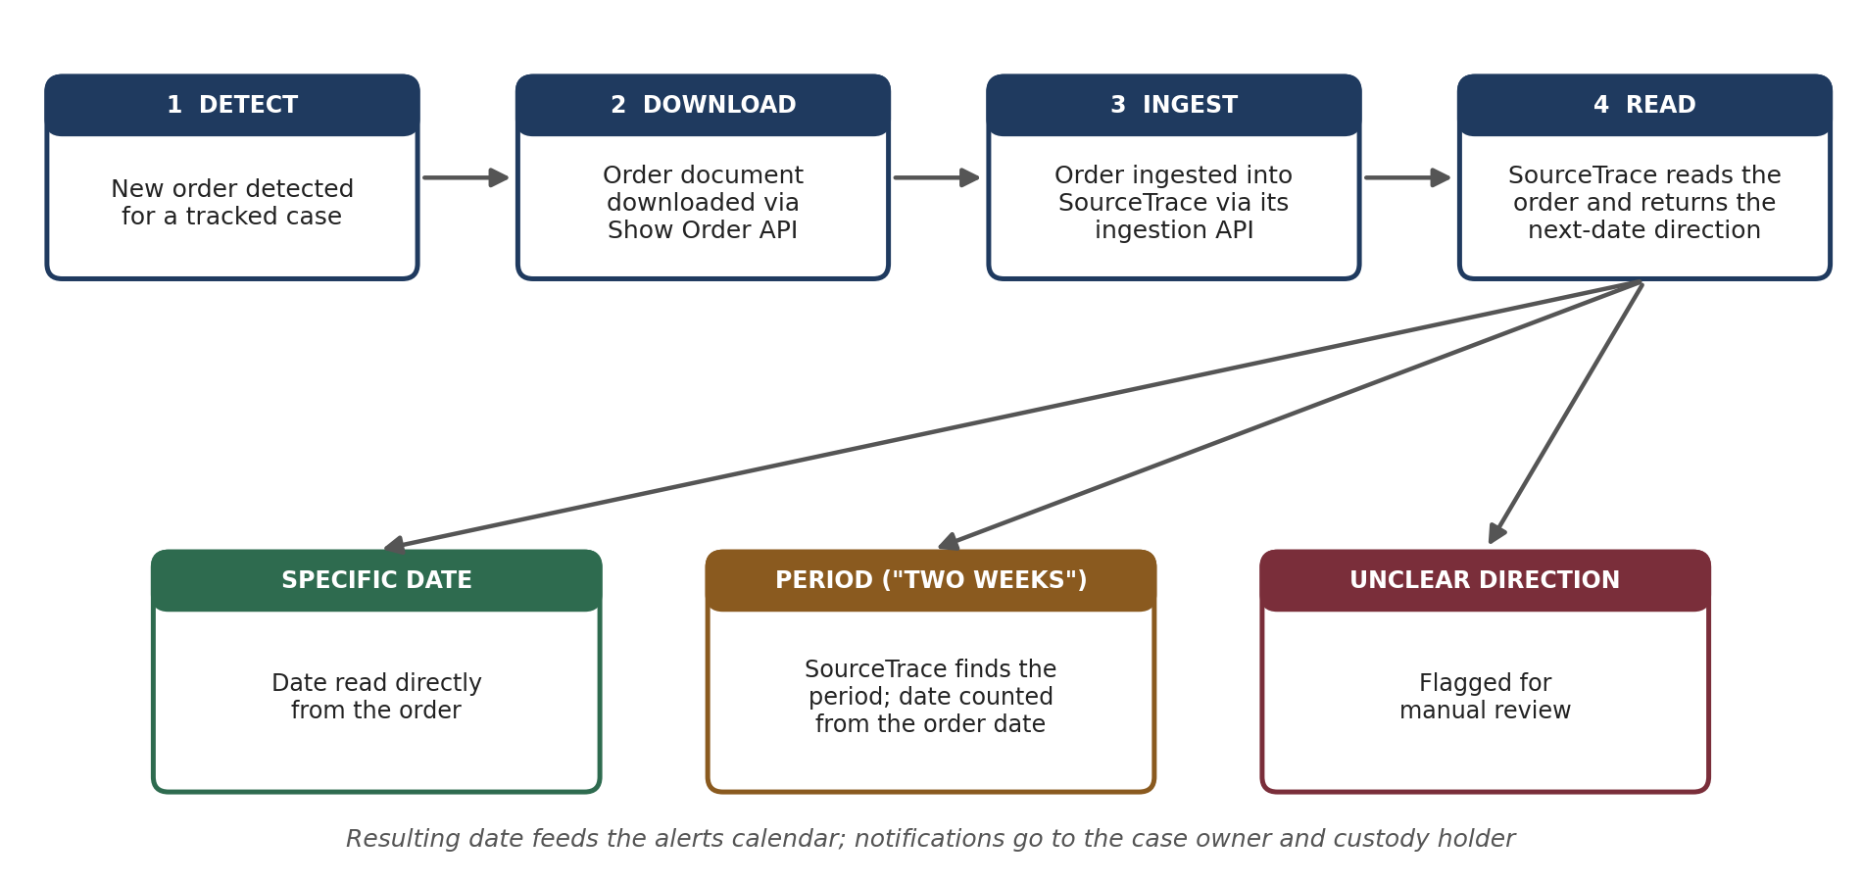
Figure 6: From court order to alert

6.3 Searching for a case
Search uses the portal's own database first, and reaches the court APIs only when a case is not yet held. A case found through live search is stored, so the next search finds it locally.
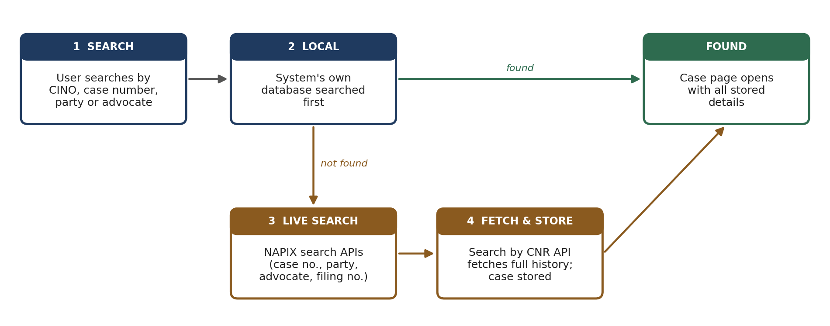
Figure 7: Search flow
The routing of a new case to its department is shown in Figure 3 (Section 4).

7. Data Layer
All data is held in the portal's own PostgreSQL database and document storage. It is organised in the groups shown in Table 8.
Data group | Contents
Organisation | Departments, directorates, offices, users and roles.
Cases | Cases, parties, advocates, hearings and linked cases, identified by CNR (CINO).
Cause lists | Daily cause lists and the case entries listed in them.
Ownership and matching | Codes, keywords and patterns; scores, recommendations, claims and dismissals.
Workflow and custody | Custody records, requests between offices, and their stages.
Case notes | The notes trail and its attachments.
Documents | Court orders, and documents uploaded by users (court filings and internal documents), with extracted text and visibility settings.
Alerts and notifications | Next dates, alerts, and the notifications sent.
SourceTrace links | Ingestion status and SourceTrace reference for each order, and each user's Case Assistant conversations; the research index itself is held in SourceTrace.
Audit | The permanent record of actions.
Table 8: Data groups
Migration of existing data. The data already collected by the scraping-based system (86,219 cases, 3,94,153 orders and 55,128 case links) will be migrated into the new database and then kept current through the NAPIX APIs, so no history is lost. The existing orders will also be ingested into SourceTrace in batches, using the same ingestion mechanism.

8. Security and Deployment

8.1 Security
- Login: individual user accounts with one-time password (OTP) verification.
- Access control: role-based permissions and the visibility hierarchy (State, department, directorate) applied to every request.
- Data protection: all data kept on government infrastructure; all AI work, case research and reading orders, is carried out on the in-house SourceTrace solution, so no case data is sent to any cloud AI service; NAPIX credentials stored securely and never exposed to the browser.
- Accountability: every significant action recorded in the audit log; notes cannot be edited or deleted.
- Uploads: only permitted file types (PDF, Word, images) accepted, with a size limit, and every upload scanned for viruses before it is stored.8.2 Deployment
The system runs as a set of Docker containers, which makes it straightforward to move between environments. It will first be deployed on a pilot server for testing with a small number of departments, and then on the State Data. Regular database and document backups, and system monitoring through Prometheus and Grafana, will be in place from the pilot stage.

9. Phasing
Development is planned in three phases, so that the core of the portal is in use early, and the more advanced functions are added on a working base.
Phase | Scope
Phase 1: Core | Live testing of NAPIX APIs; migration of existing data; daily data cycle through NAPIX; department case mapping and inbox; case tracking; orders archive; case document upload; alerts for orders with specific dates; search; case detail page; administration; login and roles; in-app and email notifications; dashboard.
Phase 2: Workflow | Custody and workflow; case notes trail; automatic ingestion of orders and uploaded court filings into SourceTrace, including the existing orders; SourceTrace-based alerts for orders that state a period of time; SMS notifications; reports.
Phase 3: Extension | Case Assistant and legal research through SourceTrace, including the Acts, rules and policies, and District Court cases through the NAPIX District Court API.
Table 9: Development phases

10. Annexure B: Indicative UI Screens
The screens below show how the main parts of the portal are intended to look. They are design mockups: the case numbers, names, officers and counts shown are sample data for illustration, and the Case Assistant answers use placeholders in place of real legal content.
Department dashboard
The first screen for a department: counts of recommended cases, upcoming hearings and pending actions; upcoming hearings with those within 48 hours marked; and items needing attention, including next dates read from new orders (Section 5.1).
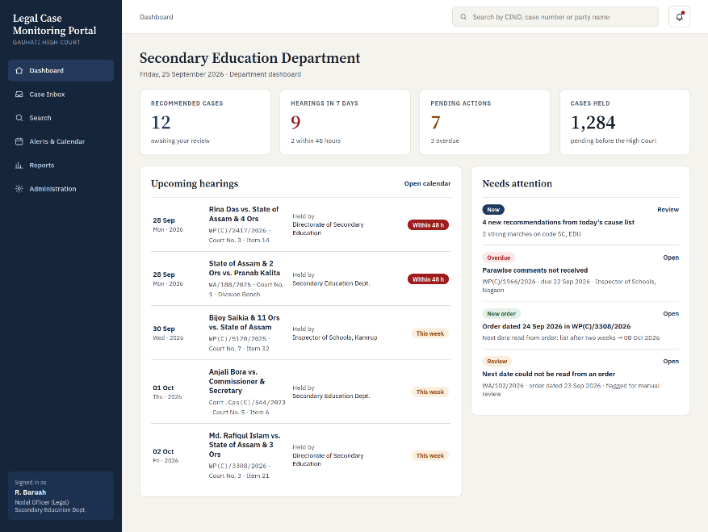
Figure: Department dashboard
Case inbox
Cases recommended to the department from the daily cause lists, with their score and the signals behind it. The department claims or dismisses each case or suggests another department; no case is assigned automatically (Sections 4 and 5.4).
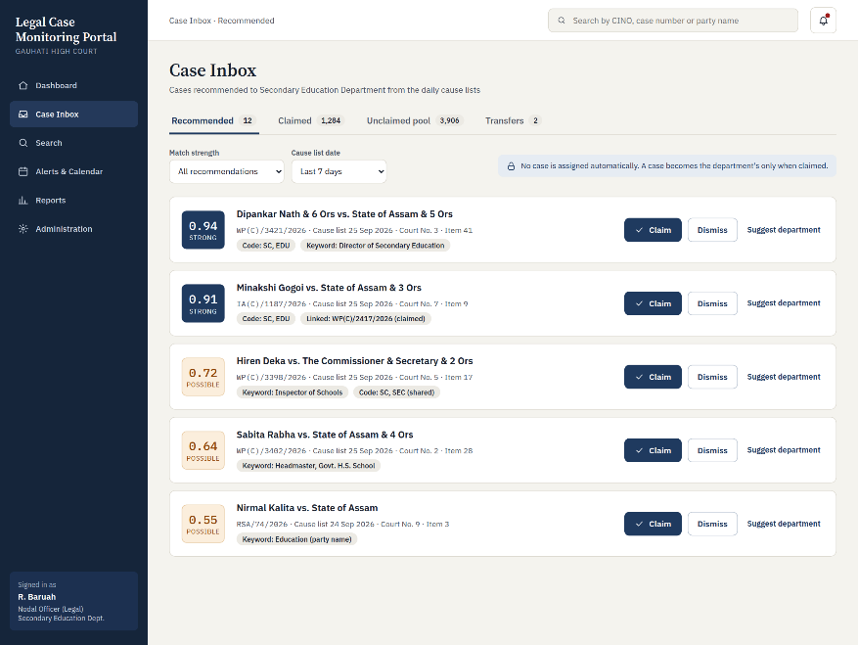
Figure: Case inbox
Department mapping
The administration screen where standing counsel codes, as they appear in the cause list, are mapped to departments (Sections 4.1 and 5.11).
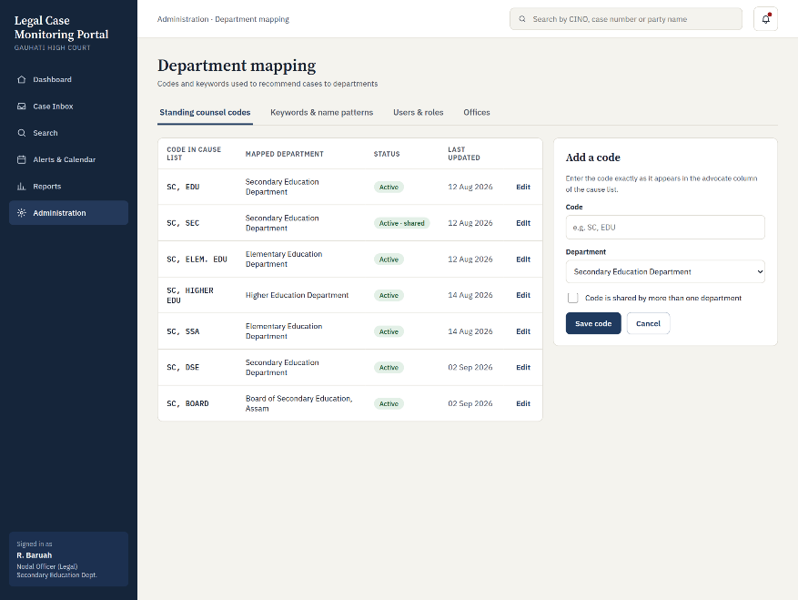
Figure: Department mapping

Case detail
The overview of a case: next hearing, parties and advocates, proceedings, current custody and pending action, the latest order with the next date read by SourceTrace, and ownership (Sections 5.3 and 5.7).
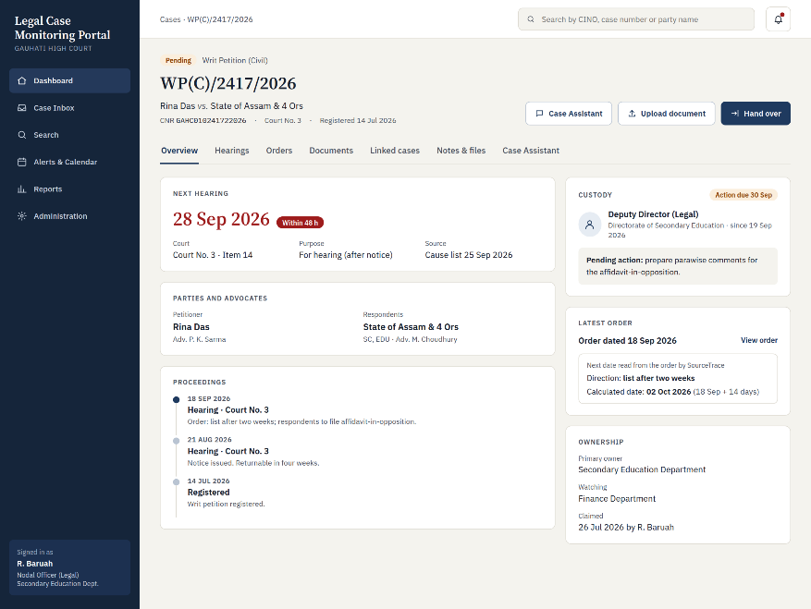
Figure: Case detail
Case documents and upload
Court orders, court filings and internal documents of a case, each marked with whether it is available to the Case Assistant and who can see it, with the upload panel alongside (Section 5.6).
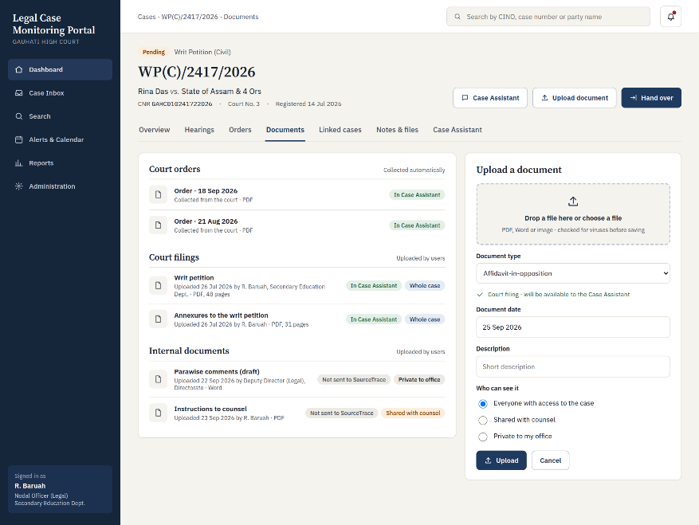
Figure: Case documents and upload

Case Assistant
The AI chat on a case page, powered by SourceTrace. Answers cite their sources and can be copied into a case note; the side panel shows the sources used (Section 5.9).
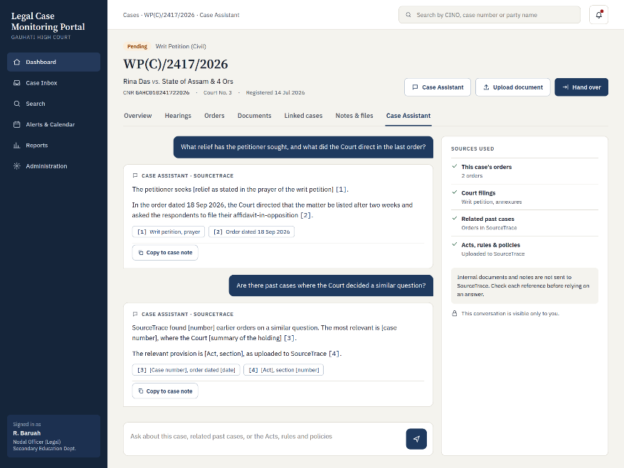
Figure: Case Assistant

