1. Executive Summary
The Legal Case Monitoring System is being developed to help government departments keep track of their cases before the Gauhati High Court and act on court directions in time. This report sets out what has been achieved so far using a website scraping methodology, and the proposed way forward.
Using the daily cause lists published by the Gauhati High Court from January 2025 to August 2026, the system has built a complete database of all cases listed over the period. Every case was extracted from the cause lists, and its full details and court orders were then collected from the High Court portal, including older cases linked to the listed ones. All data collected, including every court order, is held by the system itself. The court orders are used to find the next date fixed by the court, so that alerts can be raised before the hearing.
As the complete database is already in place, the portal displays cases to users directly from it. The system was first aimed to be developed for the Education Department, whose cases were planned to be identified using keywords but later this approach was changed to serve all the state government departments.
Currently:
- All daily cause lists from January 2025 to August 2026 downloaded and stored.
- 86,219 cases captured with their full details, including older cases linked to those in the cause lists.
- 3,94,153 court orders downloaded and stored.
- 55,128 links between related cases (appeals, interlocutory applications and connected matters) identified.
- A working web portal with a dashboard, hearing alerts, search, and a detailed view of each case. The portal (http://157.20.175.203/ghc-ui/) is being currently hosted in the state data center where 2 staging VM’s (one for application and one for database) was allotted for the development and testing of this.
- Sample verification against the court portal, which found the stored data to be accurate.
The next phase proposes moving from the current collection methods to the official eCourts / High Court APIs (NAPIX), for which access has been approved, while continuing to maintain the system's own database. It also proposes extending the system to all departments through department-specific case filters and extending alerts to court orders that state the next date as a period of time.

2. Methodology: The Scraping Pipeline
The system works as a pipeline of eight steps. The first four steps process the cause lists, and the next three collect the details, orders and alerts for every case, building a complete database of all cases listed from January 2025 to August 2026. The final step is the portal, through which users find cases in this database. Figure 1 gives an overview, and each step is described below.
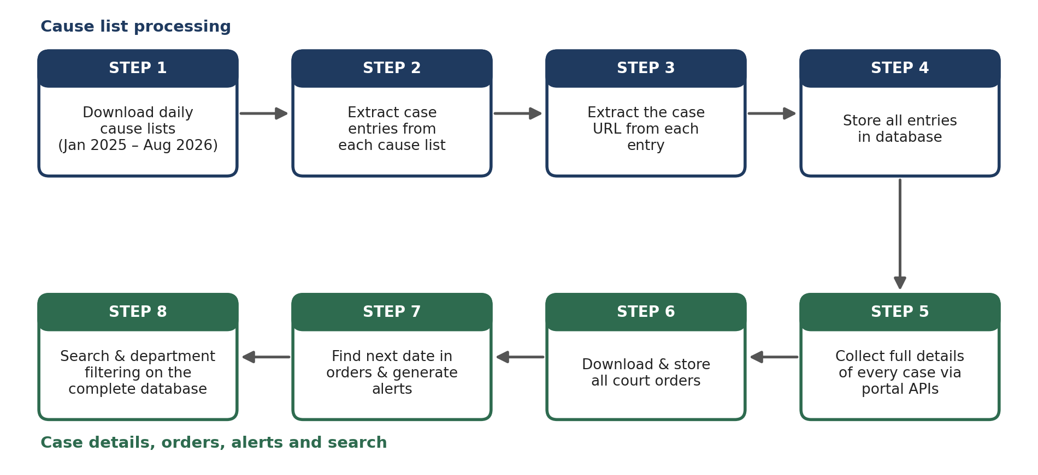
Figure 1: The eight-step scraping pipeline

Step 1: Downloading the daily cause lists
The Gauhati High Court publishes a cause list every working day, listing the cases to be heard in each court. These are published as PDF documents on the High Court website. All cause lists from January 2025 to August 2026 have been downloaded and stored, so that the original of each can always be referred back to.

Step 2: Extracting case entries from each cause list
Each cause list PDF is read by the system and broken down into individual case entries. For every case listed, the cause list gives the case number, the main parties, the petitioner's advocate, the respondent's advocate, and the court number and division bench before which the case is listed. The system separates these details using regular expressions (text-pattern rules) and stores each as a separate field in the database.

Step 3: Extracting the case URL
Each case entry in the cause list carries a URL leading to that case's detail page on the High Court website. The system extracts this URL for every case, so that the full record of the case can be reached later without any manual searching.

Step 4: Storing the cause list data
All the extracted details, together with each case's URL, are stored in the database tables. This forms the base record of every case that has appeared in the cause lists over the period.

Step 5: Collecting the full case details
The High Court portal has exposed direct access APIs through which the details of a case can be accessed directly. For every case captured from the cause lists, the system uses the stored URL to identify the case and calls these APIs to collect the additional details available for it. These include the parties and their advocates, filing and registration details, the history of hearings with the court and bench, the current status of the case, and any linked cases such as appeals or interlocutory applications. These details form the main case details table in the database.
Linked cases are also captured in full, even where they are older than the period covered. For example, if a case listed in 2025 is linked to a case filed in 2021, the details of the 2021 case are collected and stored as well.

Step 6: Downloading the court orders
The system then downloads all court orders associated with each case from the High Court website. The order documents are kept in the system's file storage, and the database holds a record of each order with its date and a link to the stored file, so that any order can be opened from within the system, independent of the website.

Step 7: Finding the next date and generating alerts
Alerts are generated from the most recent court order of each case. Court orders state the next date in one of two ways:
- A specific date (for example, “list on 15.10.2026”). The date is read from the order, and an alert is set for it. Alerts are currently generated for these orders.
- A period of time (for example, “the matter will be listed after two weeks”). Alerts are not yet generated for these orders; this is planned as part of the way forward (Section 6).
The alerts appear on the dashboard, with cases due within 48 hours marked as critical and cases due in the coming week highlighted separately.

Step 8: The portal: search and department filtering
With the complete database in place, the portal displays cases to users directly from it, without going back to the High Court website. Users can search for any case by its CINO, case number or party name.
A single day's cause list contains a large number of cases of all kinds, of which only some concern a particular department. When the system was first used for the Education Department, the department supplied a set of keywords (for example, the names and designations under which it appears as a party), and the system used these to pick out the department's cases from the cause lists.

3. Data Collected So Far
Table 1 summarises the data held by the system because of the steps above.
Item | Quantity
Cause lists downloaded and stored | All cause lists, January 2025 to August 2026
Cases captured with full details | 86,219
Court orders downloaded and stored | 3,94,153
Links between related cases | 55,128
Table 1: Data held by the system
This data forms a searchable repository of cases and court orders that will also be useful for providing it to the SourceTrace application for case research. The database tables in which it is held are listed in Annexure B.

4. Data Verification
To confirm that the scraping methodology captures and stores the data correctly, the data held by the system was checked against the Gauhati High Court's own portal.
As there are hundreds of cause lists, each containing hundreds of cases, checking every case manually was not done. The check was therefore carried out on a sample basis, which is the standard approach for verifying data at this scale, in two levels:
- Cause lists: a random sample of cause lists was selected from across the period.
- Cases: from these cause lists, cases were selected at random, and the details held in the database for each were compared with the details shown on the court portal.
The comparison found the data in the database to be accurate against the court portal data.

5. The Portal
The collected data is presented to users through a web portal. The main screens are shown below.
Dashboard and hearing alerts. The dashboard opens with the cases that need immediate attention, sorted by how soon they are listed, with the case number, next hearing date and court number for each.
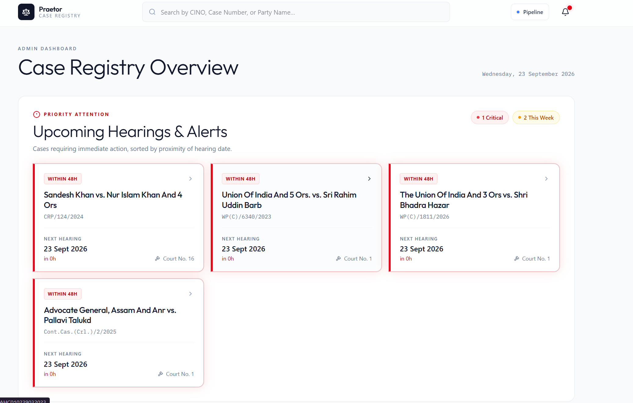
Figure 2: Dashboard showing upcoming hearings and alerts
Registry overview and upcoming cases. Summary figures show the total cases, orders and linked cases held, followed by a list of upcoming cases with their type and next hearing date.
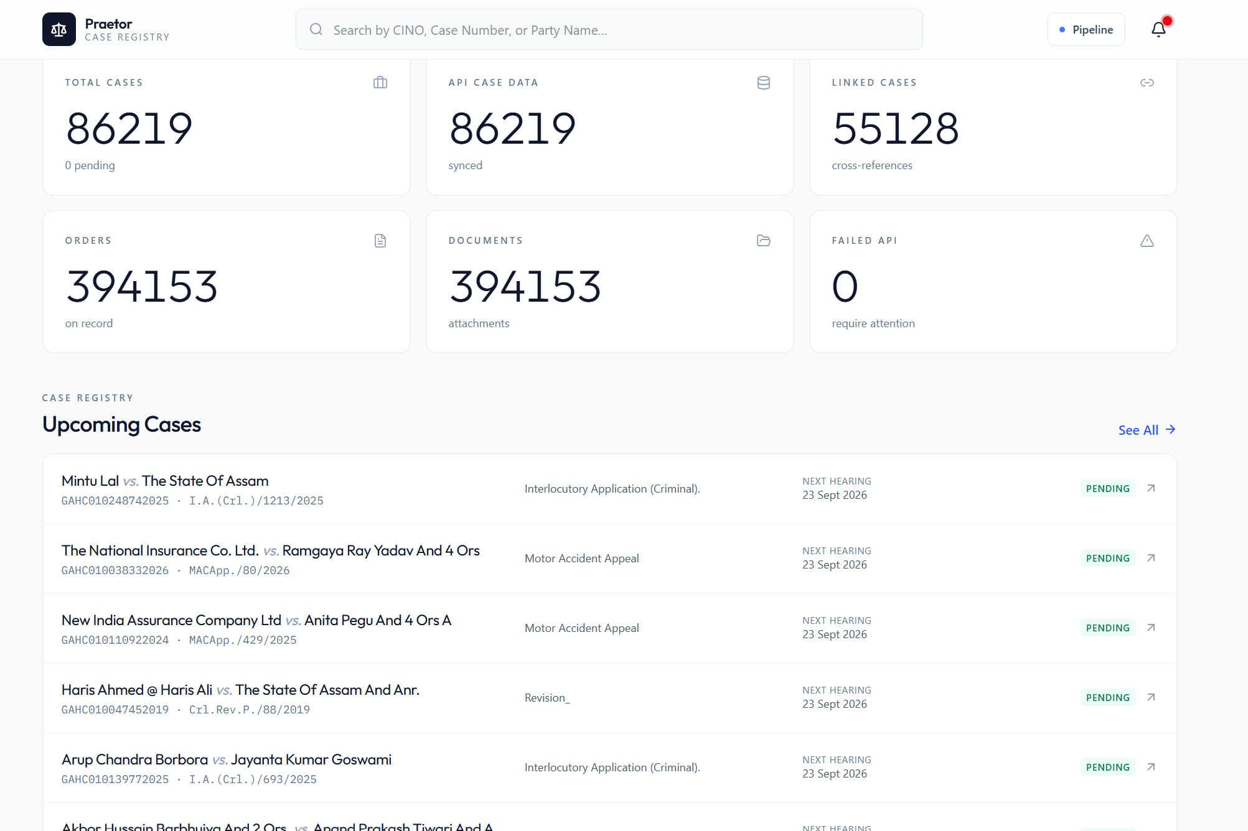
Figure 3: Summary figures and list of upcoming cases
Case detail. Each case has its own page showing the next hearing, number of orders, linked cases, registration details, and the parties with their advocates.
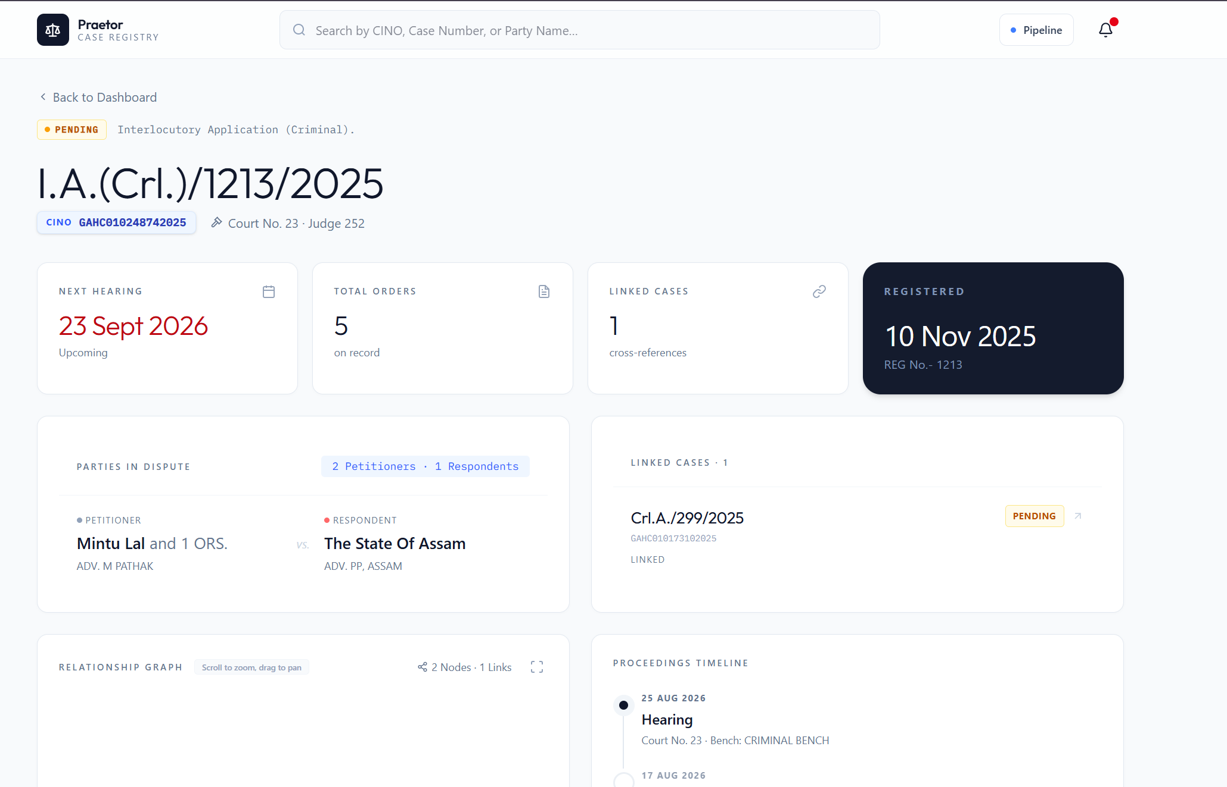
Figure 4: Case detail page
Linked cases, proceedings and orders. The case page also shows a graph of related cases, a timeline of past hearings with court and bench, and the list of court orders, each of which can be viewed or downloaded.
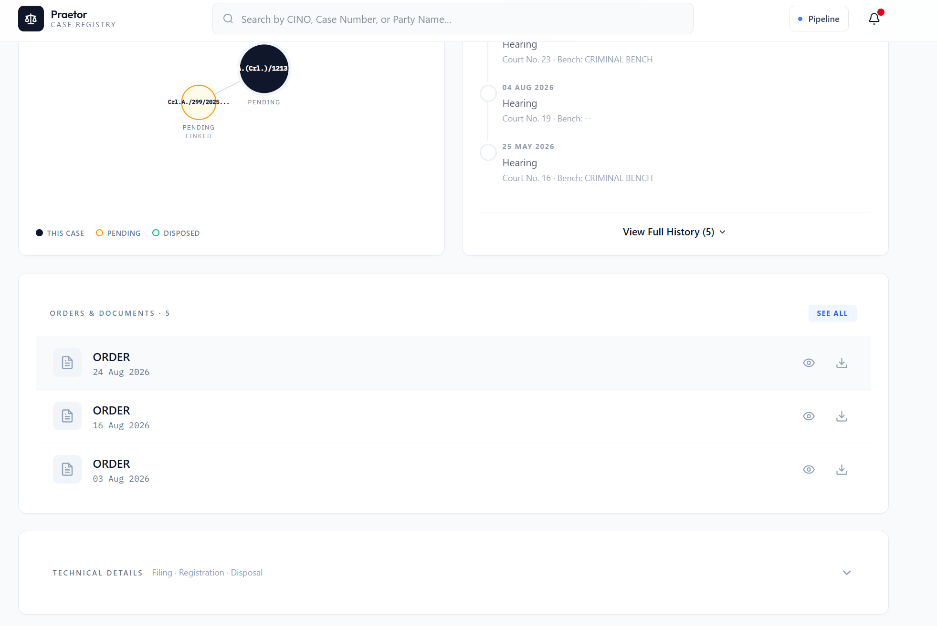
Figure 5: Relationship graph, proceedings timeline and court orders

6. Way Forward
The work so far has shown that the Gauhati High Court's case data can be collected, stored and turned into useful alerts. The next phase builds on this in the following ways:
- Moving to official APIs. Access to the official eCourts and High Court APIs (NAPIX) has been approved. Unlike the APIs exposed by the High Court portal, which are not a formally documented service and can change without notice, the NAPIX APIs are formally provided and documented, with authorised access. It is proposed to replace the current collection mechanism, both the cause list scraping and the use of the portal's exposed APIs, with the NAPIX APIs. A detailed proposal will be submitted separately.
- Maintaining the system's own database. Although case data will be obtained through the court APIs, the system will continue to maintain its own database in parallel, building on the data already collected. Alerts, search and research features for users will be provided on top of this database.
- Extending to all departments. The system is being extended from the Education Department to all departments. Each department will be able to register its own set of keywords, the terms under which its cases appear, which the system will use to pick out that department's cases from the daily cause lists. Departments will confirm or correct the cases identified, so that the filters improve over time.
- Alerts for orders that state a period of time. For orders such as “list after two weeks”, the text of each order will be extracted from the stored document and read by an AI model, which will identify the period the court has specified. The next date will then be calculated by counting that period from the date of the order, and an alert generated for it. Orders whose direction is unclear will be flagged for manual review.

7. Annexures

Annexure A: Techstack
Component | Technology
Database | PostgreSQL
Web portal (frontend) | Next.js
Backend | Python
Cause list data extraction | Regular expressions applied to the cause list PDFs
Case detail collection | APIs exposed by the High Court portal
Court order documents | File storage, with a link to each file held in the database

Annexure B: Database Tables
Table | Contents
all_causelists | The cause lists downloaded, and the case entries extracted from them.
cases | The main record of each case.
all_case_api_data | The full case details collected through the High Court portal's exposed APIs.
case_parties | The parties to each case.
case_advocates | The advocates appearing for the parties in each case.
case_orders | The court orders of each case, with their dates and links to the stored documents.
cases_linked | The links between related cases.
user | The users of the portal.

