A Laboratory Manual for

Object Oriented Programming
(BE04000231)

B.E. Semester-4
(Computer Engineering)


Vishwakarma Government Engineering College



Directorate of Technical Education, Gandhinagar, Gujarat

Vishwakarma Government Engineering College
Department of Computer Engineering



CERTIFICATE

This is to certify that Mr./Ms. Panchal Nayan Yogeshbhai Enrollment No. 240170107084 of B.E. Semester - 4 from Computer Engineering Department of this Institute (GTU Code: 017) has satisfactorily completed the Practical / Tutorial work for the subject Object Oriented Programming (BE04000231) for the academic year 2025-26.

Place: ___________
Date: ___________

Signature of Course Faculty Head of the Department

Preface

Main motto of any laboratory/practical/field work is for enhancing required skills as well as creating ability amongst students to solve real time problem by developing relevant competencies in psychomotor domain.By keeping in view, GTU has designed competency focused outcome-based curriculum for engineering degree programs where sufficient weightage is given to practical work. It shows importance of enhancement of skills amongst the students and it pays attention to utilize every second of time allotted for practical amongst students, instructors and faculty members to achieve relevant outcomes by performing the experiments rather than having merely study type experiments. It is must for effective implementation of competency focused outcome-basedcurriculum that every practical is keenly designed to serve as a tool to develop and enhance relevant competency required by the various industry among every student. These psychomotor skills are very difficult to develop through traditional chalk and board content delivery method in the classroom. Accordingly, this lab manual is designed to focus on the industry defined relevant outcomes, rather than old practice of conducting practical to prove concept and theory.
By using this lab manual students can go through the relevant theory and procedure in advance before the actual performance which creates an interest and students can have basic idea prior to performance.This in turn enhances pre-determined outcomes amongst students.Each experiment in this manual begins with competency, industry relevant skills, course outcomes as well as practical outcomes (objectives). The students will also achieve safety and necessary precautions to be taken while performing practical.
This manual also provides guidelines to faculty members to facilitate studentcentric lab activities through each experiment by arranging and managing necessary resources in order that the students follow the procedures with required safety and necessary precautions to achieve the outcomes. It also gives an idea that how students will be assessed by providing rubrics.
Java is a multi-platform, object-oriented, and network-centric language that can be used as a platform. It is a fast, secure, reliable programming language for coding everything from mobile apps and enterprise software to big data applications and server-side technologies. Java was designed to be easy to use and is therefore easy to write, compile, debug, and learn than other programming languages.
Utmost care has been taken while preparing this lab manual however always there is chances of improvement. Therefore, we welcome constructive suggestions for improvement and removal of errors if any.
Practical – Course Outcome matrix

Course Outcomes (COs):
CO-1:Describe the structure of Java programs and the foundational elements of the Java programming language, including data types, operators, control structures, memory model, and execution environment.
CO-2:Apply Object-Oriented Programming principles such as encapsulation, inheritance, abstraction, and polymorphism to design modular and reusable Java applications using classes, constructors, interfaces, and packages.
CO-3:Implement exception handling, multithreading, and file I/O operations to develop robust and efficient Java applications.
CO-4: Develop GUI-based applications using JavaFX with proper event handling and layout management.
CO-5:Utilize Java Collections and Generics to store, retrieve, and process data efficiently in Java programs.

Sr. No. | Objective(s) of Experiment |  | CO1 | CO2 | CO3 | CO4 | CO  5
1. | Practical Set-1 (Basics of JAVA) |  | √
2. | Practical Set-2 (Basic OOP concepts-1) |  |  | √
3. | Practical Set-3 (Basic OOP concepts-1) |  |  | √
4. | Practical Set-4 (Inheritance & Polymorphism) |  |  | √
5. | Practical Set-5 (Interface, Abstract Class and Package) |  |  | √
6. | Practical Set-6 (Exception Handling) |  |  |  | √
7. | Practical Set – 7 (Concurrency Control – Threading) |  |  |  | √
8. | Practical Set – 8 (File I/O) |  |  |  | √
9. | Practical Set – 9 (Collection Framework and Generics) |  |  |  |  |  | √
10. | Practical Set – 10 (JAVA FX) |  |  |  |  | √

The following industry relevant competency are expected to be developed in the student by undertaking the practical work of this laboratory.
- Core Architectural Skills: Students should be able to develop software using Modular System Design.
- Advanced Technical Competencies:Students should be able to adapt Modern Functional Programming, Industry Application, Data Structure Optimization, Modern Functional Programming competencies.
- Abstract Thinking: The ability to visualize a real-world problem (like a library system) as a set of interacting objects (Book, Member, Loan).
- Debugging Logic: Java's strict compilation teaches students to trace stack traces effectively, a skill transferable to any language.
Guidelines for Faculty members
- Teacher should provide the guideline with demonstration of practical to the students with all features.
- Teacher shall explain basic concepts/theory related to the experiment to
the students before starting of each practical
- Involve all the students in performance of each experiment.
- Teacher is expected to share the skills and competencies to be developed in the students and ensure that the respective skills and competencies are developed in the students after the completion of the experimentation.
- Teachers should give opportunity to students for hands-on experience after the demonstration.
- Teacher may provide additional knowledge and skills to the students even though not covered in the manual but are expected from the students by concerned industry.
- Give practical assignment and assess the performance of students based on task assigned to check whether it is as per the instructions or not.
- Teacher is expected to refer complete curriculum of the course and follow the guidelines for implementation.
Instructions for Students
- Students have to write answers / solutions of Assignments in separate page. The assignment answer of corresponding practical must be attached just behind each practical.
- Students are expected to carefully listen to all the theory classes delivered by the faculty members and understand the COs, content of the course, teaching and examination scheme, skill set to be developed etc.
- Students shall organize the work in the group and make record of all observations.
- Students shall develop maintenance skill as expected by industries.
- Student shall attempt to develop related hand-on skills and build confidence.
- Student shall develop the habits of evolving more ideas, innovations, skills etc. apart from those included in scope of manual.
- Student shall refer technical magazines and data books.
- Student should develop a habit of submitting the experimentation work as per the schedule and s/he should be well prepared for the same.

Sample Rubrics for Practical Evaluation

Understanding of Problem  (3 marks) | Implementation of Problem  (4 marks) | Presentation and report writing  (3 marks) | Total  (10 marks)

Understanding of Problem | Excellent understanding of problem and relevance with the theory clearly understood. | 03 | Moderate level understanding of problem and relevance with the theory clearly understood. | 02 | Problem not understood and can't establish the relation with the theory. | 01
Implementation of Problem | Efficient implementation with proper naming convention and understanding | 04 | Moderate level of implementation. Poor naming convention. | 03 | Partial implementation with poor understanding. | 01 to 02
Presentation and report writing | Unique documentation (not copied from other sources) of given problem with proper formatting and language. | 03 | Ordinary documentation of given problem with proper formatting and language | 02 | Weak documentation of given problem without proper formatting and language | 01 to 02

Index
(Progressive Assessment Sheet)
Sr. No. | Objective(s) of Experiment | Page No | Date of performance | Date of submission | Assessment  Marks | Sign. of  Teacher | Remarks
Practical-1
1.1 | Develop a Java program that prompts the user to enter a distance in meters. Your program should then convert this distance to feet (1 meter = 3.28084 feet) and display the result formatted to two decimal places.
1.2 | Write a Java program to solve a system of two linear equations with two variables (e.g., ax + by = e and cx + dy = f). Prompt the user to enter the coefficients a, b, c, d, e, f. Calculate and display the values of x and y using Cramer's rule. Include error handling for cases where the denominator is zero.  Cramer's rule : D=ad−bc, Dx=ed−bf, Dy=af−ce, x=Dx/D, y=Dy/D
1.3 | Write a Java program that prompts the user to enter a single letter (character). Determine whether the entered character is a vowel (a, e, i, o, u, case-insensitive) or a consonant, and display the result.
1.4 | Develop a Java application that calculates a person's Body Mass Index (BMI). The program should ask the user for their weight in pounds and height in inches. Convert these values to kilograms and meters respectively (1 pound = 0.45359237 kg, 1 inch = 0.0254 meters) and then calculate BMI (weight in kg / (height in meters)^2). Display the calculated BMI.
1.5 | Simulate a simple ATM or cashier. Given an integer amount to be dispensed (e.g., 787), calculate and display the minimum number of currency notes of denominations 100, 50, 10, 5, 2, and 1 that would be given to the user.
1.6 | Write a Java program that accepts a five-digit integer from the keyboard. Your program should then create a new number by adding one to each digit of the input number. For example, if the input is 12391, the output should be 23402 (note: 9+1=10, so it becomes 0 with a carry)
1.7 | Write a program that takes the lengths of three sides of a triangle as input. Calculate and print the area of the triangle. Ensure that the program validates if the given side lengths can actually form a triangle (sum of any two sides must be greater than the third side) before calculating the area (use Heron's formula: Area = sqrt(s*(s-a)*(s-b)*(s-c)) where s = (a+b+c)/2).
1.8 | Write a Java program that accepts two numbers as command-line arguments. Convert these arguments to appropriate numeric types (e.g., int or double), perform a simple calculation (e.g., sum or product), and print the result to the console.
Practical-2
2.1 | Define a Java class named Rectangle. It should have two double data fields: width and height, both with a default value of 1. Implement a no-argument constructor and a constructor that takes width and height as parameters. Include methods getArea() and getPerimeter() that return the calculated area and perimeter respectively.
2.2 | Create an Employee class with private instance variables for employeeName (String) and employeeSalary (double). Implement public methods readEmployeeData() (to take input from the user) and displayEmployeeData() (to print the employee's name and salary). Demonstrate object creation and method invocation in a main method.
2.3 | Design a class Time with hours (int) and minutes (int) as data members. Include method setTime(int h, int m) to initialize the time and displayTime() to display the time. Implement a method addTime(Time t1, Time t2) that takes two Time objects as arguments, adds their hours and minutes, and stores the result in the calling object. Do not use constructors for initialization in this specific practical.
2.4 | Create a Point class representing a 2D point (x, y). Implement a default constructor that initializes both x and y to 5. Provide a parameterized constructor to initialize x and y with user-supplied values. Also, implement a copy constructor to create a new Point object as a copy of an existing Point object. Include a display() method to show the point's coordinates and write a main method to test all constructors and the display functionality.
2.5 | Define a Java class named Rectangle. It should have two double data fields: width and  height. In your main method, create two Rectangle objects: one with width 4 and height 40, and another with width 3.5 and height 35.9. For each rectangle, display its width, height, calculated area, and perimeter. Then, compare the two rectangles based on their areas and print which one has a larger area.
2.6 | Create a class BankAccount with accountId (String), accountHolderName (String), and balance (double) as instance variables. Include methods assignValues() (for initialization) and displayValues(). Implement a search function that takes an accountId as input and, if found within an array of BankAccount objects, displays the details of that specific account. In your main method, create an array of at least five BankAccount objects and demonstrate adding, displaying, and searching for accounts.
2.7 | Write a program for billing system for a shopping mall. Create a class BillGenerator that uses method overloading to generate bills based on customer type:  generateBill(int itemTotal): For regular customers, apply no discount.  generateBill(int itemTotal, int discount): For privileged customers, apply flat discount in rupees.  generateBill(int itemTotal, double discountPercent): For festive offers, apply percentage discount.  Write a program to display the final bill amount using appropriate overloaded method based on customer category.
2.8 | A bank wants to offer a facility to calculate EMI (Equated Monthly Installment) for different types of loans. Design a class LoanCalculator with the following overloaded methods:  calculateEMI(int principal, int time, float rate): For home loans  calculateEMI(double principal, int time, double rate): For vehicle loans  calculateEMI(int principal, int time): For short-term personal loans with a fixed interest rate of 10%  Demonstrate the use of all three methods in the main method by calculating EMIs for different loan types.
Practical-3
3.1 | Create a Java class named University with a static data member totalStudents to keep track of the number of student objects created. Implement a static method getTotalStudents(). Also, include a static block to initialize a static variable (e.g., universityName) and an instance block to print a message when an object is created. Demonstrate their execution order.
3.2 | Design a class BankAccount with account_holder_name and balance. Use a static variable interest_rate (same for all accounts). Include methods to calculate and display the interest earned. Update interest rate using a static method.
3.3 | Write a Java program to model a college admission system using the concept of inner classes. Create an outer class named College that stores the collegeName as a data member and initializes it through a constructor. Within the College class, define a non-static inner class named Admission that contains student-specific details such as the studentName and the course they are enrolling in. The inner class should have methods to accept and display student information, and it should also be able to access and display the collegeName stored in the outer class. In the main method, create an object of the College class by passing the  collegeName, and then use this object to create an instance of the inner Admission class. Invoke appropriate methods to input the student’s name and course, and then display the complete admission details, including the college name.
3.4 | Create a Java method isValidPassword(String password) that checks if a given string is a valid password based on the following rules:  ● It must have at least eight characters.  ● It must consist only of letters and digits.  ● It must contain at least two digits.  The program should prompt the user to enter a password and display "Valid Password" or "Invalid Password" accordingly.
3.5 | Write a Java program that demonstrates method overloading to calculate the volume of different 3D shapes. Implement overloaded methods named calculateVolume() for a Cube (takes one side length), a RectangularCube (takes length, width, height), and a Sphere (takes radius).
Practical-4
4.1 | Design a base class Shape with two double data members d1 and d2 to store dimensions. Include a method getData(double d1, double d2) to initialize these dimensions. Create two derived classes, Triangle and Rectangle, which inherit from Shape. Each derived class should have its own method to calculate its specific area.
4.2 | Define a base class BankAccount with common attributes like accountNumber, accountHolderName, and balance. Then, define two subclasses: SavingAccount and FixedDepositAccount, which inherit from BankAccount. Implement basic operations like openAccount(), deposit(), checkBalance(), and withdraw() in BankAccount. The SavingAccount should include a calculateInterest() method specific to savings accounts, and FixedDepositAccount should have a maturityAmount() method considering fixed deposit terms.
4.3 | Create a base class named Employee that contains a method displayDetails() which prints general employee details such as name and department. Now create a subclass Manager that inherits from Employee and overrides the displayDetails() method to include additional information such as the manager's team size or project name. In the main method, create objects of both Employee and Manager classes and call the displayDetails() method using each object to show how Java determines which version of the method to execute at runtime.
4.4 | Create a base class named Vehicle that contains common attributes such as vehicleNumber, brand, and fuelType. Include a constructor to initialize these fields and a method displayDetails() to print them. Derive a subclass Car from Vehicle which adds attributes such as numberOfSeats and ACavailable (boolean). Override the displayDetails() method to include the car-specific details, and use the super keyword to invoke the parent class constructor and methods. Further, derive another subclass ElectricCar from Car that includes attributes such as batteryCapacity and chargingTime, and again override the displayDetails() method to include electric car-specific details. Demonstrate constructor chaining, method overriding, use of protected access specifier for inherited members, and instanceof operator to check object type at runtime. In the main() method, create objects of all three classes and display their details using overridden methods. Also, use upcasting (Vehicle v = new Car(...)) and downcasting with instanceof check to access subclass-  specific features.
Practical-5
5.1 | Given an interface Classify with a method String getDivision(double average). Implement this getDivision method in a class Result such that it returns "First Division" if the average is 60 or more.
5.2 | Write the Java code for an interface named Exam which declares a single abstract method boolean isPassed(int mark). This method should take an integer mark as an argument. Write the Java code for another interface named Classify which declares a single abstract method String getDivision(double average). This method should take a double average as an argument. Create a class named Result that implements both the Exam and Classify interfaces. Provide concrete implementations for isPassed() and getDivision() methods. In your main method, create an instance of Result, set some marks and average, and demonstrate the use of both interface methods.
5.3 | Design a Java program for an Online Order Processing System using partial interface implementation. Create an interface Order with three methods:  placeOrder(String item, int qty)  cancelOrder(int orderId)  generateBill()  Create an abstract class PartialOrder that implements the Order interface but provides implementation only for placeOrder() (storing order details). Create a concrete class FinalOrder that extends PartialOrder and implements the remaining methods cancelOrder() and generateBill(). Accept user input for order details and allow user to either generate a bill or cancel the order.
5.4 | Write a Java program to create an abstract class Vehicle with:  ● An abstract method fuelType() that returns the type of fuel used.  ● An abstract method noOfWheels() that returns the number of wheels.  Create two subclasses:  ● Car that uses Petrol/Diesel and has 4 wheels.  ● Bike that uses Petrol and has 2 wheels.  In the main method, create objects of Car and Bike, and display their fuel type and number of wheels.
5.5 | Write a Java program using packages to generate a mark sheet for students.  Create a package student that contains a class Student with the following:  ● Data members: rollNo, name.  ● A constructor to initialize student details.  ● A method displayStudent() to display student information.  Create another package exam that contains a class Result which:  ● Extends the Student class.  ● Has data members: marks1, marks2, marks3.  ● A method displayResult() that prints the student’s mark sheet including total and average marks.  In the main method (inside the exam package), create a student with marks and display the mark sheet.
5.6 | Write a Java program using four different packages to demonstrate the use of access specifiers.  ● Package apack:  o Define a class A with three variables:  ▪ public int pubVar  ▪ protected int protVar  ▪ private int privVar  o Provide a constructor to initialize them.  ● Package bpack:  o Define a class B that extends A.  o Create a display() method that tries to access variables of A using inheritance.  ● Package cpack:  o Define a class C with a display() method.  o Inside display(), create an object of class A and try to access its variables.  ● Package dpack:  o Define a class ProtectedDemo with main().  o Create objects of class B and class C.  o Call their respective display() methods to show which variables are accessible and which are not.
Practical-6
6.1 | Take the value of denominator and numerator from user using command-line argument. Implement the concept of exception handling to manage all possible run-time error.
6.2 | Write a Java program to create a class VotingApp where:  ● The method checkEligibility(int age) checks if a person is eligible to vote.  ● If age < 18, explicitly throw the predefined exception IllegalArgumentException with the message "Age must be 18 or above to vote".  In the main method, test the method with different age inputs.  ● Use a try-catch-finally block to handle exceptions.  ● The finally block should always print "Validation process completed"
6.3 | Write a Java application that defines a method average(String[] values) which:  ● Accepts an array of strings as an argument.  ● Converts each string element into a double and computes the average.  ● If any array element is null, the method should throw a NullPointerException.  ● If any element is not a valid number (e.g., "abc"), it should throw a NumberFormatException.  ● Include the throws clause in the method declaration.  ● In the main method, demonstrate the working of this program with valid and invalid inputs using try-catch-finally
6.4 | Write a Java program to create a Banking Application using classes and exception handling.  Create a class BankAccount with:  ● A constructor to initialize the balance with 1000.00.  ● A method deposit(double amount) to add money to the account.  ● A method withdraw(double amount) that subtracts money from the account.  ● If withdrawal is more than the available balance, it should throw a custom exception called NotSufficientFundException.  In the main method:  ● Deposit 1000.00.  ● Perform three withdrawals: 400.00, 300.00, and 500.00.  ● The last withdrawal should throw the exception with the message "Not Sufficient Fund".
6.5 | Define a custom exception class BookNotAvailableException that extends Exception.  ● Create a class Library with:  ● An instance variable availableBooks (integer).  ● A method issueBook(int count) that:  o If count <= availableBooks, reduce the number of books and display "Book issued successfully".  o Otherwise, throw BookNotAvailableException with the message "Requested books not available".  In the main() method:  ● Initialize the library with 3 available books.  ● Try issuing 2 books (valid).  ● Then try issuing 2 more books (should throw the custom exception).
Practical-7
7.1 | Write a Java program that creates two threads:  ● First thread prints numbers from 1 to 10 at the interval of 1 second.  ● Second thread prints numbers from 11 to 20 at the interval of 500 ms.  Run both threads and display the output.
7.2 | Write a Java program where Thread T1 prints 1 to 100, T2 prints 101 to 200 and T3 prints 201 to 300. Initiate execution of all the three threads but ensure that numbers should be printed sequentially.
7.3 | Write a Java program where two threads print multiplication tables (e.g., Table of 5 and Table of 7). Use a synchronized method so that table outputs do not mix and remain consistent.
7.4 | Write a Java program where:  ● Thread 1 computes the sum of numbers from 1 to 1000.  ● Thread 2 computes the sum of numbers from 1001 to 2000.  ● Both threads should run in parallel.  ● Each thread should return its computed sum to the main method (e.g., using a getter method or storing result in a shared variable).  ● The main method should wait for both threads to finish using join(), then combine the two partial sums and print the final result.
Practical-8
8.1 | Write a program that will count the number of characters, words, and lines in a file. Words are separated by whitespace characters. The file name should be passed as a command-line argument.
8.2 | Create a file named students.txt. Write at least three student records (roll number, name, marks) into the file. Read the file content and display all student records on the console. Handle exceptions like IOException properly using try-catch-finally.
8.3 | Write a Java program that reads a text file named data.txt. The program should count and display: The total number of lines, The total number of words, The total number of characters (excluding spaces and newline characters), Use FileReader / BufferedReader for reading the file.  Handle exceptions like FileNotFoundException and IOException.
8.4 | Write a Java program that takes file name(s) and commands from the command line arguments and performs the following operations:  ● Copy a file from source to destination.  ● Delete a given file.  ● Rename a file.  After performing the operation, the program should print the following file properties:  ● File name  ● Absolute path  ● File size (in bytes)  ● Whether the file is readable/writable  ● Last modified date  Use File class methods for properties, and handle exceptions such as IOException and FileNotFoundException.
Practical-9
9.1 | Write a Java program that uses an ArrayList<Integer>to store marks of students. Perform the following operations:  ● Add at least 5 marks.  ● Display all marks.  ● Find and display the highest and lowest marks using Collections.max() and Collections.min().
9.2 | Write a program that accepts a sentence from the user and counts the frequency of each word using a HashMap<String, Integer>. Display the results in the format:  Input: "Java is fun and Java is powerful"  Output:  Java -> 2  is -> 2  fun -> 1  and -> 1  powerful -> 1
9.3 | Write a Java program to simulate a Music Playlist using LinkedList<String>. Perform the following operations:  1. Add songs to the playlist.  2. Display the full playlist.  3. Play the first song (remove from front).  4. Skip the last song (remove from end).  5. Display the updated playlist after each operation.
9.4 | Create a generic class Box<T>with a method addItem(T item) that stores items in an ArrayList<T>. Demonstrate the class by:  ● Creating a Box<String>for names.  ● Creating a Box<Integer>for roll numbers.  ● Display stored items for both.
9.5 | Write a generic method searchElement that accepts a LinkedList<T>and an element T to search. Return true if the element exists, otherwise false.  ● Test with LinkedList<Integer>for roll numbers.  ● Test with LinkedList<String>for names.
9.6 | Write a generic method sortList(List<T> list) that sorts elements of an ArrayList<T>, where T extends Comparable<T>. Demonstrate with:  ● An ArrayList<Integer>of numbers.  ● An ArrayList<String>of names.  ● Display the list before and after sorting.
Practical-10
10.1 | Write a JavaFX program that displays five Text nodes vertically (stacked). For each Text:  ● Use font Times New Roman, bold + italic, size 22 px.  ● Assign a random color and random opacity (between 0.3 and 1.0) to each text.  ● Center the texts horizontally in the window and add spacing between them.  UI / Classes to use: VBox, Text, Font, Color, Random.  On launch the window shows five vertically arranged lines (e.g., “Text 1”, … “Text 5”) each with different color & opacity and same font style.
10.2 | Create a JavaFX app that shows a circle which continuously bounces (left↔right) inside the scene. Provide:  ● A Start and Stop button.  ● A Slider to control the ball speed (min: slow, max: fast).  ● When window is resized, the ball should keep bouncing within new bounds.  UI / Classes to use: Pane or AnchorPane, Circle, TranslateTransition or AnimationTimer, Button, Slider.  Following behavior is expected:  ● Press Start → ball moves horizontally and reverses on boundaries.  ● Move Slider while running → ball speed updates.  ● Press Stop → animation pauses.
10.3 | Design a registration form UI with fields: Roll_NO (numeric), Name, Age (numeric), Email and a Submit button. Requirements:  ● Validate inputs on submit:  o RollNo and Age must be integers.  o Email must contain @ and . (basic check).  ● On success show a confirmation Alert with entered data.  ● On validation failure show an error alert describing the issue.  UI / Classes to use: GridPane, TextField, Button, Alert, FileChooser,  FileWriter/BufferedWriter.
10.4 | Write a JavaFX program that displays a bar chart to represent the percentage distribution of overall grades using Rectangle shapes.  ● Projects: 20%, displayed in Red  ● Quizzes: 10%, displayed in Blue  ● Midterm Exams: 30%, displayed in Green  ● Final Exam: 40%, displayed in Orange  Requirements:  1. Each category should be displayed with a labeled bar.  2. Bars should be proportional in height to the percentage.  3. Use the Rectangle class to create the bars.  4. Display the labels (e.g., "Projects — 20%") under each bar.  5. Arrange the bars horizontally in the scene using an HBox or Pane.

NOTE: STUDENTS HAS TO PRINT BELOW RUBRIC TABLE AT THE END OF EACH PRACTICALS.

Rubric wise marks obtained:
Rubrics | Criteria | Need Improvement | Good | Excellent | Total
Marks | Design of logic (4)  Correct output (4)  Mock viva test (2) | Program has significant logic errors. (1)  Output has multiple errors. (1)  Delayed & only few correct answers (1) | Program has slight logic errors that do no significantly affect the results (2)  Output has minor errors. (2)  Partially correct response (1) | Program is logically well designed (3)  Program displays correct output with no errors (3)  All questions responded Correctly (2)

- Basic Concept of object-oriented programming
- Object and classes
- Objects are basic runtime entities in object-oriented system.
- Object may represent a person, place, chair, or any item.
- Object can interact without having to know the details of each other’s data or code.
- Object is a basically a set of data and code to perform operation on data.
person
Name
Basic pay
salary( )
tax ( )
Parrot
legs
eyes
feather
peak
eating ( )
flying ( )
object
data
methods
From above figure we can easily define object, method and data.
Note: Class members are private by default.
- Class:
- Class is prototype that defines the variables and the methods common to all object of similar type.
- Classes are user defined data types and behave like built in type of programming language.
- Simply, Class is a collection of logically related data items which includes data (variable) and function (methods) for data.
Birds
Flying birds
Non Flying birds
Parrot
sparrow
Peacock
kiwi
Penguin
class
Object
- Data abstraction and Encapsulation:
- Data abstraction refers to act of representing essential features without including background details or explanation.
- Data encapsulation means wrapping up of data and methods into a single unit.
- The data is not accessible to the outside and only these methods, which are wrapped in class access it this insulation of the data from direct access by program is called data hiding.
- Inheritance
- Inheritance is a process by which object of one class use the properties of object of another class.
- It supports hierarchical classification.
- It provides Reusability of code. We can add an additional feature to an existing class without modifying it .This is possible by deriving a new class from the existing one.
- New class with additional features can be created, that new class with have combined features of both the new classes.
- Polymorphism
- Polymorphism means the ability to take more than one form. Simply, it means that are the same operation have may behave different on different classes.
- Dynamic Binding
- Binding refers to the linking of procedure call to the code to be executed in response to call.
- Dynamic binding means code associated with a given procedure call is not know until the time or call at runtime.
- It is associated with polymorphism and inheritance.
- Message Communication
- Object oriented program consist of a set Object communicates with one another by sending and receiving information.
- Java Evolution
- Java is a general purpose, class based, and robust, secure, safe, object oriented programming language.
- It was developed by sun micro system in 1991 by James Gosling its name was Oak. In 1995 its name has been changed to Java because of some legal issues.
- Java was designed for development of software for consumer electronic devices like TVs, VCRs, toaster etc.Java removes limitation like portability and reliability of C and C++.
- Java program would run in fundamentally different execution environments.
- Java is strongly typed language.
- Compile time contains translating programs into a machine independent byte code representation.

Java source code
Java compiler
Java enabled
browser
Java
Interpreter
Output
Output
Applet type
Application type
- JDK: Java Development Toolkit:
It contains tools for develop and executes a program
No | Tools | Description
1 | applet viewer | It enables user to run java applets.
2 | javac (java compiler) | javac translates java source code to byte code files that the interpreter can understand.
3 | java (java interpreter) | It runs applets and application by reading and interpreting byte codes.
4 | Javap(java disassemble) | It enables users to convert byte code files into a program description.
5 | javah(for C header files) | It Produces header files for use with native methods.
6 | javadoc (for creating HTMLDocuments) | It creates HTML format documentation from java source code files.
7 | jdb (java debugger) | It helps user to find error in our program.

- JSL: Java Standard Library Or API: Application programming Interface
- It includes hundreds of classes and methods grouped into several functional packages. Most commonly used packages are:
No | Package name | Description
1 | Language support package (lang) | It includes classes and methods required for implementing basic feature of Java.
2 | Utility package (util) | Collection of classes to provide utility functions such as date and time functions.
3 | Input output package (io) | A collection of classes required for input/output manipulation.
4 | Networking package (net) | Collection of classes for communicating with other computers via internet.
5 | Abstract Window toolkit package (awt) | Collection of classes that implements Platform independent Graphical User Interface
6 | Applet package (applet) | Collection of classes that allows us to create java applets.

- Simple java program
class Test
{
public static void main(String args[ ])
{
System.out.println(“welcome to Java”);
}
}
- First line: class Test
- Declares a class which is an object oriented construct.java is true object oriented language and therefore everything must be placed inside a class.class is keyword and it declares that a new class definition follows.Test java identifier(name) specifies name of the class to be defined.
- Second line: Opening brace: {
- Third Line: public static void main (String args[ ])
- Every java program must include main( ) method. It is the starting point for interpreter to begin the execution of program.A java application can have any number of classes but only one of them class must include main method to initiate the execution.(java applets will not use the main method at all).

main ( ) method of java
  - public: The keyword public is an access modifier. It declares main method as unprotected .it makes method accessible to all other classes.
  - static: It is a keyword, which declare method is for entire class and not a part of any object of class. The main must always be declared as static since the interpreter uses this method before any objects are created.
  - void does not return any value.
  - String args declares parameter names args which contain an array of object of class type string.
- Output line:
System.out.println (“Hello”);

class object method
- This line is similar to printf ( ) statement of C or cout<< construct of C++.
- Since java is true object oriented, every method must be part of an object.
- println method is a member of the out object, which is a data member of a System class.println method always append a new line character to the end of the string. This means subsequent output will start on a new line.
- Semicolon at the end of each statement is used. Every java statement must end with semicolon.
- Fifth line: closing brace: }
- It is the ending of program.

Note: java program must name same as in class which includes main( ) method otherwise interpreter cannot run that class.

- Java program execution scenario

Java Source code
javadoc
HTML files
Text Editor
javac
Java class files
javah
Header files
java
jdb
Java Program output
- Command line argument
- If we want, our program to act in a particular way depending on the input provided at the time of execution. This is done in java programs by using command line arguments.
- Definition: command line arguments are parameters that are supplied to the application program at the time of on invoking it for execution.
- We can write java program that can receive and use the arguments provided in the command line.
public static void main (String args[ ])
- args is declared as an array of strings(known as string object) .Any arguments provided in the command line are passed to the array args as its elements.
- We can simply access the array elements and use them in the program as we want.
- Command line arguments are passed when we run the program:
To compile : javac Test.java
To run : java Test
- This command line contains four arguments. These arguments are assigned to the array args as follows:
Basic → args[0]
C++ → args[1]
C → args[2]
Java → args[3]

Practice Program
AIM:
A) Install JDK; How to set path in java. Write steps to develop and execute java program.
1. Install JDK
- Open browser and go to Oracle Java website.
- Download latest JDK for your OS (Windows/Linux).
- Open the downloaded file.
- Click Next → Install → Finish.
- JDK will be installed in C:\Program Files\Java folder.
2. Set Java Path
- Right click This PC → Properties.
- Click Advanced System Settings.
- Click Environment Variables.
- In System Variables, select Path → Edit.
- Click New and add JDK bin folder path.
Example: C:\Program Files\Java\jdk-21\bin
- Click OK.
Check Path:
Open Command Prompt and type:
java --version
javac --version
If version appears, path is set correctly.
3. Steps to Develop Java Program
- Open Notepad.
- Write Java code.
class Hello {
public static void main(String args[]) {
System.out.println("Hello Java");
}
}
- Save file with .java extension.
Example: Hello.java
- File name must be same as class name.
4. Compile and Run Program
Compile:
javac Hello.java
Run:
java Hello
Output:
Hello Java

B) Write a simple java program which prints “Hello World”.
Program: -
class Hello {
public static void main(String[] args) {
System.out.println("Hello, World");
}
}

Output: -

C) Write a simple java program which takes one value from user and check whether number is odd or even.
Program: -
import java.util.Scanner;

public class Even_Odd_check {
public static void main(String[] args) {
Scanner scanner = new Scanner(System.in);
int num;
System.out.print("Enter a number: ");
num = scanner.nextInt();
if (num % 2 == 0) {
System.out.println(num + " is EVEN.");
} else {
System.out.println(num + " is ODD.");
}

scanner.close();
}
}

Output: -
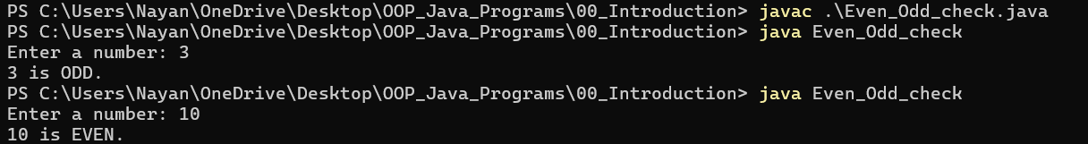
D) Write a simple java program which performs basic arithmetic operations
Program: -
import java.util.Scanner;

public class Basic_Arithmetic_Operations {
public static void main(String[] args) {
Scanner scanner = new Scanner(System.in);
double num1, num2;
int choice;
double result = 0;

System.out.print("Enter first number: ");
num1 = scanner.nextDouble();
System.out.print("Enter second number: ");
num2 = scanner.nextDouble();

System.out.println("Operations:\n1. Addition\n2. Subtraction\n3. Multiplication\n4. Division\n5. Modulo");
System.out.print("Choose the operation: ");
choice = scanner.nextInt();

switch (choice) {
case 1:
result = num1 + num2;
break;
case 2:
result = num1 - num2;
break;
case 3:
result = num1 * num2;
break;
case 4:
if (num2 == 0) {
System.out.println("Cannot divide by zero.");
return;
}
result = num1 / num2;
break;
case 5:
if (num2 == 0) {
System.out.println("Cannot divide by zero.");
return;
}
result = num1 % num2;
break;
default:
System.out.println("Enter your choice from the given list.");
}

System.out.println("Result = " + result);

scanner.close();
}
}

Output: -
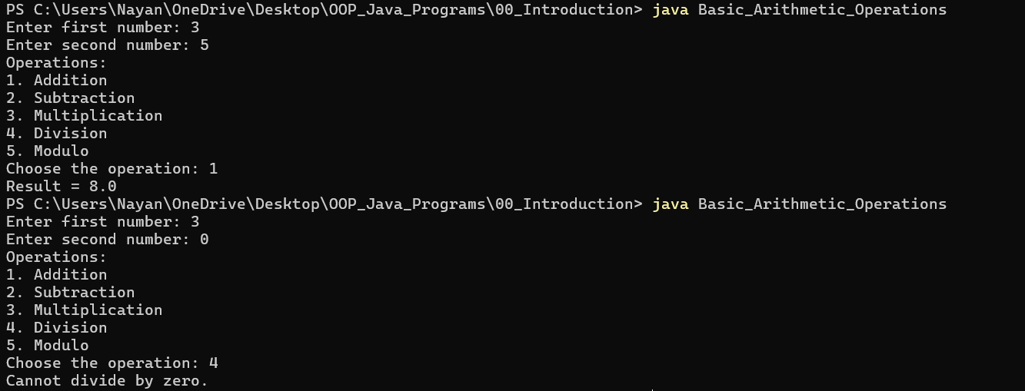

Rubric wise marks obtained:
Rubrics | Criteria | Need Improvement | Good | Excellent | Total
Marks | Design of logic (4)  Correct output (4)  Mock viva test (2) | Program has significant logic errors. (1)  Output has multiple errors. (1)  Delayed & only few correct answers (1) | Program has slight logic errors that do no significantly affect the results (2)  Output has minor errors. (2)  Partially correct response (1) | Program is logically well designed (3)  Program displays correct output with no errors (3)  All questions responded Correctly (2)

Sign of Faculty: ___________________

Assignment
1) Explain the Structure of Java Programming.
2) Explain Features of Java.
3) Explain the Advantage of Java Programming.
4) Explain following.
1) JVM
2) JDK
3) API
5) Compare of C, C++ and Java.
6) Discuss object oriented concepts in brief.
7) Differentiate: Procedure oriented programming and object oriented programming

- Basic data type in java
Data types
Non primitive
( derived)
Primitive
(built in / Intrinsic)
Numeric
Nonnumeric
Integer
Floating point
character
Boolean
classes
Interface
Arrays

1) Integer type:
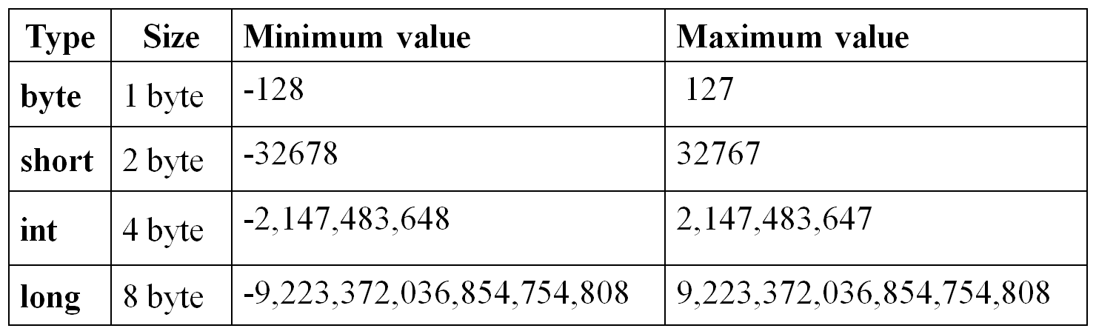
Integer
byte
short
int
long
2) Float type:
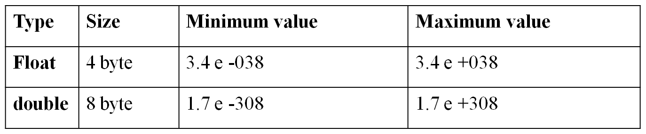
Floating point
Float
Double
(double precision)
(single precision)

- Floating point no. are treated as double precision, so to force them to be in single precision mode,we must append f or F.
- Ex: 1.23f, 7.6512F
- NaN: Not a Number
(special value supported by floating point data type)
It is used to represent result of operation such as dividing by zero, where actual number is not produced.
Character type
- char is used
- Size: 2 bytes
- It holds single character only.

Boolean type
- used to test a particular condition during execution of program
- It has two values: true or false
- boolean keyword used
- Size: 1 bit (0 or 1)
- All comparison operators return boolean type variable.
- Variable
- It is a data name used to store a data value.
- Variable may take different values at different times during execution of program.
- Rules for declaration
  - Not start with digit
  - Upper case and lower-case letters are distinct
  - Not should be a keyword
  - No white spaces
  - Variable name can be of any length.
- Declaration of variable
Syntax: type variable1, variable2……;
Ex: int count;
float x, y;
double p1;
byte b;
char ch;

- Initialization of variable

- By using assignment statement
Syntax: variable name=value;
Ex: i=0, x=0.0f;
int i=0; char ch= ‘X’;
- By using read statement: (readLine() method)
readLine() method reads input from keyboard as a string which is then converted to corresponding data type using wrapper classes.
3) using command line argument by passing value at run time
- Wrapper classes
No. | Primitive data type | Wrapper class
1 | boolean | Boolean
2 | char | Character
3 | double | Double
4 | float | Float
5 | int | Integer
6 | long | Long

- Types of operators
- Arithmetic operators
  - + , - , * , / , %
- Relational operators
  - < , <= , >= , > , == , !=
  - returns true or false
  - Arithmetic operator has higher priority than relational operator.
- Logical operators
  - && : logical AND
  - || : logical Or
  - ! : logical not
- Assignment operators
  - V op= exp; ex: X+=1;
Or
  - V = v op (exp);
- Increment / decrement operators
  - Pre increment: ++m
  - Post increment: m++
  - Pre decrement: --m
  - Post decrement: m--
- conditional operators
  - Exp1 ? Exp2 : exp3
- Bitwise operators
  - & : bitwise AND
  - ! : bitwise OR
  - ^ : bitwise exclusive OR
  - v : one’s complement
  - << : shift left
  - >> : shift right
  - >>> : shift right with zero fill
- Special operators
1)instance of operator
2) dot operator
- Instance of operator:
  - It is an object reference operator.
  - It returns true if object on left side is instance of class given on right side.
  - It defines whether object belongs to particular class or not.
  - Ex:
personinstanceOfStudent
If object person belongs to class Student, then returns true, else returns false.
- Dot ( . ) operator :
- It is used to access the instance variable and method of class objects.
- It is also accessing classes and sub package from package.
  - person1.age;
  - person1.salary();

- Array
- Array is a fixed size sequential collection of elements having same data type.
- We can declare array without giving its size.
(We do not have to provide array size at the time of declaration of array.)
- Declaration of array:
type arrayname[ ] ; Ex: int a[ ];
or
type[ ] arrayname; Ex: int[ ] a;
- Creation of array:
Arrayname=new type [size];
Ex: a=new int [10];
We can combine declaration and creation as follow:

type Arrayname[ ]=new type[size];
ex: int a[ ]=new int[10];
- Initialization of array:
- Compile time:
1) Arrayname[subscript ]=value;
2) Type Arrayname[ ]={ list of values};
Ex:
int a [ ] ={1,2,3,4,5,6};
- Run time:
Using command line argument
Using readLine( ) method of DataInputStream class

- Array length:
- In java all arrays store the allocated size in variable named length.
- We can access length of array using length variable.
int size= a. length;

Two-dimensional array
int a[ ] [ ] = new int [3] [4] ;
- 3X4 array
int a[2][3]={0,0,0,1,1,1};
int a[2][3]={ {0,0,0} , {1,1,1} };
- String
- There is no string data type in Java. But Java has String class.
- We can create String class object for string handling.
- In java strings are class objects which are implemented using two classes String andString Buffer.
- Java string is an instantiated object of the String class.
- We can declare and create string as follows:

String stringname;
stringname =new String(“string”);
Or
String str=new String (“string”);

- Find string length
int myLength = “Hello”. length();
or
int myLength=str1.length( );
- concat ( ) method:
It Concatenates two strings.
E.g. : String str1=“Hello “ ;
String str2=“world” ;
String comparison
1) equals () method:
- String class overrides the equals () method of the Object class.
- It compares the content of the two string object and returns the boolean value accordingly.
- If both strings aresame then returns “true” else “false “.
- equals ( ) method compares actual contents of two String objects.
- It differentiates Upper case and Lower case letters.
Ex:
String str1=“Hello “
String str2=“hello”
String Str3 = “Hello”
Then
str1.eqauls (str2); // returns false
str1.eqauls (str3); // returns true
- Using “==” operator:
- We can also compare two strings using “==”.
- “==” compares the references not the actual contents of the String object;
Ex:
String str1=“Hello “
String str2=“hello”
String Str3 = “Hello”
Then
If(str1==str2); // returns true
If(str1 == str3); // returns true
- equalsIgnoreCase( ) :
- It compares strings which ignores the case of contents while comparing.
- It returns true if str1=str2, ignoring the case of characters.
- If both strings aresame then returns “true” else “false “.
Ex:
String str1=“Hello “
String str2=“hello”
str1.eqaulsIgnoreCase (str2); //returns true
- compareTo( ):
- It compares two Strings and returns an int value.
- It returns value0 (zero), if str1 is equals to str2.
- It returns value negative, if str1 <str2.
- It returns value positive, if str1 > str2.
- This method behaves exactly like the first method, if the argument object is actually a String object; otherwise, it throws a ClassCastException.
Ex:
int compareTo (String str2)
int compareTo(Object object)
Searching a string
- String class provides indexOf () method which searches for the specified character inside the string object.
- This method has been overloaded.
- If the search is successful, then it returns the index of the char otherwise -1 is returned.
- int indexOf(String str) :
Finds the start index of the first occurrence of the substring argument in a String
Ex: int position= str1.indexOf (“e”); // for hello” it returns 1

- int indexOf(String str, int fromIndex)
Finds the start index of the first occurrence of the substring argument in a String, starting at the index specified in the second argument
Ex: int position= str1.indexOf (“e”,3); // for “hello” it returns -1
- int indexOf(char c):
Returns the index of first occurrence of the argument char
Ex: int position= str1.indexOf( e ); // for welcome it returns 1
- int indexOf(int c, int fromIndex) :Returns the index of first occurrence of the argument char.
Ex: int position= str1.indexOf(e , 3 ); // for welcome it returns 6

The String class also provides methods to search for a character or string in backward direction.
These methods are given below.
- int lastIndexOf(int ch)
- int lastIndexOf(int ch, int fromIndex)
- int lastIndexOf(String str)
- int lastIndexOf(String str, int fromIndex)

Replacing a character in string
- The replace method of String class can be used to replace all occurrences of the specified character with given character.
str. replace (char oldChar, int newchar)
Ex: String str1=“Hello”;
str1.replace (“H”,” c”); // Gives string “cello” instead of “Hello”
Find substring
- String class provides substring ( ) method to extract specified portion of the given String. This method has been overloaded.
- If the index value is not valid, a StringIndexOutOfBoundsException is thrown.
Note:
A new String object containing the substring is created and returned. The original String won’t be affected.
1) String substring (int startIndex)
- gives substring starting from n^{th}character
2) String substring (int startIndex, int endIndex)
- gives substring starting from n^{th}character up to m^{th}character (not including m^{th})

String conversion
- String class provides set of static overloaded valueOf ( ) method to convert primitivestypesandobject into strings.
Object to string:
- static String.valueOf(Object obj)
- static String.valueOf(char[] character)
Primitive to string:
- static String.valueOf(boolean b)
- static String.valueOf(char c)
- static String.valueOf(int i)
- static String.valueOf(long l)
- static String.valueOf(float f)
- static String.valueOf(double d)

Manipulating a string

- String class provides following methods to manipulate character case in String.
1) toUpperCase ( ) : converts the string str1 to all upper case.
Ex: String str1= “Hello”;
str2=str1.toUpperCase; // string in str2 will be HELLO

2) toLowerCase ( ) : converts the string str1 to all lower case .
Ex: String str1= “VPMP”;
str2=str1.toLowerCase; // string in str2 will be vpmp
Note: Original String object is returned if none of the characters changed; otherwise, new String object is constructed and returned.

3) trim() : This method removes white space from the front and the end of a String.
Ex: String str=" hello.. ";
System.out.println(str.trim()); // output will be hello.., no space before and after as original string str

4) int length() : Returns length of the String.
Ex: String str="hello";
System.out.println(str.length ( ));
5) charAt(): Gives n^{th} character of str1.
Ex: String str="hello";
System.out.println(str.charAt(1));
6) p.toString(): Creates a string representation of the object p.
str1.concat (str2); //output will be “HelloWorld
StringBuffer class

- StringBuffer class is peer class of String.
- It enables us to create flexible length string allow us to perform manipulation on string whenever we want.
Commonly used StringBuffer Methods:

- str1.setCharAt(n, char ch): It modifies the n^{th}character toch.
Ex: StringBuffer str=new StringBuffer("Cello");
str.setCharAt (0 , 'H'); //output string Hello

- str1.append(str2): Appends the string str2 at the end of str1.
StringBuffer str=new StringBuffer("Hello");
str.append (" GoodMorning "); //output string Hello GoodMorning

- str1.insert (n,s2) :it inserts the string str2 at the position n of the string str1.
StringBuffer str=new StringBuffer("Hello Good Morning");
str.insert (5, " class");

- str1.setLength( n) : sets the length of the string str1 to n.
str.setLength(30);
If n < str1.length( ) then str1 is truncated.
If n > str1 .length ( ) then zeros are added to str1.

Most commonly used methods of String class

No. | Method call | Action performed
1 | S2=s1.toLowerCase( ); | Converts the string s1 to all lowercase
2 | S2=s1.toUpperCase( ); | Converts the string s1 to all uppercase
3 | S2=s1.replace(‘x’, ‘y’ ); | Replace all appearance of x with y
4 | S2=s1.trim( ) | Remove white spaces at the beginning and end of the string s1
5 | s1.equals( ) | Returns true if s1 is equal to s2(case sensitive)
6 | S1.equalsIgnoreCase( ) | Returns true if s1 is equal to s2,ignoring the case of characters( upper or lower )
7 | int l=s1.length( ) | Gives the length of string s1
8 | S1.charAt( ) | Gives nth character of s1
9 | S1.compareTo( s2 ) | Returns negative ,if s1 < s2 , Positive , if s1 >s2,  Zero is s1 equals s2
10 | S1.concat( ) | Concatenates s1 and s2
11 | S1.substring( n ) | Give substring starting from n^{th} character
12 | S1.substring(n , m ) | Give substring starting from n^{th} character up to mth(not including m^{th})
13 | String. valueOf( p ) | Creates a string object of the parameter p
14 | p. toString( ) | Creates string representation of the object p
15 | S1.indexOf ( ‘x’ ) | Gives the position of the first occurrence of ‘x’ in the string s1
16 | S1.indexOf( ‘x’ , n ) | Gives the position of ‘x’ that occurs after n^{th} position in the string s1
17 | String .valueOf( variable) | Converts the parameter value to string representation

Most commonly used methods of StringBuffer class

No. | Method call | Action performed
1 | s1.setCharAt( ); | Modifies the n^{th} character to x
2 | s1.append( s2 ); | Appends string to s2 to s1at the end
3 | s1.insert( n, s2 ); | Insert the string s2 at the position n of the string s1
4 | s1.setLength( n ) | Sets the length of the string s1 to n.  If n < s1.length( ) then s1 is truncated.  If n > s1.length( ) then zeros are added to s1
- Java statement
expression
labeled
synchronization
guarding
Java statement
control
selection
iteration
jump
if
else
for
do
while
return
continue
break
switch
1) Selection statement:
1) simple if statement:
if (test expression)
{
//statement block;
}

2) if...else statement:
if (test expression)
{
//true block statement block;
}
else
{
// false block statement;
}

3) nesting of if.... else statement:

if (test condition-1)
{
if(condition-2)
{
statement-1;
}
else
{
Statement-2;
}
}
else
{
Statement-3;
}
4) else.... if ladder
if (condition-1)
{
statement-1;
}
else if (condition 2)
{
statement-2;
}
else if (condition 3)
{
statement-3;
}
...........
...........
...........
else
{
default: default statement;
}

5) switch statement:
switch (integer or character value or expression)
{
case value-1:
block-1
break;
case value-2:
block-2
break;
.........
.........
default:
default block;
break;
}

2) Iteration statement:
1) while statement:
while (test condition)
{
Body of the loop
}

2) do...while statement:
do
{
Body of the loop
} while (test condition);

3) for loop:
for (initialization; test expression; increment or decrement)
{
Body of the loop

}

Jump statement
1) break: It is used to exit from a loop or block
2) continue: it is used to skip some part of code and causes loop to be continued with the next iteration.
3)return: it is used to return values to calling function
Practical No.: 1
AIM:
1.1 Develop a Java program that prompts the user to enter a distance in meters. Your program should then convert this distance to feet (1 meter = 3.28084 feet) and display the result formatted to two decimal places.
Program: -
import java.util.Scanner;

public class Meter_to_Feet {
public static void main(String[] args) {
Scanner scanner = new Scanner(System.in);
double meter, feet;

System.out.print("Enter distance in meters: ");
meter = scanner.nextDouble();

feet = meter * 3.28084;

System.out.println("Distance in feet = " + feet);
scanner.close();
}
}

Output: -
Practical No.: 1
AIM:
1.2 Write a Java program to solve a system of two linear equations with two variables (e.g., ax + by = e and cx + dy = f). Prompt the user to enter the coefficients a, b, c, d, e, f. Calculate and display the values of x and y using Cramer's rule. Include error handling for cases where the denominator is zero.
Cramer's rule: D=ad−bc, Dx=ed−bf, Dy=af−ce, x=Dx/D, y=Dy/D
Program: -
import java.util.Scanner;

public class Cramers_Rule {
public static void main(String[] args) {
Scanner scanner = new Scanner(System.in);
double D, Dx, Dy, x, y;

System.out.println("Welcome to linear equation solver.");
System.out.println("Your equations are: ax + by = e and cx + dy = f");
System.out.println();

System.out.print("a = "); double a = scanner.nextDouble();
System.out.print("b = "); double b = scanner.nextDouble();
System.out.print("c = "); double c = scanner.nextDouble();
System.out.print("d = "); double d = scanner.nextDouble();
System.out.print("e = "); double e = scanner.nextDouble();
System.out.print("f = "); double f = scanner.nextDouble();

// Cramer's rule
D = (a * d) - (b * c);
Dx = (e * d) - (b * f);
Dy = (a * f) - (c * e);

if (D <= 0) {
System.out.println("No unique solution exists (Denominator is zero).");
} else {
x = Dx / D;
y = Dy / D;

System.out.println("Value of x = " + x);
System.out.println("Value of y = " + y);
}

scanner.close();
}
}

Output: -
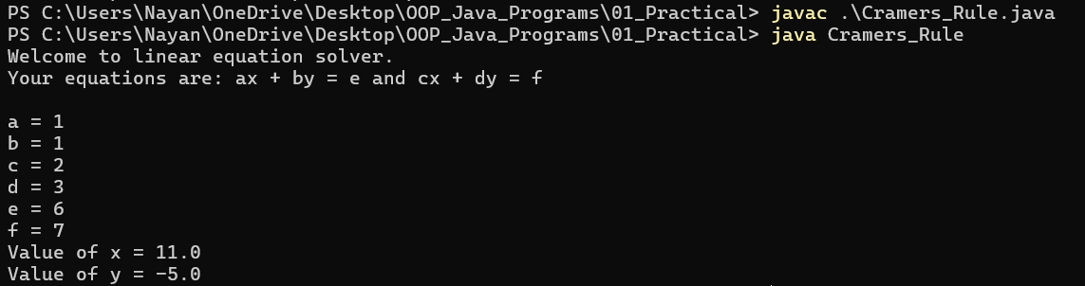
Practical No.: 1
AIM:
1.3 Write a Java program that prompts the user to enter a single letter (character). Determine whether the entered character is a vowel (a, e, i, o, u, case-insensitive) or a consonant, and display the result.
Program: -
import java.util.Scanner;

public class Check_Vowel {
public static void main(String[] args) {
Scanner scanner = new Scanner(System.in);

System.out.println("=== Vowel and Consonant Checker ===");
System.out.print("Enter a character: ");
char c = scanner.next().charAt(0);

c = Character.toLowerCase(c);

if (!Character.isLetter(c)) {
System.out.println(c + " is not a letter.");
return;
}

if (c == 'a' || c == 'e' || c == 'i' || c == 'o' || c == 'u') {
System.out.println(c + " is a VOWEL.");
} else {
System.out.println(c + " is a CONSONANT.");
}

scanner.close();
}
}

Output: -
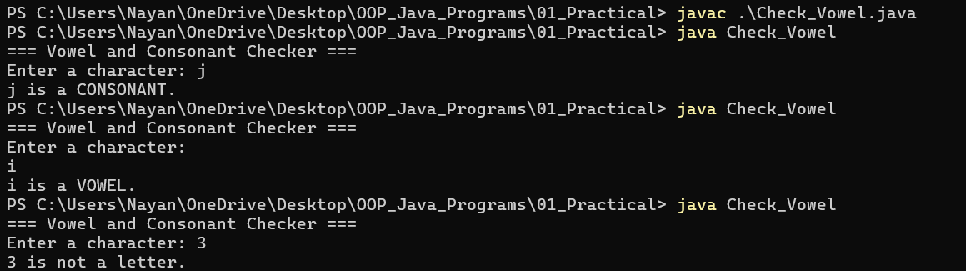
Practical No.: 1
AIM:
1.4 Develop a Java application that calculates a person's Body Mass Index (BMI). The program should ask the user for their weight in pounds and height in inches. Convert these values to kilograms and meters respectively (1 pound = 0.45359237 kg, 1 inch = 0.0254 meters) and then calculate BMI (weight in kg / (height in meters)^2). Display the calculated BMI.
Program: -
import java.util.Scanner;

public class Body_Mass_Index {
public static void main(String[] args) {
Scanner scanner = new Scanner(System.in);
double weight_pounds;
double height_inches;
double weight_kgs;
double height_meters;
double bmi;

System.out.print("Enter a weight in pounds: ");
weight_pounds = scanner.nextDouble();

System.out.print("Enter a height in inches: ");
height_inches = scanner.nextDouble();

weight_kgs = weight_pounds * 0.45359237;
height_meters = height_inches * 0.0254;

bmi = weight_kgs / (height_meters * height_meters);

System.out.println("Calculated BMI = " + bmi);

scanner.close();
}
}

Output: -
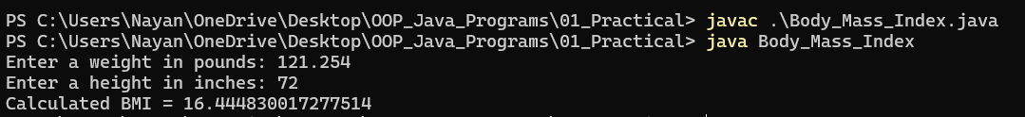
Practical No.: 1
AIM:
1.5 Simulate a simple ATM or cashier. Given an integer amount to be dispensed (e.g., 787), calculate and display the minimum number of currency notes of denominations 100, 50, 10, 5, 2, and 1 that would be given to the user.
Program: -
import java.util.Scanner;

public class ATM_Notes {
public static void main(String[] args) {
Scanner scanner = new Scanner(System.in);

int amount = 0;
System.out.print("Enter a amount to withdraw: ");
amount = scanner.nextInt();

int note_100, note_50, note_10, note_5, note_2, note_1;
note_100 = amount / 100;
amount %= 100;

note_50 = amount / 50;
amount %= 50;

note_10 = amount / 10;
amount %= 10;

note_5 = amount / 5;
amount %= 5;

note_2 = amount / 2;
amount %= 2;

note_1 = amount;

System.out.println("\nMinimum notes required:");
System.out.println("100 = " + note_100);
System.out.println("50 = " + note_50);
System.out.println("10 = " + note_10);
System.out.println("5 = " + note_5);
System.out.println("2 = " + note_2);
System.out.println("1 = " + note_1);

scanner.close();
}
}

Output: -
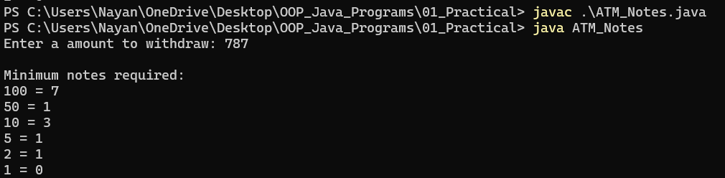
Practical No.: 1
AIM:
1.6 Write a Java program that accepts a five-digit integer from the keyboard. Your program should then create a new number by adding one to each digit of the input number. For example, if the input is 12391, the output should be 23402 (note: 9+1=10, so it becomes 0 with a carry)
Program: -
import java.util.Scanner;

public class Digit_plus_One {
public static void main(String[] args) {
Scanner scanner = new Scanner(System.in);
int num;

System.out.print("Enter a number of five digits: ");
num = scanner.nextInt();

int result = 0;
int place = 1;

while (num > 0) {
int digit = num % 10;
digit = (digit + 1) % 10;

result = result + digit * place;
place *= 10;
num /= 10;
}

System.out.println("New number = " + result);
scanner.close();
}
}

Output: -
Practical No.: 1
AIM:
1.7 Write a program that takes the lengths of three sides of a triangle as input. Calculate and print the area of the triangle. Ensure that the program validates if the given side lengths can actually form a triangle (sum of any two sides must be greater than the third side) before calculating the area (use Heron's formula: Area = sqrt(s*(s-a)*(s-b)*(s-c)) where s = (a+b+c)/2).
Program: -
import java.util.Scanner;

public class Triangle_Area {
public static void main(String[] args) {
Scanner scanner = new Scanner(System.in);
double a, b, c;
double area, s;

System.out.print("Enter a: ");
a = scanner.nextDouble();

System.out.print("Enter b: ");
b = scanner.nextDouble();

System.out.print("Enter c: ");
c = scanner.nextDouble();

if ((a + b > c) && (b + c > a) && (a + c > b)) {
s = (a + b + c) / 2.0;
area = Math.sqrt(s * (s - a) * (s - b) * (s - c));

System.out.println("\nArea of Triangle = " + area + " unit²");
} else {
System.out.println("\nInvalid triangle sides. Cannot be form a triangle.");
}

scanner.close();
}
}

Output: -
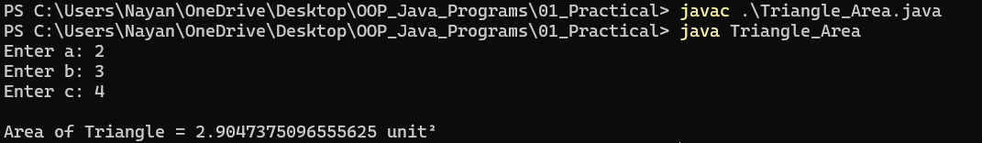
Practical No.: 1
AIM:
1.8 Write a Java program that accepts two numbers as command-line arguments. Convert these arguments to appropriate numeric types (e.g., int or double), perform a simple calculation (e.g., sum or product), and print the result to the console.
Program: -
public class Command_Line_Sum {
public static void main(String[] args) {
if (args.length != 2) {
System.out.println("Please provide exactly two numbers.");
return;
}

double num1 = Double.parseDouble(args[0]);
double num2 = Double.parseDouble(args[1]);

double sum = num1 + num2;
System.out.println("Sum = " + sum);
}
}

Output: -

Rubric wise marks obtained:
Rubrics | Design of logic  (4) | Correct Output  (4) | Mock viva test  (2) | Total

Marks

Sign of Faculty: ___________________

Assignment
1) Explain various Data Types of java.
2) Define Type Casting.
3) Explain types of operators in Java.
4) Explain garbage collector and Finalize Method.
5) Explain wrapper class.
6) What is array? Explain types of arrays. Write a program in java to find maximum value from array element using command line argument.
7 Difference between string and string buffer class.
8) Explain various methods of String classand StringBuffer class.

Introduction
- Java is true object oriented language.Anything in java program must be encapsulated in class.
- Class defines state and behavior of objects.Class create objects and objects use method to communicate between them.
- Class provide convenient method for packing together a group of logically related data items and functions that work on them.
- Class is user defined data type with a template that serves to define its properties.
- Once class has been defined we can create variables of that type ,these variables are termed as instance of classes they are actual objects.
- Everything inside square brackets is optional
Syntax: class classname[ extends superclass name ]
{
[ variable declaration; ]
[ methods declaration; ]
}
Adding variables to class
- Data encapsulated in a class by placing field inside body of class, these variable are instance variable.
class Rectangle
Instance variable
Or
Class varaible
{
int length;
int width;
}
- Here, variable are only declared and no storage space has been created in memory.
Example:
Adding methods to class
class Rectangle
{
void getData ( int x , int y)
{
length=x;
width=y;
}
}
Creating objects
How to create object?
- Object is a essential block of memory that contains space to store all instance variable.
- Creating object is referred as instantiating an object.
- new operator creates objects in java.
it creates object of specified class and returns reference to that object.

Declaration: classname objectname;
Instantiate: objectname = new classname( );

Ex: Rectangle rect;
Default constructor
rect= new Rectangle( );
or
Rectangle rect = new Rectangle( );

Class can have any no. of objects of Rectangle.
- Each object has its own instance variables copy so change to variable of one object have no effect on variable of another.

Accessing class member
Syntax:
Objectname . variablename;
Objectname . method name ( parameter list );
Example:
15
10

10
20
12

10
rect1 . length =15;
rect1 . Width =10;
rect2 . Length =20;
rect2
rect1
rect2 . Width =12;
rect1 . getData( 15 ,10) ;
- Constructor
- Constructor enables an object to initialize itself when it is created.
- Constructor is a special type of method.
- Mainly two types of constructor:
  - Default constructor
  - Parameterized constructor
Characteristics:
- Constructors have the same name as the class name itself.
- Constructor do not specify a return type, not even void (because they return the instance of the class itself).
- Constructor cannot be inherited, through a derived class can call the base class constructor.
- When you do not explicitly define a constructor for a class, java creates default constructor.
- Default constructor automatically initialize instance variable to zero.
- Once you define your own constructor, the default constructor is no longer used.
Constructor Overloading
- When multiple constructor of same name with different arguments in a single class is called Constructor overloading.
Ex class Demo
{
Demo( ) //constructor without parameter
{
-----
}
Demo( int a) //constructor with parameter
{
------
}
}
Method overloading
- In java, it is possible to create methods that have same name but different definitions. This is called method overloading.
- Definition: multiple methods of same name with different arguments in a single class is called Method overloading.
- It is used when objects are required to perform similar tasks but using different input parameters.
class classname
{
Methodname1(arguments)
{
//
}
Methodname1 (arguments)
{
//
}
}
final keyword
- final is a keyword.
- final means cannot be changed or it is final.
- It is same as const in c++.It is used for efficiency.
- final can be used with
  - Variable (data)
  - Methods
  - classes
1. final variables
- final specifies that the value of variable is final and must not be changed.
- final variable name must be in capital letters.
- All final variable must have an initial value.(it can’t specify later).
Ex: final int SIZE=100;
final float PI= 3.14f;
- final variable behaves like class variable.
- They do not take any space on individual object.
2. final method
- All methods and variable can be overridden by default in subclasses.
- We can prevent overriding of methods of super class by declared as final.
- If we declare super class’s method as final then it cannot be override by its subclass.

Example:
class A
{
final void display( )
{
---------
}
}
class B extends A
{
void display() //invalid
{
--------
}
}
Here, display () method of super class A cannot be overridden by sub class B because it is declared as final.
3. final class
- If class is declared with final modifier, then class cannot be extended and this will ensure that the exact properties and behaviour of class.
- final class cannot be sub classed.
- If we declare class as final, it prevents any unwanted extension to the class.

final class A
{
//body
}
class B extends A //invalid, it gives Error
{
//body
} Here, class B cannot extend class A, because it is declared as final.
Practical No.: 2
AIM:
2.1 Define a Java class named Rectangle. It should have two double data fields: width and height, both with a default value of 1. Implement a no-argument constructor and a constructor that takes width and height as parameters. Include methods getArea() and getPerimeter() that return the calculated area and perimeter respectively.
Program: -
class Rectangle {
double width;
double height;

// constructor without parameters
Rectangle() {
width = 1;
height = 1;
}

// constructor with parameters
Rectangle(double w, double h) {
width = w;
height = h;
}

// getArea() function returns rectangle's area
double getArea() {
return width * height;
}

// getPerimeter() function returns rectangle's perimeter
double getPerimeter() {
return 2 * (width + height);
}
}

public class Area {
public static void main(String[] args) {
Rectangle r1 = new Rectangle();
System.out.println("===Rectangle 1:===");
System.out.println("Width = " + r1.width);
System.out.println("Height = " + r1.height);
System.out.println("Area = " + r1.getArea());
System.out.println("Perimeter = " + r1.getPerimeter());

System.out.println();

Rectangle r2 = new Rectangle(5, 3);
System.out.println("===Rectangle 2:===");
System.out.println("Width = " + r2.width);
System.out.println("Height = " + r2.height);
System.out.println("Area = " + r2.getArea());
System.out.println("Perimeter = " + r2.getPerimeter());
}
}

Output: -
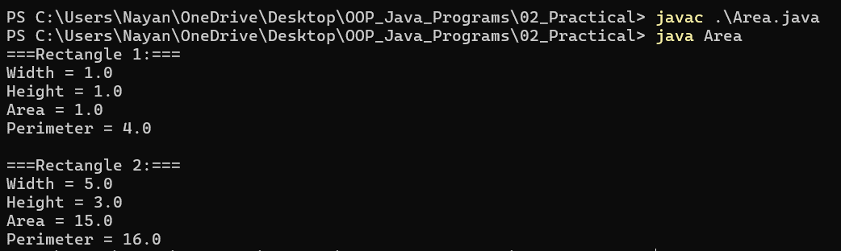
Practical No.: 2
AIM:
2.2 Create an Employee class with private instance variables for employeeName (String) and employeeSalary (double). Implement public methods readEmployeeData() (to take input from the user) and displayEmployeeData() (to print the employee's name and salary). Demonstrate object creation and method invocation in a main method.
Program: -
import java.util.Scanner;

class Employee {
public String employeeName;
public double employeeSalary;

public void readEmployeeData() {
Scanner scanner = new Scanner(System.in);

System.out.print("Enter name of the employee: ");
employeeName = scanner.nextLine();

System.out.print("Enter salary of the employee: ");
employeeSalary = scanner.nextDouble();

scanner.close();
}

public void displayEmployeeData() {
System.out.println("Employee name: " + employeeName);
System.out.println("Employee salary: $" + employeeSalary);
}
}

public class Employee_Data {
public static void main(String[] args) {
Employee emp = new Employee();

emp.readEmployeeData();
System.out.println();
emp.displayEmployeeData();

}
}

Output: -
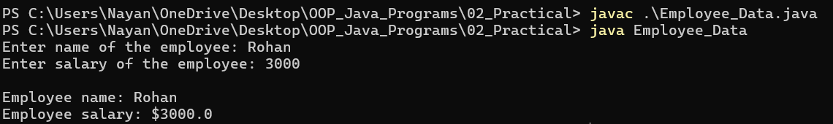
Practical No.: 2
AIM:
2.3 Design a class Time with hours (int) and minutes (int) as data members. Include method setTime(int h, int m) to initialize the time and displayTime() to display the time. Implement a method addTime(Time t1, Time t2) that takes two Time objects as arguments, adds their hours and minutes, and stores the result in the calling object. Do not use constructors for initialization in this specific practical.
Program: -
class Time {
int hours;
int minutes;

void setTime(int h, int m) {
hours = h;
minutes = m;
}

void displayTime() {
System.out.println(hours + " hours " + minutes + " minutes ");
}

void addTime(Time t1, Time t2) {
hours = t1.hours + t2.hours;
minutes = t1.minutes + t2.minutes;

if (minutes >= 60) {
hours += minutes / 60;
minutes %= 60;
}
}
}

public class Time_Practical {
public static void main(String[] args) {
Time t1 = new Time();
Time t2 = new Time();
Time result = new Time();

t1.setTime(2, 45);
t2.setTime(3, 30);

System.out.print("Time 1:- ");
t1.displayTime();

System.out.print("Time 2:- ");
t2.displayTime();

result.addTime(t1, t2);

System.out.print("Total time:- ");
result.displayTime();

}
}

Output: -
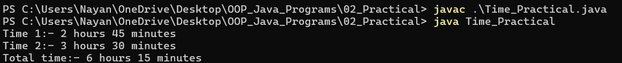

Practical No.: 2
AIM:
2.4 Create a Point class representing a 2D point (x, y). Implement a default constructor that initializes both x and y to 5. Provide a parameterized constructor to initialize x and y with user-supplied values. Also, implement a copy constructor to create a new Point object as a copy of an existing Point object. Include a display() method to show the point's coordinates and write a main method to test all constructors and the display functionality.
Program: -
import java.util.Scanner;

class Point {
int x;
int y;

Point() {
x = 5;
y = 5;
}

Point(int x, int y) {
this.x = x;
this.y = y;
}

Point(Point p) {
this.x = p.x;
this.y = p.y;
}

void display() {
System.out.println("Point coordinates: (" + x + ", " + y + ")");
}
}

public class Point_x_y {
public static void main(String[] args) {
Scanner scanner = new Scanner(System.in);

Point p1 = new Point();
System.out.println("Default constructor:");
p1.display();

System.out.print("\nEnter x: ");
int x = scanner.nextInt();
System.out.print("Enter y: ");
int y = scanner.nextInt();

Point p2 = new Point(x, y);
System.out.println("\nParameterized constructor:");
p2.display();

Point p3 = new Point(p2);
System.out.println("\nCopy constructor copied value from p2:");
p3.display();
scanner.close();
}
}

Output: -
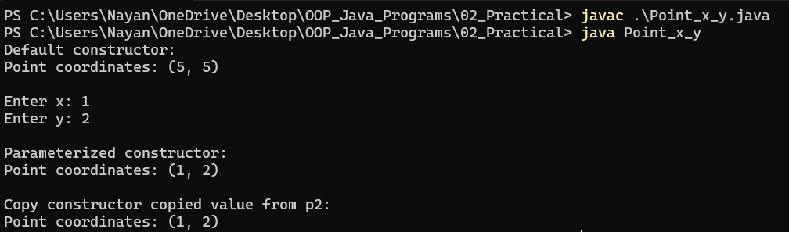

Practical No.: 2
AIM:
2.5 Define a Java class named Rectangle. It should have two double data fields: width and height. In your main method, create two Rectangle objects: one with width 4 and height 40, and another with width 3.5 and height 35.9. For each rectangle, display its width, height, calculated area, and perimeter. Then, compare the two rectangles based on their areas and print which one has a larger area.
Program: -
class Rectangle {
double width;
double height;

Rectangle(double w, double h) {
width = w;
height = h;
}

double getArea() {
return width * height;
}

double getPerimeter() {
return 2 * (width + height);
}

void display() {
System.out.println("Width = " + width);
System.out.println("Height = " + height);
System.out.println("Area = " + getArea());
System.out.println("Perimeter = " + getPerimeter());
System.out.println();
}
}

public class Rectangle_Area {
public static void main(String[] args) {
Rectangle r1 = new Rectangle(4, 40);
Rectangle r2 = new Rectangle(3.5, 35.9);

System.out.println("---Rectangle 1 details---");
r1.display();
System.out.println("---Rectangle 2 details---");
r2.display();

if (r1.getArea() > r2.getArea()) {
System.out.println("Rectangle 1 has larger area.");
} else if (r1.getArea() < r2.getArea()) {
System.out.println("Rectangle 2 has larger area.");
} else {
System.out.println("Both rectangle have equal area.");
}
}
}

Output: -
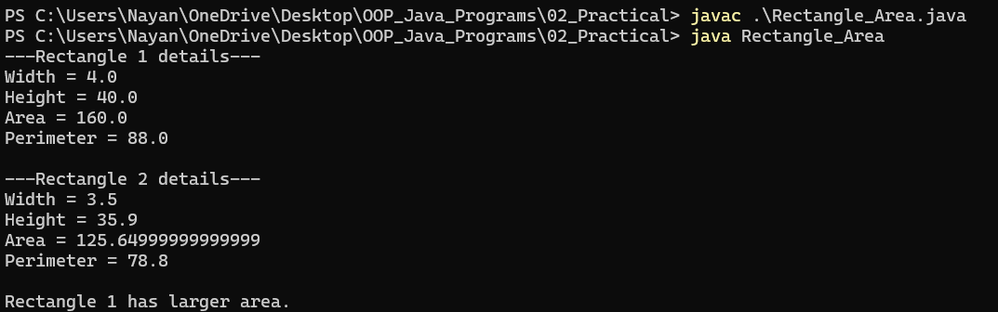
Practical No.: 2
AIM:
2.6 Create a class BankAccount with accountId (String), accountHolderName (String), and balance (double) as instance variables. Include methods assignValues() (for initialization) and displayValues(). Implement a search function that takes an accountId as input and, if found within an array of BankAccount objects, displays the details of that specific account. In your main method, create an array of at least five BankAccount objects and demonstrate adding, displaying, and searching for accounts.
Program: -
import java.util.Scanner;

class BankAccount {
String accountId;
String accountHolderName;
double balance;

void assignValues(String id, String name, double bal) {
accountId = id;
accountHolderName = name;
balance = bal;
}

void displayValues() {
System.out.println("Account Id: " + accountId);
System.out.println("Account holder name: " + accountHolderName);
System.out.println("Balance: " + balance);
System.out.println();
}

static void searchAccount(BankAccount[] accounts, String searchId) {
boolean isFound = false;

for (BankAccount acc : accounts) {
if (acc.accountId.equals(searchId)) {
System.out.println("\nAccount Found:");
acc.displayValues();
isFound = true;
break;
}
}
if (!isFound) {
System.out.println("\nAccount not found.");
}
}
}

public class Bank {
public static void main(String[] args) {
Scanner scanner = new Scanner(System.in);

BankAccount[] accounts = new BankAccount[5];

for (int i = 0; i < accounts.length; i++) {
accounts[i] = new BankAccount();

System.out.println("Enter details for Account " + (i + 1));
System.out.print("Account ID: ");
String id = scanner.nextLine();

System.out.print("Account holder name: ");
String name = scanner.nextLine();

System.out.print("Balance: ");
double bal = scanner.nextDouble();
scanner.nextLine();

accounts[i].assignValues(id, name, bal);
System.out.println();
}

System.out.println("\nAll accounts details:");
for (BankAccount acc : accounts) {
acc.displayValues();
}

System.out.print("\nEnter account id to search: ");
String seachId = scanner.nextLine();

BankAccount.searchAccount(accounts, seachId);

scanner.close();
}
}

Output: -
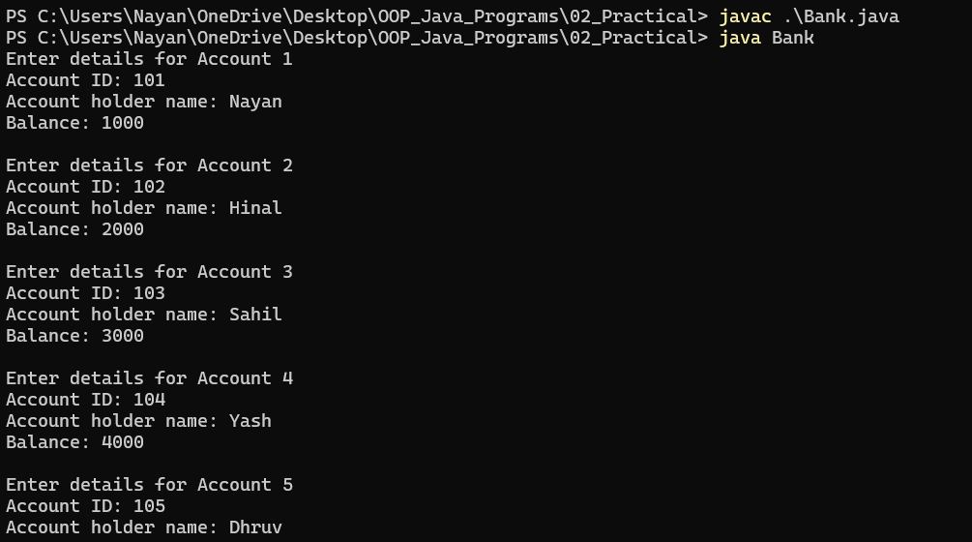
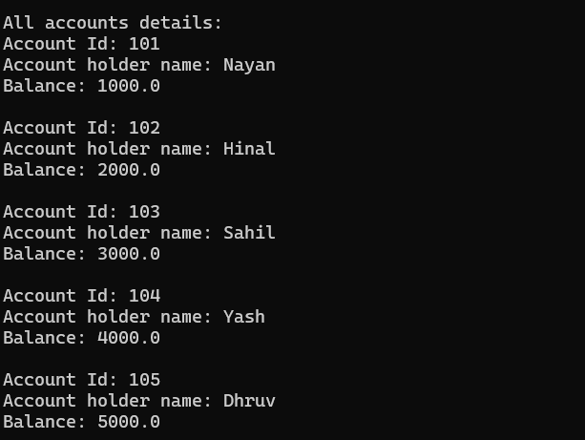
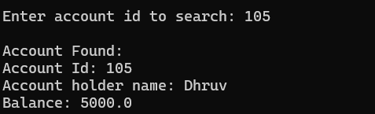
Practical No.: 2
AIM:
2.7 Write a program for billing system for a shopping mall. Create a class BillGenerator that uses method overloading to generate bills based on customer type:
generateBill(int itemTotal): For regular customers, apply no discount.
generateBill(int itemTotal, int discount): For privileged customers, apply flat discount in rupees.
generateBill(int itemTotal, double discountPercent): For festive offers, apply percentage discount.
Write a program to display the final bill amount using appropriate overloaded method based on customer category.
Program: -
import java.util.Scanner;

class BillGenerator {
// Regular Customer - No Discount
void generateBill(int itemTotal) {
System.out.println("Customer type: Regular");
System.out.println("Final Bill Amount: Rs. " + itemTotal);
}

// Privileged Customer - Flat Discount
void generateBill(int itemTotal, int discount) {
int finalAmount = itemTotal - discount;
if (finalAmount < 0) {
finalAmount = 0;
}
System.out.println("Customer type: Privileged");
System.out.println("Flat Discount: Rs. " + discount);
System.out.println("Final Bill Amount: Rs. " + finalAmount);
}

// Festive Offer - Percentage Discount
void generateBill(int itemTotal, double discountPercentage) {
double discountAmount = itemTotal * discountPercentage / 100;
double finalAmount = itemTotal - discountAmount;

System.out.println("Customer type: Festive Offer");
System.out.println("Discount Percent: " + discountPercentage + "%");
System.out.println("Final Bill Amount: Rs. " + finalAmount);
}
}

public class Shopping_Mall_Bill {
public static void main(String[] args) {
Scanner scanner = new Scanner(System.in);
BillGenerator bill = new BillGenerator();

System.out.print("Enter total item amount: ");
int total = scanner.nextInt();

System.out.println("Select Customer Type:");
System.out.println("1. Regular");
System.out.println("2. Privileged");
System.out.println("3. Festive Offer");
System.out.print("Enter choice: ");
int choice = scanner.nextInt();

switch (choice) {
case 1:
bill.generateBill(total);
break;
case 2:
System.out.print("Enter flat discount amount: ");
int flatDiscount = scanner.nextInt();
bill.generateBill(total, flatDiscount);
break;
case 3:
System.out.print("Enter percentage discount: ");
double percentageDiscount = scanner.nextDouble();
bill.generateBill(total, percentageDiscount);
break;
default:
System.out.println("Invalid choice!");
}

scanner.close();
}
}

Output: -
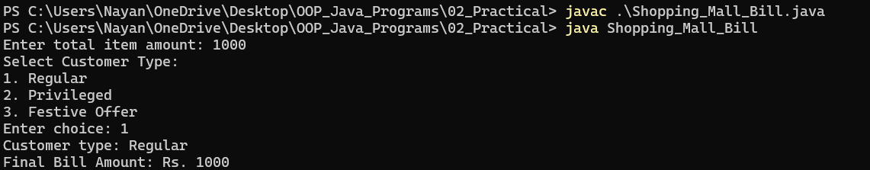
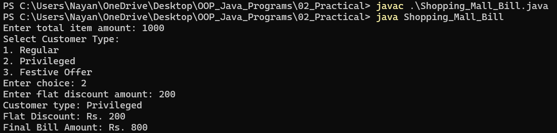
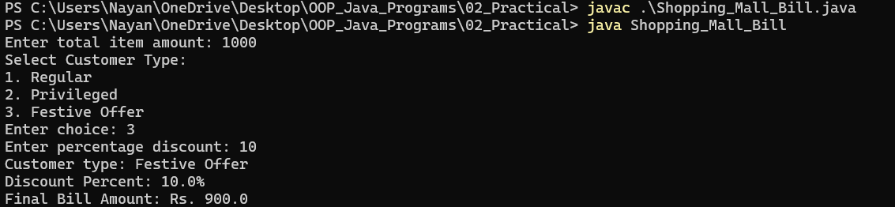

Practical No.: 2
AIM:
2.8 A bank wants to offer a facility to calculate EMI (Equated Monthly Installment) for different types of loans. Design a class LoanCalculator with the following overloaded methods:
calculateEMI(int principal, int time, float rate): For home loans
calculateEMI(double principal, int time, double rate): For vehicle loans
calculateEMI(int principal, int time): For short-term personal loans with a fixed interest rate of 10%
Demonstrate the use of all three methods in the main method by calculating EMIs for different loan types.
Program: -
class LoanCalculator {
// Home Loans
void calculateEMI(int principal, int time, float rate) {
float monthlyRate = rate / (12 * 100);
int months = time * 12;
double emi = principal * monthlyRate * Math.pow(1 + monthlyRate, months) / (Math.pow(1 + monthlyRate, months) - 1);
System.out.println("Home Loan EMI: Rs " + emi);
}

// Vehicle Loans
void calculateEMI(double principal, int time, double rate) {
double monthlyRate = rate / (12 * 100);
int months = time * 12;
double emi = principal * monthlyRate * Math.pow(1 + monthlyRate, months) / (Math.pow(1 + monthlyRate, months) - 1);
System.out.println("Vehicle Loan EMI: Rs " + emi);
}

// Personal Loans
void calculateEMI(int principal, int time) {
double rate = 10;
double monthlyRate = rate / (12 * 100);
int months = time * 12;
double emi = principal * monthlyRate * Math.pow(1 + monthlyRate, months) / (Math.pow(1 + monthlyRate, months) - 1);
System.out.println("Personal Load EMI (10%): Rs " + emi);
}
}

public class Loan_Main {
public static void main(String[] args) {
LoanCalculator loan = new LoanCalculator();

loan.calculateEMI(500000, 10, 7.5f);
loan.calculateEMI(300000, 5, 9.0);
loan.calculateEMI(200000, 2);
}
}

Output: -
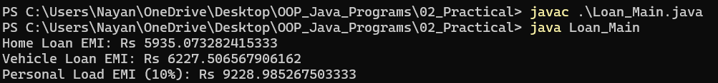

Rubric wise marks obtained:
Rubrics | Design of logic  (4) | Correct Output  (4) | Mock viva test  (2) | Total

Marks

Sign of Faculty: ___________________

Practical No. :3
AIM:
3.1 Create a Java class named University with a static data member totalStudents to keep track of the number of student objects created. Implement a static method getTotalStudents(). Also, include a static block to initialize a static variable (e.g., universityName) and an instance block to print a message when an object is created. Demonstrate their execution order.

Output :

Rubric wise marks obtained:
Rubrics | 1 | 2 | 3 | Total

Marks

Sign of Faculty: ___________________

Practical No. :3
AIM:
3.2 Design a class BankAccount with account_holder_name and balance. Use a static variable interest_rate (same for all accounts). Include methods to calculate and display the interest earned. Update interest rate using a static method.

Output :

Rubric wise marks obtained:
Rubrics | 1 | 2 | 3 | Total

Marks

Sign of Faculty: ___________________
Practical No. :3
AIM:
3.3 Write a Java program to model a college admission system using the concept of inner classes. Create an outer class named College that stores the collegeName as a data member and initializes it through a constructor. Within the College class, define a non-static inner class named Admission that contains student-specific details such as the studentName and the course they are enrolling in. The inner class should have methods to accept and display student information, and it should also be able to access and display the collegeName stored in the outer class. In the main method, create an object of the College class by passing the
collegeName, and then use this object to create an instance of the inner Admission class. Invoke appropriate methods to input the student’s name and course, and then display the complete admission details, including the college name.

Output :

Rubric wise marks obtained:
Rubrics | 1 | 2 | 3 | Total

Marks

Sign of Faculty: ___________________

Practical No. :3
AIM:
3.4 Create a Java method isValidPassword(String password) that checks if a given string is a valid password based on the following rules:
● It must have at least eight characters.
● It must consist only of letters and digits.
● It must contain at least two digits.
The program should prompt the user to enter a password and display "Valid Password" or "Invalid Password" accordingly.

Output :

Rubric wise marks obtained:
Rubrics | 1 | 2 | 3 | Total

Marks

Sign of Faculty: ___________________

Practical No. :3
AIM:
3.5 Write a Java program that demonstrates method overloading to calculate the volume of different 3D shapes. Implement overloaded methods named calculateVolume() for a Cube (takes one side length), a RectangularCube (takes length, width, height), and a Sphere (takes radius).

Output :

Rubric wise marks obtained:
Rubrics | 1 | 2 | 3 | Total

Marks

Sign of Faculty: ___________________
Assignment
Q.1) Explain Class and Object.
Q.2) Explain Constructor in detail.
Q.3) Explain method overloading with example.
Q.5) Explain final keyword.
Q-6) Explain “this” keyword with example.

- Inheritance
- It is process by which objects of one class can use properties of objects of another class.or
The mechanism of deriving a new class from old class is called inheritance.
Types of inheritance :
- Single inheritance(only one super class)
- Hierarchical inheritance(1 super class, many subclasses)
- Multilevel inheritance(derived from a derived class)
- Multiple inheritance(several super class)

Syntax:
classsubclassname extends superclassname
{
Variable section;
method section;
}
extends :it is keyword.it signifies that properties of superclassname are extended to the subclassname.
1) Single inheritance
- Only one super class
- Every class has one and only one direct superclass.
- If class inherits only a single class ,is called single inheritance.
class A
Super class
A
{
---------
---------
Sub class
}
B
class B extends A
{
Single inheritance
---------
---------
}
2) Multiple inheritance
- One class extends properties of Several super classes.
- Java does not support this directly.
multiple inheritance
A
C
B

Here class C uses properties of class A and class B at same level.
Ex:
class A
{
---------
---------
}
class B
{
---------
---------
}

Class C extends A ,B
{
---------
---------
}
Here class C can use properties of class A and class B.but A and B can not use properties of C.

3) Multilevel inheritance
- New class is derived from derived class.
- Java uses mainly in building its class library.

Multilevel inheritance
A
B
C
Super class
Intermediate super class
Sub class
Class C members
Class B members
Class A members
4) Hierarchical inheritance
- one super class, many subclasses.
- Many classes extends one sub class.
- Many programming problems can be featured of one level shared by other below level.
Multilevel inheritance
B
C
D
A
Ex:class A
{
---------
---------
}
class B extends A
{
---------
---------
}
class C extends A
{
---------
---------
}
Class D extends A
{
---------
---------
}Here, class A extended by class B ,C, D.
5) hybrid inheritance:
- two or more classes have the same parent class
- A single parent class has two or more child classes, which is quite possible to have in java.
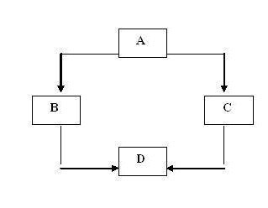
- Sub class constructor
- Constructor which is defined in subclass is called sub class constructor.
- It is used to create instance variable of both sub class and super class.
- super keyword is used.
- We can use super in two ways:
  - super is used to invoke constructor method of super class.
  - super is used to access variable of super class which have same name as in sub class.
Condition to use super keyword
- super may only be used with in sub class constructor method.
- Call to super class constructor must appear as first statement sub class constructor.
- The parameter in super call must match the order and type of instance variable declared in super class.

- Method overriding(Function Overriding)
- It is possible by defining a method in sub class that has same name, same arguments, and same return type as in method in the super class.
- When method in super class is called, the method define in subclass is invoked and executed instead of one in super class this is called overriding of method.
- When same method name, same argument & same return type) is used in sub class and super class, is called method overriding.
- We can overload methods in same class.In this case, Method in sub class overridesthe method in super class.

this keyword

- this keyword hides Instance variable.
- It is used in method body to refer to the members (variables) of current object.
- Current object is an object whose method is being called.
- this keyword used in constructor.this is used to (disambiguate) make different variable name if one of argument / parameter has same name as other method.
Recursion

- Recursion is a function that allows method to call itself.
- When recursive method calls itself new local variables and parameter are removed from the stack and execution resumes.
- A recursive call does not make a new copy of method but arguments are new.

Abstract class and methods
- final makes any method protected means it can’t be extended. Java also allows us to exactly opposite to above one.
- If we want method must always be redefined in subclass, to make overriding compulsory.
- Then abstract (modifier) keyword is used to make overriding compulsory.
- abstract keyword can be used with class and methods.

Ex: abstract class Shape
{ ------------
abstract void draw( );
-----------
-----------
}
- Subclass must override them, it cannot simply use the version defined in super class.
- Method in super class does not have body.
Syntax: abstract type name (parameter-list);
- Packages
- Packages are grouping of variety of classes and/or Interfaces together.
- Packages are conceptually similar as “class libraries “of other languages.
- Packages act as “containers” for classes.
- Java packages are classified into two types
  - Java API packages
  - User defined packages
Java API Packages
(System defined API packages or Standard Java packages)
No. | Package name | Description
1 | java.lang | - Language support classes  - These are classes that java compiler itself uses and therefore they are automatically imported  - They include classes for primitive types, math functions ,threads and exceptions.
2 | java.util | - Language utility classes  - It includes Vector ,hash tables, random numbers.
3 | java.io | - Input/output support classes  - They provide facilities for the input and output of data
4 | java.net | - Network communication supporting classes  - Classes for communicating with local computers as well as internet servers
5 | java.awt | - (Abstract window toolkit )  - Set of classes for implementing graphical user interface.  - They include classes for windows, buttons, lists, menus and many more
6 | java. applet | Classes for creating and implementing applets.

How to use system defined (standard) packages?

Two approaches:
- Use fully class name: E.g.: java.awt.Color
Syntax: import java .Packagename. classname;

2) Use short path by putting *:
Syntax : import Packagename.*;

Creating package
- To create a package first declares the name of package using package keyword.
Syntax: package packagename;
- This must be first statement in source file.

Example:
package firstPackage; //package declaration
public class First Class //class declaration
{
//body of class
}
- Save that file as FirstClass.java in directory firstPackage
- .class files must be located in directory firstPackage.

Steps to create user-defined package
Question: How to create user-defined package?
Five steps:
- Declare the package at the beginning of file using Syntax :package packagename ;
- Define the class that is to be put in the package and declare it public.
- Create a subdirectory under the directory where the main source files are stored.
- Store the listing as the classname.java file in subdirectory created.
- Compile the file. This creates .class file in subdirectory.

Java also support concept of package hierarchy .This allows to group related classes into a package and then group related packages into a larger package.
E.g. package firstPackage.secondPackage;
Access protection for classes of package

Access  Modifier  Access  Location | public | protected | Friendly  (default) | privateprotected | private
Same class | yes | Yes | yes | Yes | yes
Subclass in same package | yes | Yes | Yes | yes | No
Other classes in same package | Yes | yes | Yes | No | No
Subclass in other packages | Yes | Yes | No | Yes | No
Non-subclasses in other package | Yes | No | No | No | No

Class path
- The compiler and the interpreter searches for the classes in the current directory and the directory, which consists JDK class files.
- All JDK class files and the current directory are automatically set in your class path.
- But when we want save our class file any other directory in place of JDK ‘s bin folders, then we have to set class path to run that class file.
- A class path is a list of directories, which compiler and interpreter use to search for the respective class file.
- We can set path as following:
- Javac –d classpath filename
- set path=“c:\program files\java\jdk1.2\bin”;
- Globally path set:

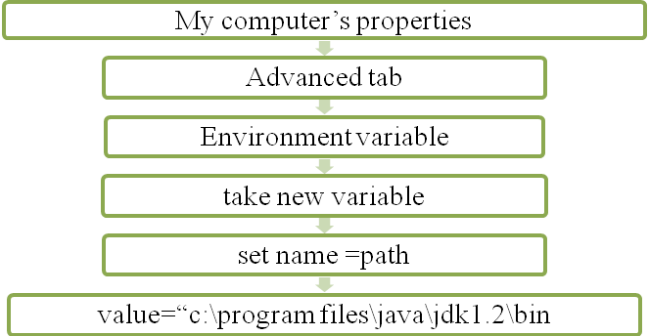
- Interface
- Java does not support multiple inheritances directly.
- Means, Java class cannot have more than super class.
Ex:
A
B
B
class C extends B,A
{
---------
C
}
- Java class cannot be a subclass of more than one super class.
- But it can implement more than one interface, this enabling us to create classes that build upon other classes without problems created by multiple inheritance.
- Interface is basically a king of class.
- Interface contains methods and variable but it defines only abstract method and final variable.
- Interface do not specify any code to implement methods(method does not have body) .
- Variables are constant (value can’t be changed).

Syntax to define interface:
access interface interfaceName
{
variable declaration;
method declaration;
}
- Interface is keyword.
- Access: is access modifier, it must be either public or not used any other (friendly).

Declaration of variable :
static final type variablename = value;
Note:
- All variables are declared as constants.
- It is allowed to declared variable without final and static ,because all variables in interface are treated as constants.

Method declaration in interface:
returntype methodname ( parameter-list );
Note:
- Method declaration will contain only a list of methods (without body) like abstract methods.
- code of that method will implements by class which use that method.
- Method declaration ends with semicolon.
How to extend interface?

- Interface can be extended, means it can be sub inherited from interface.
- New sub interface will inherit all member of super interface in same manner as class.

interface interface2 extendsinterface1
{
body of interface2
- } While extending interfaces, sub interface can’t define methods declared in super interface (because it’s not class).
- When two or more interfaces are extended by one interface, they are separated by comma.
- Interface can only extend interface but cannot extend classes.
- If a class that implements an interface does not implement all methods of interface, then class becomes an abstract class, can’t be instantiated.
Note:
- extends : class to class
- extends : interface to interface
- implements : class to interface
How to implement an interface to a class?
- Interfaces are act as super class whose properties are inherited by classes.
- Syntax:

class classname implements InterfaceName
{
body of class name
}
Or

class classname extends SuperClass implements interface1,interface2….
{
body of classname
}

Practical No. :4
AIM:
4.1 Design a base class Shape with two double data members d1 and d2 to store dimensions. Include a method getData(double d1, double d2) to initialize these dimensions. Create two derived classes, Triangle and Rectangle, which inherit from Shape. Each derived class should have its own method to calculate its specific area.

Rubrics | 1 | 2 | 3 | Total

Marks

Sign of Faculty: ___________________

Practical No. :4
AIM:
  - Define a base class BankAccount with common attributes like accountNumber, accountHolderName, and balance. Then, define two subclasses: SavingAccount and FixedDepositAccount, which inherit from BankAccount. Implement basic operations like openAccount(), deposit(), checkBalance(), and withdraw() in BankAccount. The SavingAccount should include a calculateInterest() method specific to savings accounts, and FixedDepositAccount should have a maturityAmount() method considering fixed deposit terms.

Rubrics | 1 | 2 | 3 | Total

Marks

Sign of Faculty: ___________________
Practical No. :4
AIM:
  - Create a base class named Employee that contains a method displayDetails() which prints general employee details such as name and department. Now create a subclass Manager that inherits from Employee and overrides the displayDetails() method to include additional information such as the manager's team size or project name. In the main method, create objects of both Employee and Manager classes and call the displayDetails() method using each object to show how Java determines which version of the method to execute at runtime.

Output :

Rubrics | 1 | 2 | 3 | Total

Marks

Sign of Faculty: ___________________
Practical No. :4
AIM:
4.4 Create a base class named Vehicle that contains common attributes such as vehicleNumber, brand, and fuelType. Include a constructor to initialize these fields and a method displayDetails() to print them. Derive a subclass Car from Vehicle which adds attributes such as numberOfSeats and ACavailable (boolean). Override the displayDetails() method to include the car-specific details, and use the super keyword to invoke the parent class constructor and methods. Further, derive another subclass ElectricCar from Car that includes attributes such as batteryCapacity and chargingTime, and again override the displayDetails() method to include electric car-specific details. Demonstrate constructor chaining, method overriding, use of protected access specifier for inherited members, and instanceof operator to check object type at runtime. In the main() method, create objects of all three classes and display their details using overridden methods. Also, use upcasting (Vehicle v = new Car(...)) and downcasting with instanceof check to access subclass- specific features.

Output :

Rubric wise marks obtained:
Rubrics | 1 | 2 | 3 | Total

Marks

Sign of Faculty: ___________________
Assignment
1) What is inheritance? Explain it types.
2) Explain method overriding with example.
3) Explain subclass constructor and super key word with example.
4) Explain abstract class with example.
5) What is package? Write the steps to create user defined package.
6) Explain Java API packages.
7) What is interface? How we can define variable and Methods in interface? Write syntax of interface implementation in the class.
8) Explain multiple inheritance with example.

Abstract, Interface, Package and Access Specifier in Java

1. Abstract Class (abstract)
An abstract class represents a generic concept that cannot be instantiated on its own. It is used to provide a common definition for subclasses that share a "parent-child" relationship.

Key Characteristics
- Keyword: Defined using abstract class.
- Instantiation: You cannot create an object of an abstract class (new Animal() is illegal).
- Methods:
  - Abstract Methods: Have no body (abstract void sound();). Subclasses must override these.
  - Concrete Methods: Have a body. Subclasses inherit them as-is.
- Constructors: It can have constructors (executed when the subclass is instantiated).

Code Example
Java
abstractclassVehicle{
// Abstract method (no body)
abstractvoidstartEngine();

// Concrete method (has body)
voidstopEngine(){
System.out.println("Engine stopped.");
}
}

classCarextendsVehicle{
@Override
voidstartEngine(){
System.out.println("Car key turned.");
}
}

2. Interface (interface)
An interface is a complete abstraction (a "contract"). It specifies what a class must do, but not how it does it. It is used to achieve loose coupling and multiple inheritance.

Key Characteristics
- Keyword: Defined using interface and implemented using implements.
- Multiple Inheritance: A class can implement multiple interfaces (e.g., class Duck implements Flyable, Swimmable).
- Variables: All variables are implicitly public static final (constants).
- Methods:
  - Traditionally, all methods were implicitly public abstract.
  - Note (Java 8+): Can now have default and static methods with bodies.

Code Example
Java
interfacePaymentProcessor{
voidprocessPayment(double amount);
}

classPayPalimplementsPaymentProcessor{
publicvoidprocessPayment(double amount){
System.out.println("Processing $" + amount + " via PayPal");
}
}

Quick Comparison: Abstract Class vs. Interface
Feature | Abstract Class | Interface
Relationship | "Is-a" (Identity) | "Can-do" (Capability)
Multiple Inheritance | No (Single parent only) | Yes (Multiple interfaces)
Variables | Any type (static, non-static) | Only Constants (static final)
Constructors | Yes | No
Speed | Slightly faster | Slightly slower (lookup required)

3. Packages
Packages are containers (folders) that group related classes and interfaces. They help organize code and prevent naming conflicts.

Types of Packages
- Built-in Packages: Provided by Java API.
  - java.lang: Fundamental classes (String, System). Imported automatically.
  - java.util: Collections, Date, etc.
  - java.io: Input/Output operations.
- User-defined Packages: Created by the programmer.

Keywords
- package: Placed at the very top of a source file to declare which package the class belongs to.
- import: Used to access classes from other packages.
Java
package com.myapp.utilities; // Declaration

import java.util.ArrayList; // Import specific class
import java.util.*; // Import entire package

Here are the step-by-step instructions to create a package in Java.

The Golden Rule of Packages
In Java, Package Name = Folder Structure.
If your package is named com.tools, your Java class must live inside a folder structure com/tools/.

Step 1: Declare the Package
Open your text editor and write your Java code. The very first line of your file must be the package statement.
File:Calculator.java
Java
package mytools; // This declares that this class belongs to the 'mytools' package

publicclassCalculator{
publicvoidadd(int a, int b){
System.out.println("Sum: " + (a + b));
}

publicstaticvoidmain(String[] args){
Calculator calc = new Calculator();
calc.add(10, 20);
}
}

Step 2: Compile the Package
You can compile this in two ways. The smart way (using the -d flag) is recommended because it handles folder creation for you.
Open your command prompt/terminal where your Calculator.java file is saved.
Command:
Bash
javac -d . Calculator.java
What does this command do?
- javac: The Java compiler.
- -d: Stands for "Destination". It tells the compiler to generate the package directories based on the package statement in your code.
- .: Represents the current directory. It tells Java to create the package folder here.
Result:
You will see a new folder named mytools appear in your directory. Inside it, you will find Calculator.class.

Step 3: Run the Package
This is where most beginners get stuck. You cannot go inside the mytools folder to run the class. You must stay outside in the root directory and call the class by its Fully Qualified Name.
Command:
Bash
java mytools.Calculator
Output:
Plaintext
Sum: 30

Summary Checklist
- Code: Add package mypackagename; as the first line.
- Compile: Use javac -d . Filename.java to auto-create folders.
- Run: Use java mypackagename.Filename from the root folder.

A Note on Standard Naming Conventions
Real-world Java packages usually follow the "Reverse Domain Name" convention to ensure uniqueness globally.
- Company: https://www.google.com/search?q=google.com
- Package Name:com.google.search
- Folder Structure:com/google/search/

4. Access Specifiers (Visibility Modifiers)
Access specifiers control the visibility (scope) of classes, variables, and methods. There are four levels of access in Java.
Specifier | Keyword | Visibility | Scope Description
Private | private | Class Only | Most restrictive. Cannot be seen outside the class. Used for encapsulation.
Default | (none) | Package Only | If no keyword is used. Visible to all classes in the same package.
Protected | protected | Package + Subclass | Visible within the package AND to subclasses in different packages.
Public | public | World | Visible to everyone, everywhere.

Best Practice Rule of Thumb
Always start with the most restrictive access (private) and open it up (protected or public) only when absolutely necessary. This preserves Encapsulation.

Practical No. :5
AIM:
5.1 Given an interface Classify with a method String getDivision(double average). Implement this getDivision method in a class Result such that it returns "First Division" if the average is 60 or more.

Output :

Rubrics | 1 | 2 | 3 | Total

Marks

Sign of Faculty: ___________________

Practical No. :5
AIM:
5.2 Write the Java code for an interface named Exam which declares a single abstract method boolean isPassed(int mark). This method should take an integer mark as an argument. Write the Java code for another interface named Classify which declares a single abstract method String getDivision(double average). This method should take a double average as an argument. Create a class named Result that implements both the Exam and Classify interfaces. Provide concrete implementations for isPassed() and getDivision() methods. In your main method, create an instance of Result, set some marks and average, and demonstrate the use of both interface methods.

Output :

Rubrics | 1 | 2 | 3 | Total

Marks

Sign of Faculty: ___________________

Practical No. :5
AIM:
5.3 Design a Java program for an Online Order Processing System using partial interface implementation. Create an interface Order with three methods:
placeOrder(String item, int qty)
cancelOrder(int orderId)
generateBill()
Create an abstract class PartialOrder that implements the Order interface but provides implementation only for placeOrder() (storing order details). Create a concrete class FinalOrder that extends PartialOrder and implements the remaining methods cancelOrder() and generateBill(). Accept user input for order details and allow user to either generate a bill or cancel the order.

Output :

Rubrics | 1 | 2 | 3 | Total

Marks

Sign of Faculty: ___________________

Practical No. :5
AIM:
5.4 Write a Java program to create an abstract class Vehicle with:
● An abstract method fuelType() that returns the type of fuel used.
● An abstract method noOfWheels() that returns the number of wheels.
Create two subclasses:
● Car that uses Petrol/Diesel and has 4 wheels.
● Bike that uses Petrol and has 2 wheels.
In the main method, create objects of Car and Bike, and display their fuel type and number of wheels. .

Output :

Rubrics | 1 | 2 | 3 | Total

Marks

Sign of Faculty: ___________________

Practical No. :5
AIM:
5.5 Write a Java program using packages to generate a mark sheet for students.
Create a package student that contains a class Student with the following:
● Data members: rollNo, name.
● A constructor to initialize student details.
● A method displayStudent() to display student information.
Create another package exam that contains a class Result which:
● Extends the Student class.
● Has data members: marks1, marks2, marks3.
● A method displayResult() that prints the student’s mark sheet including total and average marks.
In the main method (inside the exam package), create a student with marks and display the mark sheet.

Output :

Rubrics | 1 | 2 | 3 | Total

Marks

Sign of Faculty: ___________________

Practical No. :5
AIM:
5.6 Write a Java program using four different packages to demonstrate the use of access specifiers.
● Package apack:
o Define a class A with three variables:
▪ public int pubVar
▪ protected int protVar
▪ private int privVar
o Provide a constructor to initialize them.
● Package bpack:
o Define a class B that extends A.
o Create a display() method that tries to access variables of A using inheritance.
● Package cpack:
o Define a class C with a display() method.
o Inside display(), create an object of class A and try to access its variables.
● Package dpack:
o Define a class ProtectedDemo with main().
o Create objects of class B and class C.
o Call their respective display() methods to show which variables are accessible and which are not.

Output :

Rubrics | 1 | 2 | 3 | Total

Marks

Sign of Faculty: ___________________
Assignment

1. Explain how interfaces promote the concept of multiple inheritance in OOP.

2. What is an interface, and how does it differ from an abstract class?

3. When would you choose to use an abstract class over an interface, and vice versa, in your software design?

4. Can a class implement multiple interfaces? If so, what benefits does this provide?

5. Can you declare an interface method static? Justify your answer.

6. Explain the benefits of organizing classes into packages in a Java application.

7. How do you declare and define a package in Java?

- Introduction
- It is common to make mistakes while developing or in typing a program. A mistake leads to an error causing the program to produce unexpected results
- Errors are the wrongs that can make a program to produce unexpected or unwanted output.
- Error may produce
- An incorrect output
- may terminate the execution of program abruptly
- may cause the system to crash
- It is important to detect and manage properly all the possible error conditions in program.

Types of error

- Compile time Errors (syntactical error) : Detected by javac at the compile time
Common errors:
  - Missing semicolon
  - Missing or mismatch of brackets in classes and methods
  - Misspelling of identifiers and keywords
  - Missing double quotes in strings
  - Use of undeclared variables
  - Incompatible types in assignments/ Initialization
  - Bad references to objects
  - Use of = in place of = = operator

- Run time Errors(logical error): Detected by java at run time

Common errors:
    - Dividing an integer by zero
    - Accessing element that is out of the bounds of an array
    - Trying a store a value into an array of an incompatible class or type
    - Trying to cast an instance of a class to one of its subclasses
    - Passing a parameter that is not in a valid range or value for a method
    - Trying to illegally change the state of a thread
    - Attempting to use a negative size of an array
    - Using a null object reference as a legitimate object references to access a method or a variable
    - Converting invalid string to a number
    - Accessing a character that is out of bounds of a string
    - And many more
    - Exceptions
- An Exception is abnormal condition that is caused by a runtime error in the program.
- When java interpreter encounters an error such as dividing by zero, it creates an exception object and throws it (means informs us that an error has occurred).
- If the exception object is not caught and handled properly, the interpreter will display an error message and will terminate the program.
- If we want to the program to continue with the execution of remaining code, then we should try to catch exception object thrown by the error condition and then display an appropriate message for taking corrective actions. This is known as Exception handling.
- The purpose of exception handling is to provide a means to detect and report an “exceptional circumstances “so we can take proper actions.
- Error handling code consist of two segments
1) Detect errors and to throw exceptions
2) Catch the exceptions and take appropriate actions

This mechanism performs following tasks in sequence
- Find the problem (Hit the Exception)
- Inform that an error has occurred (Throw the Exception)
- Receive the error information catch the exception)
- Take corrective actions (Handle the Exception)
Common exception Or System defined exception
No. | Exception Type | Cause of Exception
1 | ArithmeticException | Caused by math error such as divide by zero
2 | ArrayIndexOutOfBoundsException | Caused by use of bad array indexes(if index you are trying to access is not available in array)
3 | ArrayStoreException | Caused when a program tries to store the wrong type of data in an array
4 | FileNotFoundException | Caused by an attempt to access a nonexistent file Caused by general I/O
5 | IOException | failures, such as inability to read from a file
6 | NullPointerException | Caused by referencing a null object
7 | NumberFormatException | Caused when a conversion between strings and number fails
8 | OutOfMemoryException | Caused when there’s not enough memory to allocate a new object
9 | SecurityException | Caused when an applet tries to perform an action not allowed by the browser’s security
10 | StackOverflowException | Cause when the system runs out of stack space
11 | StringIndexOutOfBoundsException | Caused when a program attempts to access a nonexistent character position in a string

Exception handling code (try – catch block) Syntax:
1) try block
- Java uses a try block defined by keywordtry.
- try block contain block of code that causes an error condition and throw an exception.
- try block can have one or more statements that could be generate an exception.
- If anyone statement generates an exception than remaining statements in block are skipped and execution jumps to the catch block that is placed next to try block.
- Every try statement should be followed by at least one catch statement; otherwise compilation error will occur.

2) catch block
- Java uses a catch block defined by keyword catch.
- catch block “catches” the exception “thrown” by the try block and handles it appropriately.
- catch block too can have one or more statements that are necessary to process the exception. The catch block is added immediately after the try block.
- catch statement works like a method definition. It is passed as single parameter which is reference to the exception object thrown.
- If catch parameter matches with the type of exception object, then exception is caught and that catch block will be executed.
- If catch parameter does not match with any type of exception then default exception handler will cause the execution to terminate

…………………………………
…………………………………
try
{
Statement; //generates an exception an throw it
}
catch (Exception-type e)
{
Statement; // catch and processes the exception
}
…………………….
…………………….

Multiple catch statements and finally statement
We can use more than one catch statements (blocks) with a single try block.
Syntax:
………………..
………………..
try
{
Statement; // generates an exception
}
catch(Exception-type-1 e)
{
Statements; // processes exception type 1
}
catch(Exception-type-2 e)
{
Statements ; // processes exception type 2
}
…………..
catch(Exception-type-N e)
{
Statements; // processes exception type N
}
Finlly
{
………………..
}
………………..
………………..

- Type of Exception
- All types of exceptions are subclasses of built in class Throwable.
- Throwable class is contained in java.lang package.

Throwing user defined exception
Throwable
Exception
Error
Interrupted
Exception
Runtime
Exception
ArithmeticException
NullPointerException
Checked
Exception
ClassCastException
Fig. Java Exception hierarchy
Super class
Sub classes
- We can make a program to throw an exception explicitly using throw statement.
throw throwableInstance;
- throw keyword throws a new exception.
- An object of class that extends throwable can be thrown and caught.
Throwable à Exception à MyException
- The flow of execution stops immediately after the throw statement ;
- Any subsequent statements are not executed. The nearest enclosing try block is inspected to see if it has catch statement that matches the type of exception.
- If it matches, control is transferred to that statement
- If it doesn’t match, then the next enclosing try statement is inspected and so on. If no catch block is matched than default exception handler halts the program.
Create java’s standard exception objects

`Syntax: throw new thowable_instance;
Example: throw new ArithmeticException ();
throw new MyException();
- Here, new is used to construct an instance of MyException ().
- All java’s runtime exception s have at least two constructors:
1) One with no parameter
2) One that takes a string parameter.
In that the argument specifies a string that describes the exception. This string is displayed when object is used as an argument to print() or println( ).
It can also obtained by a call to getMessage ( ), a method defined by Throwable class

Errors are thrown by any methods of Java API or by java virtual

Throws :

- Throws keyword declares that a method may throw particular exception.
- If method is capable of causing an exception that it does not handle.
- It must specify this behavior so that callers of that method can guard themselves against that exception.
- We can do this by including throws class in the methods declaration as follows.
SYNTAX:
type method-name (parameter list )throws Exception list

{
// body
}

Practical No. :6
AIM:
6.1 Take the value of denominator and numerator from user using command-line argument. Implement the concept of exception handling to manage all possible run-time error.

Output :

Rubric wise marks obtained:
Rubrics | 1 | 2 | 3 | Total

Marks

Sign of Faculty: ___________________

Practical No. :6
AIM:
6.2 Write a Java program to create a class VotingApp where:
● The method checkEligibility(int age) checks if a person is eligible to vote.
● If age < 18, explicitly throw the predefined exception IllegalArgumentException with the message "Age must be 18 or above to vote".
In the main method, test the method with different age inputs.
● Use a try-catch-finally block to handle exceptions.
● The finally block should always print "Validation process completed"

Output :

Rubric wise marks obtained:
Rubrics | 1 | 2 | 3 | Total

Marks

Sign of Faculty: ___________________

Practical No. :6
AIM:
6.3 Write a Java application that defines a method average(String[] values) which:
● Accepts an array of strings as an argument.
● Converts each string element into a double and computes the average.
● If any array element is null, the method should throw a NullPointerException.
● If any element is not a valid number (e.g., "abc"), it should throw a NumberFormatException.
● Include the throws clause in the method declaration.
● In the main method, demonstrate the working of this program with valid and invalid inputs using try-catch-finally

Output :

Rubric wise marks obtained:
Rubrics | 1 | 2 | 3 | Total

Marks

Sign of Faculty: ___________________

Practical No. :6
AIM:
6.4 Write a Java program to create a Banking Application using classes and exception handling.
Create a class BankAccount with:
● A constructor to initialize the balance with 1000.00.
● A method deposit(double amount) to add money to the account.
● A method withdraw(double amount) that subtracts money from the account.
● If withdrawal is more than the available balance, it should throw a custom exception called NotSufficientFundException.

In the main method:
● Deposit 1000.00.
● Perform three withdrawals: 400.00, 300.00, and 500.00.
● The last withdrawal should throw the exception with the message "Not Sufficient Fund".

Output :

Rubric wise marks obtained:
Rubrics | 1 | 2 | 3 | Total

Marks

Sign of Faculty: ___________________
Practical No. :6
AIM:
6.5 Define a custom exception class BookNotAvailableException that extends Exception.
● Create a class Library with:
● An instance variable availableBooks (integer).
● A method issueBook(int count) that:
o If count <= availableBooks, reduce the number of books and display "Book issued successfully".
o Otherwise, throw BookNotAvailableException with the message "Requested books not available".

In the main() method:
● Initialize the library with 3 available books.
● Try issuing 2 books (valid).
● Then try issuing 2 more books (should throw the custom exception).

Output :

Rubric wise marks obtained:
Rubrics | 1 | 2 | 3 | Total

Marks

Sign of Faculty: ___________________

Assignment
1) What is exception? Explain system defined exception.
2) What is error? Explain in different types of errors.
3) Explain try & catch block.
4) Explain throw, throws and finally statements.
5) How the user can throw user define exception.
Thread
- Multithreading is a conceptual programming paradigm where a program ( or process) is divided into two or more subprograms( or process),which can be implemented at the same time in parallel.
- Java enables us to use and manage multiple flows of control in developing programs.
- Each flow of control may be thought of as a separate tiny program, which is known as thread that runs in parallel to others threads of the same process.
- Threads in java are subprograms of main application program and share the same memory space, they are known as light weight process.
- Multithreading is similar to dividing a task into subtasks and assigning them to different people for execution independently and simultaneously, to achieve a single desire.
- E.g. In animation, one sub program can display an animation on the screen while another may build the next animation to be displayed.

- During the life time of a thread ,there are many states it can enter, They are:
- Newborn state
- Runnable state
- Running state
- Blocked state
- Dead state
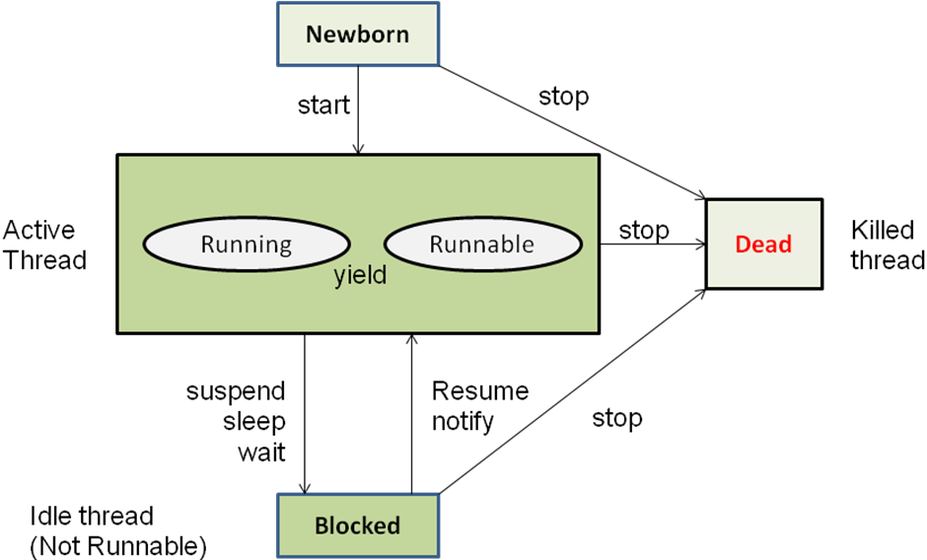
Fig. Thread life cycle
- Thread class
Thread encapsulates a thread of execution. Thread class defines several methods that help manage threads.
No. | Method | Meaning
1 | getName( ) | Obtain a thread’s name.
2 | setName( ) | Set a thread’s name.
3 | getPriority( ) | Obtain a thread’s priority
4 | setPriority( ) | Set a thread’s priority
5 | isAlive( ) | Determine if a thread is still running.
6 | join( ) | Wait for a thread to terminate.
7 | run( ) | Entry point for the thread.
8 | sleep( ) | Suspend a thread for a period of time.
9 | start( ) | Start a thread by calling run method

- Creating thread
- We can create a thread by instantiating an object of type Thread.
- The run () method is the heart and soul of any thread.
- run( ) method makes up the entire body of a thread and is the only method in which the thread’s behaviour can be implemented.
Syntax: public void run( )
{…………
………… // (statement for implementing thread)
}
The run () method should be invoked by an object of concerned thread. For that we have to create thread and initiate it with the help of other thread method called start ().
Java can create a thread by following two ways:
- You can implement the Runnable interface.
- You can extend the Thread class.

1. Implementing the Runnable interface
The Runnable interface declares the run () method that is required for implementing threads in our programs.
Steps to implement Runnable interface:
- Declare the class as implementing the Runnable interface.
- Implement the run () method.
- Create a thread by defining an object that is instantiated from this “runnable” class as the target of the thread.
- Call the thread’s start( ) method to run the thread

class classnameimplementsRunnable //step1
{
public void run() //step2
{
//body of thread execution
}
}
class main_class
{
public static void main (String args[])
{
-------
Thread t1= new Thread (obj); //step3
t1.start (); // step4
}
}

2. Extending the thread class

The Thread class declares the run () method that is required for overriding threads in our programs.
We can make our class Runnable by extending the class java.lang.Thread.
To extend Thread class, perform following steps:

- Declare the class as extending the Thread class.
- Implement the run() method that is responsible for executing the sequence of code that the thread will execute.
- Create a thread object and call the start() method to initiate the thread execution .

Step 1: Declaring the class
Thread class can be extended as follows:
class MyThread extends Thread
{
public void run( )
{
……….. //Thread code here
}
} now we have new type of thread MyThread.

To actually create and run an instance of our thread class, we must write:
MyThread aThread =new MyThread ();
aThread .start(); //invokes run() method
Or
new MyThread( ).start ( );

Example of thread creation by extending Thread class:

class threadclassextends Thread
{
public void run()
{
// body
}
}

- Thread exception
- Whenever we call a thread that may throw an exception, we have to supply appropriate exception handler to catch it.
- Here ,the example of different Exception in multithreading are given in next slide:

catch (ThreadDeath e)
{
………………
……………… //Killed threads
}
catch( InterruptedException e)
{
……………… //cannot handles it in the current state
………………
}
catch (IllegalArgumentException e)
{
……………… //illegal method argument
………………
}
catch (Exception e)
{
………………
………………
}

- Synchronization
- When two or more threads need to access to a shared resource, they need some way to ensure that the resource will be used by only one thread at a time. The process of achieving this is called synchronization.
For example, one thread may try to read a record from a file while another is still writing to the same file. Depending on situation we may get strange result. We can avoid this by synchronization.
- Monitor (semaphore) concept is key to synchronization.
- Monitor is an object that is used as a mutually exclusive lock or mutex.
- Only one thread can own a monitor at a given time.
- When a thread acquires a lock, it is said to have entered the monitor. Monitor is like a key and the thread that holds the key can only open the lock.
- All the other threads attempting to enter the locked monitor will be suspended until the first thread exists the monitor. This other threads are said to be waiting for the monitor.
- We can synchronize code in two ways:
- Using synchronized Methods
- The synchronized statement
Using synchronized methods
- To create object’s monitor, just call a method that uses synchronized keyword.
synchronized void method-name ( )
{
// code here is synchronized
}
The synchronized statement
- Creating synchronized methods within classes that you create will not work in all cases.
- To access a synchronized object of this class, we can use synchronized block by putting calling method of a class in that block.
synchronized (lock-object)
{
// statements to be synchronized
}
Practical No. :7
AIM:
7.1 Write a Java program that creates two threads:
● First thread prints numbers from 1 to 10 at the interval of 1 second.
● Second thread prints numbers from 11 to 20 at the interval of 500 ms.

Run both threads and display the output.

Output :

Rubric wise marks obtained:
Rubrics | 1 | 2 | 3 | Total

Marks

Sign of Faculty: ___________________

Practical No. :7
AIM:
7.2 Write a Java program where Thread T1 prints 1 to 100, T2 prints 101 to 200 and T3 prints 201 to 300. Initiate execution of all the three threads but ensure that numbers should be printed sequentially.

Output :

Rubric wise marks obtained:
Rubrics | 1 | 2 | 3 | Total

Marks

Sign of Faculty: ___________________

7.3 Write a Java program where two threads print multiplication tables (e.g., Table of 5 and Table of 7). Use a synchronized method so that table outputs do not mix and remain consistent.

Output :

Rubric wise marks obtained:
Rubrics | 1 | 2 | 3 | Total

Marks

Sign of Faculty: ___________________
7.4 Write a Java program where:
● Thread 1 computes the sum of numbers from 1 to 1000.
● Thread 2 computes the sum of numbers from 1001 to 2000.
● Both threads should run in parallel.
● Each thread should return its computed sum to the main method (e.g., using a getter method or storing result in a shared variable).
● The main method should wait for both threads to finish using join(), then combine the two partial sums and print the final result.

Output :

Rubric wise marks obtained:
Rubrics | 1 | 2 | 3 | Total

Marks

Sign of Faculty: ___________________
Assignment
1) What is thread? Explain the multithreading.
2) Explain Life cycle of Thread.
3) How a thread is created by extending the thread class? Explain with example.
4) What is Synchronization? What is Monitor?
5) How we can create a multiple thread?

- Introduction:
When we use variables and array for storing data inside the programs. We face two
Problems:
1) The data is lost either when a variable goes out of scope or when the program is terminated. The storage is temporary.
2) It is difficult to handle large volumes of data using variables and arrays.
We can overcome these problems by storing data into secondary storage devices. We can store data using concept of files. Data stored in file is often called persistent data.
- A file is collection of related records placed area on the disk. A record is composed of several fields. Field is a group of characters.
- Storing and managing data using file is known as file processing which includes tasks such as creating files, updating files and manipulation of data.
- Reading and writing of data in a file can be done at the level of bytes or characters or a field depending on the requirement of application.java provides capabilities to read and write class object directly.
- The process of reading and writing objects is called serialization.
Concept of stream
- In file processing, inputrefers to the flow of data into a program and output means the flow of data out of a program.
- Java uses concept of stream to representordered sequence of data, a common characteristics shared by all input/output devices.
- A stream presents uniform, easy to use, object oriented interface between the program and the input/output devices.
- A stream in java is a path along which data flows (like pipe along which water flows). It has source (of data) and destination (for that data).Both the source and destination may be physical devices or programs or other streams in same program.
- The concept of sending data from one stream to another has made streams in java a powerful tool for file processing.
- Java stream classified into basic type as follow:

Stream
Output Stream
Input Stream

- Input stream: it extracts (i.e. reads) data from the source (file) and sends it to the program.
- Output stream: it takes data from the program and sends (i.e. writes) it to the destination (file).

(a) Reading data into a program
source
Program
Input stream
Reads
Destination
Program
Output stream
Writes
(b) Writing data to a destination
Stream classes
The java.io package contains a large number of stream classes that provide capabilities for processing all types of data. The classes may be categorized into two groups based on the data type on which they operate.
1. Byte stream classes that provides support for handling I/O operations on bytes.
2. Character streamclasses that provide support for managing I/O operation on characters
- . Byte stream classes
- Byte stream classes have been designed to provide functional features for creating and manipulating streams and files reading and writing bytes.
- Since the steams are unidirectional, they can transmit bytes in only one direction and, therefore, Java provides two kinds of byte stream classes: input stream classes and output stream classes.
Input Stream Classes
- Input stream classes that are used to read 8-bit bytes include super class known as InputStream and a number of subclasses for supporting various input-related functions.
- The super class InputStream is an abstract class, and, therefore, we cannot create instances of this class.We must use the subclasses that inherit from this class. The InputStream class defines method for performing input functions such as

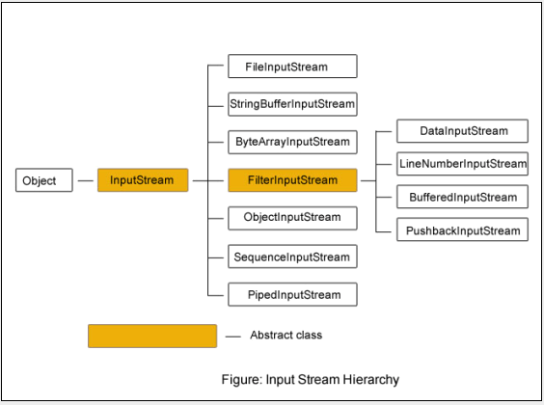

 | Method | Description
1 | read() | Reads a byte from the input stream
2 | read(byte b[]) | Reads an array of bytes into b
3 | read(byte b[],int n,int m) | Reads m bytes into b starting from nth byte
4 | available() | Gives number of bytes available in the input
5 | skip(n) | Skips over n bytes from the input stream
6 | reset() | Goes back to the beginning of the stream
7 | close() | Closes the input stream.

Output Stream Classes
- Output stream classes are derived from the base class OutputStream as shown in figure. Like InputStream, the OutputStream is an abstract class and therefore we cannot instantiate it. The several subclasses of the OutputStream can be used for performing the output operations.
The OutputStream includes methods that are designed to perform the following task:
- Writing bytes
- Closing stream
- Flushing stream

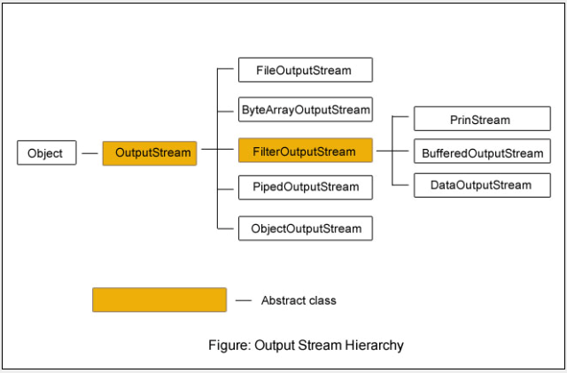
Summary of output stream methods
 | Method | Description
1 | write() | Writes a byte to the output stream
2 | write(byte b[]) | Writes all bytes in the array b to the output stream
3 | write(byte b[],int n,int m) | Writes m bytes from array b starting from nth byte
4 | close() | Close the output stream
5 | flush() | Flushes the output stream

- Character stream classes
Character streams can be used to read and write 16-bit Unicode characters. Like byte streams, there are two kinds of character stream classes, reader classes and writer stream classes.
Reader Stream Classes
- Reader stream classes are designed to read character from the files. Reader class is the base class for all other classes in this group as shown in figure.
- These classes are functionally very similar to the input stream classes, except input stream use bytes as their fundamental unit of information, while reader stream use characters.
- The Reader class contains method they are identical to those available in the InputStream class, except Reader is designed to handle characters Therefore, reader classes can perform all the functions implemented by the input stream classes.
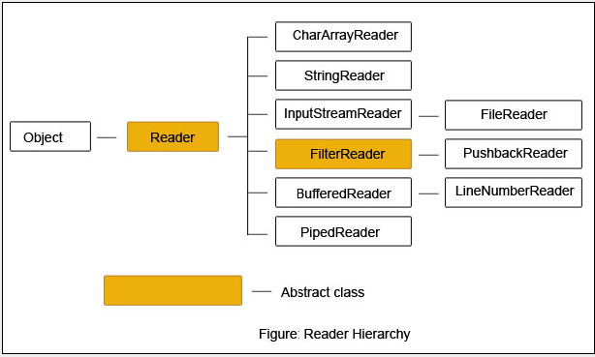
Writer Stream Classes
- Like output stream classes, the writer stream classes are designed to perform all output operations on files. Only difference is that while output stream classes are designed to write bytes, the writer stream classes are designed to write characters.
- The Writer class is an abstract class which acts as a base class for all other writer stream classes as shown in figure. This base class provides support for all output operations by defining method that are identical to those in OutputStream class.

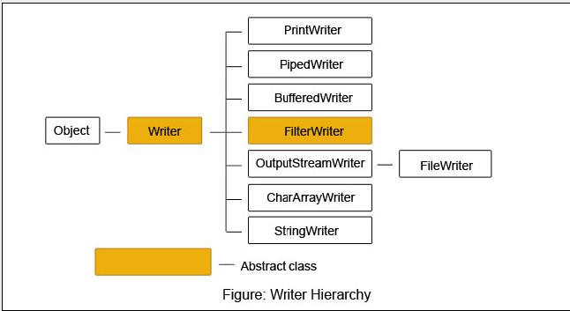
- Using streams
- We have various types of input and output stream classes used for handling both the 16-bit characters and 8-bit bytes. Although all the classes are known as i/o classes, not all of them are used for reading and writing operations only. Some perform operations such as buffering, filtering, data conversion, counting and concatenation while carrying out I/O tasks.
List of Tasks and Classes Implementing Them
Task | Character Stream Class | Byte Stream Class
Performing input operations | Reader | InputStream
Buffering input | BufferedReader | BufferdInputStream
Keeping track of line numbers | LineNumberReader | LineNumberInputStream
Reading from an array | CharArrayReader | ByteArrayInputStream
Translating byte stream into a character stream | InputStreamReader | (none)
Reading from files | FileReader | FileInputStream
Filtering the input | FilterReader | FilterInputStream
Pushing back characters/bytes | PushbackReader | PushbackInputStream
Reading from a pipe | PipedReader | PipedInputStream
Reading from a string | StringReader | StringBufferInputStream
Reading primitive types | (none) | DataInputStream
Performing output operations | Writer | OutputStream
Buffering output | BufferedWriter | BufferedOutputStream
Writing to an array | CharArrayWriter | ByteArrayOutputStream
Filtering the output | FilterWriter | FilterOutputStream
Translating character stream into a byte stream | OutputStreamWriter | (none)
Writing to a file | FileWriter | FileOutputStream
Printing values and objects | PrintWriter | PrintStream
Writing to a pipe | PipedWriter | PipedOutputStream
Writing to a string | String Writer | (none)
Writing primitive types | (none) | DataOutputStream

- Other useful classes
The java.io package supports many other classes for performing certain specialized functions. They include among others:
- RandomAccessFile :
The RandomAccessFile enables us to read and write bytes, text and java data types to any location in a file. This class extends object class and implements DataInput and DataOutput interface
- StreamTokenizer :
The class StreamTokenizer, a subclass of object can be used for breaking up a stream of text from an input text file into meaningful pieces called tokens. The behaviour of the StreamTokenizerclass is similar to that of StringTokenizer class (of java.util package) that breaks string into its component tokens.

Using the file class
The java.io package includes a class known as the File class that provides support for creating files and directories. The class includes several constructors for instantiating the File objects. File class provides methods for operations like:
- Creating a file
- Opening a file
- Closing a file
- Deleting a file
- Getting the name of a file
- Getting the size of a file
- Checking the existence of a file
- Renaming a file
- Checking whether the file is writable
- Checking whether the file is readable
- Input/output Exceptions
When creating files and performing I/O operations on them, the system may generate I/O related exceptions. The basic I/O related exception classes and their functions:

 | I/O exception class | Function
1 | EOFException | Signals that an end of file or end of stream has been reached unexpectedly during input
2 | FileNotFoundException | Informs that a file could not be found
3 | InteruuptedIOException | Warns that an I/O operations has been interrupted
4 | IOException | Signals that an I/O exception of some sort has occurred
Creation of files:
For using a file, it must be opened first. This is done by creating a file stream and then linking it to the filename. A file stream can be defined using the class of Reader/InputStream for reading data and Writer/OutputStream for writing data. The common stream classes used for various I/O operations given in table. The constructors of stream classes may be used to assign the desired filenames to the Stream objects.
Source/destination | Characters
 | Read | Write
Memory | CharArrayReader | CharArrayWriter
File | FileReader | FileWriter
pipe | PipedReader | PipedWriter

Source/destination | Bytes
 | Read | Write
Memory | ByteArrayInputStream | ByteArrayoutputStream
File | FileInputStream | FileoutputStream
pipe | PipedInputStream | PipedoutputStream

There are two ways of Italianizing the file Streamobjects. All of the constructors require that we provide the name of the file either directly or indirectly by giving a file object that has already assigned a file name.
FileInputStream fis;
try
{
//Assign the filename to the file stream object
fis = new FileInputStream (“test.dat”);
........
}
catch (IOException e)
...........

The indirect approach uses a file object that has been Italianized with the desired filename. This is illustrated by the following code
.............
File inFile;
InFile = new file (“test.dat”);
FileInputStream fis;
try
{
//give the value of the file object
//to the file stream object
Fis=new FileInputStream (inFile);
..............
}
catch (......)
...............
Reading/writing characters
Subclass of Reader and Writer implement streams that can handle characters. The two subclasses used for handling characters in files are FileReader and FileWriter.
Reading/writing bytes:
We have used FileReader and FileWriter classes to read and write 16-bit characters. Most file systems use only 8-bit bytes. Java I/O system provides a number of classes for handling bytes are FileInputStream and FileOutputStreamclasses. We can use them in place of FileReader and file writer.
Practical No. :8
AIM:
8.1 Write a program that will count the number of characters, words, and lines in a file. Words are separated by whitespace characters. The file name should be passed as a command-line argument.

Output :

Rubric wise marks obtained:
Rubrics | 1 | 2 | 3 | Total

Marks

Sign of Faculty: ___________________
Practical No. :8
AIM:
  - Create a file named students.txt. Write at least three student records (roll number, name, marks) into the file. Read the file content and display all student records on the console. Handle exceptions like IOException properly using try-catch-finally.

Output :

Rubric wise marks obtained:
Rubrics | 1 | 2 | 3 | Total

Marks

Sign of Faculty: ___________________
Practical No. :8
AIM:
8.3 Write a Java program that reads a text file named data.txt. The program should count and display: The total number of lines, The total number of words, The total number of characters (excluding spaces and newline characters), Use FileReader / BufferedReader for reading the file.
Handle exceptions like FileNotFoundException and IOException.

Output :

Rubric wise marks obtained:
Rubrics | 1 | 2 | 3 | Total

Marks

Sign of Faculty: ___________________
Practical No. :8
AIM:
8.4 Write a Java program that takes file name(s) and commands from the command line arguments and performs the following operations:
● Copy a file from source to destination.
● Delete a given file.
● Rename a file.
After performing the operation, the program should print the following file properties:
● File name
● Absolute path
● File size (in bytes)
● Whether the file is readable/writable
● Last modified date
Use File class methods for properties, and handle exceptions such as IOException and FileNotFoundException.

Output :

Rubric wise marks obtained:
Rubrics | 1 | 2 | 3 | Total

Marks

Sign of Faculty: ___________________
Assignment
1) What is file? Why do we require files to store data?
2) What is stream? How the concept of streams is used in java?
3) Classify stream classes.
4) Explain I/O related Exceptions in java.
5) Write a program to read one byte at a time from a file and copy it into another file
Immediately.

Java Collections Framework
All the following classes reside in the java.util package.

1. ArrayList (java.util.ArrayList)
A resizable-array implementation of the List interface. It is the most widely used collection in Java.
- Internal Structure: Uses a dynamic array. When the array gets full (default capacity is 10), it creates a new array (usually 50% larger) and copies old elements to it.
- Key Characteristics:
  - Order: Maintains insertion order.
  - Duplicates: Allowed.
  - Access Speed: Very fast ($O(1)$) because elements are accessed by index.
  - Manipulation Speed: Slow for insertion/deletion in the middle ($O(n)$) because bits must be shifted.
Java
ArrayList<String> list = new ArrayList<>();
list.add("Apple"); // Add element
list.add(0, "Banana"); // Add at index
String item = list.get(1); // Access element
list.remove("Apple"); // Remove element

2. LinkedList (java.util.LinkedList)
An implementation of the List and Deque interfaces. It uses a doubly-linked list structure.
- Internal Structure: Consists of "Nodes". Each node contains data and two pointers: one to the previous node and one to the next node. Elements are not stored in contiguous memory.
- Key Characteristics:
  - Access Speed: Slow ($O(n)$) because you must traverse the list from the start (or end) to find an element.
  - Manipulation Speed: Fast ($O(1)$) for insertion/deletion, as no shifting is required—only pointers are changed.
  - Memory: Uses more memory than ArrayList due to storage of pointers.
Java
LinkedList<String> list = new LinkedList<>();
list.add("Apple");
list.addFirst("Banana"); // Specific to LinkedList/Deque
list.removeLast(); // Specific to LinkedList/Deque
Feature | ArrayList | LinkedList
Backing Structure | Dynamic Array | Doubly Linked List
Access ($get$) | Fast ($O(1)$) | Slow ($O(n)$)
Insert/Delete | Slow (needs shifting) | Fast (pointer change only)
Best Use Case | Storing and accessing data. | Frequent manipulation of data.

3. HashMap (java.util.HashMap)
Stores data in Key-Value pairs. It implements the Map interface.
- Internal Structure: Uses an array of "buckets" (linked lists or balanced trees in modern Java). It uses the hashCode() of the key to determine which bucket to place the data in.
- Key Characteristics:
  - Unique Keys: Duplicate keys are not allowed (the old value is overwritten). Duplicate values are allowed.
  - Nulls: Allows one null key and multiple null values.
  - Order: Does not guarantee any order of elements.
  - Performance: extremely fast for get() and put() operations ($O(1)$ average case).
Java
HashMap<Integer, String> map = new HashMap<>();
map.put(1, "John"); // Insert
map.put(2, "Jane");
String name = map.get(1); // Retrieve "John"
map.containsKey(2); // Returns true

Part 2: Generics in Java
Generics allow types (classes and interfaces) to be parameters when defining classes, interfaces, and methods. This provides stronger type checks at compile time.

Why use Generics?
- Type Safety: Catches type errors at compile time rather than runtime.
- Elimination of Casting: You don't need to manually cast objects when retrieving them from a collection.

4. Generic Class
A class that can operate on any data type. The type is specified when the class is instantiated. Common type parameters are T (Type), E (Element), K (Key), V (Value).
Syntax & Example:
Java
// Defining a Generic Class
classBox<T>{
private T content;

publicvoidset(T content){
this.content = content;
}

public T get(){
return content;
}
}

// Usage
publicclassMain{
publicstaticvoidmain(String[] args){
// Create a Box for Integers
Box<Integer> intBox = new Box<>();
intBox.set(100);

// Create a Box for Strings
Box<String> strBox = new Box<>();
strBox.set("Hello");
}
}

5. Generic Method
A method that introduces its own type parameters. This is useful when the method logic is independent of the data type, but the class itself doesn't need to be generic.
The type parameter <T> is placed before the return type.
Syntax & Example:
Java
publicclassUtilities{

// A Generic Method to print any array
publicstatic<T>voidprintArray(T[] inputArray){
for (T element : inputArray) {
System.out.printf("%s ", element);
}
System.out.println();
}

publicstaticvoidmain(String[] args){
Integer[] intArray = { 1, 2, 3, 4 };
String[] strArray = { "A", "B", "C" };

printArray(intArray); // Output: 1 2 3 4
printArray(strArray); // Output: A B C
}
}

Practical No. :9
AIM:
9.1 Write a Java program that uses an ArrayList<Integer> to store marks of students. Perform the following operations:
● Add at least 5 marks.
● Display all marks.
● Find and display the highest and lowest marks using Collections.max() and Collections.min().

Output :

Rubric wise marks obtained:
Rubrics | 1 | 2 | 3 | Total

Marks

Sign of Faculty: ___________________

Practical No. :9
AIM:

9.2 Write a program that accepts a sentence from the user and counts the frequency of each word using a HashMap<String, Integer>. Display the results in the format:
Input: "Java is fun and Java is powerful"
Output:
Java -> 2
is -> 2
fun -> 1
and -> 1
powerful -> 1

Output :

Rubric wise marks obtained:
Rubrics | 1 | 2 | 3 | Total

Marks

Sign of Faculty: ___________________

Practical No. :9
AIM:
9.3 Write a Java program to simulate a Music Playlist using LinkedList<String>. Perform the following operations:
1. Add songs to the playlist.
2. Display the full playlist.
3. Play the first song (remove from front).
4. Skip the last song (remove from end).
5. Display the updated playlist after each operation.

Output :

Rubric wise marks obtained:
Rubrics | 1 | 2 | 3 | Total

Marks

Sign of Faculty: ___________________

Practical No. :9
AIM:

9.4 Create a generic class Box<T> with a method addItem(T item) that stores items in an ArrayList<T>. Demonstrate the class by:
● Creating a Box<String> for names.
● Creating a Box<Integer> for roll numbers.
● Display stored items for both.

Output :

Rubric wise marks obtained:
Rubrics | 1 | 2 | 3 | Total

Marks

Sign of Faculty: ___________________

Practical No. :9
AIM:

9.5 Write a generic method searchElement that accepts a LinkedList<T> and an element T to search. Return true if the element exists, otherwise false.
● Test with LinkedList<Integer> for roll numbers.
● Test with LinkedList<String> for names.

Output :

Rubric wise marks obtained:
Rubrics | 1 | 2 | 3 | Total

Marks

Sign of Faculty: ___________________

Practical No. :9
AIM:

9.6 Write a generic method sortList(List<T> list) that sorts elements of an ArrayList<T>, where T extends Comparable<T>. Demonstrate with:
● An ArrayList<Integer> of numbers.
● An ArrayList<String> of names.
● Display the list before and after sorting.

Output :

Rubric wise marks obtained:
Rubrics | 1 | 2 | 3 | Total

Marks

Sign of Faculty: ___________________

Basic Structure of a JavaFX Application
JavaFX uses a theatre analogy to describe how applications are built. The structure is hierarchical.

Key Components
- The Stage (javafx.stage.Stage):
  - This is the top-level container, essentially the Window of the application.
  - The primary stage is created by the platform and passed to the start() method.
- The Scene (javafx.scene.Scene):
  - The visual contents inside the Stage.
  - A Stage can show only one Scene at a time, but you can swap Scenes (e.g., moving from a login screen to a dashboard).
  - It acts as a container for the Scene Graph.
- The Scene Graph:
  - A hierarchical tree structure of all visual elements (Nodes).
  - Root Node: The first node in the tree (usually a Layout Pane).
  - Branch Nodes: Nodes that can have children (Layouts, Groups).
  - Leaf Nodes: Nodes that cannot have children (Buttons, Shapes, Text).

Code Skeleton
Java
import javafx.application.Application;
import javafx.scene.Scene;
import javafx.scene.control.Label;
import javafx.scene.layout.StackPane;
import javafx.stage.Stage;

publicclassMainextendsApplication{
@Override
publicvoidstart(Stage primaryStage){
// 1. Create Nodes
Label label = new Label("Hello JavaFX");

// 2. Create a Root Node (Layout) and add nodes to it
StackPane root = new StackPane();
root.getChildren().add(label);

// 3. Create a Scene containing the root
Scene scene = new Scene(root, 300, 200);

// 4. Set the Stage
primaryStage.setTitle("My App");
primaryStage.setScene(scene);
primaryStage.show();
}

publicstaticvoidmain(String[] args){
launch(args);
}
}

Layout Panes
Layout panes are containers that manage the positioning and sizing of the UI components (nodes) inside them.
Layout Pane | Description | Use Case
BorderPane | Divides space into 5 regions: Top, Bottom, Left, Right, and Center. | Main application windows (Header, Sidebar, Footer).¹²
HBox³⁴ | Arranges nodes in a single horizontal row.⁵⁶ | Button bars, navigation links.⁷⁸
VBox⁹¹⁰ | Arranges nodes in a single vertical column.¹¹¹² | Forms, lists of items.¹³¹⁴
GridPane¹⁵¹⁶ | Arranges nodes in a flexible grid of rows an¹⁷d columns.¹⁸ | Complex ¹⁹forms, calculators.
StackPane | Places nodes on top of one another (like a stack of papers). | Overlays, centering text on a shape.
FlowPane | Wraps nodes to the next line/column if space runs out. | Image galleries, tag clouds.

UI Components (Controls)
These are the interactive elements user sees and interacts with. They reside in the javafx.scene.control package.

Common Controls
- Label: Displays non-editable text.
  - Label lbl = new Label("Username:");
- Button: Triggers an action when clicked.
  - Button btn = new Button("Submit");
- TextField: Single-line text input.
  - TextField tf = new TextField();
- TextArea: Multi-line text input.
  - TextArea ta = new TextArea();
- CheckBox: A toggle that can be selected or deselected (allows multiple selections).
  - CheckBox cb = new CheckBox("I agree");
- RadioButton: Used in a group where only one option can be selected.
  - RadioButton rb1 = new RadioButton("Male");
  - Note: Must be added to a ToggleGroup.
- ComboBox: A dropdown list for selecting one item.
  - ComboBox<String> combo = new ComboBox<>();

Color and Font Classes

The Color Class (javafx.scene.paint.Color)
Used to fill shapes, set text color, or background fills.
- Predefined Constants:Color.RED, Color.ALICEBLUE.
- RGB Values:Color.rgb(255, 0, 0) (0-255 scale).
- Web/Hex Strings:Color.web("#ff0000").
- Opacity: Can be adjusted using Color.rgb(r, g, b, alpha).

The Font Class (javafx.scene.text.Font)
Used to style text within Labels, Text controls, etc.
- Static Method:Font.font(family, weight, posture, size)
- Example:
Java
Label lbl = new Label("Styled Text");
// Arial, Bold, Italic, size 24
lbl.setFont(Font.font("Arial", FontWeight.BOLD, FontPosture.ITALIC, 24));

Event Handling
Event handling is the mechanism that controls what happens when a user interacts with the application (e.g., clicking a button).

Core Concepts
- Source: The UI component generating the event (e.g., the Button).
- Event: The object describing what happened (e.g., ActionEvent).
- Handler: The code that runs in response to the event.

Implementation Styles
The modern standard uses Lambda Expressions (Java 8+) for concise code.
Example: Button Click
Java
Button btn = new Button("Click Me");

// Old way (Anonymous Inner Class) - Verbose
btn.setOnAction(new EventHandler<ActionEvent>() {
@Override
publicvoidhandle(ActionEvent event){
System.out.println("Button clicked!");
}
});

// Modern way (Lambda Expression) - Preferred
btn.setOnAction(e -> {
System.out.println("Button clicked via Lambda!");
// You can add logic here to change label text, switch scenes, etc.
});
Common Event Types:
- ActionEvent: Button clicks, TextField "Enter" press.
- MouseEvent: Mouse movement, clicks, drags.
- KeyEvent: Keyboard presses and releases.

Practical:
10.1 Write a JavaFX program that displays five Text nodes vertically (stacked). For each Text:
● Use font Times New Roman, bold + italic, size 22 px.
● Assign a random color and random opacity (between 0.3 and 1.0) to each text.
● Center the texts horizontally in the window and add spacing between them.

UI / Classes to use: VBox, Text, Font, Color, Random.
On launch the window shows five vertically arranged lines (e.g., “Text 1”, … “Text 5”) each with different color & opacity and same font style.

Output :

Rubric wise marks obtained:
Rubrics | 1 | 2 | 3 | Total

Marks

Sign of Faculty: ___________________

Practical:
10.2 Create a JavaFX app that shows a circle which continuously bounces (left↔right) inside the scene. Provide:
● A Start and Stop button.
● A Slider to control the ball speed (min: slow, max: fast).
● When window is resized, the ball should keep bouncing within new bounds.

UI / Classes to use: Pane or AnchorPane, Circle, TranslateTransition or AnimationTimer, Button, Slider.
Following behavior is expected:
● Press Start → ball moves horizontally and reverses on boundaries.
● Move Slider while running → ball speed updates.
● Press Stop → animation pauses.

Output :

Rubric wise marks obtained:
Rubrics | 1 | 2 | 3 | Total

Marks

Sign of Faculty: ___________________
Practical:
10.3 Design a registration form UI with fields: Roll_NO (numeric), Name, Age (numeric), Email and a Submit button. Requirements:
● Validate inputs on submit:
o RollNo and Age must be integers.
o Email must contain @ and . (basic check).
● On success show a confirmation Alert with entered data.
● On validation failure show an error alert describing the issue.

UI / Classes to use: GridPane, TextField, Button, Alert, FileChooser,
FileWriter/BufferedWriter.

Output :

Rubric wise marks obtained:
Rubrics | 1 | 2 | 3 | Total

Marks

Sign of Faculty: ___________________
Practical:
10.4 Write a JavaFX program that displays a bar chart to represent the percentage distribution of overall grades using Rectangle shapes.
● Projects: 20%, displayed in Red
● Quizzes: 10%, displayed in Blue
● Midterm Exams: 30%, displayed in Green
● Final Exam: 40%, displayed in Orange

Requirements:
1. Each category should be displayed with a labeled bar.
2. Bars should be proportional in height to the percentage.
3. Use the Rectangle class to create the bars.
4. Display the labels (e.g., "Projects — 20%") under each bar.
5. Arrange the bars horizontally in the scene using an HBox or Pane.

Output :

Rubric wise marks obtained:
Rubrics | 1 | 2 | 3 | Total

Marks

Sign of Faculty: ___________________
ASSIGNMENT

Explain the evolution of Java GUI technologies since awt,swing and JavaFX.

What is the purpose of a TextField control, and how can it be used to collect user input?

How to create an ImageView from an Image, or directly from a file or a URL?.

What are the primary layout controls in JavaFX, and how do they impact the arrangement of UI components?

What is CSS, and how is it used for styling JavaFX UI controls?

