CDAC MUMBAI

Concepts of Operating System

Assignment 1

**a) Navigate and List:**

a. Start by navigating to your home directory and list its contents. Then, move into a

directory named "LinuxAssignment" if it exists; otherwise, create it.

Ans:-

cdac@DESKTOP-S2FH13I:~$ pwd

/home/cdac

cdac@DESKTOP-S2FH13I:~$ cd

cdac@DESKTOP-S2FH13I:~$ ls

cdac@DESKTOP-S2FH13I:~$ mkdir LinuxAssignment

cdac@DESKTOP-S2FH13I:~$ ls

LinuxAssignment

cdac@DESKTOP-S2FH13I:~$ cd LinuxAssignment/

cdac@DESKTOP-S2FH13I:~/LinuxAssignment$

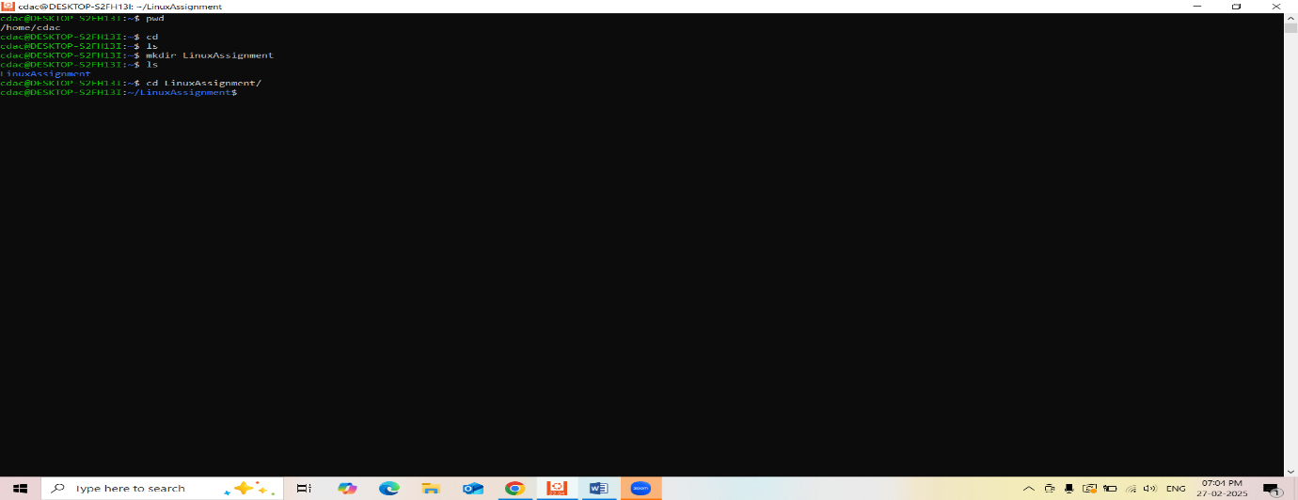

**b) File Management:**

a. Inside the "LinuxAssignment" directory, create a new file named "file1.txt". Display its contents.

Ans:-

cdac@DESKTOP-S2FH13I:~/LinuxAssignment$ touch file1.txt

cdac@DESKTOP-S2FH13I:~/LinuxAssignment$ ls

file1.txt

cdac@DESKTOP-S2FH13I:~/LinuxAssignment$ nano file1.txt

cdac@DESKTOP-S2FH13I:~/LinuxAssignment$ cat file1.txt

Nayan Patil

Cdac Mumbai

cdac@DESKTOP-S2FH13I:~/LinuxAssignment$

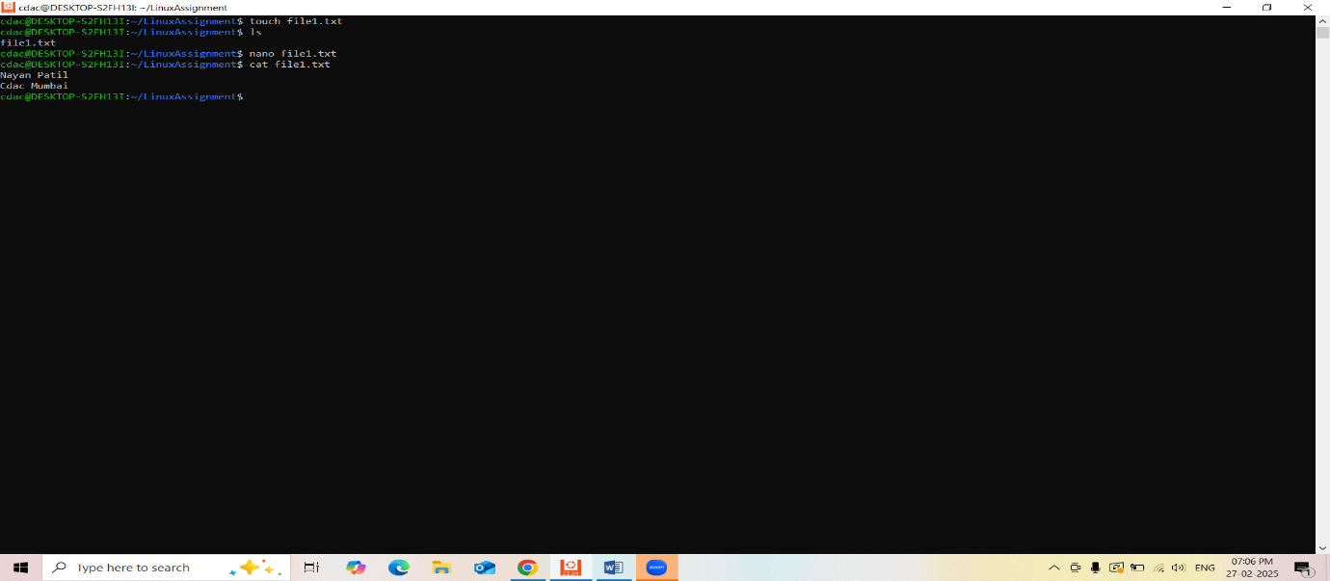

**c) Directory Management:**

a. Create a new directory named "docs" inside the "LinuxAssignment" directory.

Ans-

cdac@DESKTOP-S2FH13I:~/LinuxAssignment$ mkdir docs

cdac@DESKTOP-S2FH13I:~/LinuxAssignment$ ls

docs file1.txt

cdac@DESKTOP-S2FH13I:~/LinuxAssignment$ cd docs/

cdac@DESKTOP-S2FH13I:~/LinuxAssignment/docs$

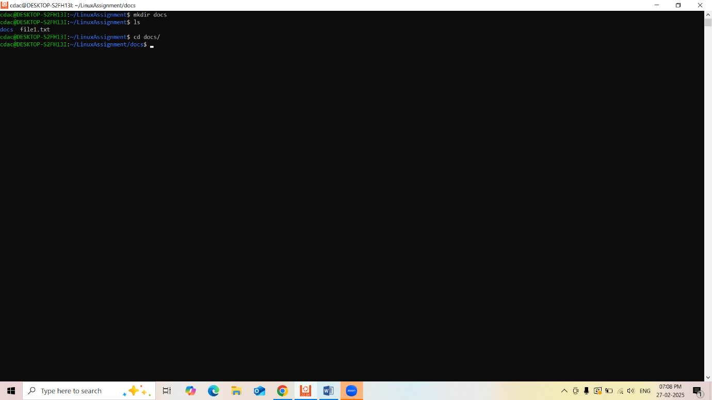

**d) Copy and Move Files:**

a. Copy the "file1.txt" file into the "docs" directory and rename it to "file2.txt".

Ans:-

cdac@DESKTOP-S2FH13I:~/LinuxAssignment/docs$ ls

cdac@DESKTOP-S2FH13I:~/LinuxAssignment/docs$ cd ..

cdac@DESKTOP-S2FH13I:~/LinuxAssignment$ ls

docs file1.txt

cdac@DESKTOP-S2FH13I:~/LinuxAssignment$ cp file1.txt file2.txt

cdac@DESKTOP-S2FH13I:~/LinuxAssignment$ ls

docs file1.txt file2.txt

cdac@DESKTOP-S2FH13I:~/LinuxAssignment$ mv file2.txt docs

cdac@DESKTOP-S2FH13I:~/LinuxAssignment$ ls

docs file1.txt

cdac@DESKTOP-S2FH13I:~/LinuxAssignment$ cd docs

cdac@DESKTOP-S2FH13I:~/LinuxAssignment/docs$ ls

file2.txt

cdac@DESKTOP-S2FH13I:~/LinuxAssignment/docs$

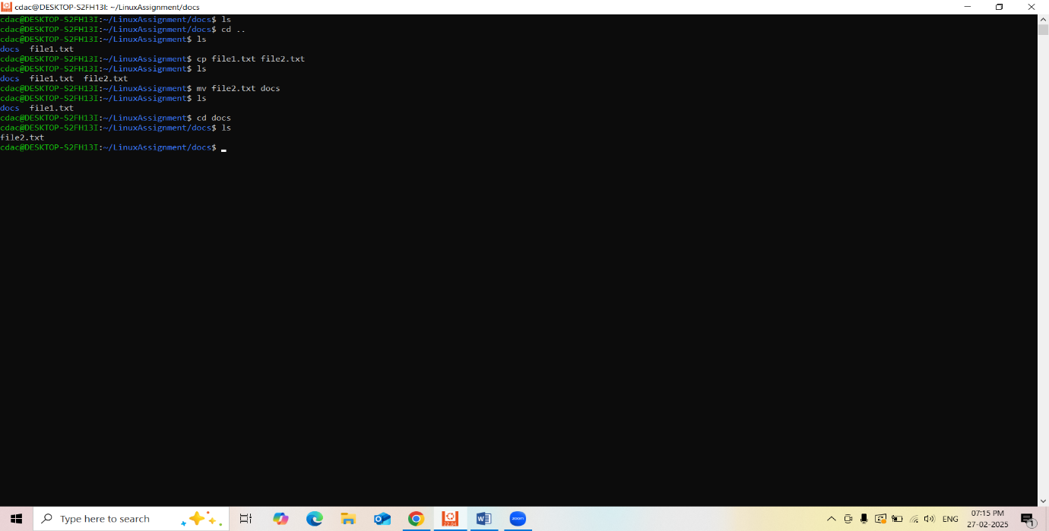

**e) Permissions and Ownership:**

a. Change the permissions of "file2.txt" to allow read, write, and execute permissions for the owner and only read permissions for others. Then, change the owner of "file2.txt" to the current user.

Ans:-

cdac@DESKTOP-S2FH13I:~/LinuxAssignment/docs$ ls -l file2.txt

-rw-r--r-- 1 cdac cdac 24 Feb 27 19:14 file2.txt

cdac@DESKTOP-S2FH13I:~/LinuxAssignment/docs$ chmod og-rwx file2.txt

cdac@DESKTOP-S2FH13I:~/LinuxAssignment/docs$ chown cdac file2.txt

cdac@DESKTOP-S2FH13I:~/LinuxAssignment/docs$ ls -l file2.txt

-rw------- 1 cdac cdac 24 Feb 27 19:14 file2.txt

cdac@DESKTOP-S2FH13I:~/LinuxAssignment/docs$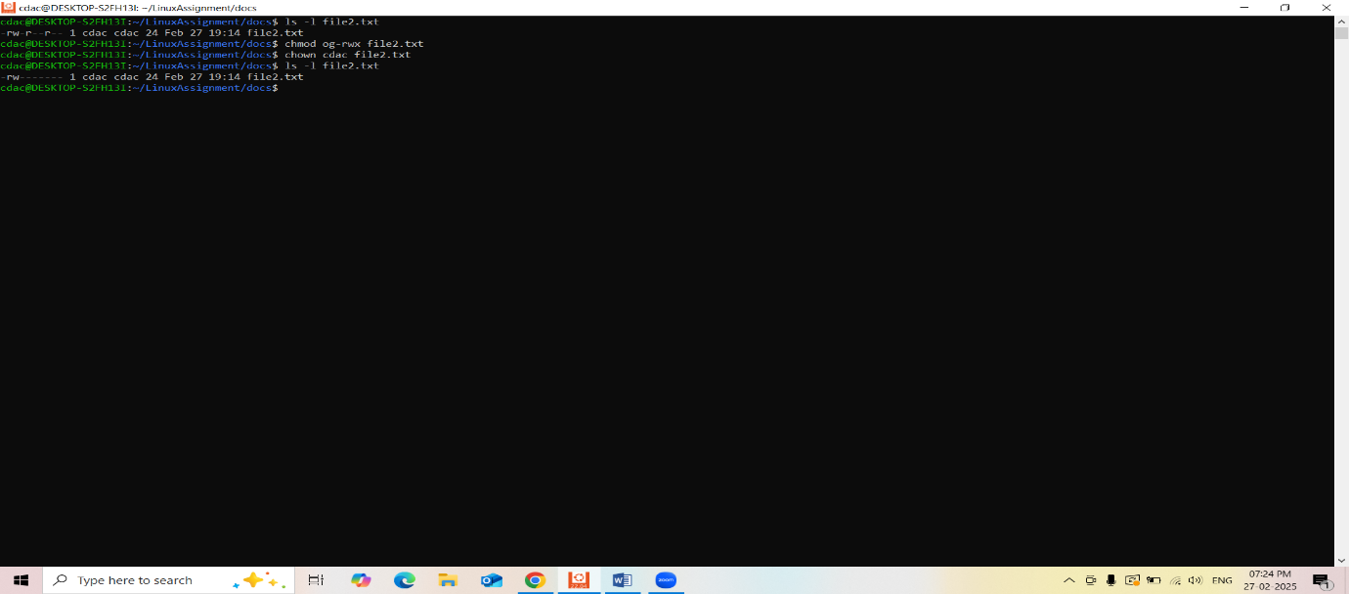

**f) Final Checklist:**

a. Finally, list the contents of the "LinuxAssignment" directory and the root directory to

ensure that all operations were performed correctly.

Ans:-

cdac@DESKTOP-S2FH13I:/$ cd

cdac@DESKTOP-S2FH13I:~$ ls

LinuxAssignment

cdac@DESKTOP-S2FH13I:~$ cd LinuxAssignment/

cdac@DESKTOP-S2FH13I:~/LinuxAssignment$ ls

docs file1.txt

cdac@DESKTOP-S2FH13I:~/LinuxAssignment$ cd docs

cdac@DESKTOP-S2FH13I:~/LinuxAssignment/docs$ ls

file2.txt

cdac@DESKTOP-S2FH13I:~/LinuxAssignment/docs$ ls -l

total 0

-rw------- 1 cdac cdac 24 Feb 27 19:14 file2.txt

cdac@DESKTOP-S2FH13I:~/LinuxAssignment/docs$

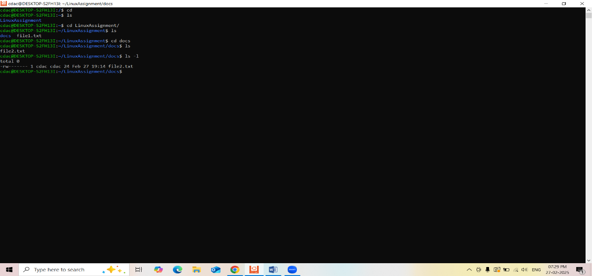

**g) File Searching:**

a. Search for all files with the extension ".txt" in the current directory and its subdirectories.

Ans:-

cdac@DESKTOP-S2FH13I:~/LinuxAssignment$ find find. -type f -name "*.txt"

find: ‘find.’: No such file or directory

cdac@DESKTOP-S2FH13I:~/LinuxAssignment$ find . -type f -name "*.txt"

./docs/file2.txt

./file1.txt

./newdocs/docs/file2.txt

cdac@DESKTOP-S2FH13I:~/LinuxAssignment$

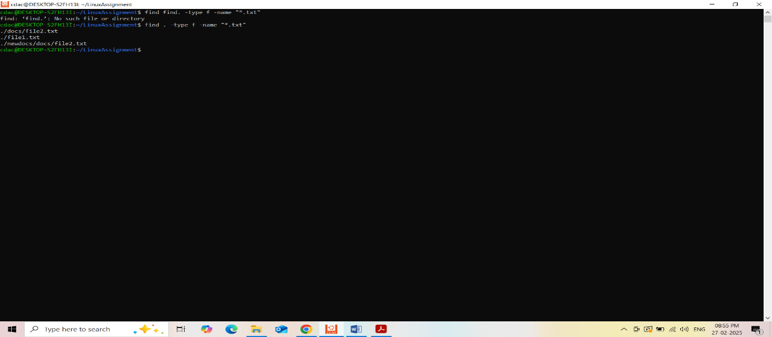

b. Display lines containing a specific word in a file (provide a file name and the specific

word to search).

Ans:-

cdac@DESKTOP-S2FH13I:~/LinuxAssignment$ nano duplicate.txt

cdac@DESKTOP-S2FH13I:~/LinuxAssignment$ cat duplicate.txt

movies

kgf

rrr

raw beast

leo

goat

bigil

cdac@DESKTOP-S2FH13I:~/LinuxAssignment$ nano duplicate.txt

cdac@DESKTOP-S2FH13I:~/LinuxAssignment$ cat duplicate.txt

movies

kgf

rrr

raw beast

leo

goat

bigil

kgf

leo

bigil

raw beast

cdac@DESKTOP-S2FH13I:~/LinuxAssignment$ grep "leo" duplicate.txt

leo

leo

cdac@DESKTOP-S2FH13I:~/LinuxAssignment$

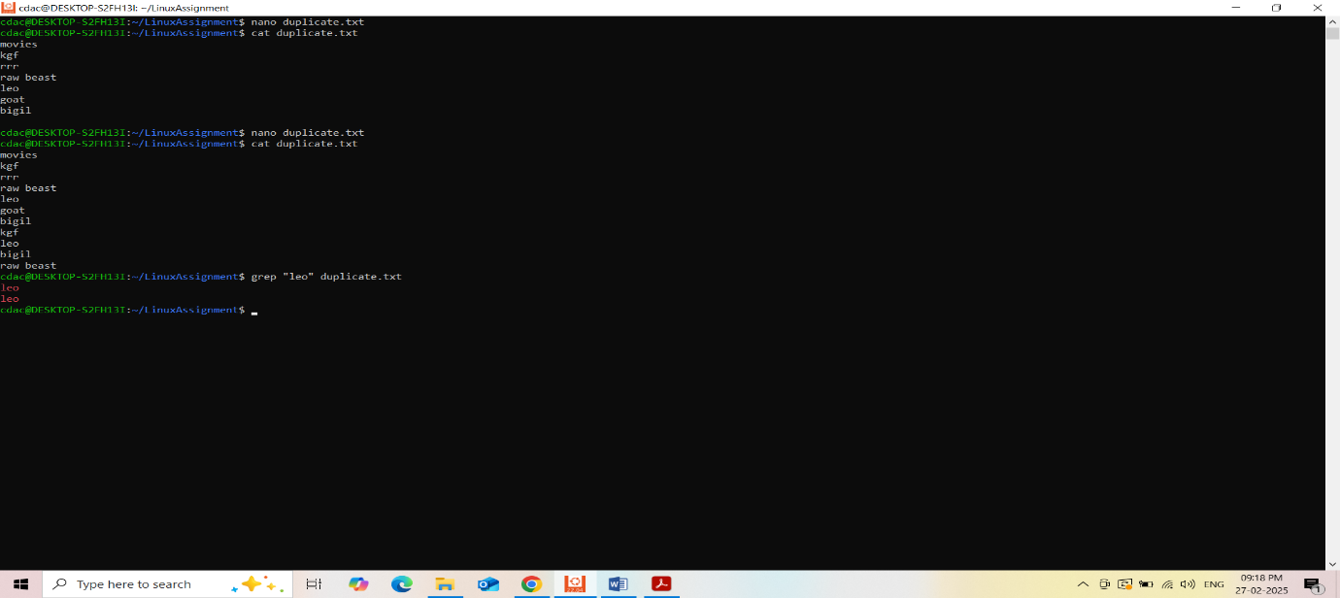

**h) System Information:**

a. Display the current system date and time.

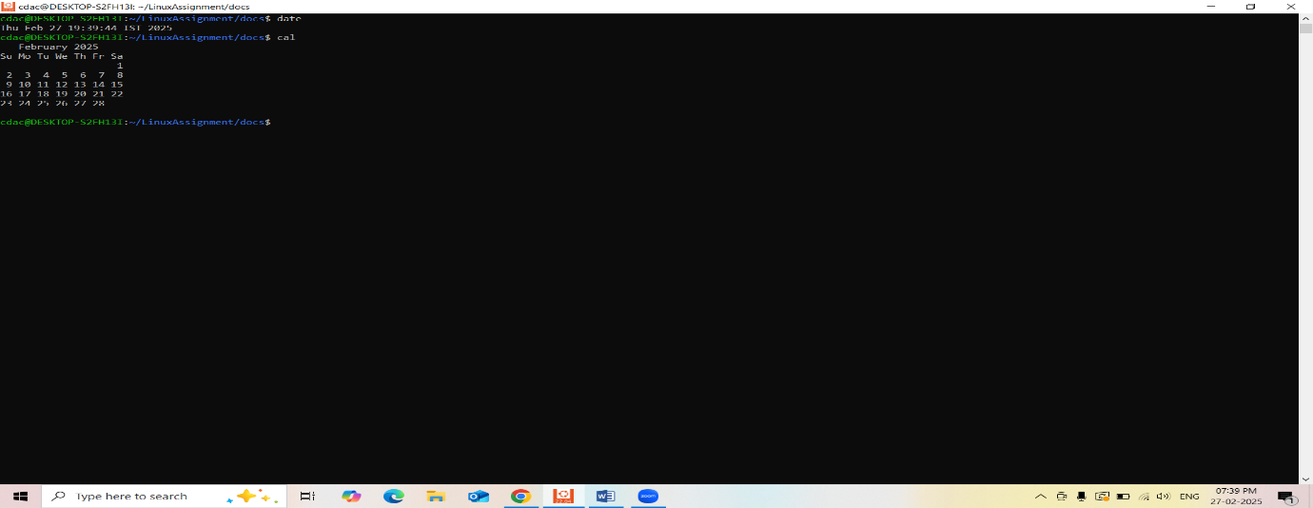

**i) Networking:**

a. Display the IP address of the system.

cdac@DESKTOP-S2FH13I:~/LinuxAssignment/docs$ ipconfig.exe

Windows IP Configuration

Ethernet adapter Ethernet:

Media State . . . . . . . . . . . : Media disconnected

Connection-specific DNS Suffix . :

Wireless LAN adapter Local Area Connection* 1:

Media State . . . . . . . . . . . : Media disconnected

Connection-specific DNS Suffix . :

Wireless LAN adapter Local Area Connection* 2:

Media State . . . . . . . . . . . : Media disconnected

Connection-specific DNS Suffix . :

Wireless LAN adapter Wi-Fi:

Connection-specific DNS Suffix . :

Link-local IPv6 Address . . . . . : fe80::b26a:f48b:d667:21d5%16

IPv4 Address. . . . . . . . . . . : 192.168.0.113

Subnet Mask . . . . . . . . . . . : 255.255.255.0

Default Gateway . . . . . . . . . : 192.168.0.1

Ethernet adapter Bluetooth Network Connection:

Media State . . . . . . . . . . . : Media disconnected

Connection-specific DNS Suffix . :

cdac@DESKTOP-S2FH13I:~/LinuxAssignment/docs$

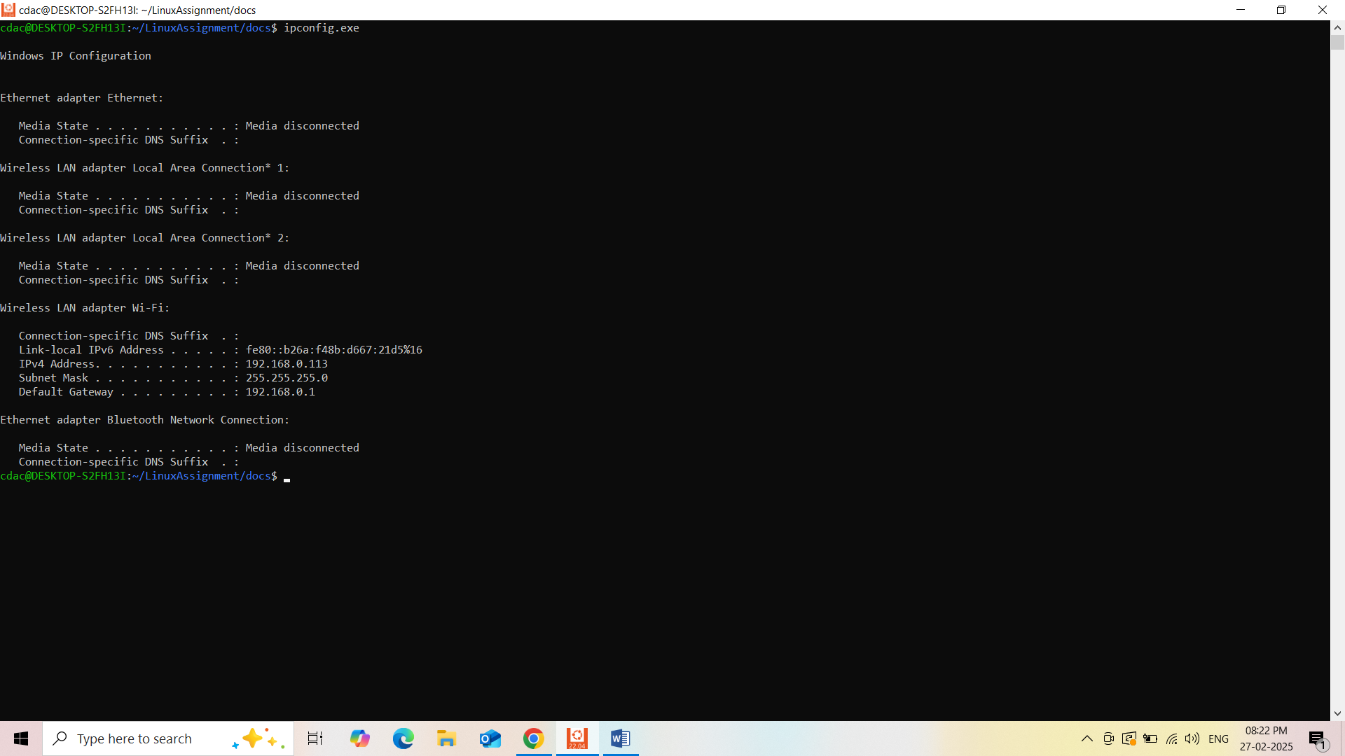

b. Ping a remote server to check connectivity (provide a remote server address to ping).

cdac@DESKTOP-S2FH13I:~/LinuxAssignment/docs$ ping -c 5 google.com

PING google.com (142.250.66.14) 56(84) bytes of data.

64 bytes from bom07s35-in-f14.1e100.net (142.250.66.14): icmp_seq=1 ttl=119 time=5.67 ms

64 bytes from bom07s35-in-f14.1e100.net (142.250.66.14): icmp_seq=2 ttl=119 time=8.15 ms

64 bytes from bom07s35-in-f14.1e100.net (142.250.66.14): icmp_seq=3 ttl=119 time=6.82 ms

64 bytes from bom07s35-in-f14.1e100.net (142.250.66.14): icmp_seq=4 ttl=119 time=6.74 ms

64 bytes from bom07s35-in-f14.1e100.net (142.250.66.14): icmp_seq=5 ttl=119 time=9.85 ms

--- google.com ping statistics ---

5 packets transmitted, 5 received, 0% packet loss, time 4006ms

rtt min/avg/max/mdev = 5.670/7.445/9.850/1.436 ms

cdac@DESKTOP-S2FH13I:~/LinuxAssignment/docs$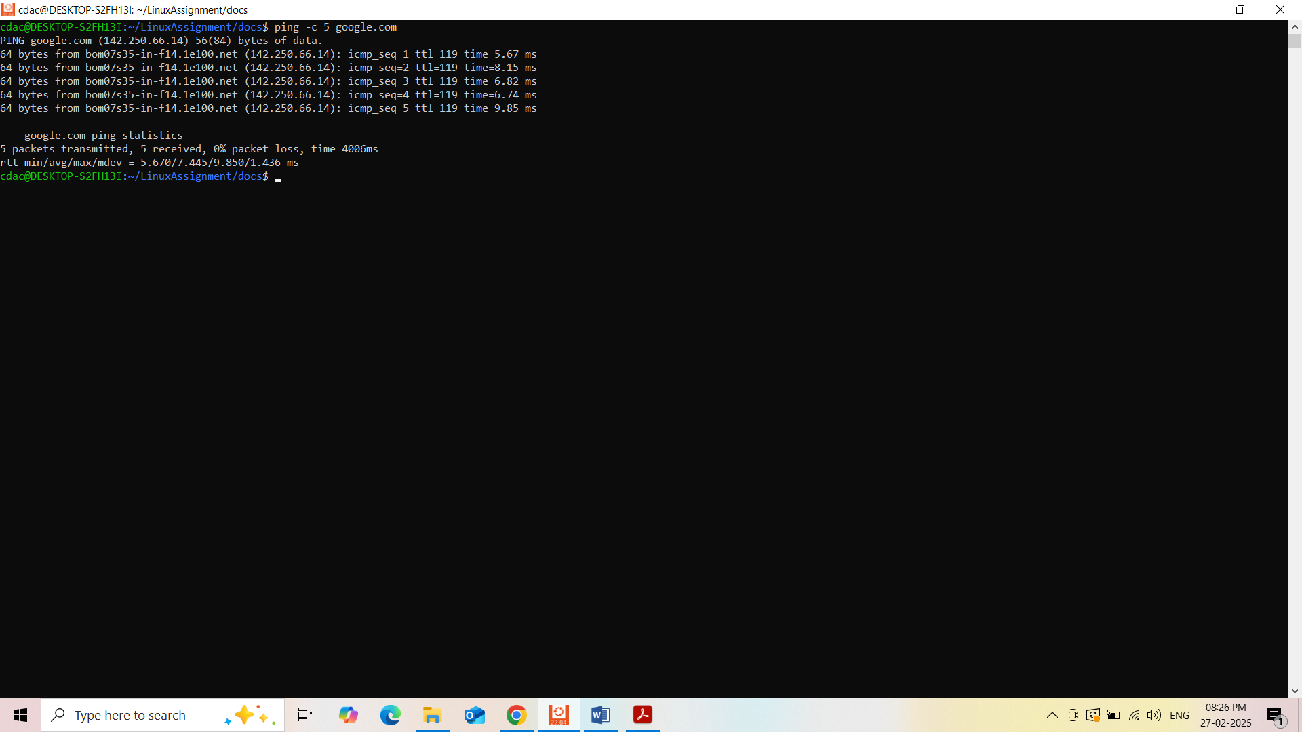

**j) File Compression:**

a. Compress the "docs" directory into a zip file.

cdac@DESKTOP-S2FH13I:~/LinuxAssignment/docs$ sudo apt install zip

[sudo] password for cdac:

Reading package lists... Done

Building dependency tree... Done

Reading state information... Done

The following additional packages will be installed:

unzip

The following NEW packages will be installed:

unzip zip

0 upgraded, 2 newly installed, 0 to remove and 50 not upgraded.

Need to get 350 kB of archives.

After this operation, 930 kB of additional disk space will be used.

Do you want to continue? [Y/n] y

Get:1 http://archive.ubuntu.com/ubuntu jammy-updates/main amd64 unzip amd64 6.0-26ubuntu3.2 [175 kB]

Get:2 http://archive.ubuntu.com/ubuntu jammy/main amd64 zip amd64 3.0-12build2 [176 kB]

Fetched 350 kB in 2s (149 kB/s)

Selecting previously unselected package unzip.

(Reading database ... 42586 files and directories currently installed.)

Preparing to unpack .../unzip_6.0-26ubuntu3.2_amd64.deb ...

Unpacking unzip (6.0-26ubuntu3.2) ...

Selecting previously unselected package zip.

Preparing to unpack .../zip_3.0-12build2_amd64.deb ...

Unpacking zip (3.0-12build2) ...

Setting up unzip (6.0-26ubuntu3.2) ...

Setting up zip (3.0-12build2) ...

Processing triggers for man-db (2.10.2-1) ...

cdac@DESKTOP-S2FH13I:~/LinuxAssignment/docs$ zip -r docsl.zip docs

zip warning: name not matched: docs

zip error: Nothing to do! (try: zip -r docsl.zip . -i docs)

cdac@DESKTOP-S2FH13I:~/LinuxAssignment/docs$ ls

file2.txt

cdac@DESKTOP-S2FH13I:~/LinuxAssignment/docs$ pwd

/home/cdac/LinuxAssignment/docs

cdac@DESKTOP-S2FH13I:~/LinuxAssignment/docs$ ls -l

total 0

-rw------- 1 cdac cdac 24 Feb 27 19:14 file2.txt

cdac@DESKTOP-S2FH13I:~/LinuxAssignment/docs$ cd ..

cdac@DESKTOP-S2FH13I:~/LinuxAssignment$ zip -r docs1.zip docs

adding: docs/ (stored 0%)

adding: docs/file2.txt (stored 0%)

cdac@DESKTOP-S2FH13I:~/LinuxAssignment$ ls

docs docs1.zip file1.txt

cdac@DESKTOP-S2FH13I:~/LinuxAssignment$

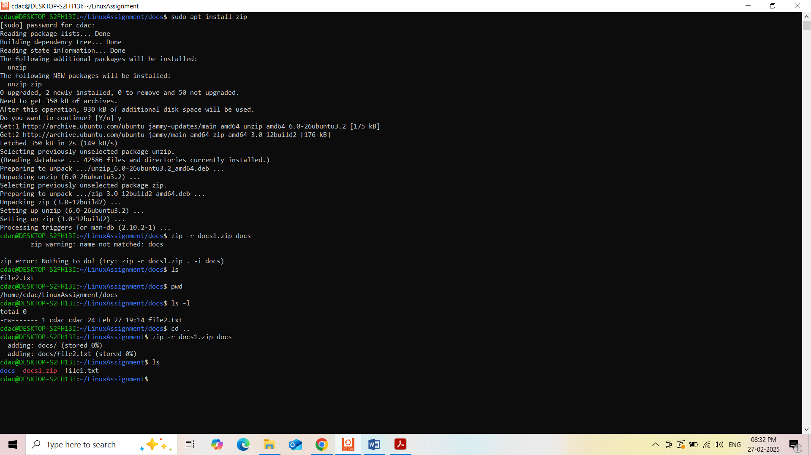

b. Extract the contents of the zip file into a new directory.

cdac@DESKTOP-S2FH13I:~/LinuxAssignment$ ls

docs docs1.zip file1.txt

cdac@DESKTOP-S2FH13I:~/LinuxAssignment$ unzip docs1.zip -d newdocs

Archive: docs1.zip

creating: newdocs/docs/

extracting: newdocs/docs/file2.txt

cdac@DESKTOP-S2FH13I:~/LinuxAssignment$ ls

docs docs1.zip file1.txt newdocs

cdac@DESKTOP-S2FH13I:~/LinuxAssignment$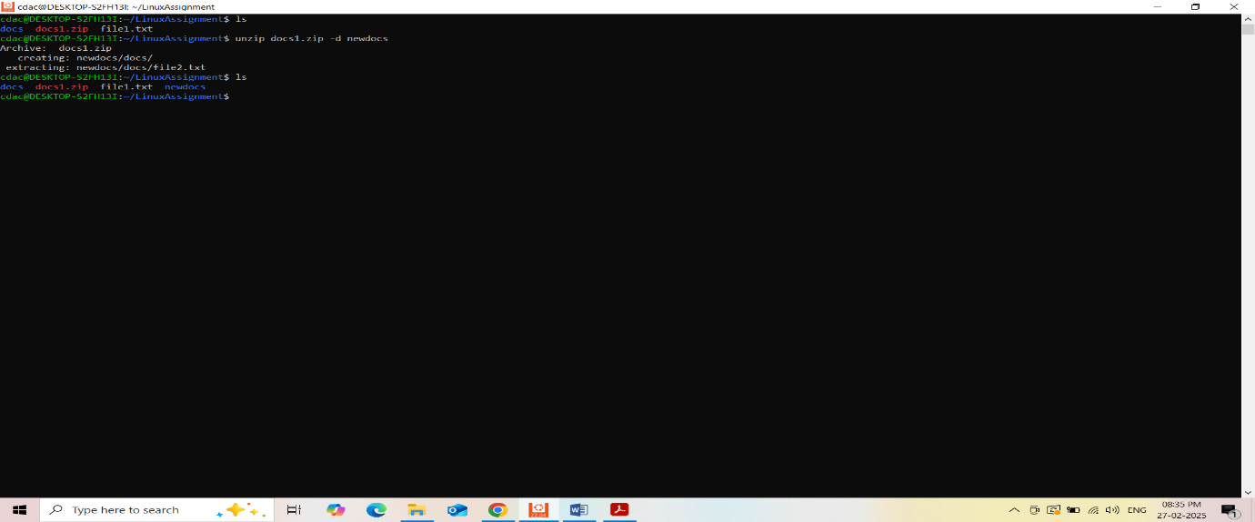

**k) File Editing:**

a. Open the "file1.txt" file in a text editor and add some text to it.

cdac@DESKTOP-S2FH13I:~/LinuxAssignment$ ls

docs docs1.zip file1.txt newdocs

cdac@DESKTOP-S2FH13I:~/LinuxAssignment$ nano file1.txt

cdac@DESKTOP-S2FH13I:~/LinuxAssignment$ cat file.txt

cat: file.txt: No such file or directory

cdac@DESKTOP-S2FH13I:~/LinuxAssignment$ cat file1.txt

Hello, My name is Nayan Patil

cdac@DESKTOP-S2FH13I:~/LinuxAssignment$

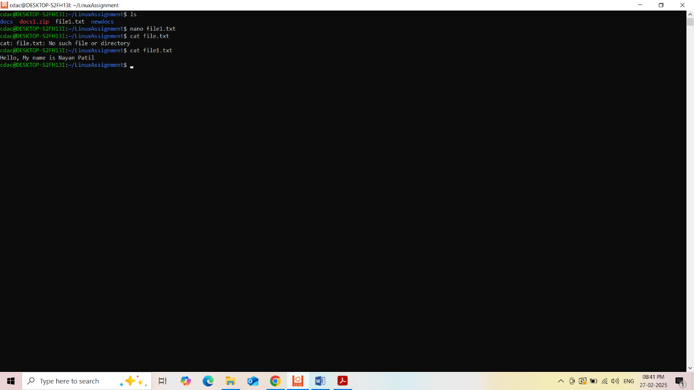

Problem 2:

a. Suppose you have a file named "data.txt" containing important information. Display the

first 10 lines of this file to quickly glance at its contents using a command.

cdac@DESKTOP-S2FH13I:~/LinuxAssignment$ nano data.txt

cdac@DESKTOP-S2FH13I:~/LinuxAssignment$ nano data.txt

cdac@DESKTOP-S2FH13I:~/LinuxAssignment$ head -10 data.txt

Nayan

Lakshit

Aditi

Vaishnavi

Sanket

Darshan

Yatin

Harshad

Omkar

Pooja

cdac@DESKTOP-S2FH13I:~/LinuxAssignment$

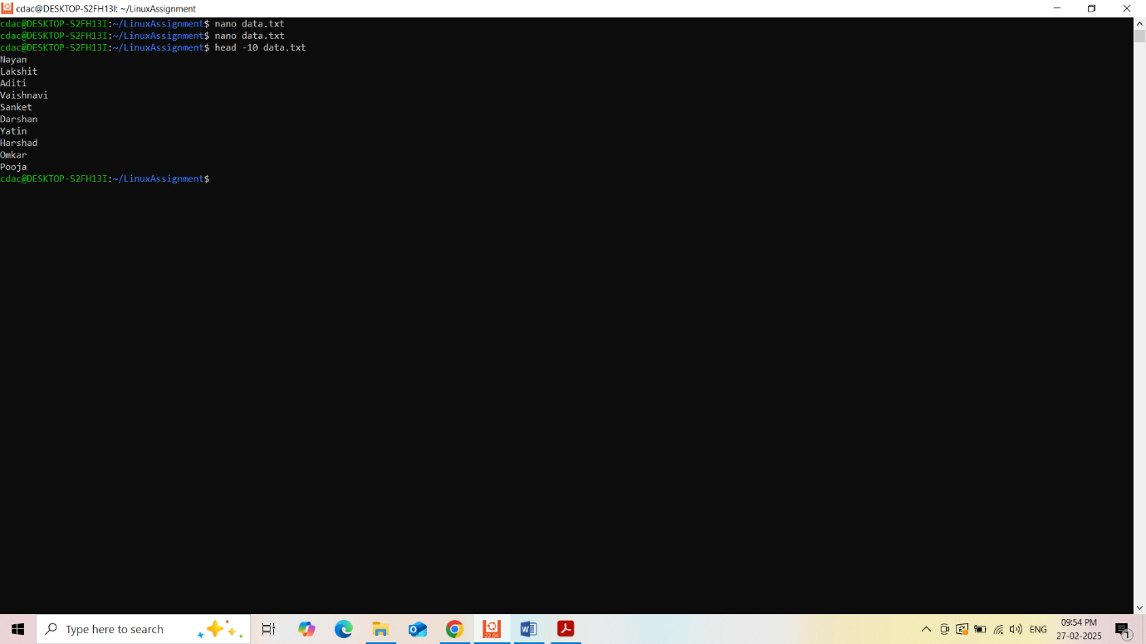

b. Now, to check the end of the file for any recent additions, display the last 5 lines of

"data.txt" using another command.

cdac@DESKTOP-S2FH13I:~/LinuxAssignment$ nano data.txt

cdac@DESKTOP-S2FH13I:~/LinuxAssignment$ head -10 data.txt

Nayan

Lakshit

Aditi

Vaishnavi

Sanket

Darshan

Yatin

Harshad

Omkar

Pooja

cdac@DESKTOP-S2FH13I:~/LinuxAssignment$ tail -5 data.txt

Harshad

Omkar

Pooja

Rushi

Jayesh

cdac@DESKTOP-S2FH13I:~/LinuxAssignment$

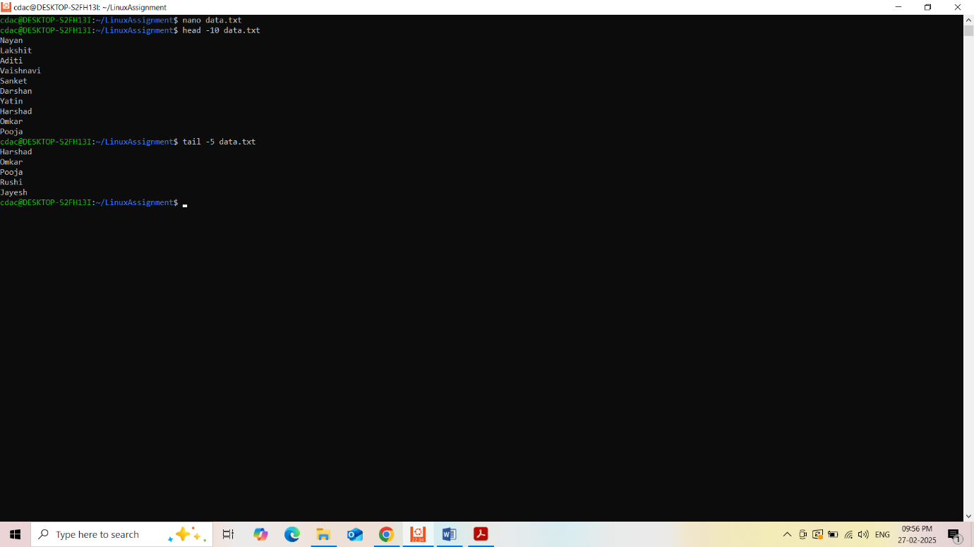

c. In a file named "numbers.txt," there are a series of numbers. Display the first 15 lines of

this file to analyze the initial data set.

cdac@DESKTOP-S2FH13I:~/LinuxAssignment$ nano numbers.txt

cdac@DESKTOP-S2FH13I:~/LinuxAssignment$ head -15 numbers.txt

12

21

6

33

18

3

29

49

5

27

35

42

17

9

35

cdac@DESKTOP-S2FH13I:~/LinuxAssignment$

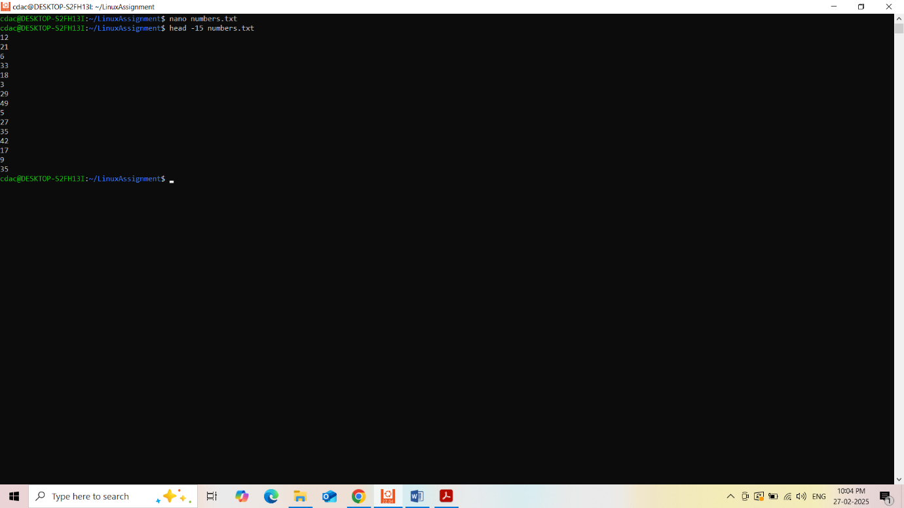

d. To focus on the last few numbers of the dataset, display the last 3 lines of "numbers.txt".

cdac@DESKTOP-S2FH13I:~/LinuxAssignment$ nano numbers.txt

cdac@DESKTOP-S2FH13I:~/LinuxAssignment$ head -15 numbers.txt

12

21

6

33

18

3

29

49

5

27

35

42

17

9

35

cdac@DESKTOP-S2FH13I:~/LinuxAssignment$ tail -3 numbers.txt

17

9

35

cdac@DESKTOP-S2FH13I:~/LinuxAssignment$

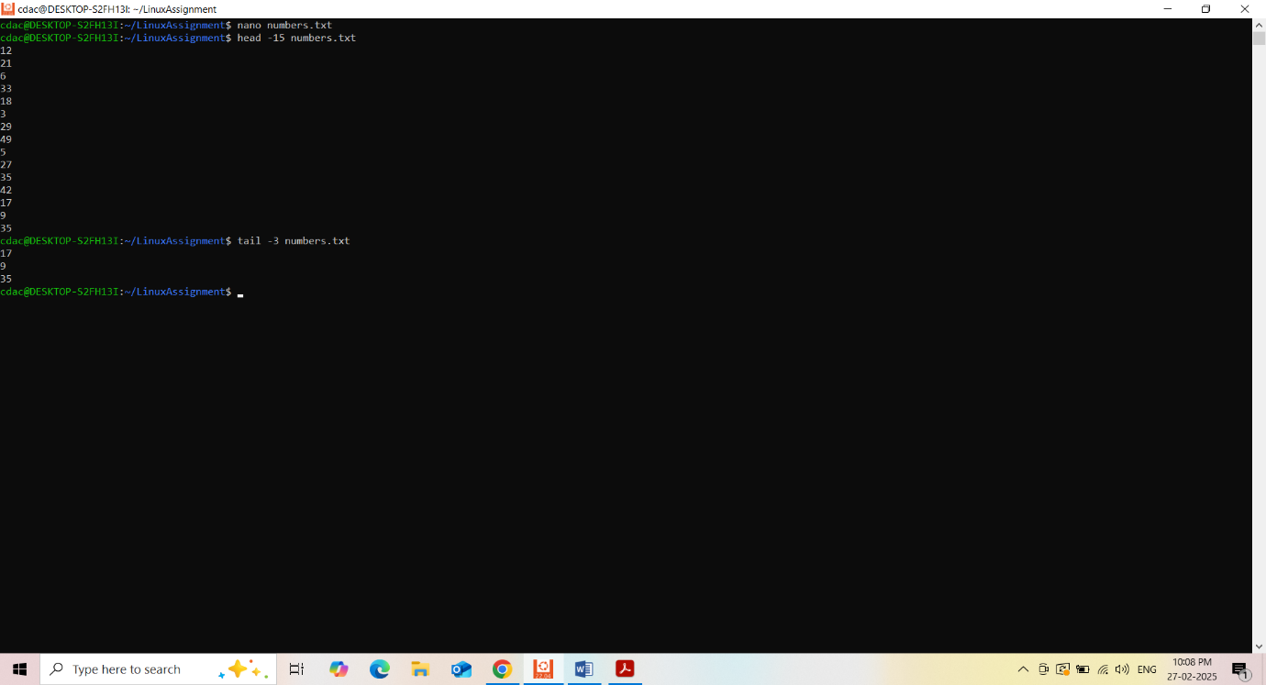

e. Imagine you have a file named "input.txt" with text content. Use a command to translate

all lowercase letters to uppercase in "input.txt" and save the modified text in a new file

named "output.txt."

cdac@DESKTOP-S2FH13I:~/LinuxAssignment$ nano input.txt

cdac@DESKTOP-S2FH13I:~/LinuxAssignment$ cat input.txt

aabcd this is lowercase

ABCD THIS IS UPPERCASE

$P3C14L C#4R4CT3R$

123456789

cdac@DESKTOP-S2FH13I:~/LinuxAssignment$

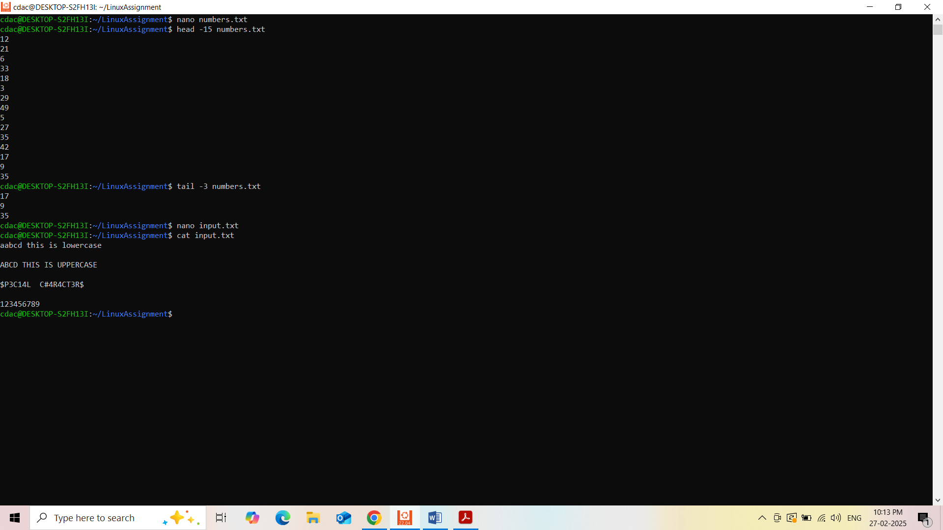

f. In a file named "duplicate.txt," there are several lines of text, some of which are

duplicates. Use a command to display only the unique lines from "duplicate.txt."

cdac@DESKTOP-S2FH13I:~/LinuxAssignment$ nano duplicate.txt

cdac@DESKTOP-S2FH13I:~/LinuxAssignment$

cdac@DESKTOP-S2FH13I:~/LinuxAssignment$ cat duplicate.txt

movies

kgf

rrr

raw beast

leo

goat

bigil

kgf

leo

bigil

raw beast

sooryavanshi

bahubali

mari

mauli

cdac@DESKTOP-S2FH13I:~/LinuxAssignment$ cat duplicate.txt | sort |uniq

bahubali

bigil

goat

kgf

kgf

leo

mari

mauli

movies

raw beast

rrr

sooryavanshi

cdac@DESKTOP-S2FH13I:~/LinuxAssignment$

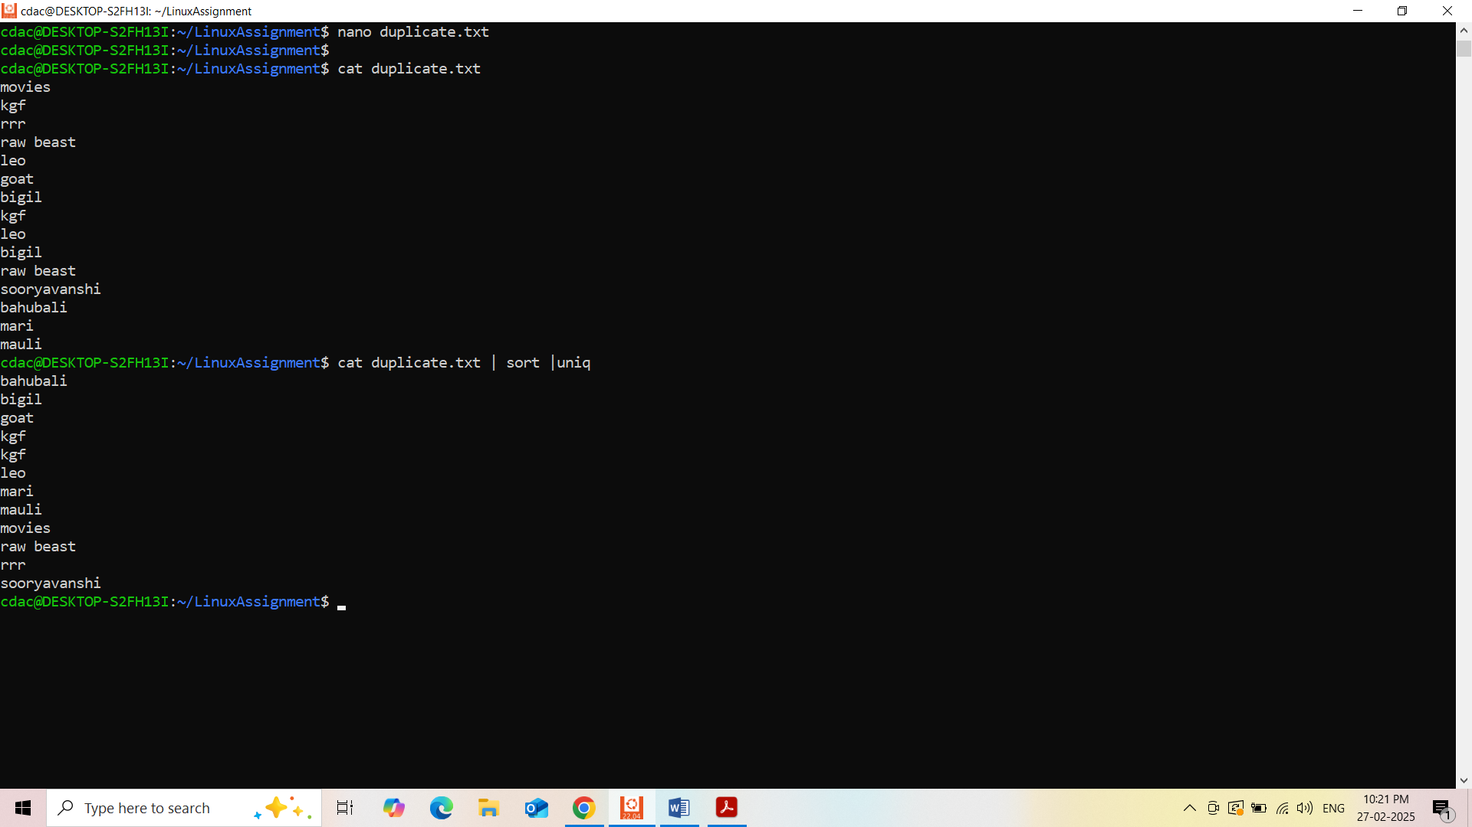

g. In a file named "fruit.txt," there is a list of fruits, but some fruits are repeated. Use a

command to display each unique fruit along with the count of its occurrences in

"fruit.txt."

cdac@DESKTOP-S2FH13I:~/LinuxAssignment$ nano fruit.txt

cdac@DESKTOP-S2FH13I:~/LinuxAssignment$ cat fruit.txt

cherry

pear

mango

grape

orange

banana

kiwi

grap

apple

chearry

banana

apple

banana

cdac@DESKTOP-S2FH13I:~/LinuxAssignment$ cat fruit.txt | sort | uniq

apple

banana

chearry

cherry

grap

grape

kiwi

mango

orange

pear

cdac@DESKTOP-S2FH13I:~/LinuxAssignment$

