Synopsis Report
On
“Fake Vote Detection”

Department of Electronics and Telecommunication

By

- Mr. Vinayak Balu Prabhavale - 1705010
- Mr. Abhay Dhondiba Marshivane - 1705034
- Mr. Amit Bharat Dhanwade -1705015
- Mr.Nayan Namdev Patil- 1705040

For the Partial Fulfillment of
Bachelor of Technology

Under the Guidance of

Prof. Mahesh S. Kumbhar



KASEGAON EDUCATION SOCIETY’S
Rajarambapu Institute of Technology, Rajaramnagar
^{(An Autonomous Institute)}
Final Year Capstone Project, 2020-21
DECLARATION BY STUDENTS
We, undersigned, declare that this written submission represents our ideas in our own words and where others’ ideas or words have been included, we have adequately cited and referenced the original sources. We also declare that we have adhered to all principles of academic honesty and integrity and have not misrepresented or fabricated or falsified any idea/data/fact/source in our submission. We understand that any violation of the above will be cause for disciplinary action by the Institute and can also evoke penal action from the sources which have thus not been properly cited or from whom proper permission has not been taken when needed.

1) Vinayak Balu Prabhavale (1705010) (Signature)
2) Abhay Dhondiba MArshivane (1705034) (Signature)
3) Amit Bharat Dhanwade (1705015) (Signature)
4) Nayan Namdev Patil (1705040) (Signature)

DECLARATION BY GUIDE
It is certified that the work contained in the project report titled “Fake Vote Detection”.By above mentioned students, has been carried out under my supervision and that this work has not been submitted elsewhere for a degree.

Signature of Project Guide
Dr. Mahesh S. Kumbhar
Dept of E & TC
February 2021

Fake Vote Detection
- Proposed Project Title :-
“Design and Construction Of Digitally Fake Vote Detection System”

- Project Motivation:
- Fake voting .
- More people work is required.

- Project Objectives:
“To Detect an Illegal Vote and make the election in more digitally controllable with accurate information for better future. ”

4.Relevance/Significance:
- Voting is one of the way where you can express your opinion in democracy.
- It gives the opportunity to choose their leader and hold them accountable for their development.
By using this project we want this above objective to taken into consideration.
- Present theories and practices:
Current voting system is based on ballot machine where when we press the button with the symbol the voting is done. Here there is a security risk, the person who votes may be a fake person. The people there might not know that a person is using fake voting card, this may cause problem. Also the person who has to vote should travel from faraway places to his constituency to cast his vote. So, effective method is to use face detection while voting online and enabling the right person to vote.

Theories (Research paper) :
Human face recognition plays an important role in applications such as video surveillance, human computer interface, and face image database management. The algorithm constructs eye, mouth, and boundary maps for verifying each face candidate. Face recognition also refers to the psychological process by which humans locate and attend to faces in a visual scene.. It is analogous to image detection in which the image of a person is matched bit by bit. Image matches with the image stores in database. Any facial feature changes in the database will invalidate the matching process. Through this paper we are aiming that voters do not need to wait for longer period of time as they do not have to wait in a queue and there is no time constraint; this system provides mobility for voters. The advantages of this proposed system is that,it is less time consuming compared to existing system. With this system man power can be reduced and there is no need to apply ink on the fingers. The proposed system is highly secure and no chances of data lost and also unlimited number of candidate information is being stored. A voter can vote only once, so voting multiple times or dummy voting shall be prohibited.

- Proposed work with Block Diagram:
Finger print and iris capturing and Detection and Recognition system is proposed and it is used an authentication technique in voting. In this we take a data before the voting ( as like we take a data from their Aadhaar card) and uploaded to our database system. At time of day of election when a person came for voting we first scan his fingerprint and match to our database if matched then he allow to go for the voting otherwise he not allow otherwise we check his iris with database if this is also not match so he /she not allow for the voting .It means he done his voting already or he/she is not a person that coming for a voting.

Methodology:
Create a database-1
• Scan fingerprint using Scanner of voter
• Fingerprint extraction from the data of voter
• Different features of the voter fingerprint is compared
• Matching of the extracted data with the stored in the database
• Display the details of the voter
• Rejection of fake voter if he/she not existing in the database.
• Allow voter to vote
• Create a database-2
• Eliminate the details of the voter who has done voting or otherwise put this on cloud and if he/she came for voting display that you done your voting.

- Block diagram:
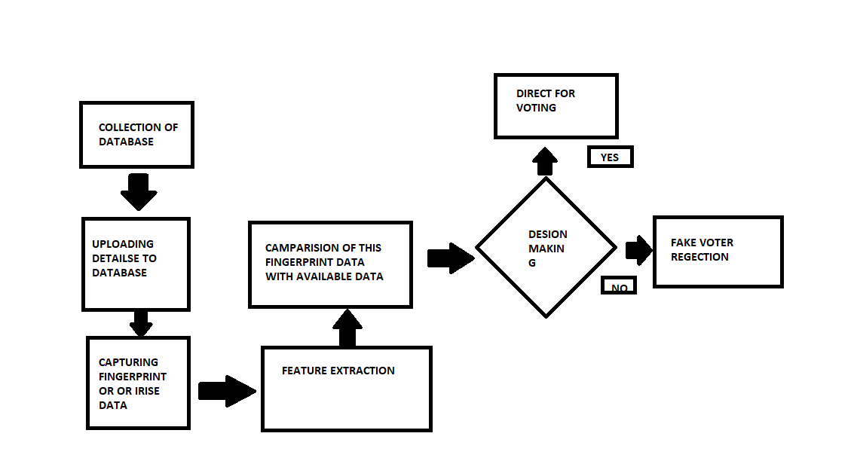
- Project Applications (Technical, Economical, Social):
- Can prevent card counters, etc. from entering casinos
- Can identify terrorists, criminals, etc.
- Can find missing children.
- Prevents voter fraud
9. Hw/Sw Requirements:
- SQL Database.
- Fingerprint Scanner.

11) Facilities Available in Dept.:
- Raspberry Pi
12) Expected date for completion of work:
Before 15-Feb-2021
13) Approximate expenditure:
- Fingerprint Scanner – 2000rs.
- Raspberry Pi - 4000rs
14) Future Scope:
- Detect the fake voters
- Any bill payment by one touch.
10) Evaluation Report (to Be filled by EVALUATORS)

Date:
Place: Rajaramnagar

- Mr. Vinayak Balu Prabhavale
- Mr. Abhay Dhondiba Marshivane
- Mr. Amit Bharat Dhanwade
- Mr. Nayan Namdev Patil

REFERENCES

- Zhengwang Wu, Yanrong Guo, Sang Hyun Park, Yaozong Gao, Pei Dong, Seong-Whan Lee, and Dinggang Shen, "Robust Brain ROI Segmentation by Deformation Regression and Deformable Shape Model," Medical Image Analysis, vol. 43, pp. 198-213, 2017.
- Shoaib Amin Banday, and Ajaz Hussain Mir, "Statistical textural feature and deformable model based brain tumor segmentation and volume estimation," Multimedia Tools Application, vol. 76, no. 3, pp. 3809-3828, 2017.
- Hala Ali, Mohammed Elmogy, Eman El-Daydamony, and Ahmed Atwan, "Multi-Resolution MRI Brain Image Segmentation Based On Morphological Pyramid and Fuzzy C-Mean Clustering," Arabian Journal for Science and Engineering, vol. 40, no. 11, pp. 3173-3185, November 2015.
- Ali Ahmadvand, Mohammad Reza Daliri, and Sayyed Mohammadreza Zahiri, "Segmentation of brain MR images using a proper combination of DCS based method with MRF," Multimedia Tools and Applications, pp. 1-18, 2017.
- Sriparna Saha, Abhay Kumar Alok, and Asif Ekbal, "Brain Image Segmentation using Semi-Supervised Clustering," Expert Systems with Applications, vol. 52, pp. 50-63, 2016.

