**Snapshots of Universal Digital Library System**

1. This is the main home page of the website.

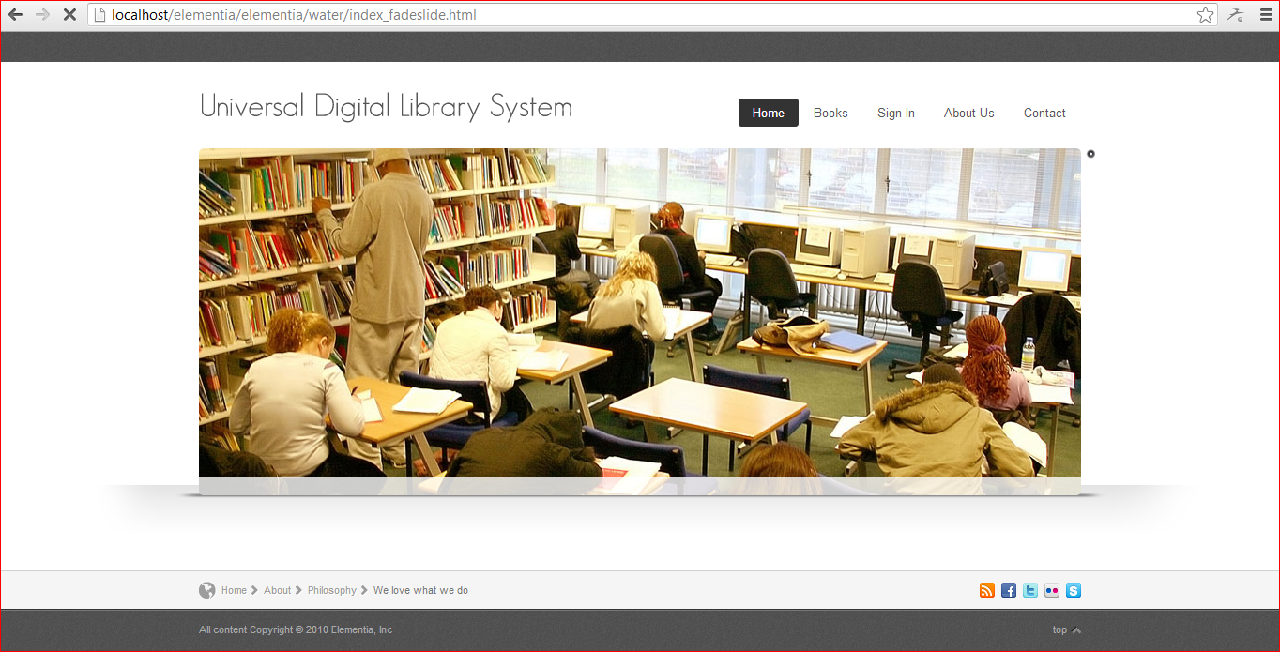

1. Main home page contains the login for Admin, Student, Professor and Worker.

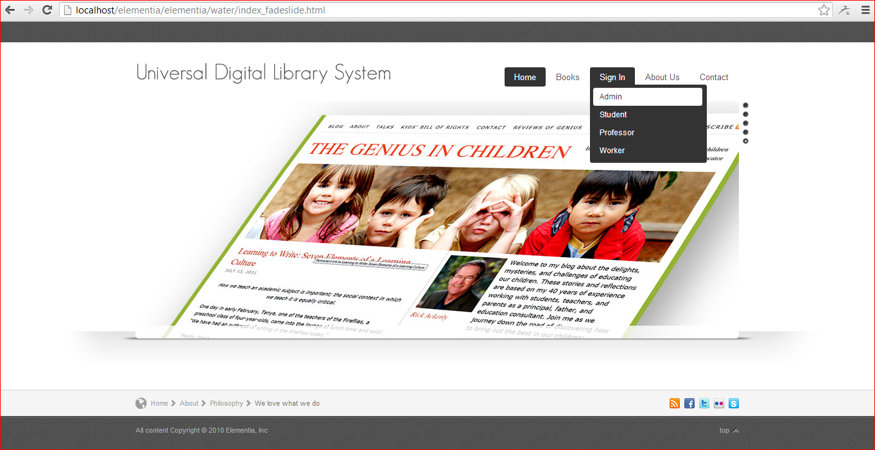

1. Login page for Admin, Student, Professor and Worker.

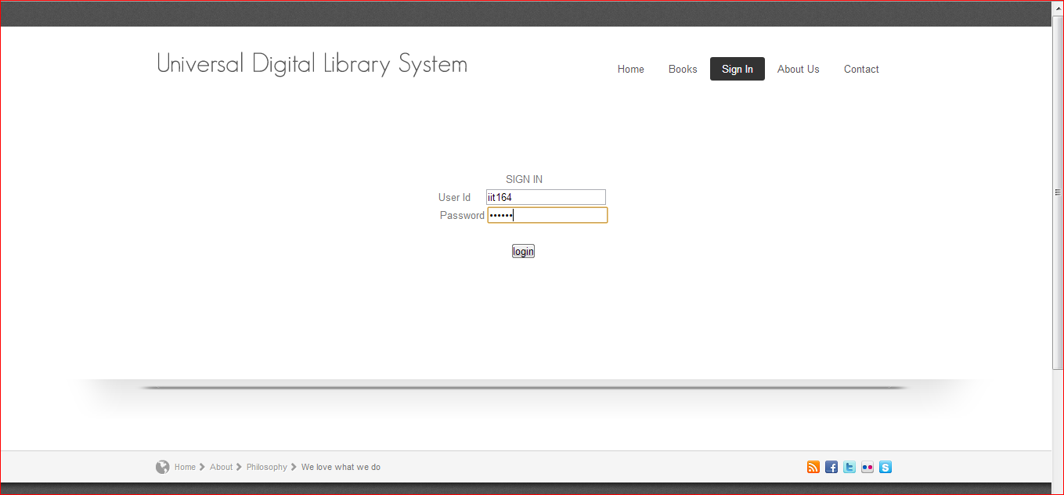

1. Login by Admin, contains all the feature for the management of the Library Management system.
   1. Add books
   2. Remove books
   3. Add Users
   4. Remove Users
   5. Search User

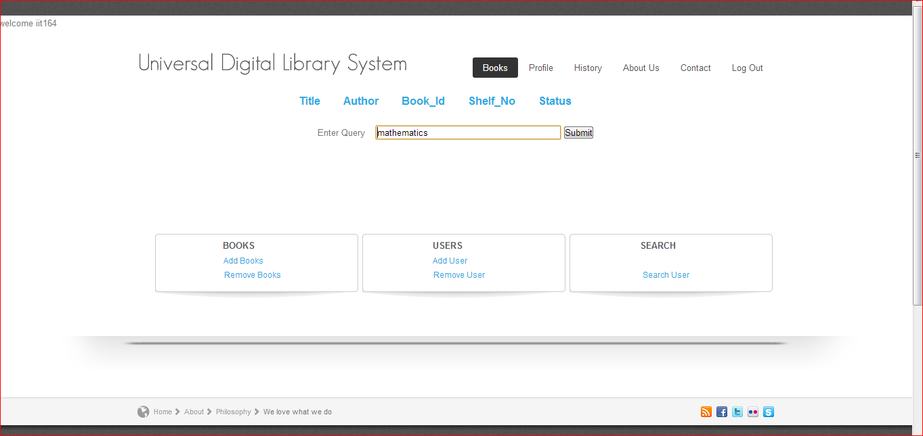

1. Profile of a user to alllow the user to see all the books issued by the user.

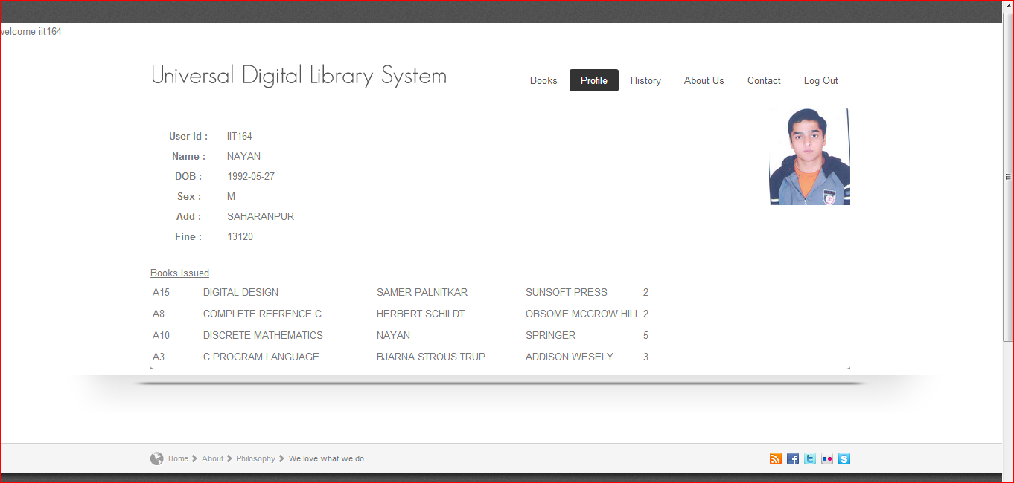

1. Result shown when user search related to title “mathematics”.

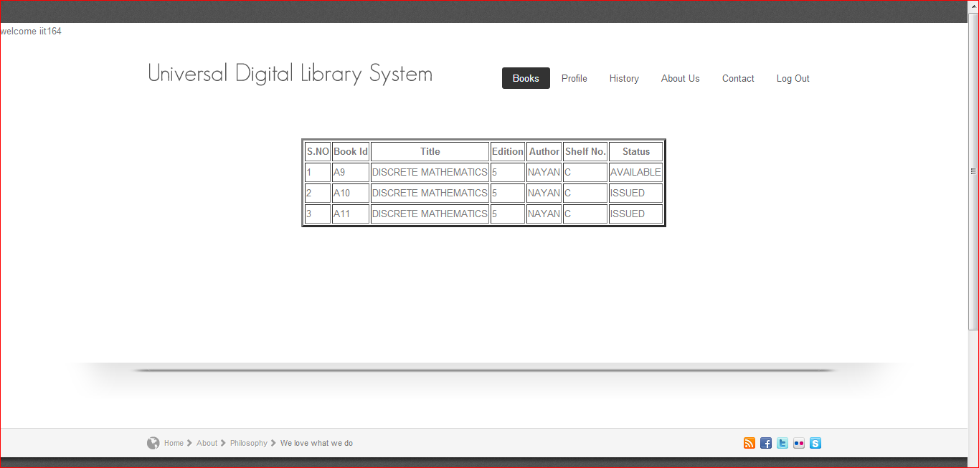

1. About Us page of the Universal Digital Library Management System.

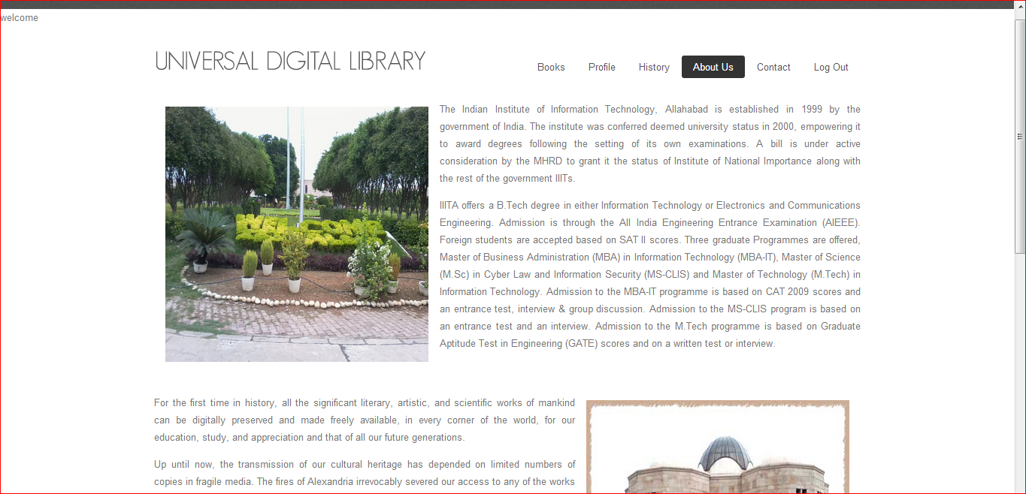

1. Contact Us Page

