Snapshots
- Ecg analysis and diagnosis system.
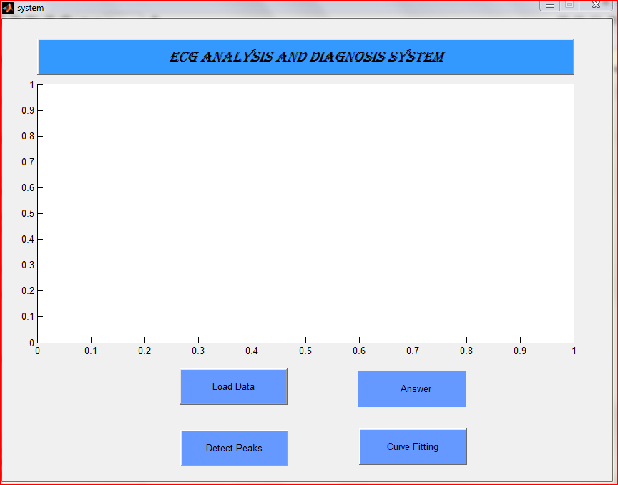

- After loading the file from the folder, answer is displayed –“arythmia”
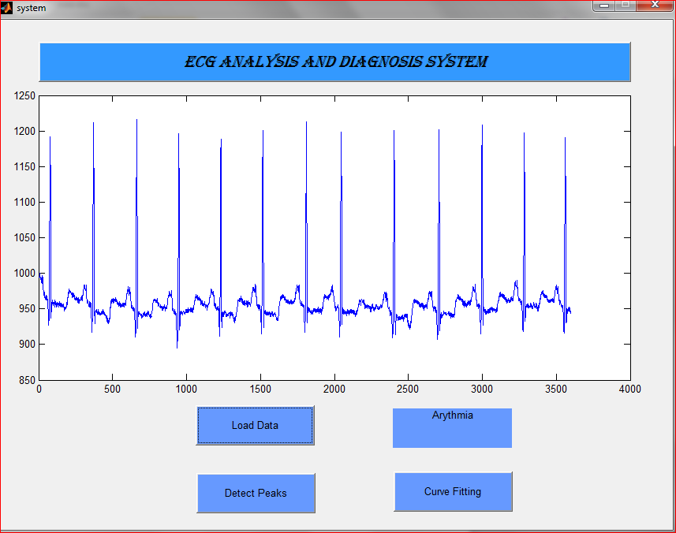

- Segmentation of each beat is shown.
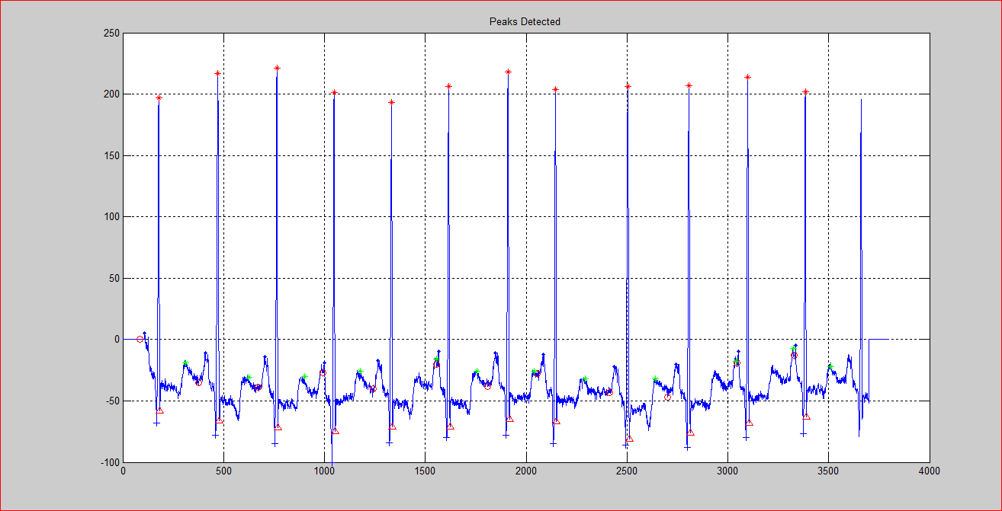

4. Curve fitting using Levenberg Marquardht algorithm of each beat is shown.
