**THEME ASSIGNMENT 2**

**Student Name** : Nayani Srinivas Vijayanand.

# What are the main parameters affecting the choice of the positioning method? What kind of compromises are generally appeared between them?

Main parameters affecting the choice of positioning method are bandwidth, clock rate, measurement time and complexity. High accuracy in positioning systems in short time needs high clock rate and high bandwidth.

A high bandwidth may result in higher noise levels and low range, also higher clock systems are complex to design , are costly, and consume more power to operate.

# Study together chapter 2.2 and give a short explanation of the following principles (Videos!)

# rho-theta

# theta-theta

# rho-rho

## Rho-theta measurement.

A navigation system in general is the one which emits one or more signals are from a facility to produce simultaneous indication of bearing and distance.

In Rho-theta measurement , rho is distance and theta being the angle. Since a bearing is a radial line of position and a distance is a circular line of position, the rho-theta system always ensures a position fix produced by the intersection of two lines of position which are at right angles to each other.

The target is located on the intersection of the circle whose radius is ‘r’ , the distance between stationary object is ‘F’ and target is ‘T’ and the bearing line that is at an angle of Ø referenced from the North. The directional antenna is located at reference point and directional finding capability may be present at the target. Target coordinates (x,y) are calculated using the below mentioned equations

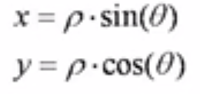

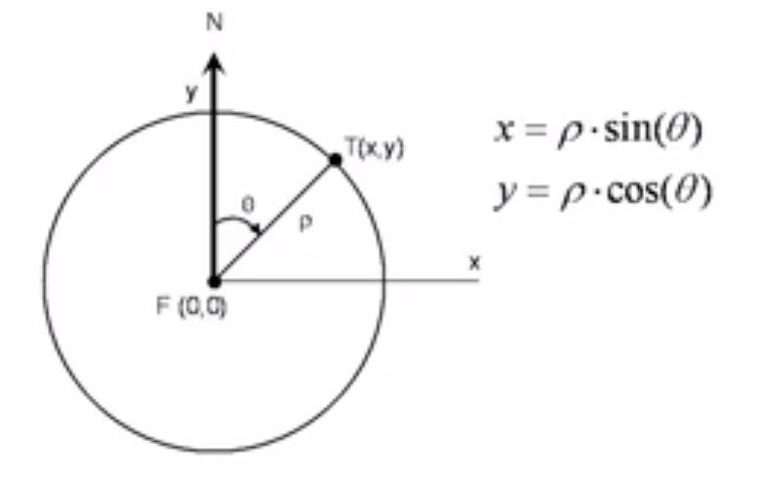

This method uses only one reference terminal for calculating the distance position. Accuracy is limited by resolution of the angle and requires a high gain antenna. This is the main principle used in radar measurement.

## Rho-Rho measurement.

In Rho-rho measurement , the distance is calculated by trilateralization using distance data only. Distance of the target is calculated by received signal strengths or time of flight data.

Receiver can find the TOF by subtracting the time the signal is received from the time of transmission.

In the below figure,Let us assume coordinates of fixed terminals are F1 and F2 and T is the location of the target.

Target T can be assumed to found at intersection points of two circles . Currently we have two such points in 2D space as we assume the target to be on positive side of XY we can think of the target to be at T(x,y). In 3D space ,we need to use third reference point to remove this ambiguity.

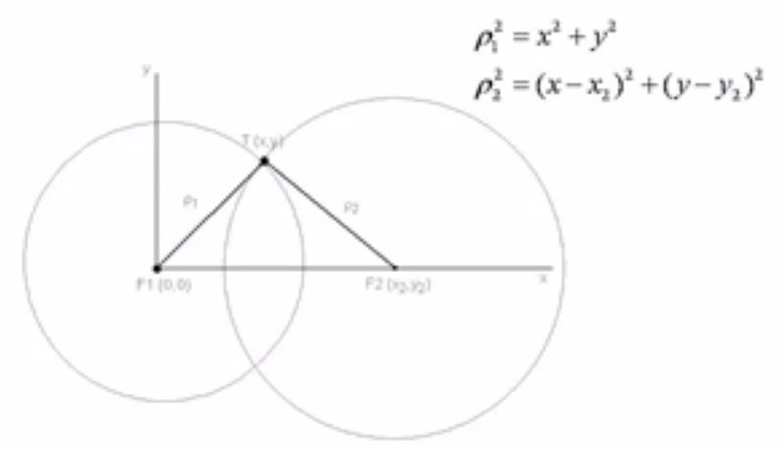

Locating a target needs at least two and in 3D space needs at least 3 reference stations.

This kind of measurement requires cooperation from the target such as clock synchronization. two way communication. There can be ambiguity when no of fixed terminal increase . In the above example there can be two points of intersection where the target can be present. But in 3D , target can be spotted on intersection of three spears. Distance to the target can be solved by the above shown linear equations in the picture.

In the case of TOA ,the one way distance between T to F1 is t1 and T to F2 is t2 and c being the speed of light. Assuming that a pulse is sent from target T at time t0 to both fixed references, pulse can reach the F1 at time t1 and F2 at t2 . Distance to the target can be derived from solving the below linear equations.

Ƿ1 = (t1-t0)* c

Ƿ2 = (t2-t0)* c

And the linear equations of the circles are



## Theta-theta measurement.

This method uses two or more fixed terminals to find the target location when coordinates of terminal are know relative to reference point using geomantic procedure called triangulation .Directional antennas are used in theta- theta measurement does not need any cooperation from the target. Two fixed terminals are needed here with the antenna beams whose directions of maximum radiation are controlled. The coordinates of these fixed terminals F1 and F2 are known and the Ø1 and Ø2 are beam angles are towards the positive direction of y-axis i.e towards the North are measured. X and Y coordinates of the target can obtained by below equation

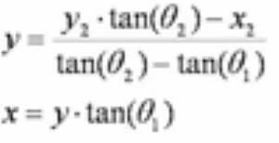

Advantage of this type of measurement is that target direction can be found without time synchronization and restrictions of protocol or modulation type.

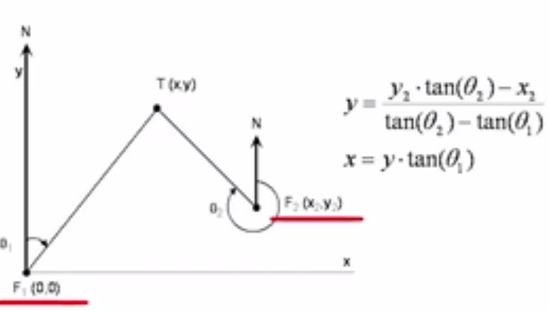

# What are the benefits of using the spread spectrum techniques in positioning when compared to narrowband techniques? (Introduction to chapter 3, p. 53)

Benefits of spread spectrum when compared to narrowband are

* Reduced spectrum power density for a given transmitted power.
* Increased immunity to jamming and co-channel Interference
* Reduced interference to other co-channel signals.
* Allow code division multiple accesses for concurrent use of channel by multiple terminals using the same carrier frequency.
* Possibility of determining time of arrival (TOA) for distance measurement to almost any degree of resolution.

# Explain the main principle in using signal strength as a way to measure of distance

It is physical property of a signal that it tends to fade with distance travelled in a medium which means that signal strength at receiver decreases as distance from transmitter increases. So having known the relationship between the signal strength and distance , distance between transmitter and receiver can be deduced.

In RSS mechanism , Signal strength at Receiver is measured by RSSI (received signal strength indicator). RSSI is an indication of the power level being received by the antenna. Therefore, the higher the RSSI number, the stronger the signal. We have an analytical data of voltage output at receiver and power that is received by receiver in dBms.. From the distance from the transmitter and receiver can be deducted from this RSSI and voltage information. Relationship between power and distance is power is proportional to inverse of the square of the distance , In free space power can be deducted from below equation.

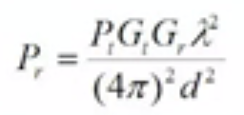Gt,Gr = Antenna gains of transmitter and receiver

ƛ = wavelength , d = distance , pt = transmitting power

Distance can be deducted as well when power is known at receiver end, Once distance between the terminal is known , coordinates of target locations can be deduced by triangulation.

As we shown in below diagram, Usually we have three or more receivers employed and a target is transmitting, We have different values of signal strength measurments at each receiver as their distance varies from the transmitter. Once we have the distances, Coordinates of the target location can be deduced from the intersection of the three circles.

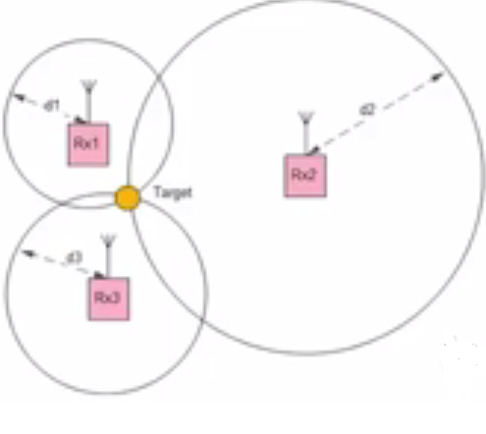

In this method , triangulation method is applied to determine the target location. Triangulation is the process of determining the location of point by measuring angles to the object from the known points at either ends of a reference base line. The point can be assumed to be the third point on the triangle with a known side and two known angles.

We have three equations of circles to find out target location in coordinate axis.

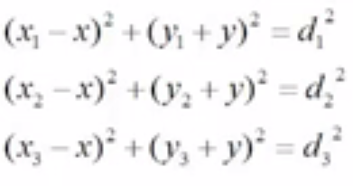

# What are the biggest problems in using RSS locationing?

RSS methods come with some disadvantages as described below.

* A less accuracy in calculating target location may result due to multipath propagation and interference like electromagnetic and co-channel interferences.
* As signal propagation is depends on several environmental, terrestrial and location factors.
* Also if often has to be that receiver systems antennas , software has to be tailored to a place rather than generalizing to all places.
* In contrast to triangulation , Often more than 3 fixed receivers are needed to attain greater accuracy to calculate target location.

# What equation You would use when determining the distance in a large open field (outdoor) using RSS method? Why?

In an open field , below set of equations are used in RSS distance measurement.

If distance d < d0, free space method is used and equation is

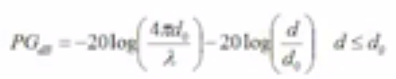

If distance d > d0 , The above equation is slightly modified , power gain is inversely proportional to 4 times the distance power where signal strength drops more rapidly.

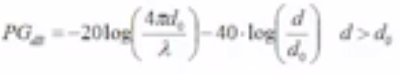

ƛ = wavelength of electromagnetic wave.

D = distance from the transmitter and receiver.

PG = Path gain

D0 is calculated using below equation.



h1 , h2 are heights of antennas,

frequency = 2400 Mhz , ƛ = 125m.

## Reason for using different equation compared to ideal or free space:

In large open field , there can be signal interferences , terrestrial operations, reflection and other environmental objects that can reflect , absorb ,scatter the electromagnetic waves which makes it more practical way to calculate the signal strength. Open field calculation gives better approximation in real life compared to free space.

# What things You should take into account when using RSS method e.g. in a factory environment (indoor)? How is this implemented in real life?

Using RSS for postining systems in indoors can be effective and more accurate for short distance positions estimations since propagation more closely follows a deterministic rule.

Also multipath propagation can effect the accuracy of RSS , In a multipath environment deviation of distance estimation from true value depends on length of non direct path of propagation.

For our discussion , let us consider how RSS is implemented in factory environment , In an closed factory environment finger printing can be used which essentially is building databases in advance which comprises of signal strengths and received power at specific survey points for all the transmitters. This database can be used to locate objects and track their position eventually.

# Explain the principle of TOA method

Wireless location systems usually require two or more receivers to intercept a signal emitted from transmitter. Common location approaches are based on time-of-arrival (TOA), received signal strength (RSS), time-difference-of-arrival (TDOA), or angle-of-arrival (AOA) measurements determined from the transmitter signals received at the receivers. In this topic, we focus on mobile positioning using the TOA information.

In the TOA method, the one-way propagation time of the signal traveling between the transmitter and each of the receiver is measured, and this can be depicted as a circle centered at the receiver on which the transmitter must lie.

By definition , Time of flight or TOA is the time taken by radio signal to travel from transmitter to receiver. In TOA location estimates are found by determining the intersections of circles or spheres whose centers are located at fixed stations and radai are estimated to be distances to the target. Localization systems can decide on the distance either by Unilateral (target communicates with fixed terminals to measure time duration) or multilateral way which performs calculations independently of the target.

## TOA can be calculated by any of the two methods.

1. **Having Synchronous clocks in both the transmitter and receiver**.

In this method we take the difference between time of transmission from the transmitter and time of signal arrival at receiver. Clocks in the transmitter and receiver have to be exactly same which is quite a challenge here and is not practically viable.

$∆t=t_{2}$- $t_{1}$

$$∆t=time of flight$$

$$t_{2}=time of signal arrival$$

$t_{1}$ = time when signal is transmitted.

Classic example of TOA is GPS positioning system , where GPS receiver needs to calculate the distance between the itself and satellites which serve as reference stations, each of whose position is fixed in space at the time of transmission . If receiver has accurate clock , it can deduct the epoch transmission time coded in GPS message from the time of arrival to know the time of flight $∆t$, and then calculate distance of the satellite at the time of epoch transmission by multiplicating with the speed of signal.

1. **Transceiver method**

In this approach , Unlike synchronous way (like GPS communication which is essentially one way ), Target can be provided with transmitter and receiver pair . Target receives the signal from the transmitter and retransmits after certain time.

So the time of flight is calculated between from the time of transmission and time of signal arrival at receiver by the following formula .

- ) – t]

$∆t=time of flight$

$$t_{2}=time of signal arrival$$

$t_{1}$ = time when signal is transmitted.

t $=time signal spent by the target before retransmission$

The problem with method is that both transmission and receiving signal can interfere if both or on same frequency. So they should be on transmitted and received signals should be on different frequencies.

Using any of the above methods TOA can be calculated and distance between the terminals can be obtained by multiplying the TOA with speed of light.

As an extension to Time of flight , let us apply TOA location method for calculation between mobile terminal and base stations (two in our case here),

Equation to calculate the distance of mobile terminal from basestaion1 can be obtained by

$$d_{1}^{2}= x^{2}+ y^{2}$$

Equation to calculate the distance of mobile terminal from basestaion2 can be obtained by

$$d_{2}^{2}= {(x-x_{2})}^{2}+ y^{2}$$

Where $d_{1}$ = distance between mobile terminal and base station1

$d_{2}$ = distance between mobile terminal and base station2

x,y = Coordinates of the Mobile terminal

0,0 is the coordinates of the reference base station1.

$x_{2}$,0 = coordinates of the base station2.

Solving for X, Y from above equations, knowing distances from TOA and known coordinates of base stations , target mobile temimal’s x,y coordinates of can be deduced by below equations.

x = $\frac{{d_{1}^{2}- d_{2}^{2}+x}_{2}^{2}}{2 * x_{2}}$ y = $±{√ (d}_{1}^{2}-x^{2})$

# Explain the principle of TDOA method

**ANSWER**

TDOA method is based on the difference of time that radio signal arrive at a receiving terminal from a pair of transmitters. Unlike TOA or time of flight measurement , this TDOA approach measures difference in flight times between target and a pair of reference fixed terminals.

TDOA can be employed between non cooperating terminals unlike TOA where the some sort of coordination between the terminals are needed for calculating the time of arrival.

The way TDOA is calculated depends on the possible topology between stations .Two possible topologies to consider are

* Unilateral topology case
* Multilateral topology case

**Unilateral Topology**:

Under this topology , target is receiver and three fixed transmitters are in 2D space and four transmitters in 3D space. All the transmitters transmit at same level of frequency but at different times. The clocks of all the transmitters are synchronized and they keep sending periodic beacons at independent time intervels so that there is no overlap of transmissions. The target knows the difference between epoc transmissions of the transmitter and thefore can find the time difference of arrival as the interval between the epochs of the received signals measured by the receiver clock minus the time difference between two transmissions. In calculating time difference of arrival , we need to deduct or compensate for the $τ_{n}$ parameter from the actual tdoa times at receiver end.

$∆t_{2 , 1}$ = (t2 - t1) - $τ_{2}$

$∆t_{3 , 1}$ = (t3 - t1) - $τ_{3}$

$∆t_{2 , 3}$ = (t3 – t2) - $τ_{3}$- $τ_{2}$

Where $τ_{2}$, $τ_{1}$, $τ_{3}$ = Time difference between epoc times and transmission times

T1, t2, t3 = Times of signal arrival at base stations.

Knowledge of two of the three time of signal arrival differences and the coordinate axis of base stations which are fixed are needed to estimate target coordinates. Classic example of unilateral topology is LORON-C navigational system.

**Multilateral Topology:**

In Multilateral case , we have three or more fixed receiving terminals and one transmitting terminal and clocks between the receiving terminals are synchronized . So in this case , time difference of arrival times is difference between the signal arrival times across the two receiving stations as according to below equations.

$∆t_{2 , 1}$ = (t2 - t1)

$∆t_{3 , 1}$ = (t3 - t1)

$∆t_{3 , 2}$ = (t3 – t2)

Where $∆t_{2 , 1}$, $∆t_{3 , 1}$, $∆t_{3 , 2}$ = Time difference of arrival at receiving terminals.

T1, t2, t3 = Times of signal arrival at base stations

.Target position can be estimated with the knowledge of at least two time difference of arrivals and coordinates of one fixed receiving terminals.

In order to achieve good accuracy levels from methods of location based time of flight, it is required to employ techniques that overcome impairments due to noise, multipath, cochannel interference.

# What are the main differences between these two methods? How do these differences affect on the costs of the system using either of them?

Advantages/ of TDOA against TOA systems is

* In TDOA ,Synchronous clocks and coordinated transmission are not needed between receivers and transmitters.
* TDOA transmissions can operate with normal communication protocol and needs no further update of either software or hardware.
* TDOA approach cannot be used in unmodulated carriers where there is no provision to modulate the carrier with epoch message used by the receiver.
* In TOA , there should be certain level of coordination needed between terminals, which is not necessary in TDOA.
* TDOA needs an additional fixed terminal compared to TOA, 3 fixed teminals needed in 2D axis and 4 needed in 3D access.
* TDOA needs clock synchronization in at least one end of communication link i.e fixed reference terminals.
* In TDOA method, Loss of clock synchronization among reference fixed known terminals can result in inaccurate results.

# Explain the principle of AOA method.

Angle of Arrival (AOA) is the angle of direction of propagation of radio wave incident on the antenna. This Angle of arrival determines the direction by measuring the measuring the time difference of arrival (TDOA) at individual elements of the array. TDOA measurement is made by measuring the difference in received phase at each element in the antenna array. AoA is calculated by the delay of arrival at each element. Classic examples of applications of AoA are direction finding, wild animals tracking, geo-location of cellphones to report location during emergency calls, etc..

AoA is the primary technique used in Radar technology. Using AoA , location of the target can be determined either by using two fixed reference terminals or by two separate measurements by a fixed terminal in motion. AoA finds the target location by triangulation, where location of a point is determined by measuring [angles](http://en.wikipedia.org/wiki/Angle) to it from known points at either end of a fixed baseline. The point can then be fixed as the third point of a triangle with one known side and two known angles.

Let us assume that we have two fixed base stations separated by known distance ‘D’ and make angle of arrivals with target as $α_{1}$ and $α_{2}$, location coordinates of target x,y can be determined by the below equations.

X = $\frac{D tan⁡(α_{2})}{\tan\left(α_{2}\right)-tan⁡(α_{1})}$ Y = $\frac{D\tan\left(α_{1}\right)tan⁡(α_{2})}{\tan\left(α_{2}\right)-tan⁡(α_{1})}$

In practical scenarios angle of measurement can be prone to errors. Estimated target coordinates can differ from actual positions. Assuming uncertainty in measurement of $α_{1}$ and $α_{2}$ are $∆α_{1}$ and $∆α_{2}$ respectively error is represented by the distance from the estimated location at point $\tilde{T}$ with coordinates ($\tilde{x}, \tilde{y}$) and the true location (x, y):

Error = $\sqrt{{(x-\tilde{x})}^{2}+{(y- \tilde{y})}^{2}}$

Position of the antenna relative to the target plays a crucial role in the accuracy of location estimates. Highest accuracy is possible when the antenna/base stations and target form a acute triangle and conversely when angles become obtuse the accuracy reduces.

# How does the antenna beam affect on accuracy of positioning in AOA systems?

Accuracy of positioning systems well depends on the antenna characteristics and performance parameters are reciprocal for transmission and reception. So of the antenna parameters are Antenna gain , Antenna directivity , Antenna Pattern, Beam width and polarization. Let us see some detail beam effect which is topic for this question.

Beam width is the angle of the half power points on the major lobe of the antenna pattern. Beam width is inherently related to Antenna directivity , antenna with narrow beam would have high directivity when compared with antenna with broad beams. An approximation of the directivity D expressed as ratio between angles horizontal and vertical beams can be deduced from the below equation.

${ Ø}_{V}$ = Vertical beam width

${ Ø}_{H}$ = Horizontal beam width.

D = Antenna directivity

D = $\frac{4π}{Ø_{HØ_{V} }{(π/180)}^{2}}$

# Explain the idea of proximity positioning. What parameters are affecting the accuracy of positioning using this method?

Proximity refers to detection of a mobile terminal with reference to range of fixed terminal’s location so that the mobile can be detected with in that area or particular premises. Range can be defined as the maximum distance between terminal over which communication becomes feable and cannot be supported. Positioning methods widely used are TOA , RSS and finger printing.

There can be several factors affecting the positioning methods like, distance between transmitters and receivers, severe multipath environment, direction of antennas, non-line of sight , other systems operating in the same bandwidth causing interference . RSS (received signal strength) can be accurate only for short distances since position estimations closely follows some deterministic rules.TOA can be more accurate estimate compared to RSS when calculating distance between terminals. There can be large deviations on the signal strengths when there is non direct paths. Finger printing can also achieve better accuracy that RSS ,but it comes with it own drawbacks like creation of a database which is highly dependent on the locations , ambience, size and shape of the areas and movement of people around.

# Explain the idea of fingerprinting in positioning. Give a practical example how it can be used e.g. with WLAN positioning.

Fingerprinting involves in building databases in advance for a given area and are useful in locating the terminal. Databases include data like various signal parameters at or from the terminal and building

Let us consider a typical office environment or factory or big building or shopping mall , given a case to track an asset or target.

We plan several access points and survey points in different locations inside the premises. We make a database in advance while installing up the systems which consists of certain measurements at fixed survey points . In our practical example we can consider transmitters being mobile and receivers are present at access points.

At each of the survey points at various locations in the area the measurements of signal parameters like signal strength and received power from all of the access points are recorded in the database along with the identity number or location of survey points. Database can also include the antenna orientation of the test transmitter. However fingerprinting has its own share of drawbacks as databases are highly dependent on size of the premises , structure of the arrangement, location , movement of obstacles and people around etc. Any changes in the above can lead to updating of the database to arrive at good accuracy levels.