Security Solution for Embedded Wireless Base Stations.

Nayani Srinivas Vijayanand.

Oulu University of Applied Sciences, School of Engineering, Oulu, Finland

t3nasr00@students.oamk.fi
vijay.nayani@gmail.com

Abstract

This document deals on possible security concerns and solutions that can be considered while designing secure embedded systems in general and wireless systems in particular.

Keywords: Security in embedded systems, Wireless base stations, Trust boot, Root of trust, IPSEC , Air interface security, Firewall, Kernel security, Backhaul security.

Introduction

Today increasing number of embedded systems has to deal with security in one form or other from low end systems , wireless systems , smart cards, network routers , gateways , webservers. It has been proven that cost of insecure systems can be very expensive.

In technology terms , Security can be defined as the process of preventing and detecting unauthorized use of the system. Security is quite essential at protecting any system and information from harm, theft, and unauthorized use.

With the evolution of internet, wide variety of tools, information ,technology around, it has becoming increasing easier for hackers to exploit and break the systems. This has enabled organizations to have an increasing emphasis on security in pursuit to build and maintain robust and fool proof systems.

Building an embedded system can demand reasonable amount of security to be embedded inside the device for carrying their operations. This security needs to be enabled across various levels and subsystems depending on the functionality of the device.

For building a wireless base station device, security is paramount. Security needs to be considered at both hardware and software level. Security solutions can be chosen either from set of standard solutions or by designing proprietary ones.

In any secure embedded systems, Software is based on secure device technology. This means that only the software that is meant for the device made by device manufacturer of shall run in the device.

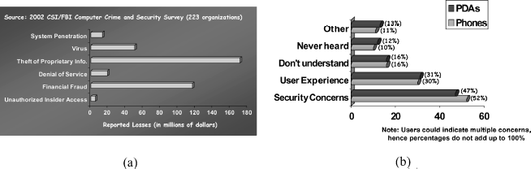

Methodology

Embedded systems often provide critical functions that could be sabotaged by malicious entities. Before discussing the common security requirements of embedded systems, it is important to note that there are many entities involved in a typical embedded system design, manufacturing, and usage chain. Security requirements vary depending on whose perspective we consider.
Security in wireless base station can be broadly divided into
- Hardware security
- Software security
Hardware security solution which is also called on-chip SOC security is provided by semi- conductor vendors and is eventually configured by the device manufactures depending on their needs.
Software security solutions are either picked from available standard solutions or by implementing device manufactures proprietary solutions.

Software security can be further be broken into
- Boot time security
- Network security
- Operating system security
- Application security.
- Air interface security.
- Data security.
We consider each of the above mentioned topic in detail as we further move in this discussion.

Results and Discussion
It can be noted that the above discussed security systems can be implemented in any embedded systems that are meant for secure solutions.

Conclusions

It can be concluded that if any embedded system is enabled with the above discussed security features can operate high secure use cases without compromising user information and unauthorized device operations.

