Author Guidelines for Proceedings of SWF2010
A.B. Firstauthor*, C. Coauthor** and D.E. Other coauthor⁺
* Institution1/Department, Affiliation, City, Country, E-mail
** Institution1/Department, Affiliation, City, Country, E-mail
+ Institution/Department, Affiliation, City, Country, E-mail

Abstract

The ABSTRACT should be written in fully-justified text, at the top of the left-hand column, below the author and affiliation information. Use the word “Abstract'' as the title, in 12-point Times New Roman, boldface type, centered relative to the column, initially capitalized. The abstract is to be in 10-point, single-spaced type. The abstract may be up to 7.5 cm (approximately 3 inches) long. KEYWORDS are to be followed by no blank line after the abstract,accompanied with the hedding “Keywords:” in Times New Roman 12-point boldface, initially capitalized. Leave two blank lines after the Keywords, then begin the main text.
Keywords: SWF2009, Author Guidelines.

1 Introduction

Please follow the steps outlined below when submitting your manuscript to the Proceedings of ISATE Symposium. This guideline and manuscript are a modified version of the IEEE proceedings ones [3].

2 Instruction

Please read the following carefully.

2.1 Language

All manuscripts must be in English.

2.2 Printing your paper

Print your properly formatted text on high-quality A4 white printer paper. Those of you who usually use US Letter paper, bear with us---this layout is for A4 paper, hence the longer-than-usual pages. Adjust the top-margin if necessary to avoid text running off the bottom of the page. Do not exceed 8 pages.

2.3 Margins and page numbering

All printed material, including text, illustrations, and charts, must be kept within a print area 16.0 cm (6-3/8 inches) wide by 24.2 cm (9-1/2 inches) high. Do not write or print anything outside the print area.

2.4 Formatting your paper

Body text must be in a two-column format. The total allowable width of the text area is 16.0 cm (6-5/16 inches) wide by 24.2 cm (9-1/2 inches) high. Columns are to be 7.6 cm (3.0 inches) wide, with a 0.8 cm (5/16 inch) space between them. The main title (on the first page) should begin 3.5 cm (1-3/8 inches) from the top edge of the page. The second and following pages should begin 2.5 cm (1.0 inch) from the top edge. On all pages, the bottom margin should be 3.0 cm (1-3/16 inch) from the bottom edge of the page.

2.5 Type-style and fonts

Wherever Times New Roman is specified, Times Roman may also be used. If neither is available on your word processor, please use the font closest in appearance to Times New Roman that you have access to.
MAIN TITLE. Center the title 3.5 cm (1-3/8 inches) from the top edge of the first page. The title should be in Times New Roman 14-point, boldface type. Capitalize the first letter of nouns, pronouns, verbs, adjectives, and adverbs; do not capitalize articles, coordinate conjunctions, or prepositions (unless the title begins with such a word). Leave two blank lines after the title.
AUTHOR NAME(s), AFFILIATION(s), E-MAIL ADDRESS(s) are to be centered beneath the title and printed in Times New Roman 12-point, non-boldface type. This information is to be followed by two blank lines.
The ABSTRACT, KEYWORDS and MAIN TEXT are to be in a two-column format.
MAIN TEXT. Type main text in 10-point Times New Roman, single-spaced. Do NOT use double-spacing. All paragraphs should be indented 1 pica (approx. 0.4 cm or 1/6 inch). Make sure your text is fully justified---that is,
flush left and flush right. Please do not place any additional blank lines between paragraphs. Figure and table captions should be 10-point Helvetica boldface type as in

Table 1. Parameters
Specifications | Notation | Estimated value
Delay time [s] | δ | 0.1
Time Constant [s] | τ | 0.2
Time constant [s] | ζ | 0.3
Feed-forward gain | γ | 0.4

Figure 1. Sample figure
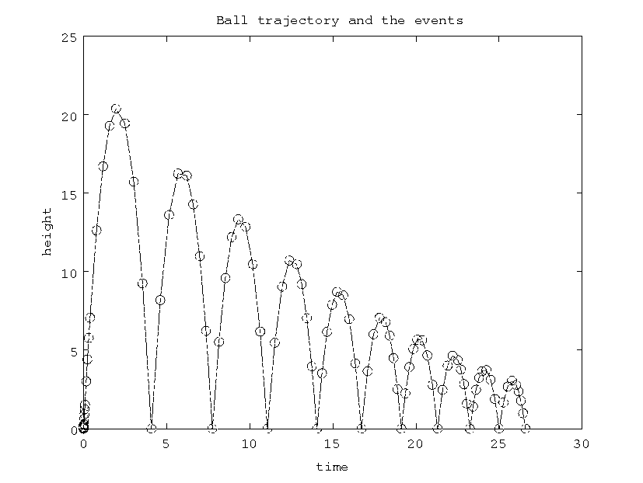
Long captions should be set as in

Figure 2. Example of long caption requiring more than one line. It is not typed centered but aligned on both sides and indented with an additional margin on both sides of 1 pica.

Callouts should be 9-point Helvetica, non-boldface type. Initially capitalize only the first word of section titles and first-, second-, and third - order headings.
FIRST-ORDER HEADINGS. (For example, 1. Introduction) should be Times New Roman 12-point boldface, initially capitalized, flush left, with one blank line before, and one blank line after.
SECOND-ORDER HEADINGS. (For example, 1.1. Database elements) should be Times New Roman 11-point boldface, initially capitalized, flush left, with one blank line before, and one after. If you require a third-order heading (we discourage it), use 10-point Times New Roman, boldface, initially capitalized, flush left, preceded by one blank line, followed by a period and your text on the same line.

2.6 Footnotes

Please use footnotes sparingly¹ and place them at the bottom of the column on the page on which they are referenced. Use Times New Roman 8-point type, single-spaced.

2.7 References

List and number all bibliographical references in 9-point Times New Roman, single-spaced, at the end of your paper. When referenced in the text, enclose the citation number in square brackets, for example [1]. Where appropriate, include the name(s) of editors of referenced books.

2.8 Conclusions

Please direct any questions to the production editor in charge of ISATE2008 organization: E-mail,
< isate2008@ec.knct.ac.jp >
When preparing your manuscript, please see the following web site, < http://isate.cs.knct.ac.jp/ >. If you use 'latex8.sty', please adjust the margin settings, the same as the LaTeX source file of author guidelines.

References
[1] I. M. Author. Some related article I wrote. Some Fine Journal, 99 (7): 1-100, January 1999.
[2] A. N. Expert. A Book He wrote, His Publisher, Erewhon, NC, 1999.
[3] P. Ienne.. LaTeX author guidelines for 8.5 x 11-inch proceedings manuscripts. Manuscripts for making IEEE proceedings.

¹ Or, better still, try to avoid footnotes altogether. To help your readers, avoid using footnotes altogether and include necessary peripheral observations in the text (within parentheses, if you prefer, as in this sentence).

