Security solutions for embedded systems
Nayani Srinivas Vijayanand
Oulu University of Applied sciences
School of engineering
Oulu, Finland.
t3nasr00@students.oamk.fi
vijay.nayani@gmail.com

Abstract

The ABSTRACT should be written in fully-justified text, at the top of the left-hand column, below the author and affiliation information. Use the word “Abstract'' as the title, in 12-point Times New Roman, boldface type, centered relative to the column, initially capitalized. The abstract is to be in 10-point, single-spaced type. The abstract may be up to 7.5 cm (approximately 3 inches) long. KEYWORDS are to be followed by no blank line after the abstract,accompanied with the hedding “Keywords:” in Times New Roman 12-point boldface, initially capitalized. Leave two blank lines after the Keywords, then begin the main text.
“This paper focuses on common kinds of security attacks prevelent in embedded systems discussing on methods to minimize if not nullifying them.”
Keywords: SWF2009, Author Guidelines.

Introduction

Security in electronic systems has been gaining importance due to ever increasing amount of attacks in today's world. Operating in a secure environment has been of paramount importance right from high end systems like space shuttles, defense & control systems, Internet routers, telecom infrastructure equipment to right until low end consumer appliances and gadgets. Primary focus of the paper is to draw attention on aspects of system wide approach to security in embedded systems, types of security attacks and possible approaches to mitigate them. Providing a secure systems or service in practice means to address wide variety of challenging security concerns which includes data confidentiality and integrity, authentication, privacy, denial of service and digital content protection.

Driving forces for designing a secure systems
- Advent of interconnectedness of devices via Internet of Things (IoT) in today’s world is posing a bigger threat in embedded world. A compromised device in the network can have a cascading effect on whole network.
- Increased use of open source software by companies in an effort to bring down the software costs is turning out as breading grounds for hackers.
- Ever increasing use of microprocessors in day today life which has carry the risk of compromising on personal information, For ex: washing machines, cameras etc.

Security design constraints in embedded systems
Embedded system s are self-contained systems designed to work on SoC (System on Chip) often with real time computing restrictions unlike general-purpose operating systems.
Greater computational demands, limited battery life, hardware capabilities & low flexibility pose challenges to implement fool proof security architecture.
Developing an embedded systems with tamper resistance measures to sustain physical and side-channel attacks poses challenges due to systems minimal foot print and increased circuit complexity.
Cost and complexity can also be major contributors that can influence the security architecture of an embedded system. For example, task of incorporating physical security mechanisms in a single-chip cryptographic module.

Security requirements

Security requirements vary according to end usage of the system. For example, security considerations for point-of-sale (POS) terminals typically consumer gadgets may be quite different from those applicable to a wireless base station. Embedded systems, because of their physical accessibility, also raise some unique security concerns.
An Internet server which is well protected by firewalls has little to worry about from attacks, unlike for a wireless cellular base station deployed on user premises. Often also the value of the intellectual property (IP) in these devices makes them an enticing target for sophisticated attacks.
Never the less , this section jots down some of typical security requirements that needs to be addressed by large variety of embedded devices ranging from point of sale to devices customized for dedicated functionalities.
- Device Availability: Systems must ensure they don't fall pray for Denial of Service (DoS) attacks and shall be able to perform its intended duties without disruption.
- User Authentication: All systems shall need to validate the users by effective mechanisms before they are allowed to gain access to system resources.
- Content security: Systems need to enforce restrictions on usage of digital content in the system typically DRM etc..
- Secure storage: Devices shall need to ensure the integrity and confidentiality of the stored content. Typical examples are service/device certificates , authentication keys , passwords..etc
- Secure network/ communication: Devices working on network shall provide services and access to only authorized devices on the network. This includes authenticating communicating peers, ensuring confidentiality and integrity of communicated data, preventing repudiation of a communication transaction, and protecting the identity of communicating entities. Typical examples are secure bank transactions, PIN codes etc..
- Restricting unauthorized software: Devices shall be able to restrict running unauthorized software which can seriously dent the functionality of the device and depriving the legitimate revenue for the service providers. Also running unauthorized software on embedded devices can be far more serious in other areas such as military and aerospace applications, where dangerous equipment and even state secrets can fall into unfriendly hands.

- Software Reverse Engineering: Devices shall take steps to ensure that reverse engineering shall not succeed. Several tools and techniques are can be used to reverse engineer embedded software to extract useful and valuable information. Typical examples are disassemblers tools for extracting file systems.

Security approaches
Embedded devices need to adopt comprehensive security solution that addresses many of the above mentioned security concerns at the system level.
Providing comprehensive secure solution is a system-wide approach in which security emanates from software execution environment and permeates throughout the hardware interfaces, buses and IP blocks.

In practice building a best of class secure device boils down to below considerations
- Device when doing a secure operations shall take the help of designated software designed to take care of secure operations. Typically operations that fall under this category are software authentication , user identify verification, decryption & encryption functionalities, accessing secure information , establishing secure communication channels etc..
- Specially designated software meant to execute secure operations shall take the help and exploit the underlying hardware that is specially built for supporting secure operations effectively.
Thus a combination of hardware based software solution provides a robust foundation for software to run the device in perfect secure mode.

Attacks and mitigation methods
Approach for providing security solutions varies depending upon attack to address and hence forth difficult to generalize. Certain solutions can be a combination of software and hardware based while others are purely either software or hardware. Choice of security solutions are based on target of attack to mitigate robustness needed for handling such an attack. This section focuses on typical attacks and ways to mitigate them by employing software / hardware or both.

Software based solutions
Most general attacks on systems include
- Network security: Common network securities include dictionary attacks, DoS (Denial of services), TCP hijackings, and sniffing attacks. Most of these attacks can be mitigated by effectively configuring the firewall and frequent monitoring the network traffic. In Linux world, range of tools like nmap, netstat, wire shark can be deployed to track and monitor the packets. Attacks like eavesdropping, MITM (Man In the Middle Attack) can be mitigated by establishing secure communication by employing IPSEC protocols.
- Operating system /kernel security: Linux is predominantly used in embedded systems is open source based and hence forth vulnerable to attacks. Linux can special security patches to harden it and plug the potential loopholes and enhancing the operating system kernel security. Typical example include LIDS(Linux Intrusion Detection System) , grsecurity kernel patches, SE-Linux , LSM (Linux Security Modules) etc..
- Local and file system security: Employing more conservativeness approach at giving minimum amount of privileges a to user groups. Creation of group accounts needs to be discouraged as they accountability is difficult to enforce. Files system access and permissions for executable partitions in particular need to be disabled to curtail unauthorized installations and thereafter executions.
- System Services : Security employed by system services is paramount and is more often the start point for initiating and executing secure operations. Applications and service providers (daemons) shall need to carry user authentications , integrity checking and establish secure communication channels before providing the actual services. It is often suggested to use operating system level provided authentication modules/schemes instead of employing application specific ones. Typical examples include Secure shell services, PGP ,DHCP , Web servers, file servers, DNS bindings, LDAP accesses , VPNs, authentication via PAM modules in Linux based systems, IPSEC protocols for secure communication..etc.

Hardware based security solutions

2 Instruction

Please read the following carefully.

2.1 Language

All manuscripts must be in English.

2.2 Printing your paper

Print your properly formatted text on high-quality A4 white printer paper. Those of you who usually use US Letter paper, bear with us---this layout is for A4 paper, hence the longer-than-usual pages. Adjust the top-margin if necessary to avoid text running off the bottom of the page. Do not exceed 8 pages.

2.3 Margins and page numbering

All printed material, including text, illustrations, and charts, must be kept within a print area 16.0 cm (6-3/8 inches) wide by 24.2 cm (9-1/2 inches) high. Do not write or print anything outside the print area.

2.4 Formatting your paper

Body text must be in a two-column format. The total allowable width of the text area is 16.0 cm (6-5/16 inches) wide by 24.2 cm (9-1/2 inches) high. Columns are to be 7.6 cm (3.0 inches) wide, with a 0.8 cm (5/16 inch) space between them. The main title (on the first page) should begin 3.5 cm (1-3/8 inches) from the top edge of the page. The second and following pages should begin 2.5 cm (1.0 inch) from the top edge. On all pages, the bottom margin should be 3.0 cm (1-3/16 inch) from the bottom edge of the page.

2.5 Type-style and fonts

Wherever Times New Roman is specified, Times Roman may also be used. If neither is available on your word processor, please use the font closest in appearance to Times New Roman that you have access to.
MAIN TITLE. Center the title 3.5 cm (1-3/8 inches) from the top edge of the first page. The title should be in Times New Roman 14-point, boldface type. Capitalize the first letter of nouns, pronouns, verbs, adjectives, and adverbs; do not capitalize articles, coordinate conjunctions, or prepositions (unless the title begins with such a word). Leave two blank lines after the title.
AUTHOR NAME(s), AFFILIATION(s), E-MAIL ADDRESS(s) are to be centered beneath the title and printed in Times New Roman 12-point, non-boldface type. This information is to be followed by two blank lines.
The ABSTRACT, KEYWORDS and MAIN TEXT are to be in a two-column format.
MAIN TEXT. Type main text in 10-point Times New Roman, single-spaced. Do NOT use double-spacing. All paragraphs should be indented 1 pica (approx. 0.4 cm or 1/6 inch). Make sure your text is fully justified---that is,
flush left and flush right. Please do not place any additional blank lines between paragraphs. Figure and table captions should be 10-point Helvetica boldface type as in

Table 1. Parameters
Specifications | Notation | Estimated value
Delay time [s] | δ | 0.1
Time Constant [s] | τ | 0.2
Time constant [s] | ζ | 0.3
Feed-forward gain | γ | 0.4

Figure 1. Sample figure
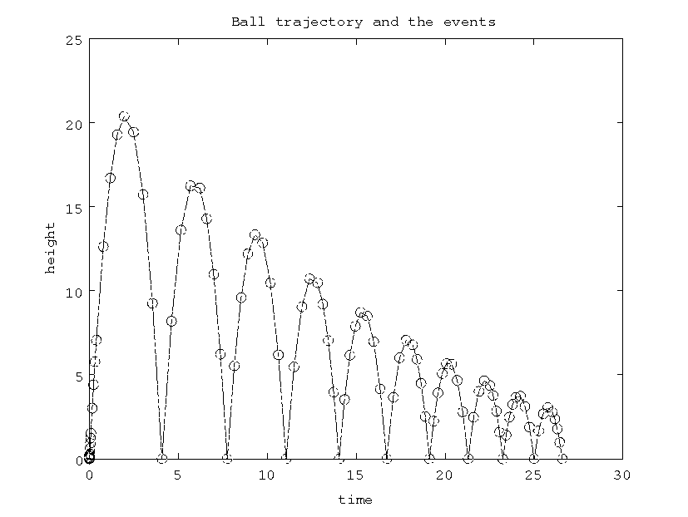
Long captions should be set as in

Figure 2. Example of long caption requiring more than one line. It is not typed centered but aligned on both sides and indented with an additional margin on both sides of 1 pica.

Callouts should be 9-point Helvetica, non-boldface type. Initially capitalize only the first word of section titles and first-, second-, and third - order headings.
FIRST-ORDER HEADINGS. (For example, 1. Introduction) should be Times New Roman 12-point boldface, initially capitalized, flush left, with one blank line before, and one blank line after.
SECOND-ORDER HEADINGS. (For example, 1.1. Database elements) should be Times New Roman 11-point boldface, initially capitalized, flush left, with one blank line before, and one after. If you require a third-order heading (we discourage it), use 10-point Times New Roman, boldface, initially capitalized, flush left, preceded by one blank line, followed by a period and your text on the same line.

2.6 Footnotes

Please use footnotes sparingly¹ and place them at the bottom of the column on the page on which they are referenced. Use Times New Roman 8-point type, single-spaced.

2.7 References

List and number all bibliographical references in 9-point Times New Roman, single-spaced, at the end of your paper. When referenced in the text, enclose the citation number in square brackets, for example [1]. Where appropriate, include the name(s) of editors of referenced books.

2.8 Conclusions

Please direct any questions to the production editor in charge of ISATE2008 organization: E-mail,
< isate2008@ec.knct.ac.jp >
When preparing your manuscript, please see the following web site, < http://isate.cs.knct.ac.jp/ >. If you use 'latex8.sty', please adjust the margin settings, the same as the LaTeX source file of author guidelines.

References
[1] I. M. Author. Some related article I wrote. Some Fine Journal, 99 (7): 1-100, January 1999.
[2] A. N. Expert. A Book He wrote, His Publisher, Erewhon, NC, 1999.
[3] P. Ienne.. LaTeX author guidelines for 8.5 x 11-inch proceedings manuscripts. Manuscripts for making IEEE proceedings.

¹ Or, better still, try to avoid footnotes altogether. To help your readers, avoid using footnotes altogether and include necessary peripheral observations in the text (within parentheses, if you prefer, as in this sentence).

