|  |
| --- |
|  |
| Web UI Design Project |
|  |
|  |
| **Nayani Vijay** |
| **4/19/2014** |

|  |
| --- |
| This document contains a detail description of WEB UI project that is intended for an institute. Document also explains the site construction, screens , functionality and their purpose. |

Contents

Description of task 2

Structure of the site 2

Screens Description: 2

Screen 1 : Course catalog 2

Screen 2: Course details 3

Screen 3 : Registration form. 4

Screen 4: Details Form 5

Navigation of the site 6

Graphical design of forms 7

Course catalog screen 7

Course Details screen 8

Registration form screen 9

Form for more details. 10

Inter screen navigation diagram. 11

References 11

Appendix 12

Basic rules to be followed for screen designing 12

# Description of task

This project describes building a website for education institution that offers software programming courses. In addition to providing the course information , website also allows user to enroll to courses via specifically designed forms.

# Structure of the site

Site is designed keeping the following rules in mind

* Information provided in site shall be easy to read and interpret
* Navigation across pages and controls in the pages should be quite easy.
* Website shall be light weighted enough for a possibility of a quick download.
* Web page layout , design , fonts , colors shall be pleasing and consistent across.

Web UI design project is a very basic version that comes with four screens . Each of the screens can be navigated back and forth and are interlinked. User or a student is expected to execute the below use cases for a successful registration to a course.

1. Course catalog screen.
2. Course details screen.
3. Registration screen
4. Details screen.

# Screens Description:

## Screen 1 : Course catalog

This screen shows the a list of all the courses that are offered by the institution. The courses that are open for registration are depicted in with a highlighted font and the ones closed for registration are lowlighted (greyed) font. This page comes with a mouse tooltip that displays registration status either “Course open for registration “or “Registration closed” as the mouse runs over the courses.

* **List of courses:** This screen comes with a list box which presents the combined list of courses offered by the institute. Control used here a regular list box with an vertical scroll listing of all the courses. Courses that are open for enrolment are enabled and other courses are displayed as well but with a disabled state .
* **Enrollment Status:** Each course presented as a list box item comes with an trailing check box that has enrollment status marked as ‘**√** ‘or ‘**X**’. These check boxes denote whether a particular course is enrolled by the user or not. User can not explicitly does this marking but is marked by the backend logic once user signs up for the course. This enrollment is done in the next screen.
* **Course details push button:** Each course element in the list box with a push button labelled as “**>**” .This button when used would enable the user to navigate to course details screen where further action is action would happen.

Screen is designed with below mentioned controls

* **Registering for the courses** : Once the user decides on the courses for enrollment , he or she can use the “**Register**” push button . User does this once he decides upon choice of the courses that he or she is interested to enroll. This button would take navigate the user to registration screen
* **Text controls**: Page comes with pure text controls are used to convey information to the user like title of the page , Legend inside the page ..etc.

**Validation mechanisms**

* These mechanisms check for validity of user input. For example : Email entry is checked for a format correctness.
* Validation mechanism would be in place to check if all the mandatory * fields are filled before final sign up.
* Contact mode control is designed with radio buttons where the default is set as Email.
* If validation mechanism fails , User will be displayed the message box which contains information on what is the problem and which control has this.

**Navigation:**

Navigations across the controls in screen can be done either by tab key which is more sequential or by using shortcut keys for navigating to specific control. Key board short cuts are mentioned by underline for example : “Question” :Here letter ‘S’ underlined which means this control can be accessed by keyboard shortcut “ALT+S”

Screen comes with an “?” button in the top right corner of the screen. Users can click this button and place it on the top of the item which they need some text help. When mouse rolls over the control , a tool tip information about the control will be displayed .

## Screen 2: Course details

Main objective of this screen is to give details regarding the course , information on its schedule , class composition and help user decide if he can sign up for this course.

**Course Contents :**

All the contents of the selected course are briefed here on the lines of sessions. Control used here is a bulleted list box that shows the each of the content topic as a separate element in list box. Alternate elements in the list box come with a matching background colour to give user a pleasant differentiation between the elements.

**Course Schedule :**

Course Schedule presents detailed schedule of the selected course . Control used here is also a bulleted list box that shows exact schedule in terms of time and date for each session. Similar to course contents , alternate list elements in course schedule also comes with matching colors to give a pleasant feeling to the user.

**Professor details:**

Details of the professor concerned for the course selected are presented here in this slot. Details like Name , Contact email , and link to CV are the primary fields here.

All the fields here are pure non editable text elements.

Link to the CV is a underlined which a widely used gesture . Mouse shall turn into hand when it gets rolled over the CV link conveying to user that this is a link.

**Class details:**

Class details slot presents the user information relating to total strength of class and availability of seats for the course. Again all the fields described here are pure non editable text elements just intended to convey information to user.

**Course Sign up :**

Course sign up space comes with a text box and check box. User uses this check box to sign up for the chosen course. Once user signs up for the course , a dialog box confirming the signup with a thank you greeting shall be displayed.

**Sign for more information:**

Users get to know more information on the course by using the push button ”Sign up for more information” . By using this button , users will transition to different screen which opens up another set of information where user can request .

## Screen 3 : Registration form.

Main objective of this screen is to allow user to provide all information that are needed for a successful registration .

Primary controls in this screen are text boxes, labels, calendar control and a list box containing list of enrolled courses as elements.

Controls accepting user inputs such as Name , Data of birth , social security number and address are captured in the text boxes. All the controls accepting user inputs have input validation logic in place. The mandatory fields that are vital for registration process are marked with *

Push button “**Sign up**” enables user to register for the selected list of courses with the information provided in the process of registration. This is pretty much last step in the process of course registration. There are set validation checks that will be fired when opts for for “**Sign up**” .

**Validation mechanisms**

* These mechanisms check for validity of user input. For example : Email entry is checked for a format correctness.
* Validation mechanism would be in place to check if all the mandatory * fields are filled before final sign up.
* Date of birth control is designed as calendar control where there is no scope for a possible error.
* If validation mechanism fails, User will be displayed the message box which contains information on what is the problem and which control has this.
* Back ground validations in place to warn the user if he or she has tried to enroll to courses which has schedule overlap.

**Navigations:**

Sequential navigation between the controls in the screen can be performed by the keyboard tab . Push buttons controls can be operated by designated keyboard shortcuts.

Key board short cuts are mentioned by an underlined letter for example : “Email” :Here letter ‘m’ is underlined which means this control can be accessed by keyboard shortcut “ALT+m”. This is not shown in UI screen below because of tool limitations.

Navigation button “**Back**” is provided to the user which enables him to revisit the earlier screen

Screen comes with an “?” button in the top right corner of the screen. Users can click this button and place it on the top of the item which they need some text help. When mouse rolls over the control , a tool tip information about the control will be displayed .

## Screen 4: Details Form

This screen will come up with the needed elements that can help user to get more details on the course.

It is quite usual that the users can have more clarifications to make apart from the one that are provided in the course details screen. Sometimes users can have their own questions where in they can write down the questions in want of additional clarifications regarding the courses. Institute can get back to the user on this information later point of time.

Elements and control that come in this screen are Name , Email, Question and contact mode.

Name , Email and Question have input accepting text controls where in user needs to fill the relevant information. Contact Mode slot has a set of radio buttons where in user can select preferred mode of contact. Default mode here is set to Email.

**Validation mechanisms**

* These mechanisms check for validity of user input. For example : Email entry is checked for a format correctness.
* Validation mechanism would be in place to check if all the mandatory * fields are filled before final sign up.
* Contact mode control is designed with radio buttons where the default is set as Email.
* If validation mechanism fails , User will be displayed the message box which contains information on what is the problem and which control has this.

**Navigation:**

Navigations across the controls in screen can be done either by tab key which is more sequential or by using shortcut keys for navigating to specific control. Key board short cuts are mentioned by underline for example : “Question” :Here letter ‘S’ underlined which means this control can be accessed by keyboard shortcut “ALT+S”

Screen comes with an “?” button in the top right corner of the screen. Users can click this button and place it on the top of the item which they need some text help. When mouse rolls over the control , a tool tip information about the control will be displayed .

# Navigation of the site

Every screen comes with navigation buttons to traverse the next and previous screens.

Below is the link to screen design application that I have done for this webUI project.

Please be informed that this is an elementary application to demonstrate and support the writings in the report.

This application only demonstrates the screen design and navigation. It does not have support to other approaches like validation / error handling mechanism , gestures, help , tooltips and confirmation messages to the user. Hopefully the below link works

<https://www.fluidui.com/editor/live/preview/p_GmIRg0dzVpkhOnx552T1kBKNLppC1Lkb.1397533409243>

# Graphical design of forms

Push button to take to course details.

Navigates to registration screen.

## Course catalog screen

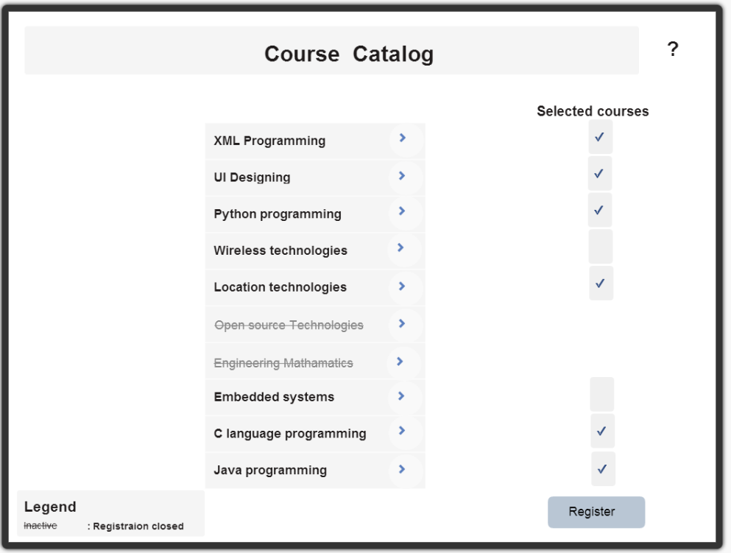

## Course Details screen

Push button control, navigates to form for more details.

Navigates back to parent screen

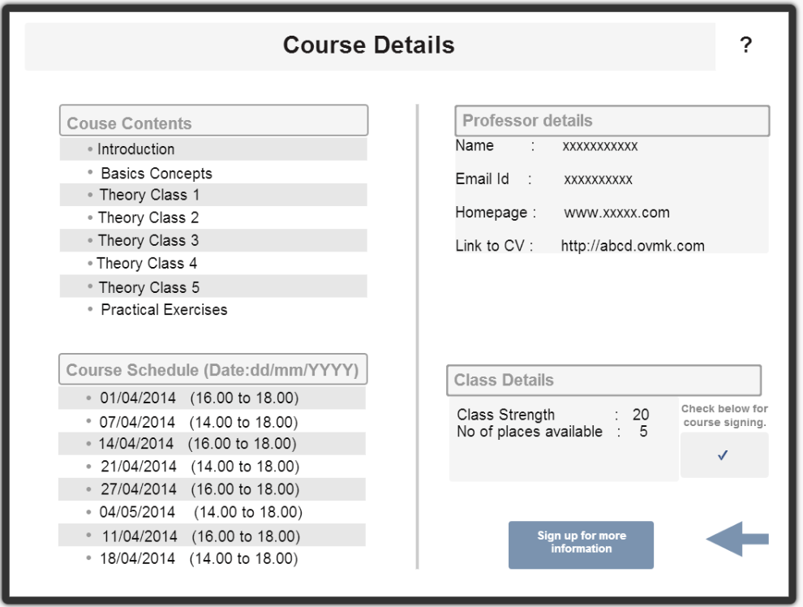

## Registration form screen

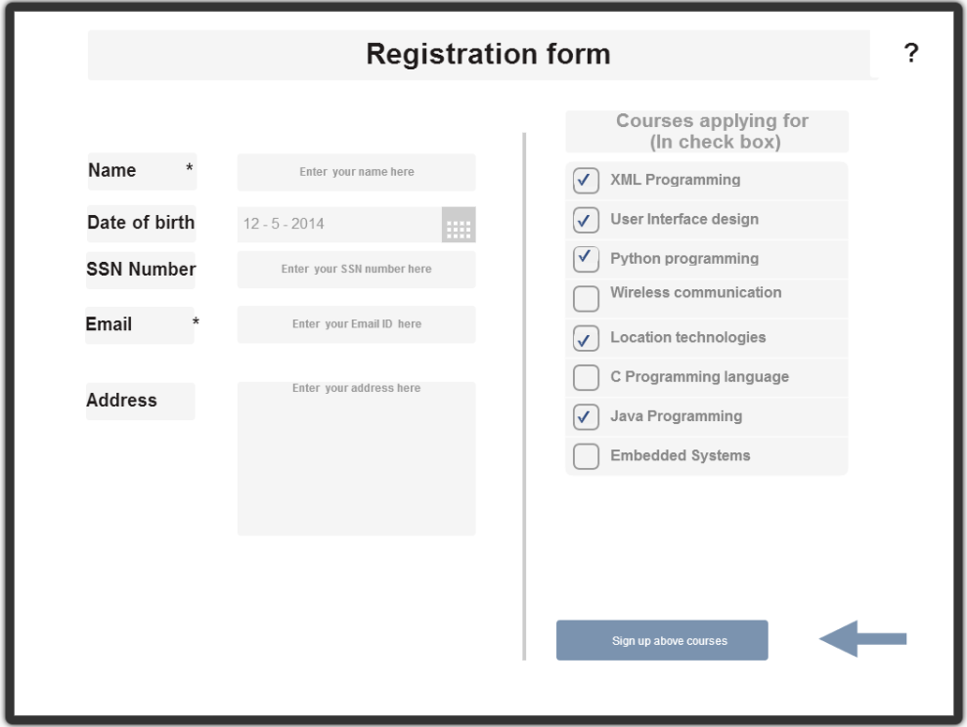

Push button to sign up for courses with check mark.

Navigates back to parent screen

## Form for more details.

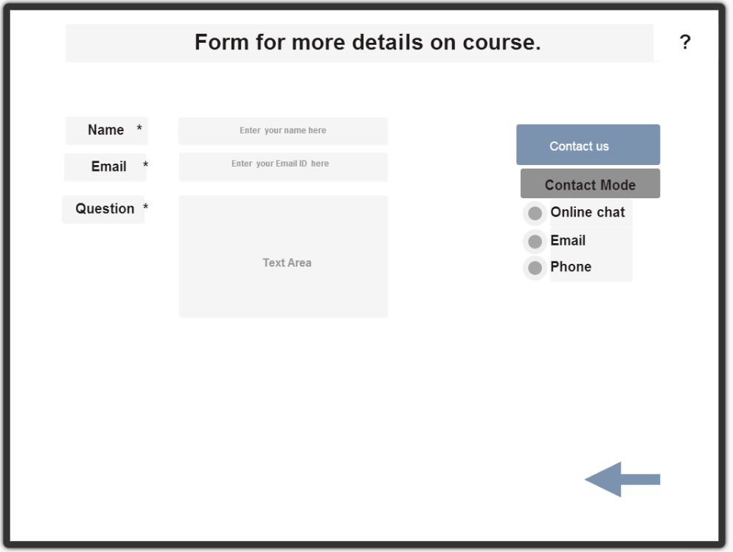

Navigates back to parent screen

## Inter screen navigation diagram.

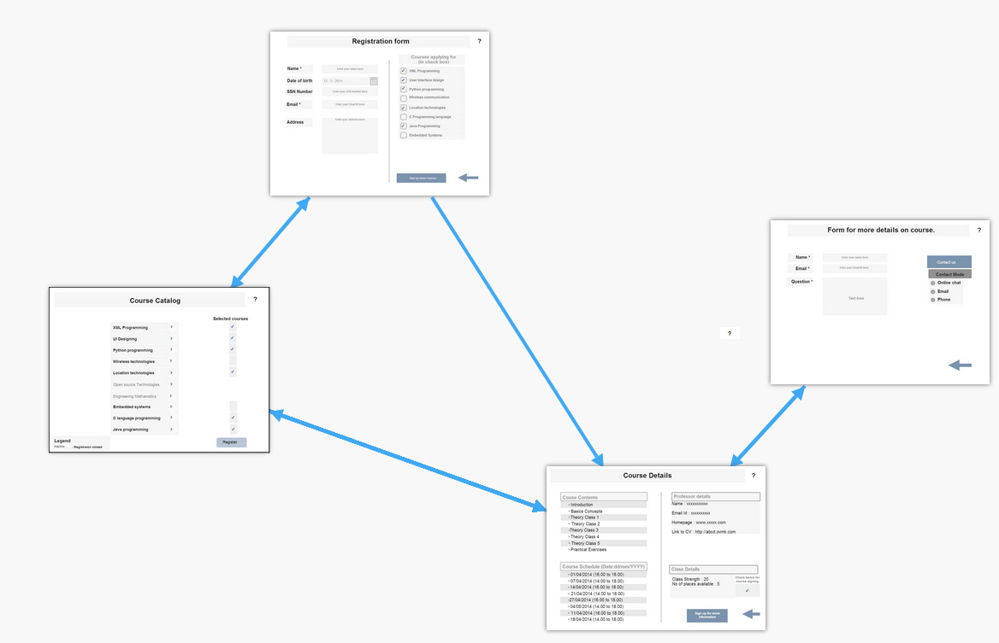

# References

<http://www.search-usability.com/5rules.cfm>

<https://www.fluidui.com/editor/live/>

# Appendix

## Basic rules to be followed for screen designing

* Group of controls designed to address functionality are grouped together. This is done to create an impression to user that these go together and relate to same or similar functionality.
* Screen and messages dialogs pop in/pop out gestures are inline with the users thinking.

For ex: Back buttons which take user to previous screens have gesture of sliding to back side.

* Background and fore ground colors for the screen and controls are selected so that they are visible to all kinds of people.
* Every screen comes with predictive helps and tooltips for extra bit of information regarding the controls.
* Drop down controls like list boxes and combo boxes shall come with a text filtering feature.
* Designer shall make sure not to pack too many things and crowd the screen.
* Every possible validation needs to be checked when user is exchanging information to screen.
* Make sure users will be able to navigate to all the controls in the screens by using either Keyboard as well as mouse which ever is applicable.