Vinayak Arora
  - Audio engineer, composer, sound designer, educator and builder
I make music, design sound, build instruments and teach. My work moves between the recording studio, games, live performance, spatial audio and interfaces that people can play.
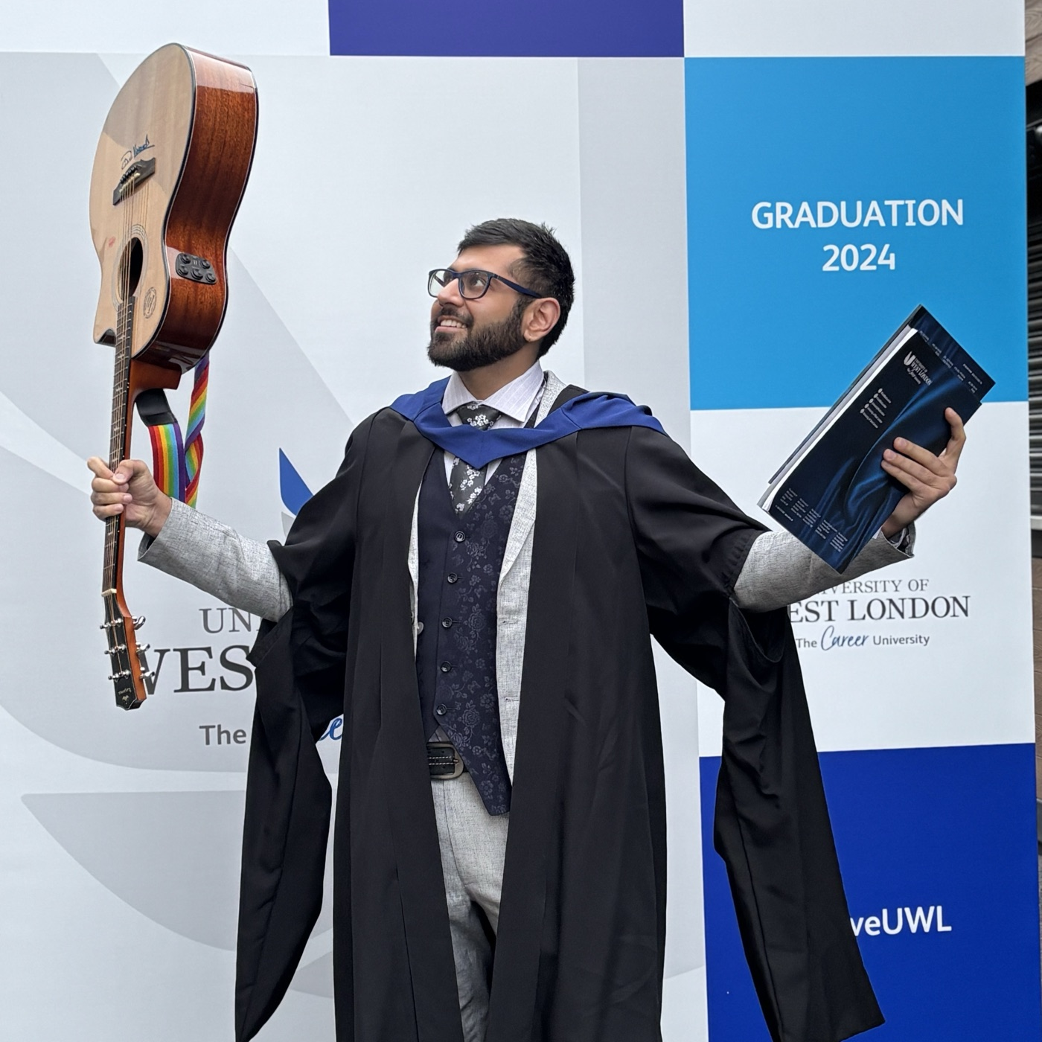
I am an audio engineer, composer, sound designer, educator and creative technologist with 5+ years of professional experience. An engineering degree gave me a grounding in systems and problem-solving; music led me toward recording, immersive listening and interaction design. I like working at the point where an idea becomes something you can hear, use or perform.
United Kingdom / India / Remote | +44 7407 317766 | vvkvvn@gmail.com
Portfolio / LinkedIn

The work
  - Studio craft, game audio and the judgement behind a good sound.

GameCrafters Collective
Sound designer and game composer | Jul 2024 - Present | Remote
Create and implement sound effects, ambience, dialogue and adaptive music with FMOD and Unity. Projects include Don't Witch Me Now and Cluck Yeah.
Delivered end-to-end audio for Don't Witch Me Now, a publicly playable Unity puzzle adventure. Collaborate with programmers, artists and designers, test builds and refine systems through feedback.
Gameplay / Play the game

Freelance audio and creative technology
Self-employed | Aug 2024 - Present | United Kingdom / India / Remote
Recording, editing, restoration, sound design, mixing and spatial audio across music, voice, performance and multimedia. I help artists and teams solve technical problems without losing sight of the creative intention.
Engineered a binaural album for Dhruv Vishwanath at Vestry Hall Studio and assisted a 10-person choir recording for Jacob Collier at Abbey Road Studios. Work also includes live setup, microphone placement, sound checks and multitrack recording.

Teevra Ma Studio
Audio engineer and music solutions specialist | Dec 2021 - Present | Noida / Remote
Designed and acoustically treated the studio, and work across recording, production, vocal arrangement, editing, mixing and delivery. Collaborators include Bumble, Salim-Sulaiman, Antariksh and Piyush Bhisekar.
Translate briefs into practical signal chains and creative decisions; organise sessions, revisions, schedules and client communication.
Studio

Micro1 and contract AI training
AI music and audio trainer / evaluator | 2025 - Present | Remote
Evaluate music, audio and technical reasoning for accuracy, perceptual quality and usefulness. Identify artefacts, broken assumptions and reproducible failures; write structured corrections that explain why a decision succeeds or fails.

Lotustree Studio
Audio engineer intern | Jun - Dec 2021 | Delhi
Supported drums, tabla, choir and live sessions; edited and time-corrected multitracks in Pro Tools. Worked with Apollo x8p, outboard compression and Neumann KH420 monitoring, developing disciplined setup, gain staging and troubleshooting.

Sound you can play
  - From a moving body to a game world: sound as a response to action.
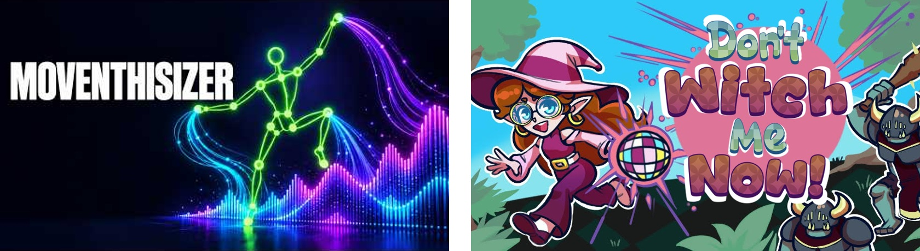

Moventhisizer
Gestural instrument and exhibition installation | UWL | 2024
I designed a body-controlled instrument using iKeleton OSC, Max/MSP and Logic Pro X. Tracking data from 17 body points becomes melodic, percussive and sci-fi sound, with movement controlling pitch, dynamics, filtering and effects.
Binaural sounds follow head position; different limbs have different musical roles. I built adjustable mappings, presets, resets and an iPad control interface through MiraWeb, and reduced mappings when MIDI traffic caused CPU overload. Exhibition visitors explored the instrument through headphones.
Watch people play it

Game audio
Composition, sound design and implementation
Don't Witch Me Now combines my sound design and music with FMOD/Unity implementation. Cluck Yeah is another GameCrafters project I have worked on. Innerspace documents my sound design, composition and integration for an FPS game portfolio project.
Innerspace gameplay / Implementation overview / Cluck Yeah

Bassify and immersive experiments
Max instrument design, binaural sound and VR
Bassify is a bass-triggered polyphonic vocal harmoniser built in Max, connecting pitch detection, synthesis and effects. Other work explores binaural listening, sound for VR and hands-on Dolby Atmos 7.1.4 production.
Bassify / VR sound design

Music and moving picture
  - Original releases, voices, analogue experiments and sound for the screen.
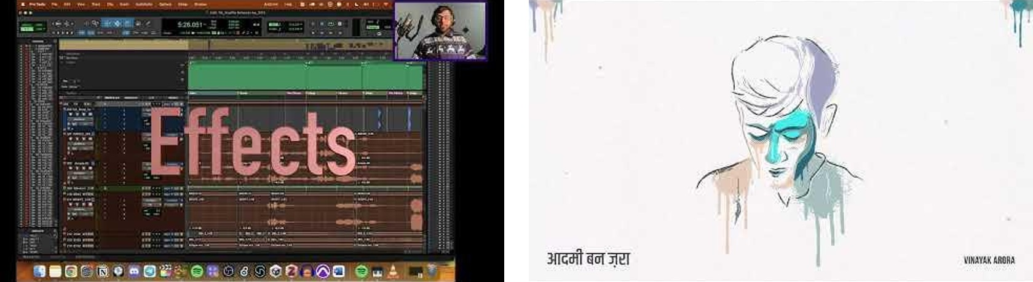

Original music
Composer, producer, singer and guitarist
My practice includes songwriting, arrangement, harmony, electronic and acoustic production, recording, mixing and mastering my own work. Aadmi Bann Zara is my debut single; other releases include Fuzzy Cuddly Scrampadoodlicious and F*ck You with Apoorva Malik and Khushi Pallavi.
Aadmi Bann Zara / Fuzzy Cuddly Scrampadoodlicious / F*ck You

Kaafile Bahaaron Ke and Synth Fest
Hybrid production and experimental performance
Kaafile Bahaaron Ke documents composition, arrangement, production, mixing and mastering. Synth Fest brings together self-built Max instruments, VCV Rack calibration and modular systems. My studio practice also includes Custom Series 75 Neve workflows and the Analogue Solutions Colossus.
Kaafile Bahaaron Ke / Synth Fest

Film, foley and spatial listening
Sound for picture and headphone listening
Created score, sound design and foley for the short film Khwaab through Teevra Ma Studio. Portfolio sound redesigns explore advertising and sonic identity; immersive work includes the binaural piece Mata-e-Gair and VR fashion sound design.
Khwaab / Mata-e-Gair / Sound redesign

EOTD
An ongoing daily music practice
I go live on Instagram to share a spontaneous moment of music: vocal harmony, improvisation, arrangement ideas, experiments or a reimagined song. EOTD is a continuing record of practice and discovery, with sessions documented on YouTube.
EOTD archive

Teaching and people
  - Lessons, ensembles, shared stages and work on the other side of the bar.
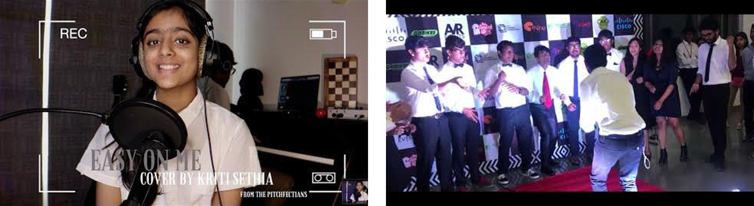

Music and audio educator
Freelance / music schools | May 2019 - Present | India and UK
Teach music production, recording, guitar, vocals, music theory, ear training and audio technology. Build lessons, demonstrations, exercises and feedback around the individual learner, connecting theory with something they can make or perform.
Teaching spans signal flow, synthesis, mixing, composition, game audio and creative technology. I have organised online and in-person recitals and guided performance, improvisation and ensemble work.
Student performance / Summer recital

The Pitchfectians
Founder and faculty | May 2019 - Sep 2023 | Noida
Coached vocal and guitar performance, improvisation and composition; combined practical work with Indian and Western music theory and organised musical performances and ensemble recitals.

Rouble's Guitar School
Guitar faculty and vocal coach | May - Dec 2019 | Noida
Taught guitar, ear training and rhythm, including work with Rockschool and Trinity College music syllabuses.

Madhurima, DTU Music Society
President, a cappella choir founder and conductor
Composed and arranged the annual a cappella piece for four consecutive years. Directed ensembles, university performances and musical events, and helped organise the national music competition DoReMiPa.
Queen a cappella / Linkin Park a cappella

The Garage, London
Part-time bar staff | 2026
Worked part-time as bar staff alongside my creative work.

Things I build
  - I use technology to turn an idea into something people can try.
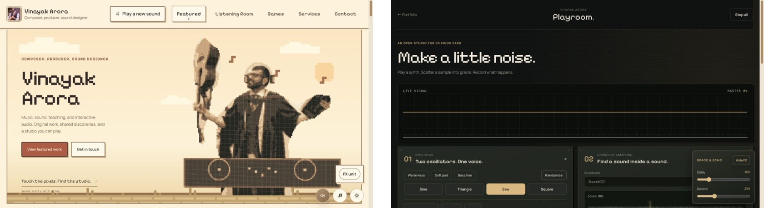

A portfolio that is also an instrument
Independent, AI-assisted development | Website redevelopment in progress
My website brings together music, screen work, games, teaching and interactive sound. Its redesign includes a playable pixel portrait and a browser studio, alongside sonic click feedback, scroll-responsive audio and a sound-effects unit.
Ear Memory Lab and Chord Decoder connect listening, input and feedback. The browser studio prototype includes synthesis, sample-based granular controls, sequencing and a scope. I develop these ideas with React, JavaScript and Web Audio, using AI tools to support implementation and iteration.
Explore the portfolio

SignalPath Academy
Independent education website and portal project
Built an academy website and student/application portal around a React/Vite frontend, Express API and PostgreSQL-oriented backend. This work connects my teaching experience with interface design, information structure and practical workflow prototyping.

Living Sound Entity
Independent 3D and audio interaction project
Created a cinematic audio-reactive experience with Three.js, React Three Fiber and Web Audio, including microphone-responsive behaviour. The project explores how sound, movement and visual form can influence one another.

EOTD publishing workflow
Automation for my own creative practice
Developed a workflow to help archive long-running live music sessions on YouTube, reducing the repeated manual download and re-upload process. It is a practical tool built around an ongoing creative habit.
Public archive

Tools and foundations
  - A broad practice, with sound at its centre.

Audio engineering
Recording, production and delivery
Microphone selection and placement; signal flow and gain staging; multitrack editing; vocal and dialogue cleanup; restoration; dubbing experience; EQ, dynamics and automation; mixing, mastering preparation, live setup and quality control. Dante audio-networking familiarity.

Composition and sound design
Music, texture and sonic storytelling
Songwriting, harmony, arranging, guitar and vocals; Indian and Western music theory; synthesis, sampling, foley, sound for picture, game music, loops, stingers and adaptive layers.

Interactive and immersive systems
Games, gestures and spatial sound
FMOD, Unity, Max/MSP, OSC, MIDI and MiraWeb; gesture mapping and instrument design; binaural audio, Dolby Atmos 7.1.4, Dolby Atmos Renderer, dearVR MUSIC, Blue Ripple Sound and Sound Particles.

Production and creative software
Tools used across my projects
Logic Pro, Pro Tools, Reaper, Ableton Live, Ardour and LMMS; Sibelius and MuseScore; Final Cut Pro; Melodyne; Plugin Alliance and Valhalla tools; iZotope RX familiarity and audio restoration workflows.

Independent software prototyping
AI-assisted project work
React, Vite, JavaScript, HTML and CSS; Three.js, React Three Fiber, Web Audio and Tone.js; Express APIs, PostgreSQL and Redis project experience; VS Code, Git and Vercel. Prototyping and iteration with ChatGPT, Claude, Codex and GitHub Copilot.

People and practice
Teaching, evaluation and collaboration
Lesson design, demonstrations, performance coaching and constructive feedback; AI music/audio evaluation and structured technical writing; studio logistics, client communication, remote collaboration, event coordination and part-time bar work.

My route into sound
  - Engineering foundations. Studio training. Music technology.

MA Advanced Music Technology
London College of Music, University of West London | Dec 2024
Distinction; topped the course. Advanced hybrid production, immersive audio, game audio, interface design and interactive music technology.

Diploma in Audio Engineering and Music Production
Sri Aurobindo Centre of Arts and Commerce, New Delhi | Mar 2021
Practical recording, signal flow, editing, mixing and studio production.

BTech Environment Engineering
Delhi Technological University, New Delhi | Jul 2019
Engineering analysis, systems thinking and structured technical problem-solving.

A continuing practice
Teaching, performance, EOTD and building new instruments give me different ways to listen, learn and share what I discover.
Explore my work / Get in touch

