**FINAL Exam: DATABASE**

**WEP 2024**

**{3h 00}**

25 JAN 2023

**RULES:**

* Chatting and talking to other students is forbidden
* You are allowed to use PhpMyAdmin or VSCode or any other software. But it is not required
* Write (copy/paste) your answer below the question. Do not screenshot.

**HOW DO I SUBMIT THE EXAM?**

* Save this document as a yourfullname.PDF file
* In Google Classroom, attach this file to submit.

|  |  |
| --- | --- |
| **EXERCISES** | **POINTS** |
| THOERYS | 20 |
| EXERCISE 1 | 20 |
| EXERCISE 2 | 20 |
| EXERCISE 3 | 20 |
| EXERCISE 4 | 20 |
| EXERCISE 5 | 20 |
| **TOTAL** | **100** |

# Exercise 03 (20 points) Basic SQL Query

Write SQL query to create tables that have in Entity Relational Diagram (ERD) below:

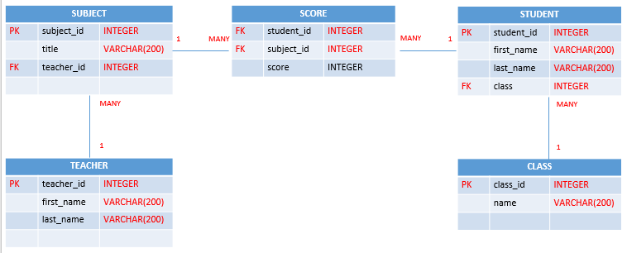

**Your Query:**

|  |
| --- |
| * **Teachers**   **CRATE table teachers(**  **teacher_id int NOT NULL primary key auto_increment,**  **first_name varchar(200),**  **last_name varchar(200)**  **);**     * **Classs**   **CREATE table classs(**  **class_id int NOT NULL primary key auto_increment,**  **name varchar(200)**  **);**   * **Subjects**   **CREATE table subjects(**  **subject_id int NOT NULL primary key auto_increment,**  **title varchar(200),**  **teacher_id int,**  **FOREIGN KEY (teacher_id) REFERENCES teachers(teacher_id)**  **);**   * **Students**   **CREATE table students(**  **student_id int NOT NULL primary key auto_increment,**  **first_name varchar(200),**  **last_name varchar(200),**  **class_id int,**  **FOREIGN KEY (class_id) REFERENCES classs(class_id)**  **);**   * **Score**   **CREATE table scores(**  **student_id int,**  **subject_id int,**  **FOREIGN KEY (student_id) REFERENCES students(student_id),**  **FOREIGN KEY (subject_id) REFERENCES subjects(subject_id)**  **);** |
|  |
|  |

# Exercise 04 (20 points) SQL Query Select

***Important****: Import database name “database_final_exam.sql” into your databasae.*

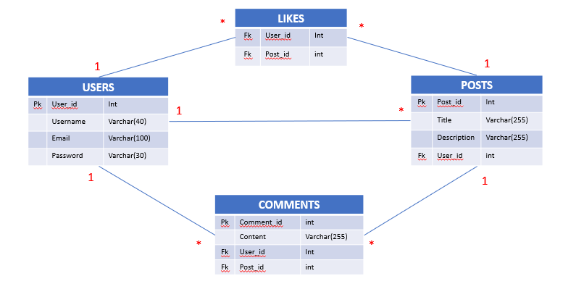

**Q1 – (10 POINTS):** Write a SQL statement to display all POSTS for the user named “**Rady Y**”

**Expected result:**

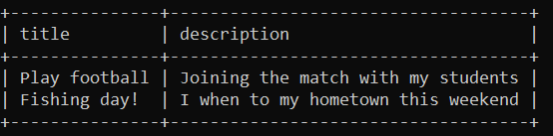

**Your Query:**

|  |
| --- |
| **SELECT title,description FROM posts**  **INNER JOIN users ON users.user_id=posts.user_id WHERE username='Rady Y';** |

**Q2 – (10 POINTS):** Write a SQL statement to display the username of who likes on many posts.

**Expected result:**

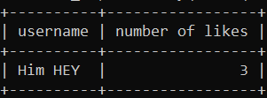

**Your Query:**

|  |
| --- |
|  |