**The Storyboard**

**Wireframe:**

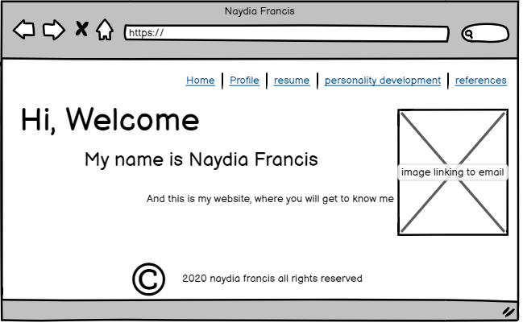

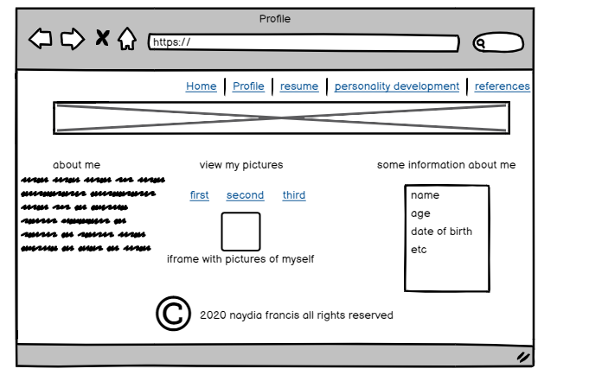

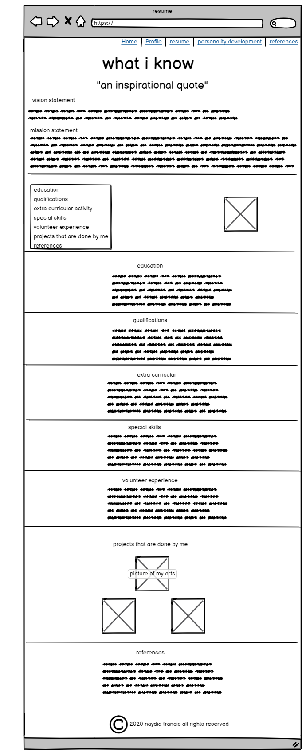

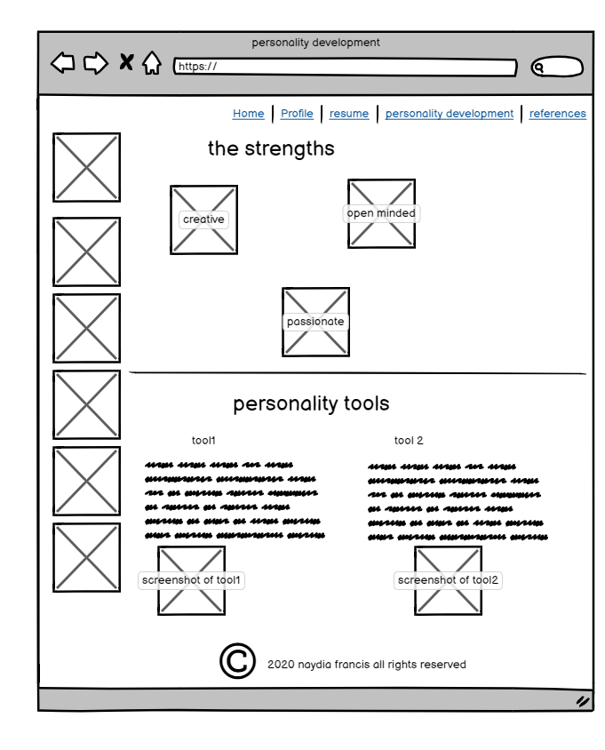

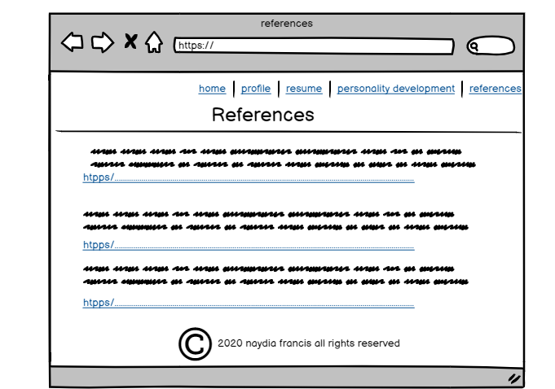

|  |  |
| --- | --- |
| **List of pages** | **Purpose** |
| Home | To introduce myself and contact information. |
| Profile | To give the audience a more personal feel to my website. |
| Resume | To layout the professional aspect of my life so far |
| Personality development | To give an analysis about my personality |
| References | To give credit to the images used and websites used |

**Themes**

Bright neon colours (pale green for navigation bar horizontal line, bright pink/fuchsia for main headings, navy blue for text, pale purple/lavender for background colour and background images that complement each other.

**Target Audience**

General Audience

**List of features used:**

* <iframes>
* Image Map
* Images
* <marquee>
* Lists
* <mailto>
* External hyperlinks
* Bookmarks