Hi Nayeam,

Can you please update it as shown below; Many Thanks.

Can you please make the image fade? I mean when I click on get in touch can you please make it appear as I click on ‘WELCOME TO OUR WORLD’ please. And please change the text colour to White without background highlights please



REGISTERED OFFICE ADDRESS:
FD PLASTIX TOOLS AND SPARES LTD
FD PLASTIX, TOOLZ & SPAREZ LTD
CAN YOU PLEASE CORRECT MY COMPANY`S NAME ? THANK YOU.
PLEASE SEE THE IMAGE BELOW:
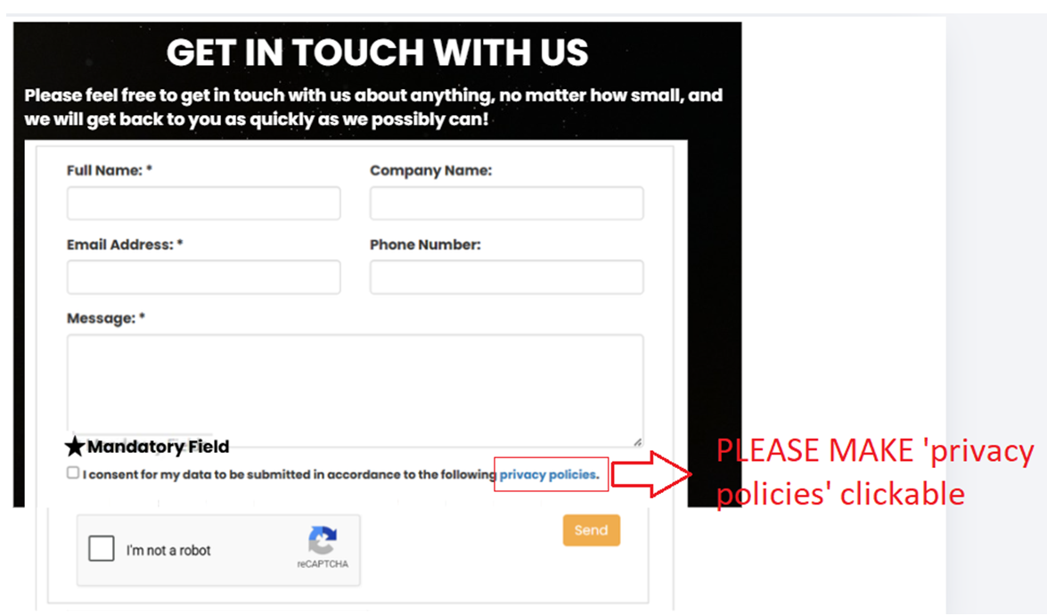
Can you please change the texts as I wrote on the image and add “*Mandatory Field” too as I did on the image please ? Thanks.
- Full Name:*
- Company Name:
- Email Address:*
- Phone Number:
- Subject:*
- Message:*
After GET IN TOUCH WITH US, PLEASE ADD THE TEXT BELOW:
Please feel free to get in touch with us about anything, no matter how small, and
we will get back to you as quickly as we possibly can!
Also, can you make “privacy policies” clickable please ?
Please leave inside of the boxes empty as shown below:
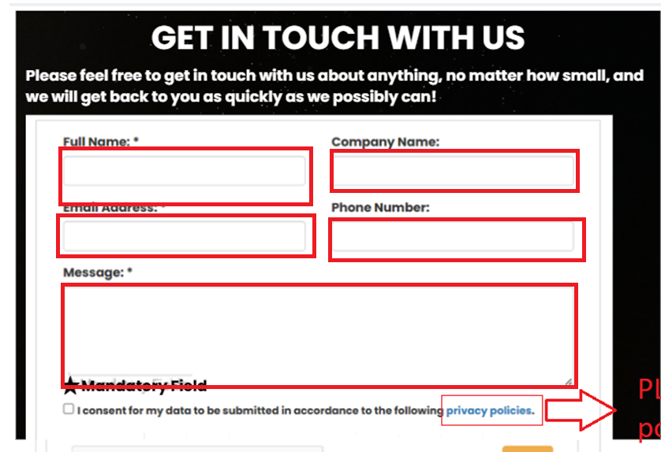

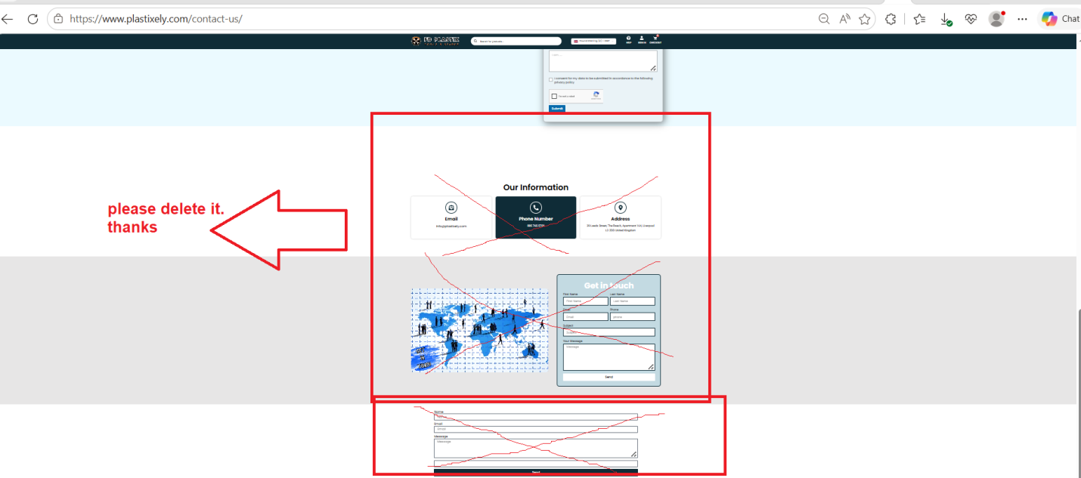
Please Delete them. Thanks.

