Assignment 02

Comparative Evaluation of Deep Transfer Learning Models for Rice Leaf Disease Classification

Course: Advance Machine Learning

Submitted by:
Name: Chowdhury Nayebul Jannath
Student ID: 22646206

Abstract
Rice leaf diseases can reduce agricultural productivity, making automated disease identification an important application of computer vision. This study evaluates four ImageNet-pretrained convolutional neural network architectures MobileNetV3-Large, EfficientNet-B0, EfficientNet-B3, and MobileNetV2 for rice leaf disease classification. Following the research direction established in Assignment 01, the models were evaluated independently on two rice leaf image datasets comprising 4,794 and 1,427 images, respectively. A consistent two-stage transfer learning strategy was employed: classifier training with frozen pretrained features, followed by partial fine-tuning. Model performance was assessed using accuracy, macro-averaged precision, recall and F1-score, and multiclass one-vs-rest macro ROC-AUC.
Across eight completed evaluations, MobileNetV3-Large achieved the highest observed test accuracy and macro-F1 on both datasets. On Dataset 1, it obtained 99.71% accuracy and 99.71% macro-F1; on Dataset 2, it achieved 91.59% accuracy and 92.22% macro-F1. EfficientNet-B3 ranked second by macro-F1 on both datasets.

1. Introduction
Rice is an important food crop, and diseases affecting its leaves can adversely influence crop health and agricultural productivity. Visual identification of leaf diseases may require specialist expertise and can be affected by similarities in disease symptoms. Deep learning provides a practical approach for extracting image features and classifying disease categories.
Transfer learning is especially relevant when task-specific agricultural image datasets are relatively small. Models pretrained on large-scale image collections can provide useful feature representations that are adapted to the target classification problem.
Assignment 01 reviewed research on deep transfer learning for rice leaf disease classification, covering convolutional neural networks, lightweight architectures, feature-fusion approaches, and other recent methods. Building on that review, Assignment 02 moves from literature analysis to implementation and comparative experimentation.
The objective of this study is to implement and evaluate four relevant pretrained convolutional architectures using a consistent experimental procedure across two independent datasets.
The specific objectives are:
- Implement MobileNetV3-Large, EfficientNet-B0, EfficientNet-B3, and MobileNetV2 for four-class rice leaf image classification.
- Evaluate each model independently on two relevant datasets.
- Apply a common two-stage transfer learning and fine-tuning procedure.
- Compare accuracy, macro precision, macro recall, macro-F1, and macro one-vs-rest ROC-AUC.
- Analyze training behavior, classification errors, and dataset-integrity limitations.

2. Related Work and Model Selection
Assignment 01 reviewed recent deep transfer learning approaches for rice leaf disease classification, highlighting the effectiveness of MobileNet and EfficientNet architectures. Based on their relevance to previous research, computational efficiency, and suitability for comparative evaluation, four models were selected:
- MobileNetV3-Large: Selected for its efficient architecture and strong performance potential, offering a balance between classification accuracy and computational cost.
- EfficientNet-B0: Selected as a lightweight EfficientNet baseline to evaluate whether a compact architecture can achieve competitive classification performance.
- EfficientNet-B3: Selected to investigate whether a larger, more capable EfficientNet architecture improves classification performance compared with EfficientNet-B0.
- MobileNetV2: Selected as an established lightweight baseline using depthwise separable convolutions and inverted residual blocks, enabling comparison with the newer MobileNetV3-Large.
These four models provide a meaningful comparison of lightweight versus larger architectures, different model generations, and computational efficiency versus classification performance. All were evaluated on the same two datasets using a consistent experimental protocol, ensuring a fair comparison within each dataset.

3. Datasets
Two rice leaf image datasets were used to evaluate the four selected deep transfer learning models. Each dataset contains four classes and was divided into training, validation, and test sets.

3.1 Dataset 1
Dataset 1 consists of 4,794 rice leaf images distributed across four disease classes: Bacterialblight, Blast, Brownspot, and Tungro.

3.2 Dataset 2
Dataset 2 contains 1,427 rice leaf images covering four categories: Bacterial Leaf Blight, Brown Spot, Healthy Leaf, and Tungro Virus.

3.3 Dataset Distribution
Training, validation, and test image distribution
Partition | Dataset 1 | Dataset 2
Training | 3,372 | 999
Validation | 739 | 214
Test | 683 | 214
Total | 4,794 | 1,427
Although both datasets contain rice leaf images, their class definitions are not identical. Therefore, each model was trained and evaluated independently on each dataset using its respective class labels. The same recorded data partitions were maintained across all four models within each dataset to ensure consistent experimental comparisons.

4. Experimental Methodology

4.1 Data Preprocessing and Augmentation
All images were converted to RGB format and resized to 224 × 224 pixels. ImageNet normalization was applied using mean values of (0.485, 0.456, 0.406) and standard deviations of (0.229, 0.224, 0.225).
To improve generalization, training images were augmented using random horizontal and vertical flips, rotations of up to 15°, and slight brightness and contrast adjustments. Validation and test images underwent resizing and normalization only, without random augmentation.

4.2 Model Initialization and Adaptation
Four pretrained architectures MobileNetV3-Large, EfficientNet-B0, EfficientNet-B3, and MobileNetV2 were initialized with ImageNet weights. Their classification layers were modified to predict the four classes of each dataset.
Each architecture was independently initialized and trained on both datasets, resulting in eight experiments. The experiments adapted established pretrained architectures rather than introducing new network designs.

4.3 Training Configuration
All eight experiments followed a consistent two-stage transfer learning strategy.
Training configuration for the two-stage approach
Parameter | Stage A: Feature Extraction | Stage B: Fine-Tuning
Training objective | Train classifier | Fine-tune later feature layers
Epochs | 5 | 3
Batch size | 32 | 32
Optimizer | Adam | Adam
Learning rate | 0.0001 | 0.00001
Loss function | Cross-entropy | Cross-entropy
Input size | 224 × 224 | 224 × 224
In Stage A, pretrained feature-extraction layers were frozen, and only the newly adapted classification head was trained. In Stage B, selected later feature-extraction layers were unfrozen to refine the pretrained representations. Batch-normalization running statistics were kept fixed during fine-tuning.
All experiments used a random seed of 42 and were implemented in PyTorch using a Kaggle GPU environment. The best model checkpoints were selected based on validation macro-F1, while the test sets were reserved for final evaluation.

4.4 Performance Evaluation
Five evaluation metrics were used to assess classification performance:
- Accuracy: Proportion of correctly classified images.
- Macro Precision: Average class-wise precision, giving equal weight to each class.
- Macro Recall: Average class-wise recall, giving equal weight to each class.
- Macro-F1 Score: Average of the F1-scores calculated independently for each class.
- Macro ROC-AUC (One-vs-Rest): Average of class-wise ROC-AUC scores using predicted probabilities.
Macro-averaged metrics were selected to provide balanced evaluation across classes, regardless of differences in class frequencies.

5. Experimental Results

5.1 Dataset 1
Model | Accuracy | Precision | Recall | F1 | AUC
MobileNetV3-Large | 0.9971 | 0.9976 | 0.9965 | 0.9971 | 1.0000
EfficientNet-B0 | 0.9854 | 0.9849 | 0.9844 | 0.9846 | 0.9989
EfficientNet-B3 | 0.9883 | 0.9875 | 0.9875 | 0.9875 | 0.9992
MobileNetV2 | 0.9722 | 0.9710 | 0.9734 | 0.9720 | 0.9986
Note: AUC is rounded to four decimal places; a displayed value of 1.0000 does not necessarily indicate an exact underlying AUC of 1.
MobileNetV3-Large achieved the highest observed accuracy and macro-F1 on Dataset 1, correctly classifying 681 of 683 test images. EfficientNet-B3 ranked second by macro-F1, followed by EfficientNet-B0 and MobileNetV2.
All four architectures produced high values on the original Dataset 1 test split. These results must nevertheless be considered alongside the dataset-integrity findings discussed below.
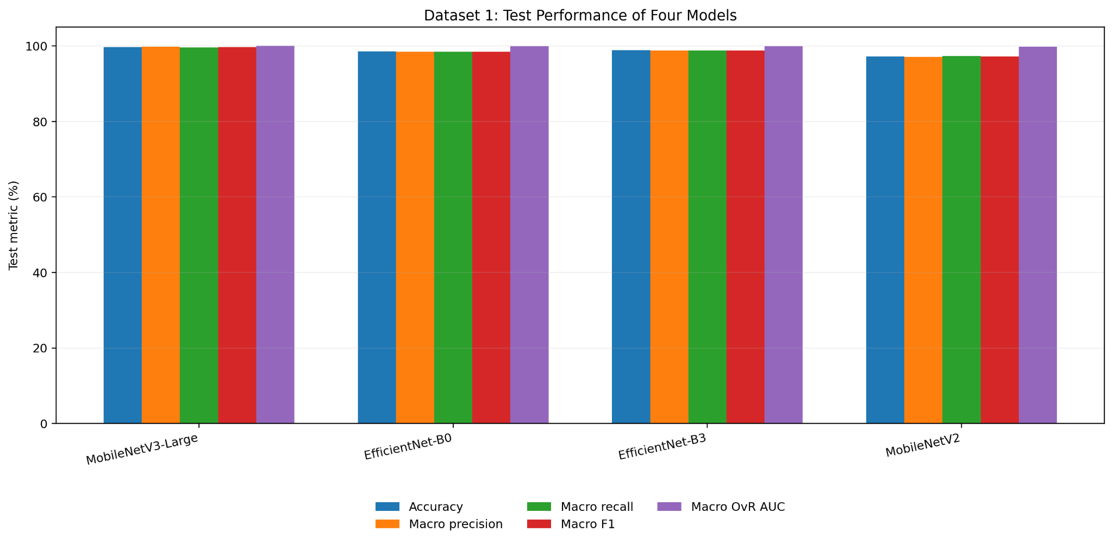
Figure 1: Dataset 1 five-metric model comparison

5.2 Dataset 2
Model | Accuracy | Precision | Recall | F1 | AUC
MobileNetV3-Large | 0.9159 | 0.9211 | 0.9235 | 0.9222 | 0.9851
EfficientNet-B0 | 0.8411 | 0.8693 | 0.8601 | 0.8569 | 0.9701
EfficientNet-B3 | 0.8785 | 0.8929 | 0.8788 | 0.8852 | 0.9748
MobileNetV2 | 0.8692 | 0.8835 | 0.8802 | 0.8795 | 0.9737
MobileNetV3-Large again recorded the highest accuracy and macro-F1, correctly classifying 196 of 214 test images. EfficientNet-B3 ranked second by macro-F1, while MobileNetV2 outperformed EfficientNet-B0 on this dataset.
The models achieved lower observed performance on Dataset 2 than on Dataset 1. Because the datasets differ in class definitions, sample composition, and image sources, this difference cannot be attributed to dataset difficulty alone.
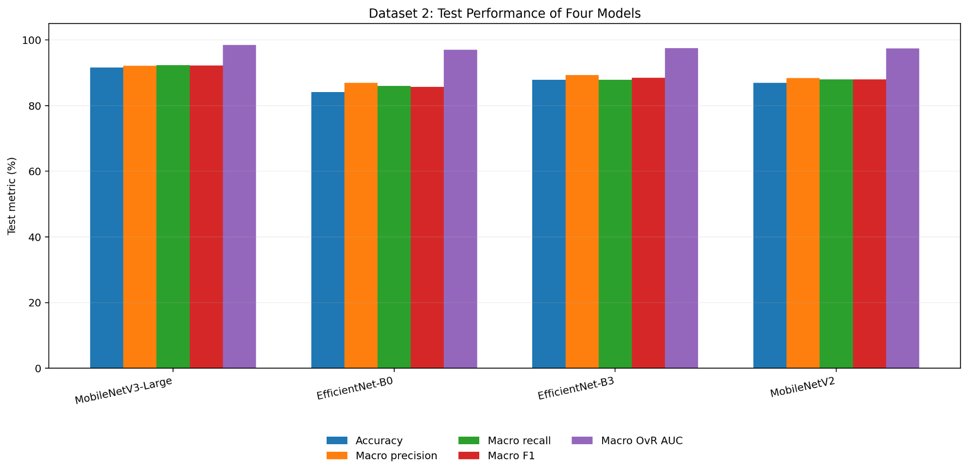
Figure 2: Dataset 2 five-metric model comparison

5.3 Cross-dataset comparison
MobileNetV3-Large achieved the highest observed accuracy and macro-F1 in both independently conducted dataset evaluations. EfficientNet-B3 achieved the second-highest macro-F1 in both datasets.
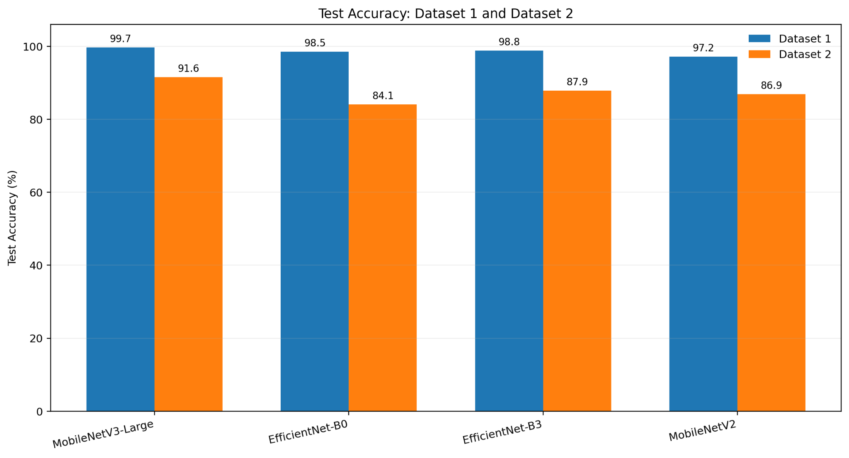
Figure 3: Accuracy comparison

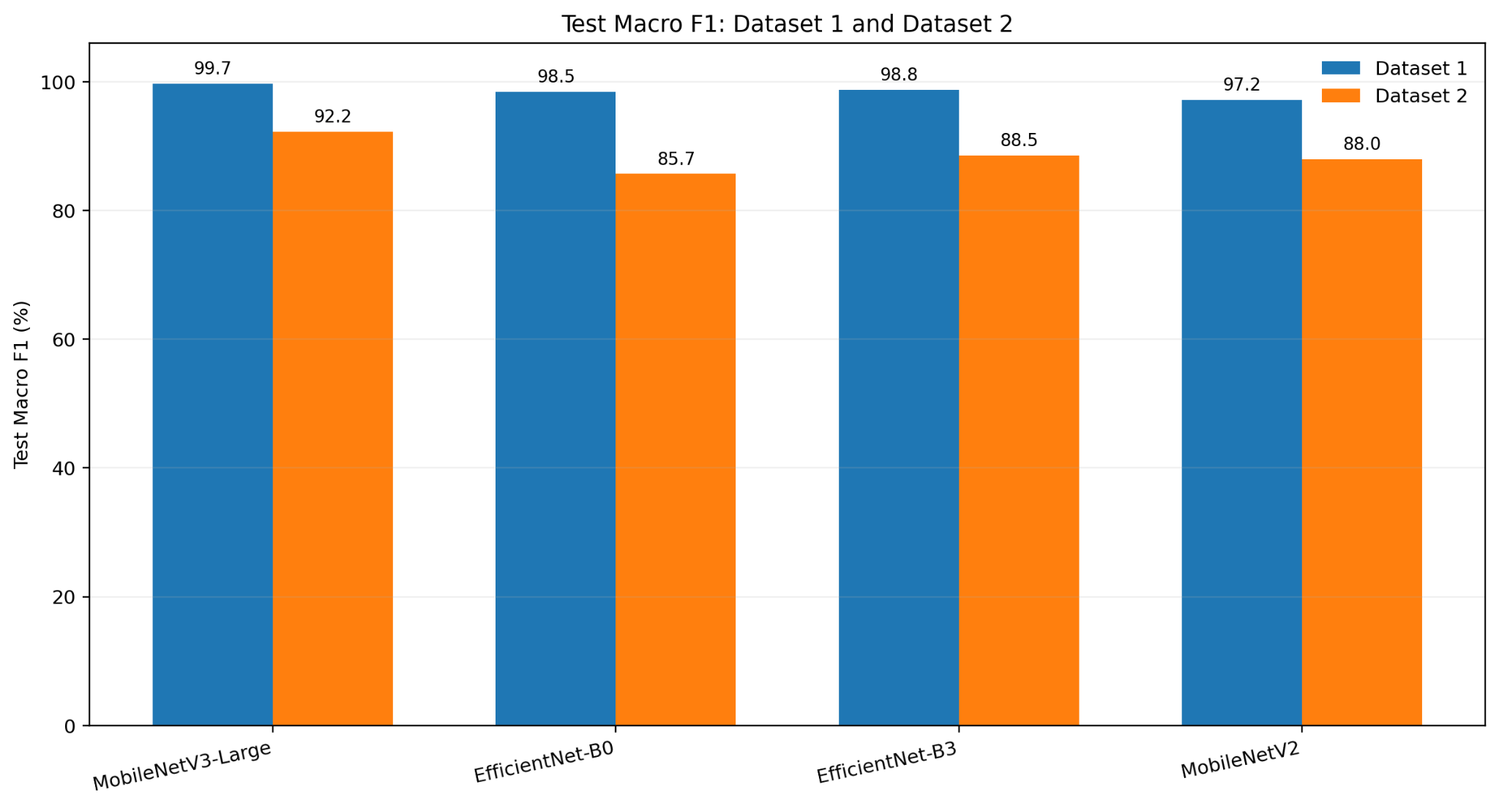
Figure 4: Macro-F1 comparison
These figures summarize the results from the original test partitions. They are descriptive comparisons between separate tasks and should not be interpreted as a controlled cross-domain generalization experiment.

6. Training and Validation Analysis
Each experiment produced training histories containing five Stage A epochs and three Stage B epochs.
The recorded learning curves generally showed decreasing training and validation losses, accompanied by improving accuracy and macro-F1. The transition to partial fine-tuning was associated with further improvement in validation performance.

6.1 Final-epoch Stage B validation results

Model | Dataset 1 validation F1 | Dataset 2 validation F1
MobileNetV3-Large | 0.9892 | 0.9149
EfficientNet-B0 | 0.9779 | 0.8502
EfficientNet-B3 | 0.9875 | 0.8636
MobileNetV2 | 0.9765 | 0.8567

These values describe the final recorded Stage B epochs. They are not necessarily identical to the best validation metrics used to select model checkpoints.

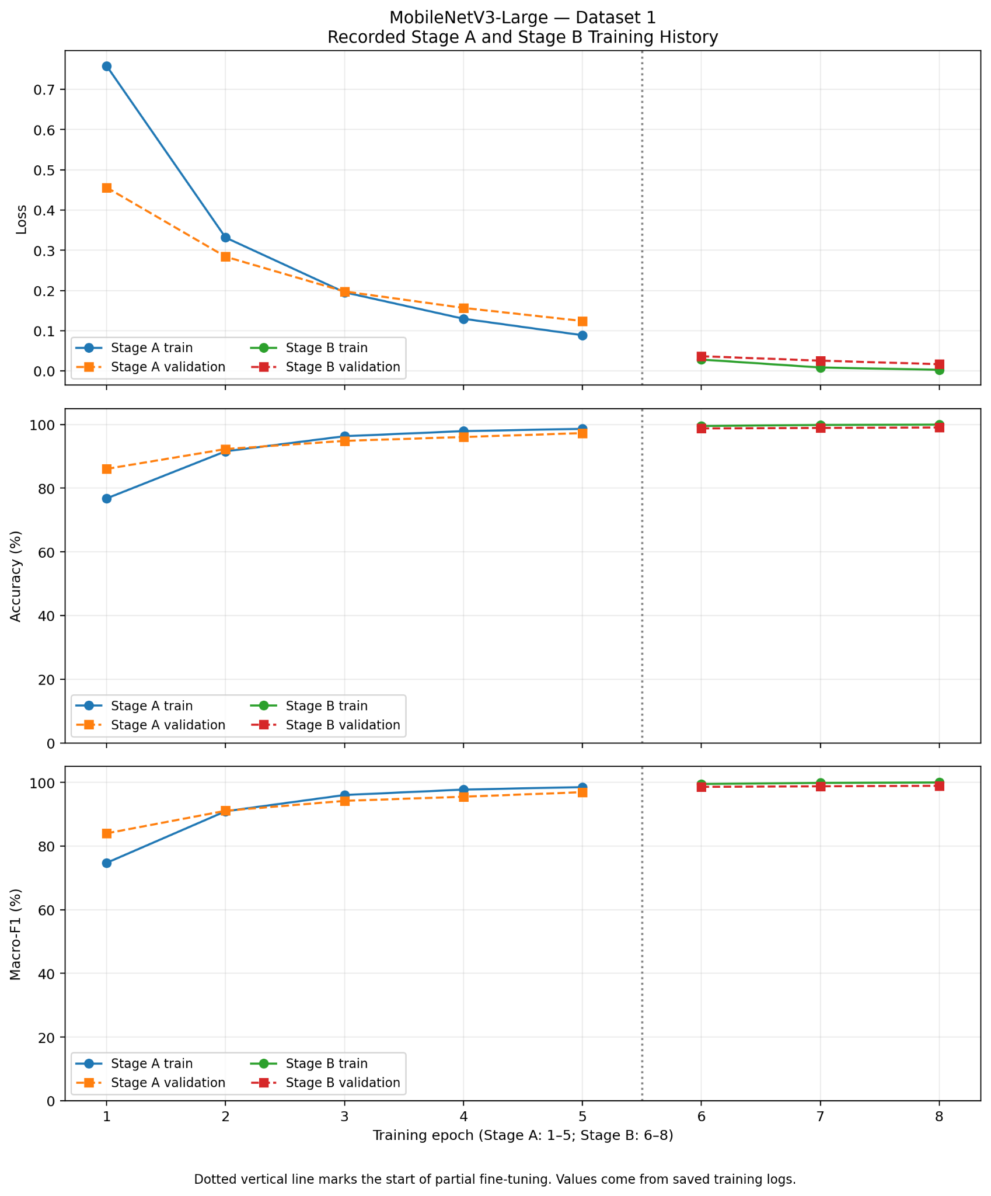 | 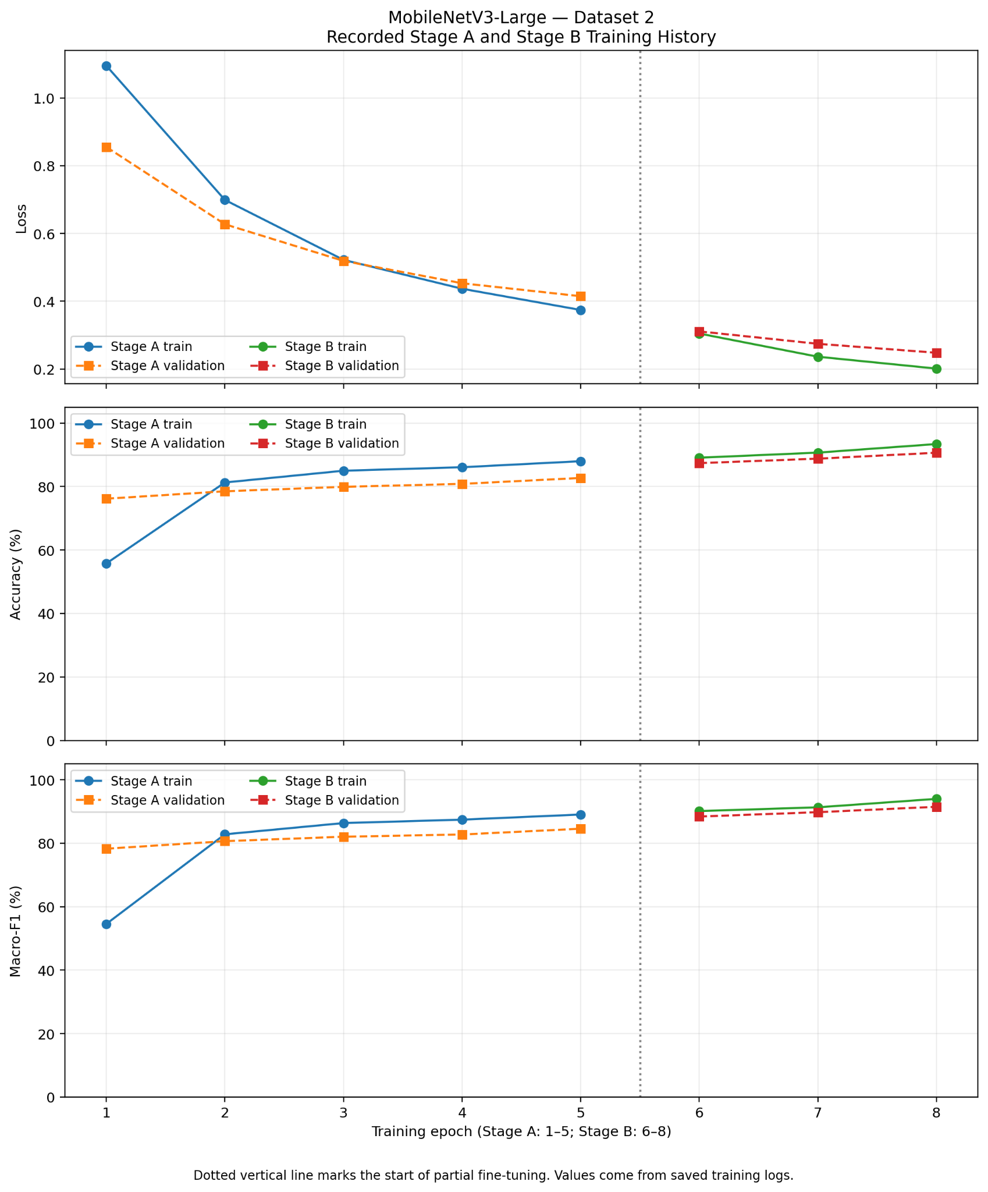
MobileNetV3-Large, Dataset 1 learning curves | MobileNetV3-Large, Dataset 2 learning curves
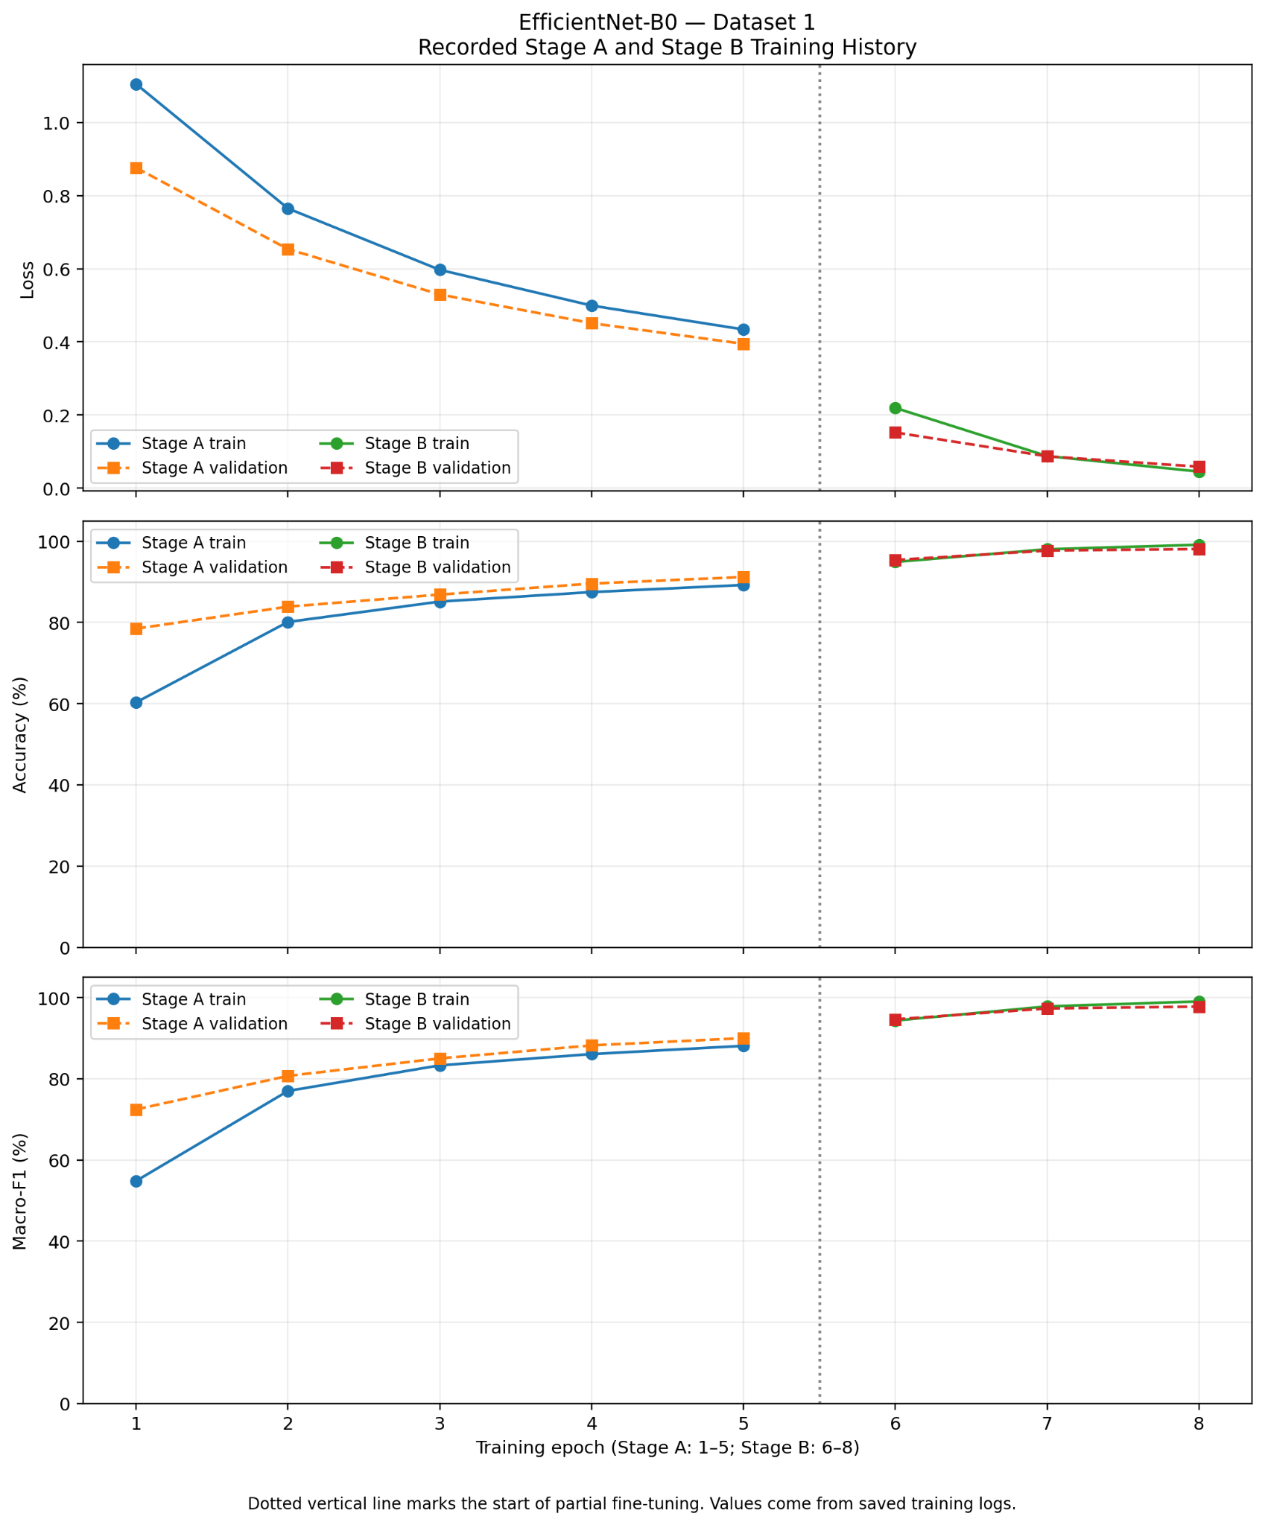 | 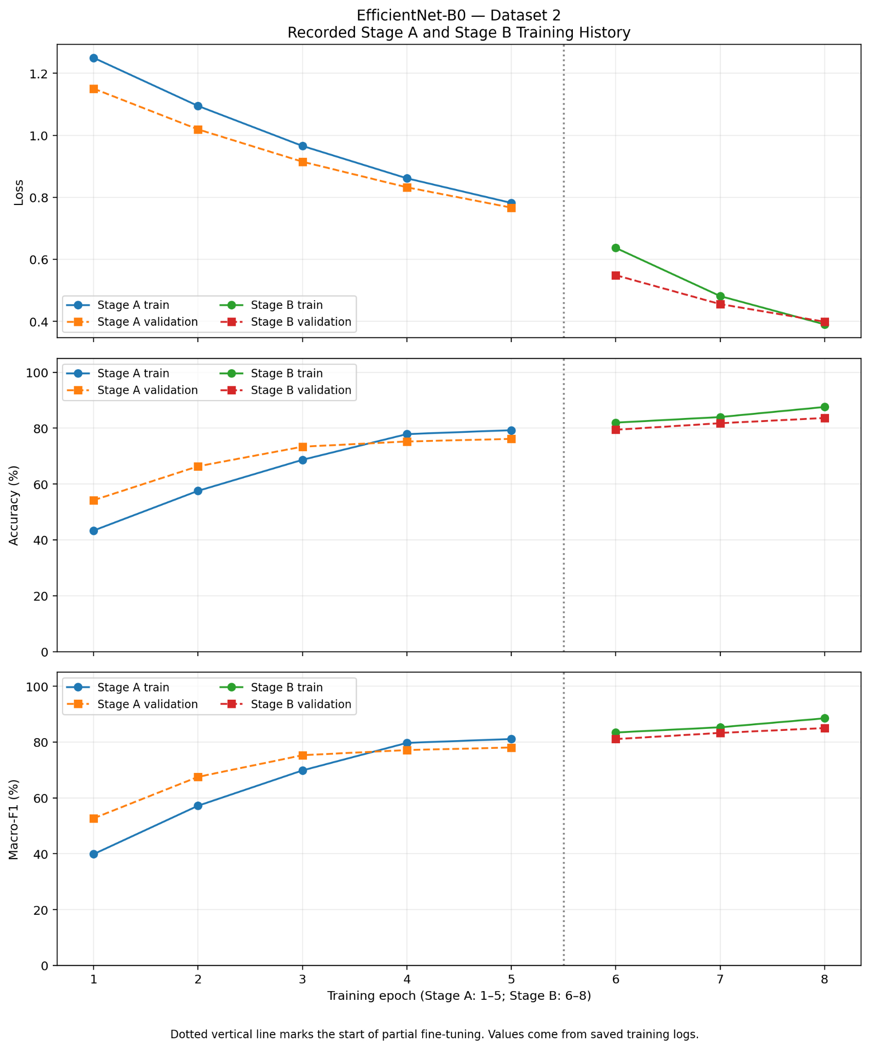
EfficientNet-B0, Dataset 1 learning curves | EfficientNet-B0, Dataset 2 learning curves
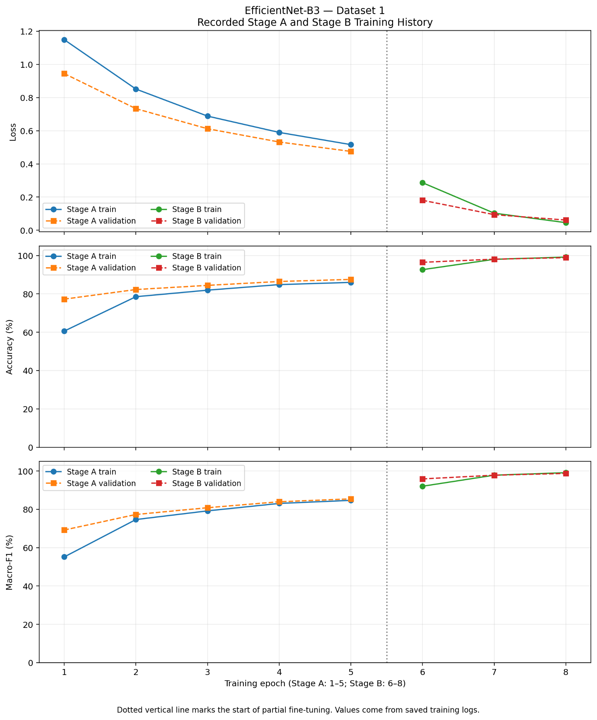 | 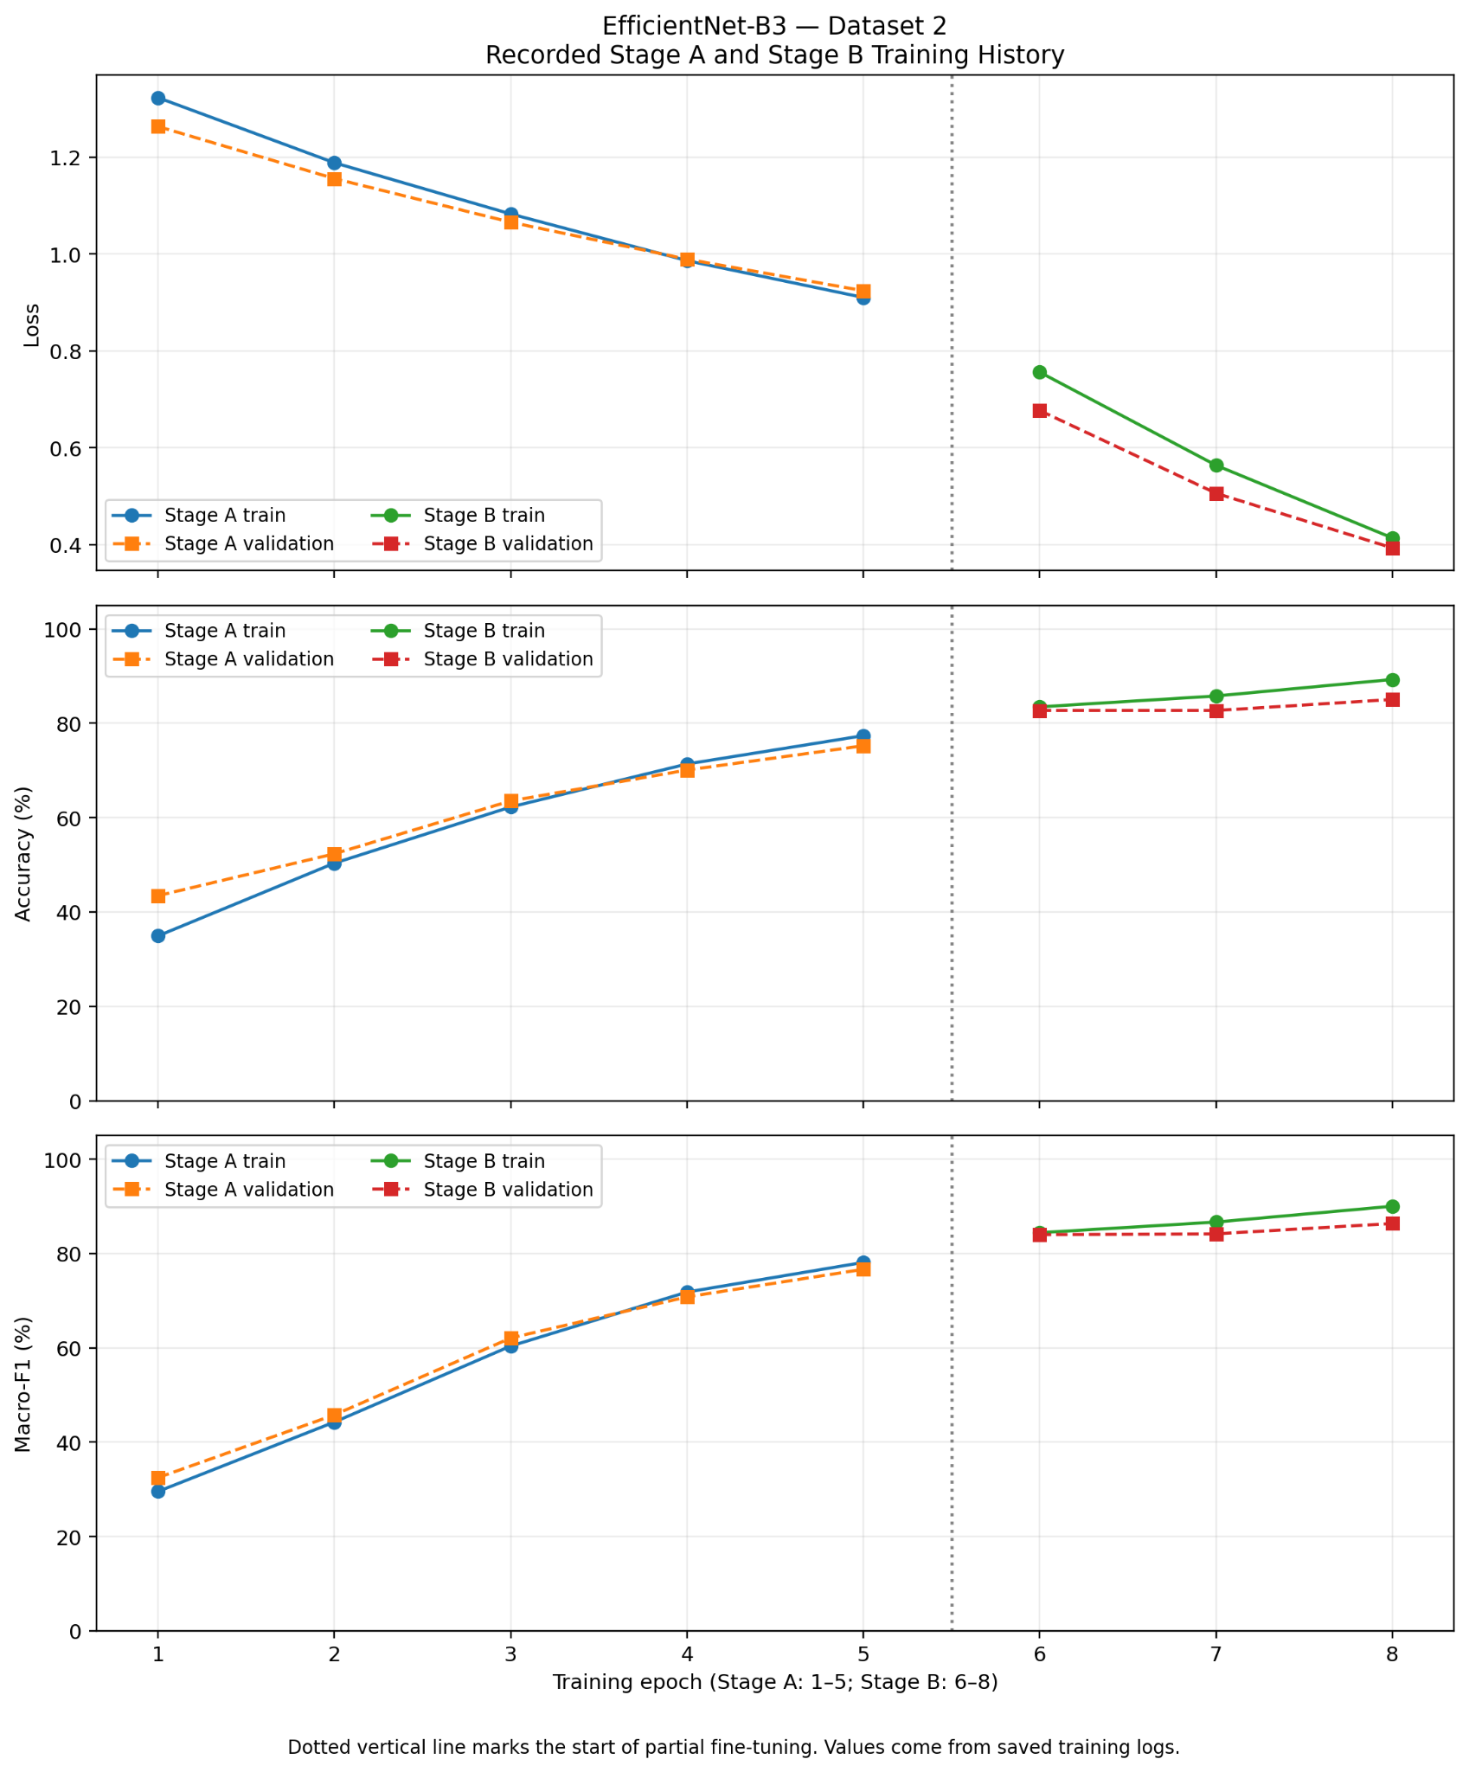
EfficientNet-B3, Dataset 1 learning curves | EfficientNet-B3, Dataset 2 learning curves
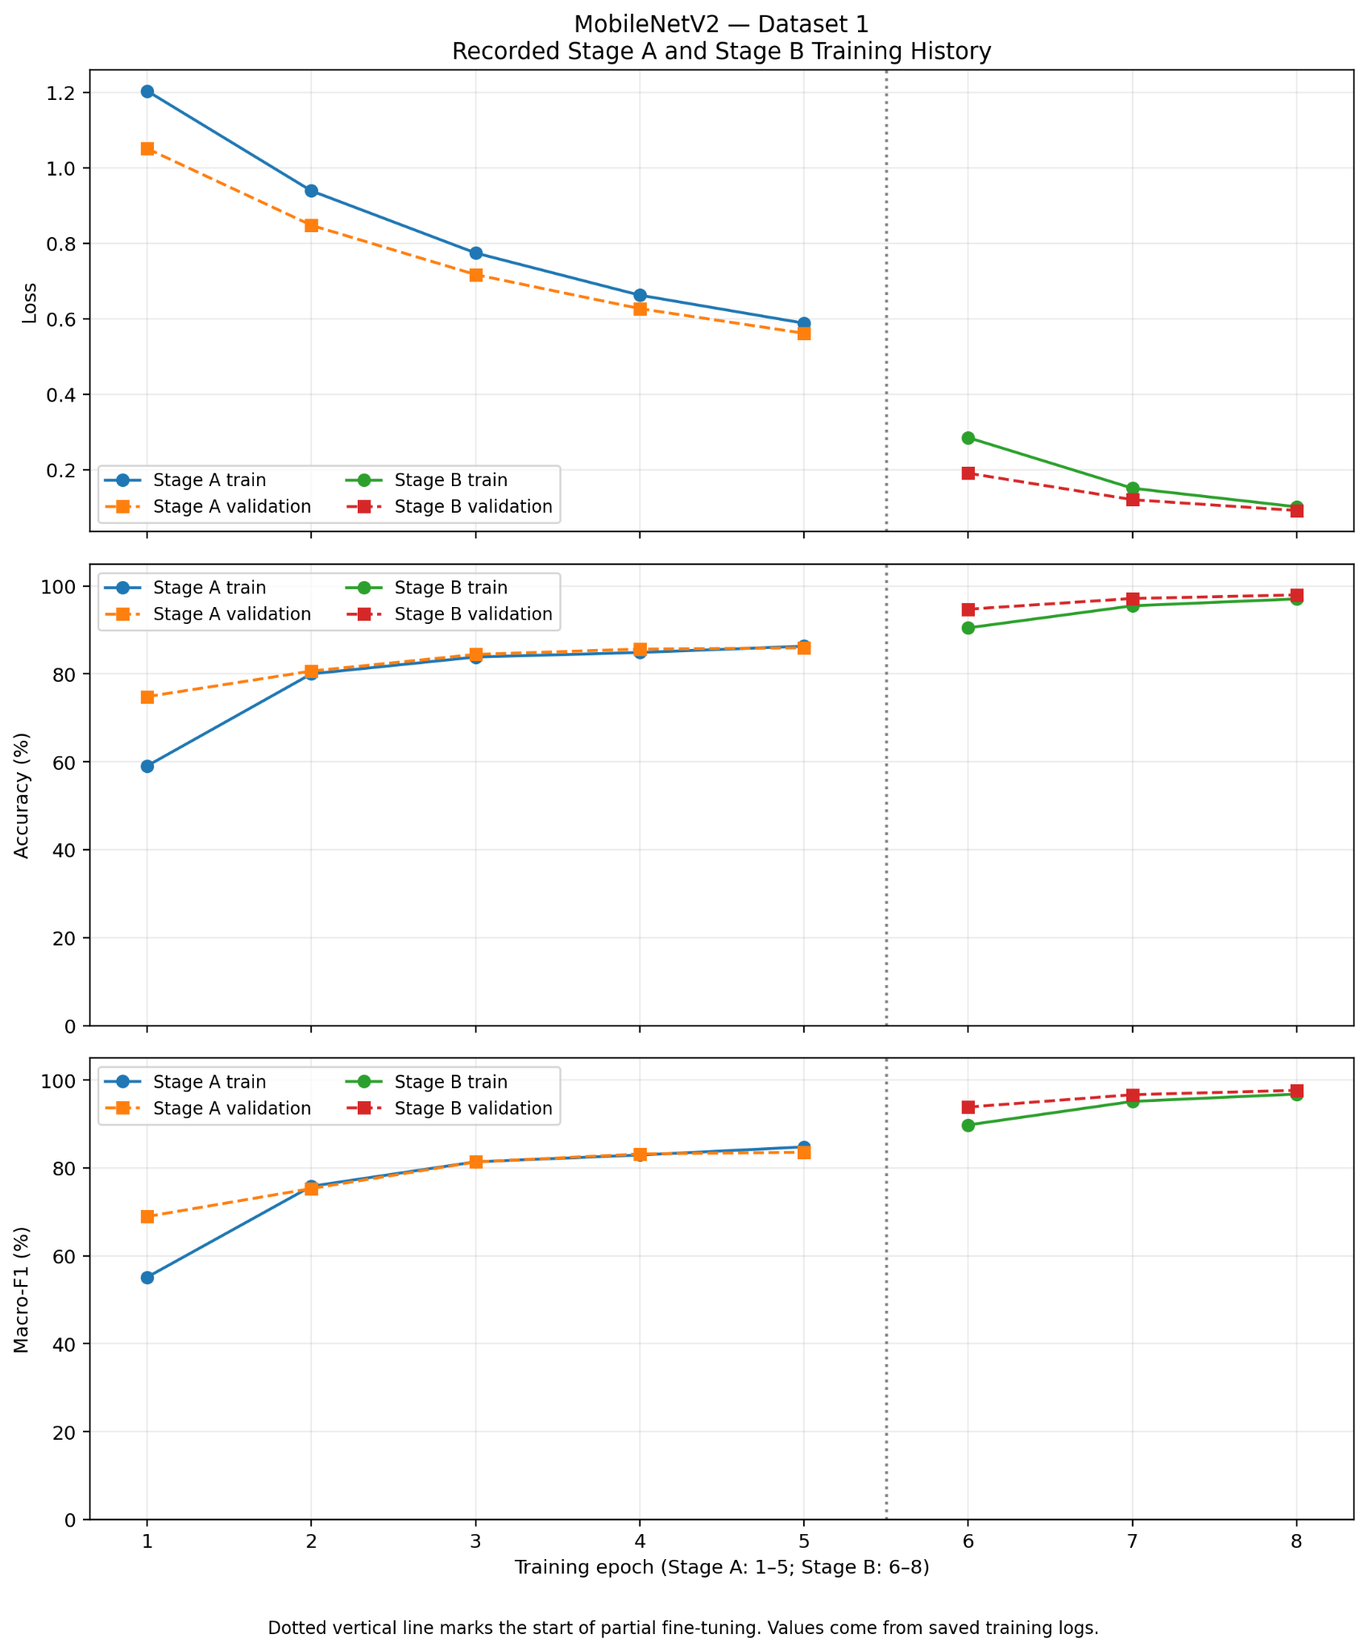 | 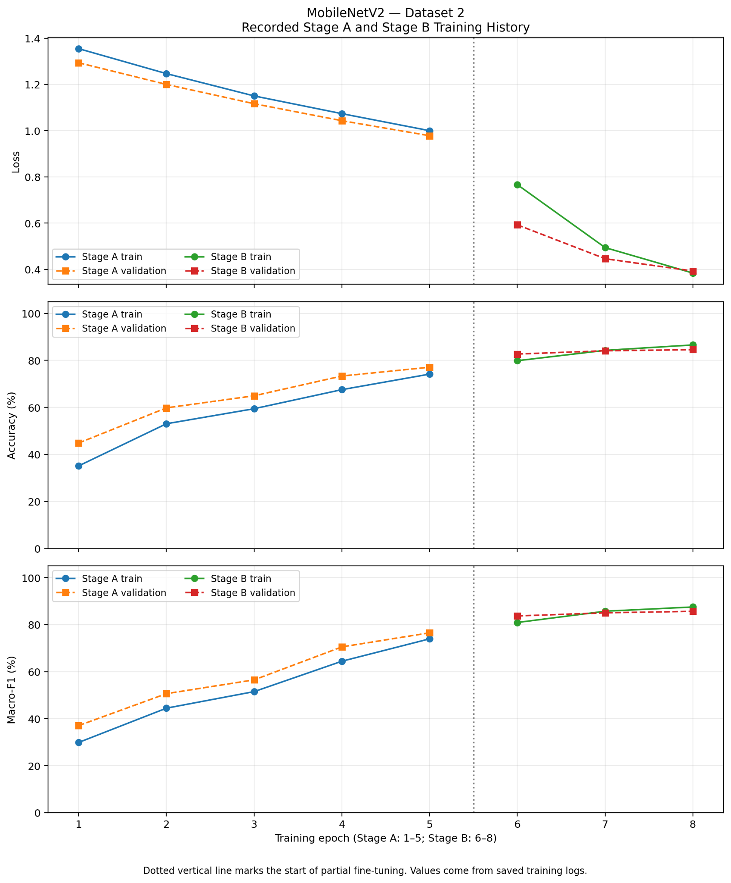
MobileNetV2, Dataset 1 learning curves | MobileNetV2, Dataset 2 learning curves

7. Dataset Integrity and Study Limitations
A dataset-integrity analysis was conducted to assess potential duplication across the training, validation, and test partitions. A total of 6,221 images from both datasets were examined using SHA-256 cryptographic hashing. Each image was assigned a unique hash value, allowing the identification of byte-identical files. The analysis confirmed that all 6,221 images had distinct SHA-256 hashes, with no exact duplicate files detected across the datasets or data partitions. This verification provides evidence of file-level uniqueness.

8. Conclusion
This study implemented and evaluated four pretrained convolutional architectures for rice leaf disease classification on two independently assessed datasets. All eight selected experiments were completed using a consistent two-stage transfer learning framework.
MobileNetV3-Large achieved the highest observed accuracy and macro-F1 on both original test sets, followed by EfficientNet-B3 in macro-F1 ranking. The recorded training histories support the usefulness of staged classifier adaptation and partial fine-tuning in the experimental setting.
The results demonstrate the potential of deep transfer learning for rice leaf disease classification, while the dataset-integrity analysis highlights the need for stronger controls against related images appearing across evaluation partitions.

References
[1] A. N. Abiyyu and M. Rahardi, “Comparison of transfer learning models MobileNetV3-Large and EfficientNet-B0 for rice leaf disease classification,” Journal of Applied Informatics and Computing, vol. 10, no. 1, pp. 818–828, 2026. doi: 10.30871/jaic.v10i1.12033.
[2] V. Samanthula, N. Adithya Valli, S. Sirojiddin, M. Ruzieva, S. Atajanova, and B. Venkataramanaiah, “Smart agriculture: Rice leaf disease prediction and classification using transfer learning and deep learning,” in Proc. 2026 6th International Conference on Inventive Computation and Information Technologies (ICICIT), IEEE, 2026, pp. 1216–1221. doi: 10.1109/ICICIT69063.2026.11634087.
[3] N. S. Sukanya, V. Asha, M. T. Vasumathi, S. Singh, S. Trivedi, and S. M. Mundaragi, “Rice leaf disease classification using EfficientNet and transfer learning,” in Proc. 2026 6th International Conference on Image Processing and Capsule Networks (ICIPCN), IEEE, 2026, pp. 416–420. doi: 10.1109/ICIPCN67432.2026.11439007.
[4] L. Mohammed and A. A. Abdullahi, “A lightweight transfer learning framework for rice leaf disease detection using MobileNetV2: Baseline study and performance evaluation,” Current Research Bulletin, vol. 3, no. 6, pp. 182–190, 2026. doi: 10.55677/CRB/I6-01-CRB2026.
[5] A. Prashanth, Nafiza, and K. Sukanya, “Rice leaf diseases classification using CNN with transfer learning,” in Proc. 2025 3rd International Conference on Advances in Computation, Communication and Information Technology (ICAICCIT), IEEE, 2025, pp. 148–153. doi: 10.1109/ICAICCIT68829.2025.11434428.
[6] W. Aslam, K. Sana, F. Irfan, and A. Dilawari, “Rice leaf disease detection using MobileNetV2 transfer learning: Comparative study on small and large-scale datasets with Stream-lit deployment,” in Proc. 2025 IEEE 19th International Conference on Open Source Systems and Technologies (ICOSST), IEEE, 2025. doi: 10.1109/ICOSST69113.2025.11315468.
[13] P. K. Sethy, “Rice Leaf Disease Image Samples,” Mendeley Data, Version 2, 2024. doi: 10.17632/fwcj7stb8r.2.
[14] S. A. Rimi and M. J. U. Chowdhury, “RiceLeafBD: A Real-Field Image Dataset for Rice Leaf Disease Detection and Classification in Bangladesh,” Mendeley Data, Version 1, 2025. doi: 10.17632/kx9rx8p2mz.1.

