Modulation is the process of varying one or more parameters(amplitude, frequency or Phase) of a carrier signal in accordance with the instantaneous values of the message signal.

The message signal is the signal which is being transmitted for communication and the carrier signal is a high frequency signal which has no data, but is used for long distance transmission.
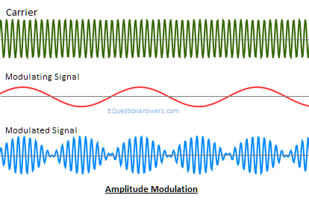
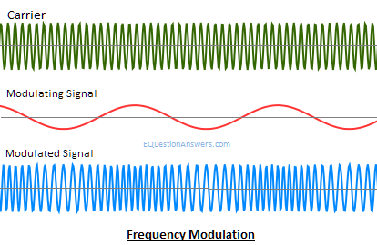
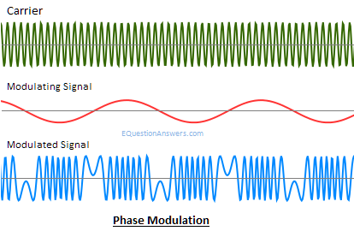

Digital Modulation is defined as changing the amplitude, frequency or phase (or some characteristics) of the carrier signal with respect to the modulating signal which is binary information or digital signal.
So, in analog modulation modulating signal or message signal is of analog nature and in digital modulation modulating signal or message signal is of digital nature.
Distinguish between Digital modulation & Analog modulation.
Ans: Digital modulation offers many advantages over analog modulation. Some advantages include greater noise immunity and robustness to channel impairments, easier multiplexing of various forms of information (e.g., voice, data, and video), and greater security. Furthermore, digital transmissions accommodate digital error-control codes which detect and/or correct transmission errors, and support complex signal conditioning and processing techniques such as source coding, encryption, and equalization to improve the performance of the overall communication link.

What factor influence the choice of digital modulation.
Ans: Several factors influence the choice of a digital modulation scheme. A desirable modulation scheme provides low bit error rates at low received signal-to-noise ratios, performs well in multipath and fading conditions, occupies a minimum of bandwidth, and is easy and cost-effective to implement.
The performance of a modulation scheme is often measured in terms of its power efficiency and bandwidth efficiency. Power efficiency describes the ability of a modulation technique to preserve the fidelity of the digital message at low power levels. In a digital communication system, in order to increase noise immunity, it is necessary to increase the signal power.
Bandwidth efficiency describes the ability of a modulation scheme to accommodate data within a limited bandwidth. In general, increasing the data rate implies decreasing the pulse width of a digital symbol, which increases the bandwidth of the signal.

What is linear modulation technique.
Ans: In linear modulation techniques, the amplitude of the transmitted signal, s(t), varies linearly with the modulating digital signal, m(t). Linear modulation techniques are bandwidth efficient and hence are very attractive for use in wireless communication systems where there is an increasing demand to accommodate more and more users within a limited spectrum.
In a linear modulation scheme, the transmitted signal s (t) can be expressed as

where A is the amplitude, 4 is the carrier frequency, and m(t) = m_{R}(t)+jm_{I}(t) is a complex envelope representation of the modulated signal which is in general complex form. From equation (5.65), it is clear that the amplitude of the carrier varies linearly with the modulating signal. Linear modulation schemes, in general, do not have a constant envelope. The most popular linear modulation techniques include pulse-shaped QPSK, OQPSK, and Π/4 QPSK.

What is BPSK? Explain BPSK Receiver.
Ans: Binary Phase Shift Keying (BPSK): In binary phase shift keying (BPSK), the phase of a constant amplitude carrier signal is switched between two values according to the two possible signals m₁ and m₂ corresponding to binary 1 and 0, respectively. Normally, the two phases are separated by 180°. If the sinusoidal carrier has an amplitude A_{C} and energy per bit
E_{b} =1/2A_{c}T_{b} then the transmitted BPSK signal is either
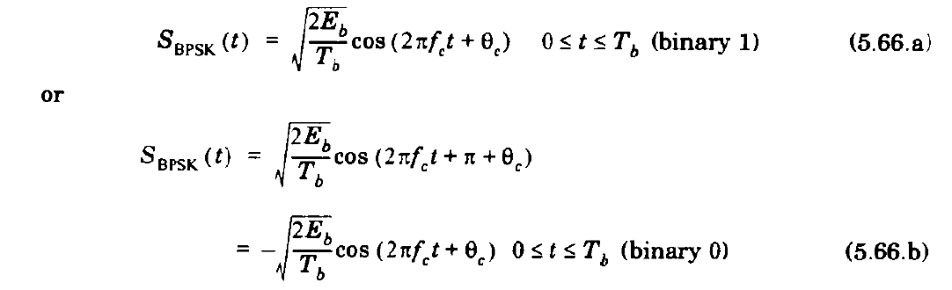

It is often convenient to generalize m₁ and m₂ as a binary data signal m(t), which takes on one of two possible pulse shapes. Then the transmitted signal may be represented as
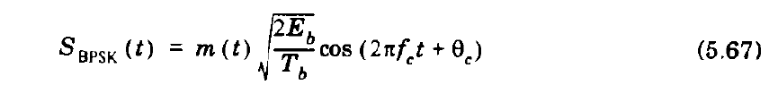

BPSK Receiver
If no multipath impairments are induced by the channel, the received BPSK signal be expressed as
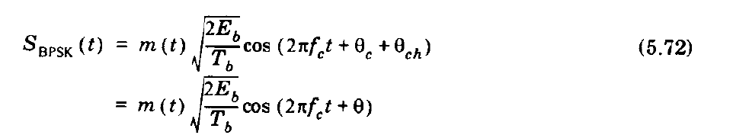
where Ɵ_{ch} is the phase shift corresponding to the time delay in the channel. If a low level pilot carrier signal is transmitted along with the BPSK signal, then the carrier phase and frequency may be recovered at the receiver using a phase locked loop (PLL). Figure 5.23 shows the block diagram of a BPSK receiver along with the carrier recovery circuits.
The received signal cos(2∏f_{c}t +Ɵ) is squared to generate a dc signal and an amplitude varying sinusoid at twice the carrier frequency. The de signal is filtered out using a bandpass filter with center frequency tuned to 2f_{c} . A frequency divider is then used to recreate the waveform cos(2∏f_{c}t +Ɵ). The output of the multiplier after the frequency divider is given by
This signal is applied to an integrate and dump circuit which forms the low pass filter segment of a BPSK detector. If the transmitter and receiver pulse shapes are matched, then the detection will be optimum. A bit synchronizer is used to facilitate sampling of the integrator output precisely at the end of each bit period.

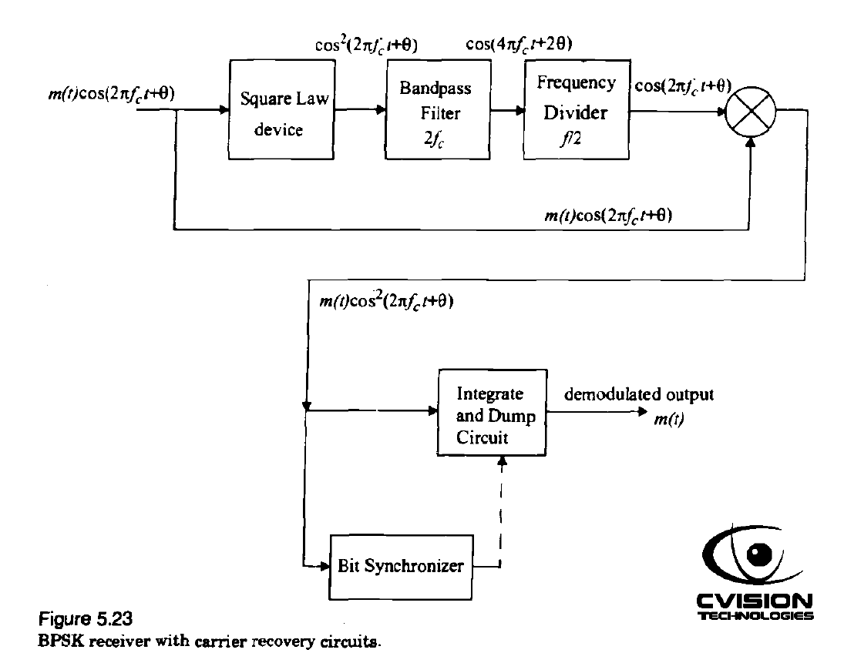

Depending on whether the integrator output is above or below a certain threshold, the decision circuit decides that the received signal corresponds to a binary 1 or 0. If it is equally likely that a binary 1 or 0 is transmitted, then the voltage level corresponding to the midpoint between the detector output voltage levels of binary 1 and 0 is used as the optimum threshold.

Explain DPSK transmitter & receiver with block diagram.
Ans: Differential Phase Shift Keying (DPSK): Differential PSK is a noncoherent form of phase shift keying which avoids the need for a coherent reference signal at the receiver. Noncoherent receivers are easy and cheap to build, and hence are widely used in wireless communications. In DPSK systems, the input binary sequence is first differentially encoded and then modulated using a BPSK modulator. The differentially encoded sequence { dk} is generated from the input binary sequence {m_{k} }. The effect is to leave the symbol d_{k} unchanged from the previous symbol if the incoming binary symbol m_{k} is 1, and to toggle d_{k} if m_{k} is 0.
A block diagram of a DPSK transmitter is shown in Figure 5.24. It consists of a one bit delay element and a logic circuit interconnected so as to generate the differentially encoded sequence from the input binary sequence. The output is passed through a product modulator to obtain the DPSK signal. At the receiver, the original sequence is recovered from the demodulated differentially encoded signal through a complementary process, as shown in Figure 5.25.
While DPSK signaling has the advantage of reduced receiver complexity, its energy efficiency is inferior to that of coherent PSK by about 3 dB. The average probability of error for DPSK in additive white Gaussian noise is given by
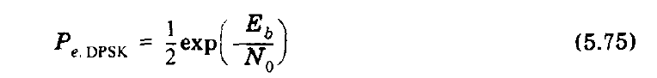
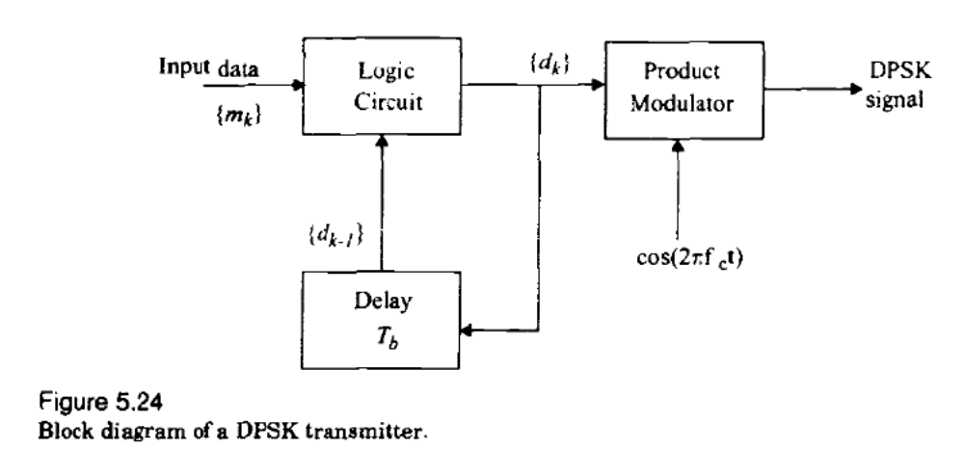
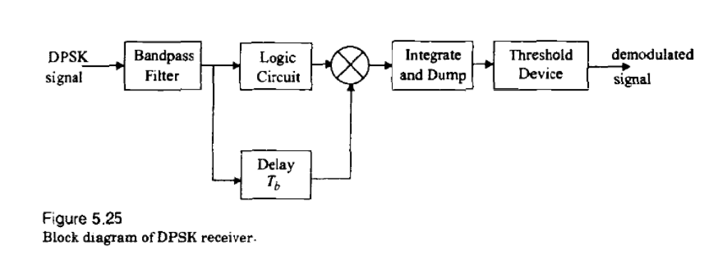
Explain QPSK transmitter & receiver with block diagram.
Ans: Quadrature Phase Shift Keying (QPSK): Quadrature phase shift keying (QPSK) has twice the bandwidth efficiency of BPSK, since 2 bits are transmitted in a single modulation symbol. The QPSK signal for this set of symbol states may be defined as
where T9 is the symbol duration and is equal to twice the bit period.

QPSK transmitter: Figure 5.28 shows a block diagram of a typical QPSK transmitter. The unipolar binary message stream has bit rate Rb and is first converted into a bipolar non-return-to-zero (NRZ) sequence using a unipolar to bipolar converter. The bit stream m(t) is then split into two bit streams m₁(t) and m_{Q}(t) (in-phase and quadrature streams), each having a bit rate of R_{s}= R_{b}/2. The bit stream m₁(t) is called the "even" stream and m_{Q}(t) is called the "odd" stream. The two binary sequences are separately modulated by two carriers, which are in quadrature. The two modulated signals, each of which can be considered to be a BPSK signal, are summed to produce a QPSK signal. The filter at the output of the modulator confines the power spectrum of the QPSK signal within the allocated band. This prevents spill-over of signal energy into adjacent channels and also removes out-of-band spurious signals generated during the modulation process. In most implementations, pulse shaping is done at baseband to provide proper RF filtering at the transmitter output.
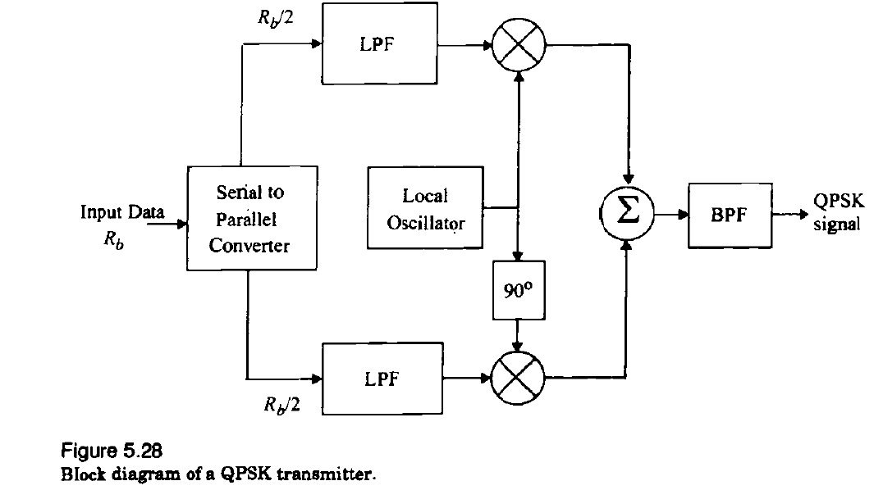

QPSK receiver: Figure 5.29 shows a block diagram of a coherent QPSK receiver. The frontend bandpass filter removes the out-of-band noise and adjacent channel interference. The filtered output is split into two parts, and each part is coherently demodulated using the in-phase and quadrature carriers. The coherent carriers used for demodulation are recovered from the received signal using carrier recovery circuits. The outputs of the demodulators are passed through decision circuits which generate the in-phase and quadrature binary streams. The two components are then multiplexed to reproduce the original binary sequence.
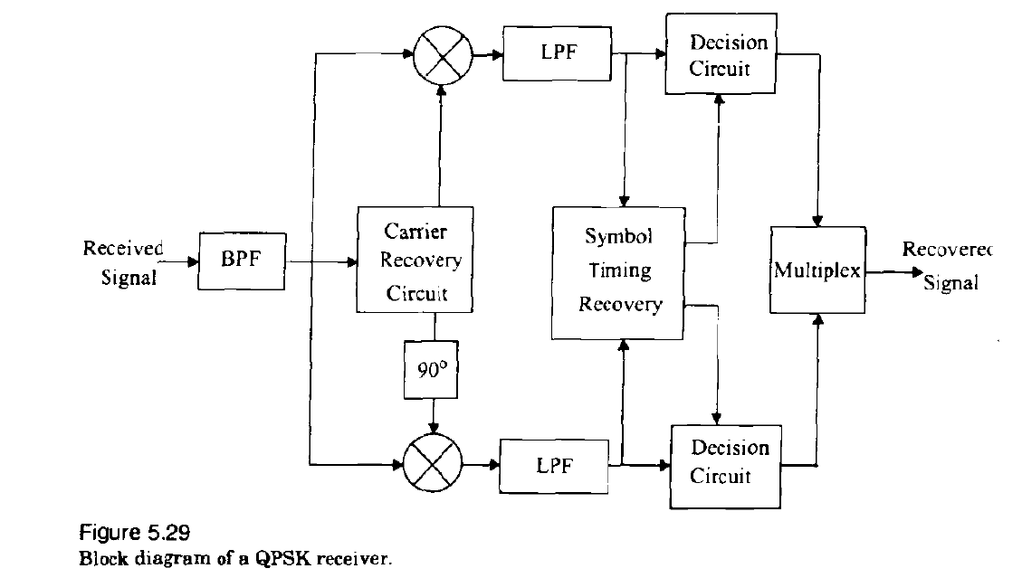

Explain in detail Offset QPSK.
Ans: The amplitude of a QPSK signal is ideally constant. A modified form of QPSK, called offset QPSK (OQPSK) or staggered QPSK is less susceptible to these deleterious effects and supports more efficient amplification.
OQPSK signaling is similar to QPSK signaling except for the time alignment of the even and odd bit streams. In QPSK signaling, the bit transitions of the even and odd bit streams occur at the same time instants, but in OQPSK signaling, the even and odd bit streams, m₁(t) and m_{Q}(t) are offset in their relative alignment by one bit period (half-symbol period). This is shown in the waveforms of Figure 5.30.
Due to the time alignment of m₁(t) and m_{Q}(t) in standard QPSK, phase transitions occur only once every T_{S} = 2T_{b} s, and will be a maximum of 180⁰ if there is a change in the value of both m₁(t) and m_{Q}(t). However, in OQPSK signaling bit transitions (and hence phase transitions) occurs every T_{b} s. Since the transitions instants of m₁(t) and m_{Q}(t) are offset, at any given time only one of the two bit streams can change values. This implies that the maximum phase shift of the transmitted signal at any given time is limited to ±90°. Hence, by switching phases more frequently OQPSK signaling eliminates 180° phase transitions.

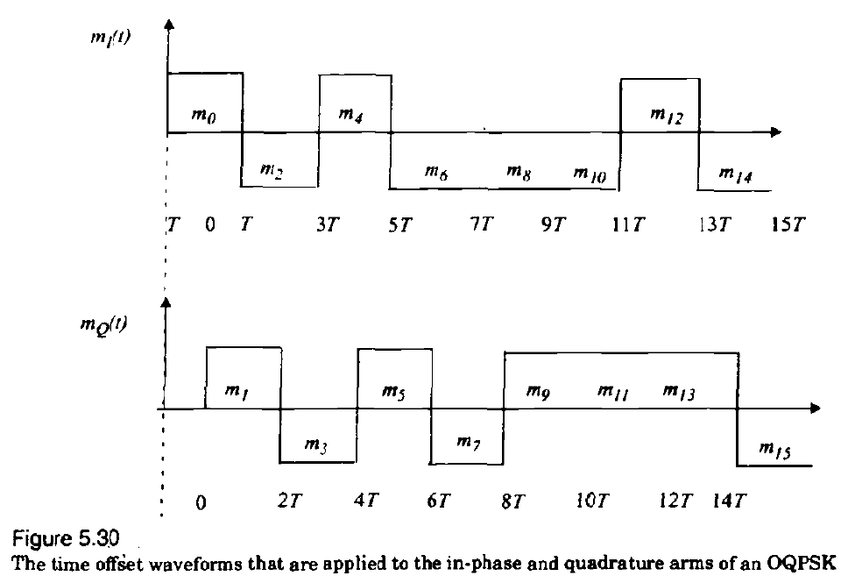

What is ∏/4 QPSK? Explain its transmission technique.
Ans: The ∏/4 shifted QPSK modulation is a quadrature phase shift keying technique which offers a compromise between OQPSK and QPSK in terms of the allowed maximum phase transitions. It may be demodulated in a coherent or noncoherent fashion.
In a ∏/4 QPSK modulator, signaling points of the modulated signal are selected from two QPSK constellations which are shifted by ∏/4 with respect to each other. Switching between two constellations, every successive bit ensures that there is at least a phase shift which is an integer multiple of ∏/4 radians between successive symbols. This ensures that there is a phase transition for every symbol, which enables a receiver to perform timing recovery and synchronization.

∏/4 QPSK Transmission Techniques: A block diagram of a generic ∏/4 QPSK transmitter is shown in Figure 5.32. The input bit stream is partitioned by a serial-to-parallel (S/P) converter into two parallel data streams m_{l,k} and m_{Q,K}. The k th in-phase and quadrature pulses, I_{K} and Q_{k} are produced at the output of the signal mapping circuit over time kT ≤ t ≤ (k+1)T and are determined by their previous values, I_{K-l} and Q_{K-I} as well as Ɵ_{k'}, which itself is a function of Ɵ_{k'} , which is a function of the current input symbols m_{lK} and m_{Qk} and Q_{k} represent rectangular pulses over one symbol duration having amplitudes given by
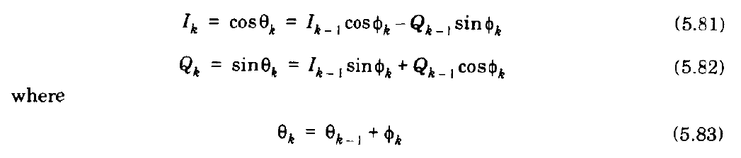
and Ɵ_{K} and Ɵ_{k-1} are phases of the k th and (k—1)st symbols. The phase shift Ɵ_{k} is related to the input symbols m_{lk} and m_{Qk..}

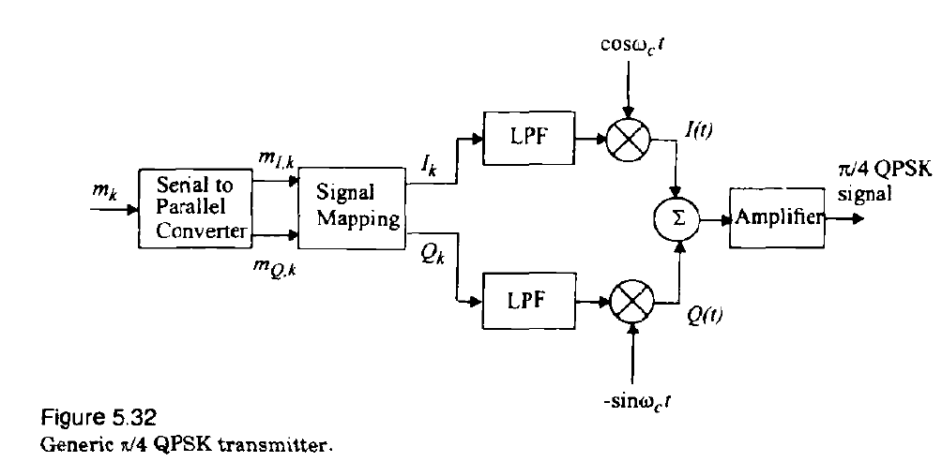
The in-phase and quadrature bit streams I_{K} and Q_{k} are then separately modulated by two carriers which are in quadrature with one another, to produce the ∏/4 QPSK waveform given by
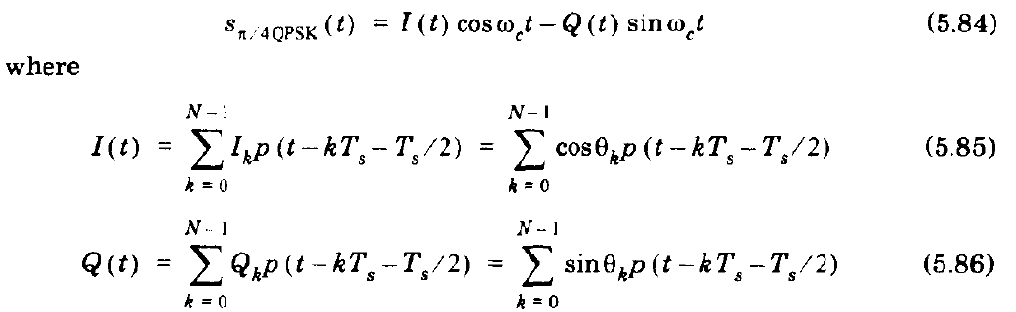
Both I_{k} and Q_{K}are usually passed through raised cosine rolloff pulse shaping filters before modulation, in order to reduce the bandwidth occupancy. The function p(t) in equations (5.85) and (5.86) corresponds to the pulse shape, and T_{s} is the symbol period. The values of I_{k} and Q_{K} and the peak amplitude of the waveforms 1(t) and Q (t) can take one of the five possible values, 0, +1, -1, 

